 |  |  | CBD
 |  | CONVENTION ON  BIOLOGICAL DIVERSITY |  |  | Distr.  GENERAL  UNEP/CBD/COP/6/INF/10  5 March 2002  ENGLISH ONLY
CONFERENCE OF THE PARTIES TO THE CONVENTION ON BIOLOGICAL DIVERSITY
Sixth meeting
The Hague, 7-19 April 2002

Item 24 of the provisional agenda*

ASSESSMENT OF THE INFORMATION CONTAINED IN THE SECOND NATIONAL REPORTS CONCERNING CROSS-CUTTING ISSUES UNDER THE CONVENTION

Note by the Executive Secretary
CONTENTS
 |  |  |  |  | Paragraphs |  | Page
I. | INTRODUCTION |  |  |  |  | 1-9 |  | 2
II. | ASSESSMENT OF INFORMATION IN SECOND NATIONAL REPORTS CONCERNING CROSS-CUTTING ISSUES UNDER THE CONVENTION
 | A. |  | Access and benefit-sharing |  |  | 10-34 |  | 3
 | B. |  | Ecosystem approach |  |  | 35-44 |  | 8
 | C. |  | Public education and awareness |  |  | 45-60 |  | 9
 | D. |  | Global taxonomy initiative |  |  | 61-94 |  | 13
 | E. |  | Alien species |  |  | 95-110 |  | 18
 | F. |  | Traditional knowledge, innovations and practices |  |  | 111-130 |  | 21
 | G. |  | Incentive measures |  |  | 131-147 |  | 26
 | H. |  | Sustainable use of biological diversity |  |  | 148-161 |  | 35
 | I. |  | Biological diversity and tourism |  |  | 162-170 |  | 39
 | J. |  | Impact assessment and indicators |  |  | 171-193 |  | 41
 | K. |  | Protected areas |  |  | 194-206 |  | 45
III. | ASSESSMENT OF INFORMATION IN SECOND NATIONAL REPORTS CONCERNING OTHER ARTICLES OF THE CONVENTION
 | A. |  | Cooperation, research and training, access to and transfer of technology, exchange of information, technical and scientific cooperation |  |  | 207-252 |  | 50
 | B. |  | Handling of biotechnology and distribution of its benefits |  |  | 253-265 |  | 80
 | C. |  | General measures for conservation and sustainable use |  |  | 266-279 |  | 82
 | D. |  | Financial resources and mechanism |  |  | 280-309 |  | 87

I. INTRODUCTION

- The objective of national reporting, as specified in the Article 26 of the Convention, is to present to the Conference of the Parties reports on measures which the Parties have taken for the implementation of the provisions of this Convention and their effectiveness in meeting the objectives of this Convention. The reporting process under the Convention is key to enabling the Conference of the Parties to assess the overall status of the implementation of the Convention.

- At its fifth meeting, the Conference of the Parties considered and adopted the guidelines and the format for future national reporting that were developed by the Secretariat through a pilot project, carried out with the collaboration of a number of Parties.

- Following the request made in Decision V/19, the Executive Secretary revised the format, by incorporating views from the Parties and decisions adopted at the fifth meeting of the Conference of the Parties, and circulated the revised version to the Parties in September 2000. This version was then used by the Parties for their second national reports.

- The Intersessional Meeting on Strategic Plan, National Reports and the Implementation of Convention, which was held in Montreal, Canada, from 19 to 21 November 2001, considered a preliminary synthesis of the second national reports prepared by the Secretariat, and requested the Executive Secretary to make a full assessment of the information contained therein, taking into consideration the progress in, and constraints to the implementation.

- The information presented in this paper is based on the 62∗ second national reports received by the end of January 2002. The majority of Parties have used the format recommended by the Conference of the Parties in its decision V/19, with the revision circulated in September 2000.

- From a statistical point of view, it should be noted that a number of constraints limit the scope of this first attempt at a full assessment of the contents of the second national reports. First of all, only 65 reports, out of a total of 182 Parties, were received by the Secretariat by the end of January 2002. It must also be underlined that, according to the request made by the MSP, only the second national reports are used in this assessment. Other sources of information were not included.

- From a technical point of view, it should be noted that the number of the responses on which different assessments are based varies slightly due to the multiple options some Parties have selected or to the fact that some Parties did not respond to some questions for various reasons. In addition, in many instances, Parties answered questions that were not designed for them.

- A searchable database and an electronic tool called the Second National Reports Analyser have been developed by the Secretariat to post all the national and thematic reports on the website of the Convention (see http://www.biodiv.org/world/reports.asp). This enables access to the information on the status of implementation by fields of inquiry (for example, by regions, subregions and programme of work). It should be noted that a few margins of error still exist in the database partly due to the inappropriate use of the format by some Parties.

- Acronyms and references to issues by article numbers have been kept to a minimum for ease of use of this document. Please note that percentage figures between parentheses in the text relate the number of Parties that replied in a certain way to the overall number of Parties who replied to the same question, whose second national reports were received by the Secretariat up to the end of January 2002 (62 Parties); it does not refer to the total number of Parties to the Convention (182 Parties). Figures with decimals, although generally avoided, occur sometimes in the text and refer to questions in which Parties chose more than one option from the multiple choice offered to them.

II. ASSESSMENT OF INFORMATION IN THE SECOND NATIONAL REPORTS CONCERNING CROSS-CUTTING ISSUES UNDER THE CONVENTION

- Access and Benefit-sharing
1. Introduction

- The fair and equitable sharing of the benefits arising out of the utilization of genetic resources, including by appropriate access to genetic resources and by appropriate transfer of relevant technologies, has been identified as one of the three objectives of the Convention.

- At its second meeting, the Conference of Parties, in Decision II/11, urged Governments to send information to the Secretariat on national measures to implement Article 15. Through Decision III/15, Governments were again urged to send information on legislative, administrative and policy measures and guidelines for activities under Article 15.

- Also through Decision III/15, the third meeting of the Conference of the Parties urged Governments to promote the successful development and implementation of the above measures and to conduct analyses of ongoing experience in this field. Governments were also encouraged to explore, develop and implement the guidelines and practices to ensure mutual benefits to providers and users of access measures. Governments were further encouraged to identify the competent national authorities responsible for granting access to genetic resources.

- At its fifth meeting, the Conference of Parties, through Decision V/26, urged Parties to ensure that national biodiversity strategies as well as legislative, administrative or policy measures on access and benefit-sharing contribute to conservation and sustainable-use objectives.

- The following assessment is based on responses provided in 62 national reports. The responses to the questions relating to the implementation of Article 15 and its associated decisions are analysed on the basis of the United Nations regional groups since regional approaches for access to genetic resources have been developed in a number of regions, such as Andean Pact countries, ASEAN and Africa.

2. Implementation of Article 15 (Access to Genetic Resources), level of priority and resource availability

- The implementation of Article 15 is clearly a high priority for African countries and is a medium priority for the countries of other regional groups. The resources constraint is found in all groups of countries. Out of 46 Parties indicating limiting and severely limiting resources, 27 responses (58%) were from developing countries, 10 (21%) from industrialized countries and 9 (19%) from countries with economies in transition.

Figure 1

  - Implementation of Decisions II/11, III/15 and V/26
(Measures at the national level for facilitating access and benefit sharing)

- Despite resource constraints, a majority of reporting Parties from different regions have endeavored to create conditions to facilitate access to genetic resources for environmentally sound uses by other Parties. 34 Parties (54%) indicate that they have made limited endeavors and 16 Parties (25%) have significant endeavors in this field. Only 10 (16%) Parties have not made efforts in this direction.

  - A number of reporting Parties are in various stages of putting in place a process to ensure that access to resources is subject to prior informed consent. 22 Parties (35%) are in early stages of development; 10 Parties (16%) are in advanced stages and 4 Parties (6%) have a process in place. However, 23 Parties (37%) indicate that they have not developed such a process.

  - A number of Parties have taken some measures or are reviewing potential measures to ensure that any scientific research based on genetic resources provided by other Parties is developed and carried out with the full participation of such Parties. However, 24 out of 60 Parties (40%) indicate that they have no measures for this purpose in place. To date, no Party has comprehensive measures in place.

  - The situation is slightly different for the measures taken to ensure the fair and equitable sharing of the results of research and development and the benefits arising from the commercial and other use of genetic resources with any Contracting Party providing such resources. 17 Parties (27%) have some measures in place; 16 Parties (25%) are reviewing potential measures and 5 Parties (8%) have comprehensive measures in place. 22 Parties (35%) indicate they have no measures in place for this purpose.

Figure 2

  - For those Parties indicating measures in place, 6 Parties cite legislation, 4 Parties statutory policy or subsidiary legislation and 16 Parties policy and administrative measures.

Figure 3

  - At the national level, agreement or memoranda between different interest groups and the State on access to genetic resources and the sharing of benefits arising from their utilization have been undertaken in a majority of Parties, but only to a limited extent.

4. Information provided by Parties to the Secretariat

  - Half of the Parties did not submit the information on relevant legislation, administrative and policy measures, participatory processes and research programmes. 14 Parties (22%) have included such information in their first national reports. 5 Parties (8%) have submitted case studies in this field and 10 Parties (16%) have made submissions through other means.

- With the exception of Latin American and Caribbean countries, a majority of countries have not provided information to the Secretariat on user institutions, market for genetic resources, non-monetary benefits, new and emerging mechanisms for benefit sharing, incentive measures, sui generis systems and intermediaries.

- About two thirds of Parties (44 or 70%) have not submitted information on specific issues related to the role of intellectual property rights in the implementation of access and benefit-sharing arrangements. 13 Parties (20%) have made such submission to the Secretariat.

5. Capacity building and technology development

- Half of the Parties (31) have implemented some programmes covering some needs to promote successful development and implementation of legislative, administrative policy and measures and guidelines on access. Only 5 Parties (8%) have implemented many programmes covering some needs in this regard. 21 Parties (33%) have not implemented such programmes and 2 Parties have no perceived need in this regard.

Figure 4

- Over a half of Parties (36 or 58%) are making analysis or have completed the analysis of the experience of the above measures, including regional initiatives and efforts, for use in further development and implementation of measures and guidelines. 24 Parties (38%) have not done any analysis in this field.

- 44 Parties (70%) are undertaking the collaboration to various extents (35 to limited extent and 9 to significant extent) with relevant stakeholders to explore, develop and implement the guidelines and practices that ensure mutual benefits to providers and users of access measures. The remaining 18 Parties (25%) are not undertaking such cooperation.

- Half of the Parties have, and another half of Parties have not identified national authorities responsible for granting access to genetic resources. More than a half of the Parties (34) have not designated a national focal point and one or more competent national authorities to be responsible for access and benefit-sharing arrangements or provide information on such arrangements. 17 Parties have designated the focal points for access and benefit-sharing arrangements but have not notified the Secretariat yet. 8 Parties have made such notification to the Secretariat.

- A majority of Parties report that they have taken an active role in negotiations concerning the International Undertaking on Plant Genetic Resources for Food and Agriculture. (Please note that the negotiation was concluded early December 2001.) A majority of WEOG countries coordinated their positions under the Convention and the International Undertaking.

- While a majority of WEOG countries and CEE countries have provided capacity building and technology development and transfer for the maintenance and utilization of ex-situ collections, a majority of developing countries have not done so or have done so only to a limited extent.

6. Measures for access to genetic resources and benefit sharing

- A majority of Parties report that their national biodiversity strategies, and legislative, administrative or policy measures on access and benefit sharing contribute to varying extents to conservation and sustainable-use objectives (34 to a limited extent and 23 to a significant extent).

- Only a small number of Parties (10) have adopted administrative or policy measures that are supportive of efforts made by provider countries to ensure that access to their genetic resources is subject to Articles 15, 16 and 19 of the Convention. In addition, 15 Parties indicate that they have made other arrangements for this purpose. However, almost half of the Parties (29) have not adopted such measures. More than half of the Parties (31) are not undertaking cooperation with other Parties in order to find practical and equitable solutions supportive of the above efforts. 23 Parties (37%) indicate that they are doing so. A number of Parties did not respond to this question.

- In developing their legislation on access, only 8 Parties (12%) have taken into account, and allowed for the development of a multilateral system to facilitate access and benefit sharing in the context of the International Undertaking. Legislation on access is under development in 23 Parties (37%), but it is unclear at this time whether such a multilateral system will be taken into account. A similar number of Parties (24 or 38%) indicate that they have not considered this element in developing their legislation on access.

7. Conclusion

  - Overall, the implementation of Article 15 on access to genetic resources is a medium to high priority for a majority of Contracting Parties having submitted a second national report. However, only limited actions have been undertaken to date to implement Article 15. Although progress has been rather slow, possibly as a result of limited resources, initiatives are being undertaken to address the issue. Based on the responses provided, no major differences are observed among different regional groups in this respect.

- Ecosystem Approach
1. Introduction

- At its fifth meeting, the Conference of the Parties, in Decision V/6 and its annex, endorsed the Ecosystem Approach and called upon the Parties to apply it, as appropriate, and develop practical expressions of the approach for national policies and legislation and for appropriate implementation activities, with adaptation to local, national and regional conditions. The Parties were also encouraged to promote the regional cooperation in applying the ecosystem approach across national borders. Meanwhile, the principles and guidelines of the Ecosystem Approach will be reviewed based on case studies and information from the Parties, other Governments and relevant bodies, according to Decision V/6.

- Following this, five questions were included in the format for the second national reporting. Out of 65 second national reports received, around 60 Parties responded to these questions. Considering the nature of the issue, regional perspectives will be employed in some cases in the following assessment of the information concerning the implementation of Decision V/6.

2. Assessment of Information concerning Decision V/6

- As far as the application of the Ecosystem Approach is concerned, 34 Parties (56%) report that they are applying some aspects of the approach. 14 Parties (23%) are considering application of these principles and guidelines for the Ecosystem Approach. Only 6 countries (10%) have substantially implemented the approach. Another 6 indicate that they have not applied any principles or guidance for the approach. Application at the regional level varies only slightly among the countries from different regions, judging from the second national reports received.

    - From the responses and the status of application, it is clear that the application of the Ecosystem Approach is in its initial stage. This may be due to the fact that the approach is a recent development, and more understanding and further exploration are needed. The application of some of its aspects may indicate that countries choose the principles and guidance that fit in with their regional, national and local conditions.

Figure 5

    - On the development of practical expressions of the approach for national policies and legislation and for implementation activities, 37 Parties (61%) report that they are applying some aspects of the approach and 13 Parties (21%) indicate that they are considering developing such expressions, taking into account the national and local conditions. Only 3 Parties (5%) indicate that they have substantially implemented the approach for relevant national policy making and legislation. 7 Parties (11%) have not developed any expression of the approach for their national policies and legislation.

    - Again, there is no obvious difference among countries from different regions. This indicates that most of the Parties are in the early stages of developing practical expressions of the approach for national policies and legislation. Clearly more efforts are to be made in putting the approach into practice in the process of national policy making and legislation. The understanding of relevant principles and guidance should also be improved to make application possible.

    - As far as case studies are concerned, only 8 Parties (13%) indicate that case studies have been identified and 17 Parties (28%) are preparing pilot projects to demonstrate the ecosystem approach. 8 Parties are planning or have held workshops for the purpose of enhancing awareness and sharing the experience in this field. Two Parties have made relevant case studies available through the clearing-house mechanism (Clearing-house Mechanism). However, it should be noted that a significant number of Parties (26 or 43%) have not identified any case studies or implemented any pilot projects that demonstrate the ecosystem approach.

    - In terms of capacity building, 30 Parties (50%) are strengthening their capacity of implementation of the ecosystem approach. 10 Parties (16%), most of them industrialized countries, are providing support to other Parties for capacity building, in addition to their own capacity-strengthening efforts. It should be noted that 19 Parties (31%) are neither strengthening themselves nor assisting others in capacity building.

    - Finally, as to the regional cooperation in applying the approach across national borders, the Parties are evenly distributed among formal, informal and no cooperation. This means that two thirds of the reporting Parties are undertaking some form of cooperation across national borders.

3. Conclusion

- Clearly the application of the ecosystem approach is only in the early stages, and more efforts are needed to adapt the approach for use in different regional, national and local conditions. For this purpose, more case studies are definitely needed.

- Public Education and Awareness

- Public awareness and education are basic instruments for reversing the loss of biological diversity and for the eradication of poverty. These instruments are fundamental in promoting the objectives of the Convention by assisting Parties in integrating biological diversity into national strategies and country-driven activities.

- Article 13 of the Convention states that the Contracting Parties shall: (a) promote and encourage understanding of the importance of, and the measures required for, the conservation of biological diversity, as well as its propagation through media, and the inclusion of these topics in educational programmes; and (b) cooperate, as appropriate, with other Parties and international organizations in developing educational and public awareness programmes, with respect to conservation and sustainable use of biological diversity.

- This analysis is based only on 61 national reports that were received by the end of January 2002 representing a third of the Parties to the Convention.

- For the purposes of this analysis, Parties were grouped by economic criteria. Reports were received from the following Parties: 32 from developing countries (under a fifth of total members of this group), 9 from countries with economies in transition (a little over a third), 20 from industrialized countries (almost 2 thirds), 15 from least developed countries (over a third), 7 from small island developing states (over a fifth).

1. Review of information in second national reports

- A preliminary analysis of responses submitted under the second national report on the topic suggests that the majority of Parties place high and medium priority on public education and awareness. Adequate resources for meeting the obligations and recommendations made are, however, limited and severely limited, especially in developing and least developed countries and small island developing Parties. Also, only slightly over a half of the industrialized countries report good (only 2 out of 20 countries) and adequate resources (7).
Figure 6
- All countries promote and encourage understanding of the importance of, and the measures required for, the conservation of biodiversity through media, although to a different degree: almost half to a significant and half to a limited extent. In the case of industrialized, developing and least developed countries, almost half responded that they promote and encourage such understanding to a significant extent. Another half of these countries promote understanding to a limited extent. In the case of small island developing Parties, almost all declared that they promote understanding to a significant extent. Over two thirds of the countries with economies in transition replied to a limited extent. In addition, for the same question but through the inclusion of this topic in education programmes, the answers are split approximately to a 50/50 ratio of all respondents between “limited extent” and “significant extent”, irrespective of country group.

- Cooperation with other Parties and international organizations in developing relevant educational and public awareness programmes is reported by a majority of Parties irrespective of economic situation to a limited extent (over two thirds), whereas a few report a significant extent (20%) and some no cooperation at all (less than 20 %).

Figure 7

- Public education and awareness needs are covered in the national strategy and action plans to a significant extent in more than half of the countries and to a limited extent in the remaining respondents. It is noteworthy that an overwhelming majority of the countries with economies in transition and small island developing Parties report that they have covered public education and awareness needs in their national strategies and action plans to a significant extent. In this regard, the industrialized countries, developing and least developed countries are split by roughly half/half for having covered and not having covered.

- A majority of Parties in almost all categories have limited resources for the strategic use of education and communication instruments at each phase of policy formulation, implementation and evaluation. Even over half of industrialized countries report that they have significant but not adequate resources, while a third report limited resources.

Figure 8

- Most of the Parties (all small island states, almost all countries in transition, over 80% of least developed, developing and industrialized countries) support initiatives by major groups that foster stakeholder participation and that integrate biological diversity conservation matters in their practice and education programmes. A vast majority of Parties report that they have integrated biodiversity concerns into education strategies, irrespective of their economic status, but stages of development differ.

- Over half of the Parties report that they have made available case studies on public education and awareness and public participation, or otherwise sought to share experiences. Results per different groups of countries suggest the same almost half/half distribution, except for the small island states where almost all have made available such case-studies.

- Very few Parties have illustrated and translated the provisions of the Convention into local languages to promote public education and awareness. This is most probably related to the lack of financial resources mentioned before, especially for developing, least developed countries, small island states and countries with economies in transition. Some countries do not find the issue at all relevant, possibly because their official language coincides with one of the 6 UN languages in which the Convention documents are published.

- Almost all Parties are supporting local, national, sub-regional and regional education and awareness programmes but to different degrees: all countries with economies in transition, half of the small island countries, two thirds of the developing countries and least developed countries and one third of industrialized countries support education and awareness programmes to a limited extent. Two thirds of industrialized countries support to a significant extent. The need seems, therefore, to be recognized but the means and resources are not available.

Figure 9

- More than half of the eligible countries proposed projects that promote measures for implementing Article 13 of the Convention when requesting assistance through the Global Environment Facility (Global Environment Facility). This demonstrates that the importance of the public education and awareness issue is being widely recognized. The majority of small island states reported positively to this. industrialized countries do not answer this question, as they are not eligible to receive Global Environment Facility funding.

- Over half of the countries have limited or no support in capacity building for education and communication in biological diversity as part of the national biodiversity strategy and action plans; there is a clear need therefore to acquire support in this area. Surprisingly, over half of industrialized countries seem to suffer from this as well, as opposed to most small island countries which report that they receive the support needed. The majority of countries in transition report limited support.

2. Conclusions

- Overall, there is a need for more funds and resources, more practical and concrete solutions, strategies and ideas, more focus and a better understanding of the issues, as well as increased cooperation.

- Global Taxonomy Initiative (GTI)

1. Introduction

- The GTI has been established by the Conference of the Parties to address the ‘taxonomic impediment’. This is one of the main impediments to sound decisions for the conservation, sustainable use and equitable sharing of the benefits derived from genetic resources, and refers to the lack of available and appropriate taxonomic information and expertise at national, regional and global levels. The GTI is most closely related to the implementation of Article 7 of the Convention, and is specifically intended to support implementation of the work programmes of the Convention on thematic and cross cutting issues. The GTI has been developed and established in three main Conference of the Parties decisions (III/10, IV/1 D, V/9), and the importance of its activities noted in others. Overall, the implementation of the GTI is still in its early stages, as evidenced by the analysis of Parties’ second national reports.

- The following analysis is based on the 62 reports received. Of those 62 reports 32 are from developing countries, 10 from countries with economies in transition, and the remaining 20 from industrialized countries. Those not submitted are 124, 18 and 9 respectively.

2. Implementation of Article 7 (Identification and Monitoring) and level of priority

- Out of the 62 Parties to the Convention which submitted their second national reports, 55% declared that the priority afforded to implementation of article 7 on identification and monitoring and associated decisions was high, 37% accorded it a medium priority, and for 7% the level of priority was low.

- 60% of countries with economies in transition gave the issue a high level of priority, followed closely by 57% of industrialized countries and 52% of developing countries. Economies in transition are split between high and medium levels of priority (6 and 4 respectively out of 10 which submitted their second national reports).

3. Availability of resources

- 57% recognized that the adequacy of the resources available was limiting in terms of meeting obligations and recommendations under Article 7. 25% stated that those resources were severely limiting. Only 5% declared that the resources available were good.

- Amongst the Parties that had severely limiting or limiting resources, a majority are countries with economies in transition (55% and 35% respectively). However, 2 of the 3 Parties that declared that resources available are good are also developing countries. A small majority of the Parties that had adequate resources are industrialized countries.

4. Inventory programmes

- Inventory programmes at species, ecosystem and genetic levels were underway at minimal levels only in 18%, 18% and 38% of Parties respectively. However, such programmes were underway on a comprehensive basis in 13%, 6% and 1% of Parties respectively.

5. Monitoring programmes

- There was only minimal activity in monitoring programmes at species, ecosystem and genetic levels by 23%, 18% and 65% of Parties respectively. Comprehensive programmes were underway in 3% and 2% of parties at species and ecosystem levels respectively, and in no cases at the genetic level.

6. Taxonomy-related Decisions and National taxonomic needs assessment

- 21 of the responding Parties (34%) had not prepared a national taxonomic needs assessment, and not held workshops to determine national taxonomic priorities. 44% of the responding Parties declared that the assessment was in its early stages, 7% of the Parties (4 Parties) have a completed assessment, although one of these has commenced a reassessment.

- Approximately half of the Parties that declared a completed assessment or an assessment at advanced stages of development are industrialized countries (2 out of 4 and 3 out of 7 respectively). Assessments were at early stages of development in the majority of economies in transition. developing countries constitute the majority of Parties that declared that they had not assessed national taxonomic priorities.

7. National taxonomic action plan

- 60% of the Parties had not developed any national taxonomic action plan, or such a plan is in the early stages of development (29%). Such an action plan was in place in only 1 State.

- The majority of countries that had no national taxonomic action plan were developing countries (66%). The majority of economies in transition countries had plans at early stages of development. The Party which had a national taxonomic action plan is from the developing countries group.

Figure 10

8. Taxonomic information requirements and provision

- A majority of Parties (57%) had identified their taxonomic information needs, and carried out a basic assessment of their national capacity to meet these requirements. 21 Parties (34%) had not made an assessment, while 5 (8%) had made a thorough assessment.

- None of the responding parties were making available resources to enhance the availability of taxonomic information in sufficient degree to cover all known needs. 66% of reporting Parties were making resources available, although those resources did not cover all known needs adequately, whilst 21 states (34%), the majority of which are developing countries (13), no such resources were being made available.

- Of the 95% of respondent Parties which hold relevant collections, 77% were seeking to make taxonomic information held in them more widely available, whilst the remaining 18% were taking no action to do so.

9. Taxonomic institutions and reference centres

Concerning the establishment or consolidation of taxonomic reference centres, Parties were evenly split. 49% of the Parties had established such centres, while 48% had not.

- 49% of the Parties had taken steps to ensure that some or all major institutions responsible for biological diversity inventories and taxonomic activities are financially and administratively stable.

- 58% of Parties declared making some investment on a long-term basis in the development of appropriate infrastructure for national taxonomic collections. Significant investment was made by a minority of Parties (18%), the majority of which were industrialized countries. 24% of the Parties were not investing in the development of appropriate infrastructure for national taxonomic collections.

Figure 11

10. Collection housing

- 60% of the Parties had implemented international agreed levels of collection housing in at least some collections, while 27% had not. Three countries had the issue under review.

11. Increase of capacity

- A majority of Parties (53%) had worked to increase their capacity in the area of taxonomic research.

Figure 12

12. Partnerships and Regional networks

- For 56% of the Parties, encouraging partnerships between taxonomic institutions in developed and developing countries is a stated policy. There is a systematic national programme in only 9%. A relatively large number of Parties, 21 Parties (34%), do not have any such policy.

- 42% of Parties were participating in regional networks to facilitate information-sharing for the Global Taxonomy Initiative, while a small majority of Parties (55%) were not.

- Similarly, a minority of Parties (44%) had assisted taxonomic institutions to establish consortia to conduct regional projects majority of Parties either to a limited or significant extent. A small majority (47%) had not.

13. Training

- 74% of the Parties declared that they had provided some or many training programmes in taxonomy. However, 61% of the Parties do not provide any programmes for re-training of qualified professionals moving into taxonomy-related fields.

- 61% of Parties encouraged bilateral and multilateral training and employment opportunities for taxonomists, particularly those dealing with poorly known organisms. This was not done in 35%. Significant opportunities are declared by 3 Parties.

- A majority of Parties (58%) had given special attention to international funding of fellowships for specialist training abroad or for attracting international experts to national or regional courses, although to a limited extent. This was under review in 8 Parties (13%).

- 36% of the respondent Parties had provided programmes for re-training of qualified professionals moving into taxonomy-related fields, and one Party professed to have many such programmes. 61%, however, had no such programmes.

14. Report on initiatives

- A majority of Parties (63%) still have not reported on measures adopted to strengthen national capacity in taxonomy, to designate national reference centres, and to make information housed in collections available to countries of origin.

15. GTI Pilot Projects

- 84% Parties had not communicated information on programmes, projects and initiatives for consideration as pilot projects under the Global Taxonomy Initiative to the Executive Secretary.

16. GTI focal point

- 60% of Parties had at the time of the report not designated any national Global Taxonomy Initiative focal point linked to other national focal points. 37% had.

17. Resources

- 36 Parties out of the 41 (i.e. 88%) developing countries and countries with economies in transition which submitted a report and responded to this question, have not sought any financial assistance from the financial mechanism for the priority actions identified in the decision. 4 did apply but were unsuccessful while 1 was successful.

18. Conclusion

- The second national reports suggest that a great deal remains to be done in the area of taxonomic support for implementation of the Convention. In terms of the responders versus non-responses there is a disproportionate lack of response from developing countries. There is thus a sampling bias in favour of those with better resources. One of the constraints noted by Parties in their responses is in terms of resources. The picture gained from the results above may thus considerably exaggerate the levels of activity under way.

- The responses examined above show that where programmes and policies are at early stages of development or not undertaken at all, developing countries are a majority. In this respect, several impediments have been mentioned by Parties, such as the lack of financial and trained human resources. Logistical problems to identification and monitoring activities have also been mentioned. There are still many taxonomic needs assessments and action plans to be constructed, although even where such activities have been carried out there are still insufficient resources to make taxonomic information available to meet all known needs adequately.

- The need for comprehensive surveys rather than surveys of specific species have been stressed by a few Parties. It is interesting to note that in developing countries, taxonomic activities are still very much based on individual initiatives by scientists.

- Alien Species

1. Introduction

- At its fifth meeting, the Conference of the Parties, in Decision V/8, adopted the interim guiding principles contained in annex I to the decision above. The sixth meeting of the Subsidiary Body for Scientific, Technical and Technological Advice further elaborated the interim guiding principles and the outcome of their work will be presented to the sixth meeting of the Conference of the Parties for consideration of options for full and effective implementation of Article 8 (h) including the possibilities of (a) further developing the guiding principles on the prevention of introduction, and mitigation of the impacts, of alien invasive species; (b) developing an international instrument; and/or (c) other options. Parties were urged to develop strategies and action plans for alien invasive species and mechanisms for transboundary cooperation and regional and multilateral cooperation, and were requested to submit case studies and disseminate publicly available information which they hold or acquire.

- Altogether 16 questions were included in the format for the second national reports concerning the implementation of the Article 8 (h), the Decision V/8 and the Recommendation of SBSTTA IV/1. In addition, Parties were requested to provide a thematic report on alien species. 52 thematic reports have been received by the end of January 2002 and a synthesis and assessment of information contained in thematic reports will be presented to Conference of the Parties 6 in a separate information document. The following assessment contains information from the second national reports only.

- Regional and global perspectives lend themselves naturally to the analysis of alien species, considering the transboundary nature of the issue and the regional and multilateral cooperation that is fundamental for preventing the introduction of, and controlling and eradicating the alien species that threaten ecosystems and habitats.

2. Implementation of Article 8(h) (Alien Species), level of priority and resource availability

- In terms of priority setting, out of 60 Parties, 38% of reporting Parties (23) give a high priority, 46% of the Parties (28) a medium priority and 15% of the Parties (9) a low priority to the implementation of Article 8(h). The importance of the issue of alien species is being recognized by some Parties. They are taking some measures including legislation, quarantine and trade control. Some Parties are working on a strategy for control and eradication of alien species. However, due to lack of relevant knowledge and effective tools for risk assessment, some Parties find difficulty in recognizing the priority to the issue.

- One of the most important constraints for alien species control and eradication is that the resources available are limiting for a significant number of Parties (34 or 56%), and severely limiting for a considerable number of Parties (17 or 28%). Together they account for over 80% of the total Parties submitting a second national report. The resources scarcity for the implementation of the Article 8(h) is felt in all groups of countries, including 13 industrialized countries (out of 20), but severe resources limitation is found in developing countries and only a few countries with economies in transition.
Figure 13
Figure 14

3. Assessment and Identification of Alien Species introduced

- For identification of alien species introduced, about 75% of the Parties report (46 out of 61 or 88%) that only major species of concern have been identified. 6 Parties report that only new or recent introductions have been identified. 6 Parties indicate that a comprehensive tracking system is in place for all known introductions of alien species. Only a few Parties (3) inform that the tracking system is in place only for new introductions. Only one Party has not identified any alien species.

- Asked about whether any assessment has been made of the risks posed to the ecosystems, habitats or species by the introduction of alien species, a majority of Parties (53 out of 61 or 86%) report that only some alien species of concern have been assessed. Only one Party has assessed most alien species. A few Parties (7) indicate that no assessment is made.

4. Measures to Prevent Introduction, Control and Eradicate Alien Species

- In terms of the measures to prevent the introduction of, control or eradicate those alien species, again a majority of Parties (51 out of 61 or 85%) indicate that some measures are in place. Only 3 Parties and 2 Parties report on comprehensive and no measures respectively. 4 Parties are reviewing potential measures for this purpose.

5. Implementation of SBSTTA Recommendation IV/1

- For collaborative project development, 57% of the reporting Parties (35) inform that they are discussing potential projects at national, regional, sub-regional and international levels to address the issue of alien species. 15 Parties report on no or little action and 12 Parties on developing actively new projects. A majority of Parties (42 out of 61or 68%) address to a limited extent the issue of alien species in their national biodiversity strategy and action plan. 17 Parties address significantly this issue in their NBSAP. Only 2 Parties have not addressed this issue in their NBSAP. This is consistent with the level of implementation of the Article 8 (h).

6. Implementation of Decision V/8 and Application of Interim Guiding Principles

- In applying the interim guiding principles, 45% of the reporting Parties (28) report on limited implementation in some sectors, 9 Parties on extensive implementation in some sectors and 2 Parties on extensive implementation in most sectors. 23% of the Parties (14) are considering the application of the interim guiding principles and 8 Parties are not applying. A majority of Parties (53 out of 61 or 86%) have not submitted any written comments on the interim guiding principles to the Secretariat. A considerable number of Parties (40 or 65%) have not submitted any case studies in this field. 14 Parties have submitted and 6 Parties are preparing case studies.

- However, 67% of reporting Parties (41) have given priority to the development and implementation of alien species strategies and action plans. 54% of the Parties (33) are employing the ecosystem approach and the precautionary approach in their work on alien species while 44% of the Parties (27) are not. 40 Parties have developed some educational and awareness raising initiatives on the issue of alien species. 16 Parties have not developed such initiatives. Only a few (3) Parties have developed many initiatives in this field.

- In dealing with the issue of alien species, 59% of the Parties (36) do not pay priority attention to the geographically and evolutionarily isolated ecosystems. In contrast, 39% of the Parties (24) do. This is particularly the case in most of small island developing countries due to their special geographical conditions and ecosystems. For those giving negative answers, this may be due to the national circumstances of some Parties where they may not have such isolated ecosystems.

- About 65% of the reporting Parties (40) have been involved in various forms of cooperation and mechanisms to deal with the issue of alien species. However, this is not the case for the remaining 35% of the Parties (21). A considerable number of Parties have not provided any support to enable the Global Invasive Species Programme to fulfill its tasks while 20 Parties have provided limited support and only 3 Parties substantial support to GISP.

- Finally, the availability of information is limited at this stage. 32% of the reporting Parties (20) could provide limited information on alien species and only 5 Parties can provide all available information. In contrast, 44% of the Parties (27) cannot make any information available.

7. Conclusion

- The differences among countries from different regions are not remarkable. However, some regional groups of countries are more advanced in legislation and policy and programme development than other groups of countries. Generally the countries of all groups are at a similar level of implementation, which may be attributed to the fact that the issue of alien species is relatively new and the work on various aspects of the issue is still ongoing within the Convention or other relevant fora.

- Judging from the responses concerning identification of alien species, risk assessment and measures taken, it is clear that more needs to be done for a full implementation of the Article 8(h), though a number of Parties have made some progress in scientific research, monitoring, legislation and planning. Some Parties have identified the following as a number of constraints for implementation of the Article 8 (h).

- Weak capability of research, inventorying, risk assessment and monitoring
- Lack of measures to control unintentional introduction
- Inconsistency of policy among relevant sectors and industries
- Weak information exchange and cooperation among the countries at the regional level
- Lack of regulatory and technical tools

- Article 8(j): Traditional Knowledge, Innovations and Practices

1. Introduction

- At its third meeting, the Conference of the Parties, in its Decision III/14, recognized that traditional knowledge should be given the same respect as any other form of knowledge in the implementation of the Convention. In the same decision, Parties were requested to develop national legislation and corresponding strategies for the implementation of Article 8(j). Parties were also urged to include in their national reports information concerning implementation of Article 8(j).

- At its fourth meeting, the Conference of the Parties, in Decision IV/9, decided that an ad hoc open-ended intersessional working group would be established to address the implementation of Article 8(j) and related provisions of the Convention. One of the mandates of the working group is to develop a programme of work. Parties were encouraged to include representatives of indigenous and local communities in their delegations.

- The Conference of the Parties, in Decision V/16 of its fifth meeting, endorsed a programme of work, which is subject to periodic review during its implementation. Parties and Governments were urged to promote and implement the programme of work taking into consideration their own national circumstances. The mandate of the working group was also renewed to continue its work on Article 8(j) and related provisions.

- To obtain information concerning the implementation of Article 8(j) and the decisions above, 22 questions were included in the second national report format. 58 Parties responded to most of the questions. The analytic perspective is flexible here considering varying national circumstances of different Parties.

2. Implementation of Article 8(j)

- In terms of priority setting, a relatively large number (13 or 22%) of low priorities are found in the implementation of Article 8. This may be related to the fact that some Parties do not find these provisions of much relevance to their national circumstances. Even so, 44% of the reporting Parties (26) give a high priority and 32% of the Parties (19) a medium priority to the implementation of Article 8(j). It should be noted that the high priority is found in a very high percentage of least developed countries (12 out of 15, or 80% of the least developed countries) and small island developing countries (6 out of 7, or 85% of the small island developing countries).

- The resources constraint, on the other hand, may also explain the basis for priority setting. 51% of the reporting Parties (30) find the resources available limiting and 27% of the Parties (16) have severely limiting resources. They are mostly the countries that accord it a high priority. Only 3 Parties indicate good and 9 Parties adequate resources for the implementation of Article 8(j). While not a high priority domestically, some industrialized countries indicate that they consider this as a high priority in their development assistance and cooperation programs.

Figure 15

- Over half of the Parties (30) report that they have undertaken some measures to ensure that the knowledge, innovations and practices of indigenous and local communities embodying traditional lifestyles relevant for conservation and sustainable use of biological diversity are respected, preserved and maintained. Only 2 Parties have comprehensive measures in place. 13 Parties indicate that they are reviewing potential measures. 12 Parties report on no measures, mostly because they do not consider they have the traditional knowledge within the definition of the Convention.

Figure 16

- As to the sharing of the benefits arising from the utilization of traditional knowledge, half of the Parties (29) indicate they are in early stages of developing some policies or programs to encourage such benefit sharing. Only 6 Parties are in advanced stages and 4 Parties have put a program or policy in place. Again, notably 31% of the Parties (18) are not working towards this direction.

3. Implementation of Decisions III/14 and IV/9

- The development of national legislation and corresponding strategies for implementation of Article 8(j) is still in the early stages in a significant number of countries (22 or 37%). 43% of the Parties (25) have not taken any action in legislative or strategic development. Only 7 Parties have established legislation or other measures in place.

- The information sharing among the Parties for implementation of Article 8(j) is still preliminary. One half of the Parties have not supplied any information to other Parties and another half of Parties are exchanging information through the clearing-house mechanism (Clearing-house Mechanism) and other means or including relevant information in their national reports. Most of them (47 out of 58 or 81%) have not submitted case studies on their measures to implement the related provisions of the Convention relating to indigenous and local communities.

4. Implementation of Programme of Work Annexed to Decision V/16

- Only 4 Parties have reviewed the program of work and identified ways to implement it. Half of the Parties (29) report that the program of work is being reviewed. 39% of the Parties (23) indicate that they have neither reviewed the program of work nor identified ways of implementation. 43% of the Parties (25) indicate that they have integrated some tasks in the program of work into their ongoing programs. Only 4 Parties have integrated to a significant extent. Over a half of Parties (30) indicate they have made no integration or found the tasks inappropriate to their national circumstances.

- In implementing the program of work, 38% of the reporting Parties (18) report that they are taking limited account of existing relevant instruments, guidelines and codes. However, a considerable number of Parties (23 or 39%) are not doing so and 11 Parties indicate that they are not appropriate to their national circumstances. The financial support provided to the implementation of the program of work is not satisfying. Only 27% of the Parties (16) have provided limited financing and 2 Parties allocated significant funding. The financial resources are not yet available from about a half of Parties (28 or 48%) for the implementation of the programme of work.

- Slightly over half of the Parties (30) have involved women and women’s organizations in the implementation of the program of work while 28 Parties have not. However, the participation of indigenous and local communities in the implementation of the Convention is still limited. Only 13 Parties (22%) have taken significant measures to facilitate effective participation of indigenous and local communities. By contrast, the countries with economies in transition as a group have done less than other groups of countries in taking measures to facilitate the participation of indigenous and local communities in activities undertaken by the Convention. The participation of representatives from indigenous and local communities in the national delegations is even more limited. Only 13 Parties report that they have sent their indigenous and local representatives to the meetings under the Convention.

- Out of 59 Parties, 39 (66%) are taking some measures to promote the conservation and maintenance of knowledge, innovations and practices of indigenous and local communities. Only 2 Parties are taking extensive measures for this purpose.

- With respect to the establishment of the registers of traditional knowledge, a specific measure that could facilitate the implementation of all of the provisions of Article 8(j) as well as prevent the unauthorized use of traditional knowledge, 44% of the reporting Parties (26) report that they are developing registers of traditional knowledge, innovations and practices. The rest are not registering or find this inappropriate to their national circumstances. To date, no register is fully developed. In contrast to other measures, the establishment of traditional knowledge registers stands out as a significant measure among small island developing countries for the protection of traditional knowledge, and its significance is also greater among least developed countries than for Parties in the other economic groupings.

Figure 17

- The information exchange for the implementation of this decision is similar to that above. About half of the Parties have made some information available through various means, including national reports, and another half still have not undertaken information sharing with other Contracting Parties. The number of case studies submitted by the Parties is very small. Only 5 Parties (8%) have made such submissions to the Secretariat.

- From additional information provided by some Parties, it can be concluded that a number have established a legal system and some institutional capacity, and have adopted some practical measures to protect traditional knowledge, innovations and practices of indigenous and local communities. However, the following limiting factors are identified for implementation.

- Lack of regulatory and policy framework for protection of traditional knowledge
- Ambiguity in conceptual understanding of relevant issues
- Lack of institutional building and information collection and sharing
- Lack of evaluation of traditional knowledge
- Lack of mechanisms or policies for benefit sharing arising from the utilization of traditional knowledge
- Lack of awareness and capacity at local levels

5. Conclusion

- In analyzing the responses to 22 questions that address the implementation of Article 8(j) and its related provisions, the decisions of previous meetings of Conference of the Parties and the programme of work, some clear trends have emerged. From 58 reports, it is evident that only a small number of Parties (4) have consistently given positive responses to the 22 questions, indicating that they have effectively addressed the requirements. On the other hand, a third of the responses indicate that no measures have been taken to address the matters raised in the questions. Generally, for most of the questions, a little more than half of the reports indicated that some actions were either being taken or considered to address the implementation of Article 8(j).

- While only a small number of Parties have taken the actions required to fully implement Article 8(j), a significant number of Parties nevertheless have started the process. Noting that whereas the programme of work includes developing guidelines or principles, many Parties indicate that they are waiting for these to be finalized in order to fully develop their own programmes for the implementation of Article 8(j).

- Finally, the assessment indicates that much more still needs to be done in relation to putting in place measures (such as national legislation or policies) to implement the provisions of Article 8(j), including increasing the level of participation of indigenous and local communities in the activities undertaken under the Convention, addressing the programme of work on Article 8(j) and related provisions, and increasing the level of participation of women and their organizations in the programme of work for the implementation of Article 8(j).

- Incentive Measures

1. Introduction

- The Parties to the Convention on Biological Diversity have addressed the implementation of Article 11 of the Convention, on incentive measures, in several decisions: decision III/18; decision IV/10 and decision V/15.

- At Conference of the Parties 5, a programme of work on incentive measures was established in order to support Parties in developing practical policies and projects and to develop practical guidelines to the financial mechanism for effective support and prioritization of these policies and projects (decision V/15, paragraph 1).

- At Conference of the Parties 4, Parties were encouraged to promote the design and implementation of appropriate incentive measures, to identify threats to biological diversity and underlying causes of reduction or loss of biological diversity and relevant actors, as a step in the formulation of incentive measures, to develop supportive legal and policy frameworks for the design and implementation of incentive measures, to identify perverse incentives and consider the removal or mitigation of their negative effects on biological diversity; and to undertake value addition and enhancement of naturally occurring genetic resources, based on the participatory approach. (decision IV/10 A, paragraph 1).

- Conference of the Parties 3 has encouraged Parties to review existing policies to identify and promote incentives for the conservation and sustainable use of components of biological diversity (decision III/18, paragraph 3), to ensure adequate incorporation of market and non-market values of biodiversity into plans, policies and programmes, including national accounting systems and investment strategies (decision III/18, paragraph 4), to develop training and capacity-building programmes and promote private sector initiatives in this area (decision III/18, paragraph 5) and incorporate biodiversity considerations into impact assessments (decision III/18, paragraph 6).

2. Progress in design and implementation: Programmes

- Country groups differ with respect to the general progress made in designing and implementing incentive measures. While 65 % of reporting industrialized countries have corresponding programmes in place or are even in the stage of programme assessment, the figures are of 30 % for Countries with economies in transition and of 10 % for developing countries. Conversely, 60 % of Countries with economies in transition and approximately 90 % of developing countries (as well as of LDC) have, up to now, no such programmes established or are in an early stage of development (industrialized countries: approximately 15 %; see figures 18(a) and 18(b)).

Figure 18 (a)

Figure 18 (b)
3. Progress in design and implementation: Sectoral activities
- Differences can also be observed in regard to sectoral mainstreaming. While approximately 35 % of reporting industrialized countries report that the programmes cover all major sectors or all sectors, the figures are of approximately 20 % for developing countries and 15 % for Least developed countries. One Country with Economy in Transition reports that its programmes cover all major sectors or all sectors, representing 10 %. Conversely, approximately 40 % of Countries with economies in transition report no sectoral mainstreaming (industrialized countries: 10 %, developing countries: 20 %, Least developed countries: 35 % -- see figures 19(a) and 19(b)).

Figure 19 (a)

Figure 19 (b)

4. Prioritization

- Approximately half of all reporting Parties assign medium priority to the implementation of article 11 and the associated decisions. However, large differences can be observed among Convention regional groups. Importantly, these differences do not follow national income brackets (see figures 20(a) and 20(b)). Please note that, under the sample, the African group largely corresponds to the LDC group. As can be seen from these figures, the highest priority is given by the African/LDC group (60 % high, 40 % medium priority), followed by WEOG (30 % high, 65 % medium) and CEE (20 % high, 70 % medium). Responses from Asia and GRULAC spread more evenly over the priority levels, with a substantial quota of countries giving low priority to the design and implementation of incentive measures.

Figure 20 (a)

Figure 20 (b)

5. Resource constraints

- From the aggregate data as well as from the Parties’ comments, the availability of resources, or the lack thereof, can be identified as the most important explaining variable for these differences in implementation progress among country groups. While almost 60 % of reporting industrialized countries characterized the availability of resources as good or adequate, resources are a limiting or severely limiting factor for almost 80 % of developing countries and over 90 % of Countries with economies in transition (see figures 21(a) and 21(b)). Resource availability and implementation progress are positively correlated.

Figure 21 (a)

Figure 21 (b)

- Note, however, that this correlation is not perfect, as Countries with economies in transition perceive their resource constraint to be more severe than developing countries, but are nevertheless further advanced in implementation. This phenomenon may reflect the subjectivism inherent in assessments of resource adequacy, but may also point to the existence of other explaining variables not covered by the questionnaire.

6. Prioritization and progress in implementation

- A low priority given to the implementation of article 11 may be suspected to act as a constraint of successful implementation. Hence, prioritization may be an additional explaining variable for implementation progress. However, the data gives only limited support for the significance of this relationship. As a counter-example, consider the differences between least developed countries and GRULAC. Reporting least developed countries and GRULAC countries have a similar perception of their resource situation. Even while GRULAC countries put a considerable lower priority on the issue, they are slightly more advanced in implementation. Again, this observation points to the existence of other, country group-specific characteristics which are responsible for implementation progress and were not covered by the questionnaire.

- Alternatively, it might be argued that the priority given to the issue also depends on the implementation progress observed so far. The rationale is that Parties achieving substantial implementation progress may, as a reaction, now prefer to put a lower priority on the issue. While this relationship may explain the differences between, e.g., WEOG and the least developed countries group, it is at odds with the CEE data. CEE countries put less priority on the issue than the WEOG group, even while they have so far less progressed in implementation.

- Resource scarcity may also feed into the given priority as an additional explanatory variable. The rationale is that Parties, from the outset, may prefer to give a lower priority to issues they perceive as being resource-intensive. However, even while such an addition may reconcile the CEE data with a theoretical explanation, it can still not explain the differences between least developed countries and GRULAC. As noted before, reporting least developed countries and GRULAC countries have a similar perception of their resource situation. While GRULAC countries report slightly more implementation, this cannot account for the large difference in prioritization between these country groups. This observation suggests that the differences in prioritization are also due to country-specific peculiarities and other characteristics not covered by the questionnaire.

7. Training

- Country groups largely differ in their development of training and capacity building measures (see figures 22(a) and 22(b)). While 80 % of reporting countries with economies in transition and 75 % of least developed countries do not have, at the moment, corresponding programmes in place, the figure is of 25 % for industrialized countries.

Figure 22 (a)

Figure 22 (b)
8. Assessment
- Approximately 70 % of all reporting Convention members have incorporated biodiversity considerations into impact assessments. When compared with general programme implementation (see paragraph 138 above), the spread in implementation among country groups is smaller (80 % for industrialized countries, 65 % for developing countries) and is not only along national income differentials (least developed countries having approximately 75 %, small island developing countries having 85 %; see figures 23(a) and 23(b)).

Figure 23 (a)

Figure 23 (b)

9. Valuation

- A similar conclusion concerning the spread among country groups can be drawn with respect to the economic valuation of biological diversity. However, when compared with the incorporation into impact assessments, as well as with general programme implementation, all country groups report less progress: 70 % of reporting industrialized countries do not have valuation mechanisms or are in early stages of identifying such mechanisms. Corresponding figures are of 95 % for developing countries and of 90 % for Countries with economies in transition (see figures 24(a) and (b)). These results may reflect the fact that many valuation methods are expensive and need considerable capacity, and that economic valuation in general is still an object of controversy.

Figure 24 (a)

Figure 24 (b)

10. Perverse incentives
- When compared with general programme implementation, figures are also lower in regard to identifying and removing perverse incentives (see figures 25(a) and (b)): between 45 % (industrialized countries) and 15 % (developing countries) of a country group report to have identified (but not neutralized all) perverse incentives. These figures may reflect the huge political obstacles of such an endeavor, due to rent-seeking activities of economic actors who profit from perverse incentives. Only one Asian small island developing country reports to have identified and neutralized perverse incentives.

Figure 25 (a)

Figure 25 (b)

11. Conclusion

- It can be concluded that implementation of article 11 by the Parties to the Convention is not yet complete. In particular, general implementation deficits can be noted in regard to valuation and to the identification and removal of perverse incentives. The analysis also points to the importance of resource constraints in implementing Article 11.

- Sustainable Use of Biodiversity

1. Introduction

- At its fifth meeting, the Conference of the Parties has adopted Decision V/24 concerning sustainable use as a cross-cutting issue under the Convention. In that decision, Parties and Governments were urged to “develop or explore mechanisms to involve the private sector and indigenous and local communities in initiatives on the sustainable use of biological diversity and in mechanisms to ensure that indigenous and local communities benefit from such sustainable use. Parties and Governments are invited to undertake appropriate actions to assist with other Parties to increase their capacity to implement sustainable-use practices, programmes and policies at regional, national and local levels.

- 13 questions were included in the second national reporting format to assess the implementation of Article 10 and Decision V/24. The analysis is based on the responses from 60 Parties.

2. Implementation of Article 10

- Article 10 may be one of the typical cases where high priority is accorded by most of the Parties (39 Parties out of 60 for high priority, 20 Parties for medium priority and only 1 for low priority), but the level of resource availability restraint is high. In fact, 55% of the reporting Parties (33) report on limiting resources and 16% of the Parties (10) indicate that resources are severely limiting. 26% of the Parties (16) indicate that resources are inadequate.

Figure 26

- The importance of integrating considerations of conservation and sustainable use of biological diversity into national decision-making is increasingly recognized by most of the Parties. 24 Parties (40%) report that programs or policies are in place for this purpose. 21 Parties (35%) are in early stages and 11 Parties (18%) are in advanced stages of developing such programs or policies. 3 Parties have reviewed the implementation of such programs or policies and made relevant information available.

Figure 27

- According to 61second national reports, 46 Parties (75%) have put in place some measures relating to the use of biological resources to avoid or minimize adverse impacts on biological diversity. 8 Parties (13%) have adopted comprehensive measures for this purpose and 6 Parties (10%) are reviewing potential measures of such kind. Only one Party indicates that no measures are in place.

- A similar number of Parties responded to the question concerning the measures that protect and encourage customary use of biological resources that is compatible with conservation or sustainable use requirements.

- It is however likely that high priority accorded to the minimization of adverse impacts on biological diversity is a result of the adoption of some general provisions for environmental protection rather than specialized regulations for addressing issues relating to Article 10 of the Convention of Biological Diversity. The information concerning measures to encourage the customary use of biological resources seems to be a direct consequence of the awareness raised by the Convention on this issue, through the provisions contained in Article 10(c) but, most probably, through Article 8(j), calling for the respect, preservation and maintenance of indigenous knowledge and practices relevant to the conservation and sustainable use of biodiversity and the promotion of their wider application.

- With respect to the establishment of measures to help local populations to develop and implement remedial actions in degraded areas where biological diversity has been reduced, 39 Parties (63%) report that some measures are in place and 5 Parties (8%) indicate they have comprehensive measures in place. 7 Parties (11%) are reviewing potential measures for this purpose. Also in this case, given the variety of possible environmental damage involving biodiversity as well as the wide range of measures utilized to limit such damage, it is possible that the responses to the questionnaire report on measures and remedial actions, which relate to general environmental legislation and are not necessarily specific to the Convention.

- The development of sustainable use methods through cooperative initiatives between the government authorities and the private sector is in the early stages in about more than 40% of the reporting Parties. This may indicate that sustainable use is a more delicate issue and needs further efforts in method development and this also confirms that the issue of sustainable production and consumption has not been effectively addressed, in particular for what concerns relevant industrial sectors. 16 Parties (26%) have such programme or policy in place for sustainable-use method development and 8 Parties (13%) are in advanced stages of method development.

3. Implementation of Decision V/24

- 41 Parties (67%) report that they are assessing potential indicators and incentive measures for sectors relevant to the conservation and sustainable use of biodiversity. 8 Parties (13%) have identified indicators and incentive measures in this field. The indicators and incentive measures are yet to be developed, according to 12 reports (19%). This indicates that the potential involvement of relevant sectors in the conservation and sustainable use of biological diversity remains to be explored.

Figure 28

- It seems that more cooperation among the Parties is needed to increase their capacity for implementing sustainable-use practices, programmes and policies at regional, national and local levels, especially in pursuit of poverty alleviation. 15 Parties (24%) have provided limited assistance and 13 (21%) have assisted to a significant extent while 27 Parties (44%) have not and 6 Parties (9%) find this not relevant.

- With regard to the mechanisms to involve the private sector and indigenous and local communities in initiatives on sustainable use, and in mechanisms to ensure that indigenous and communities benefit from such sustainable use, 33 Parties (54%) report that such mechanisms are under development and 14 Parties indicate that the mechanisms are in place. The mechanisms of this kind are not in place in 14 Parties (22%). The way the question on involvement mechanisms was formulated, encompassing two major stakeholders (the private sector and indigenous and local population), does not allow for a clear evaluation of the involvement of the either sector per se. However, through the interpretation of previous answers to the questionnaire, it is possible to infer that such mechanisms have been preferably directed to the involvement of indigenous and local communities, more than the private sector.

Figure 29

- 47 Parties (77%) indicate that they have not yet identified areas for the conservation that will benefit through the sustainable use of biological diversity or communicated this information to the Executive Secretary. This shows that the issue of sustainable use is still in the very early stage, and that analysis of potential benefits for different sectors relevant to biodiversity are a priority, since they will set the stage for subsequent identification, development and implementation of measures and associated instruments for the sustainable use of biological diversity.

4. Conclusion

- The analysis of 61second national reports seems to indicate that a majority of reporting Parties are taking action to integrate consideration of conservation and sustainable use of biological resources into national decision-making. Many Parties are taking some measures to avoid or minimize the adverse impacts of use of biological resources on biological diversity, protect and encourage customary use of biological resources and help local populations develop and implement remedial action in degraded areas where biological diversity has been reduced. It seems that more actions are needed for identifying indicators and incentive measures for sectors relevant to the conservation and sustainable use of biodiversity, increasing the capacity to implement sustainable-use practices, programmes and policies at various levels, and developing the mechanisms for the private sector and indigenous and local communities to be involved in the initiatives on sustainable use.

- Biological Diversity and Tourism

1. Introduction

- At its fifth meeting, the Conference of Parties adopted Decision V/25 and its annex, which contains the assessment of the interlinkages between biological diversity and tourism, and decided to transmit the above assessment to the Commission on Sustainable Development (CSD) with a recommendation to CSD that the assessment be included in the international work programme on sustainable tourism development. The assessment primarily includes: (a) the economic importance of tourism and its interrelationship with the conservation and sustainable use of biological diversity; (b) the potential impacts of tourism on biological diversity, including economic, social and environmental impacts.

- Parties, Governments and relevant international organizations were recommended to consider the assessment as a basis for their policies, programmes and activities in the field of sustainable tourism. Parties, Governments and relevant international organizations were also encouraged to undertake the activities in support of the preparation for both the International Year of Ecotourism and the International Year of Mountains.

- 8 questions were included in the format of second national reporting to assess the implementation of Decision V/25, including two questions concerning the implementation of Decision IV/15. The following assessment is based on the responses from 61 Parties.

2. Implementation of Decision IV/15

- As called for by Decision IV/15, Parties were requested to submit information on tourism and its impacts on biological diversity, and efforts to effectively plan and manage tourism development and activities. Two thirds of Parties have not submitted any information to the Secretariat yet. 12 Parties have included relevant information in their first national reports and only 5 Parties have submitted case studies.

- Out of 59 Parties that answered this question, 38 Parties (64%) have not submitted to the Secretariat information on biodiversity-related activities under the CSD. 14 Parties (24%) have included relevant information in their first national reports. A few Parties (7 or 12%) have included relevant information through other means, such as national reports to the CSD.

3. Implementation of Decision V/25

- 37 Parties (60%) report that they have done so to a limited extent and 12 Parties (20%) have done this to a significant extent. 12 Parties (20%) have not developed their policies and programmes for sustainable tourism development based on the assessment annexed to the Decision V/25.

Figure 30

- As indicated above, limited information has been submitted to the Secretariat on tourism and its impacts on biological diversity, and efforts to effectively plan and manage tourism activities. The same could be said for information biodiversity-related activities of the Commission on Sustainable Development. More than 80% of the Parties have not submitted case studies on tourism as an example of the sustainable use of biodiversity and a significant number of Parties indicate that they have not undertaken any activities in the field of tourism and biodiversity in support of the International Year of Ecotourism. However, the same can be reported for other international events, such as the International Year of Mountains and the International Coral Reef Initiative, and it could be partially because such events were far away in time when the second national reports were under preparation.

- More than a half of Parties (34) report that the enabling policies and legal frameworks have been established to a limited extent to complement voluntary efforts for effective implementation of sustainable tourism. 10 Parties (17%) indicate that they have carried out these activities to a significant extent. 15 Parties (25%) report that there are no such policies or legal frameworks in place.

4. Conclusion

- The majority of sustainable tourism policies, programmes and activities have only to a limited extent been based on an assessment of the interlinkages between tourism and biological diversity. In addition, only 15 per cent of the Parties have made significant progress in the establishment of enabling policies and legal frameworks to complement voluntary efforts for the effective implementation of sustainable tourism. At the same, it should be borne in mind that the programme of work on this issue is at its beginning and only recently has the Convention process given clear indications and guidance to Parties.

- Impact Assessment and Indicators

1. Introduction

- Environmental Impact Assessment is identified by the Parties to the Convention on Biological Diversity as a key instrument for achieving the conservation of biodiversity, the sustainable use of its components, and the fair and equitable sharing of benefits arising out of the utilization of genetic resources.

- At its fifth meeting, the Conference of the Parties invited Parties and Governments to integrate environmental impact assessment into the work programmes on thematic areas, address loss of biological diversity and the interrelated socio-economic, cultural and human-health aspects when carrying out environmental impact assessment, consider biological diversity concerns from the early stages of the drafting of new legislative and regulatory frameworks and ensure the involvement of interested and affected stakeholders in a participatory approach to all stages of the assessment process. Parties and Governments were encouraged to use strategic environmental assessment to assess not only the impact of individual projects, but also their cumulative and global effects, and include the development of alternatives, mitigation measures and consideration of the elaboration of compensation measures in environmental impact assessment. Parties were requested to include in their national reports information on practices, systems, mechanisms and experiences in the area of strategic environmental assessment and impact assessment.

2. Implementation of the programme of work

- The primary implementation of the programme of work is at the national and local levels, and takes place through national legislation and/or guidelines.

- To date, two sets of national reports have been received. The first set of national reports was due in 1 January 1998. A total of approximately 120 first national reports were received by the Secretariat. Analysis of the reports revealed that many Parties had experienced difficulties in interpreting or following the guidelines contained in the annex to decision II/17. As a result, it was difficult to develop a comparative analysis of the information in those reports. This problem was solved through the development of a standard format of national reporting, which was used in the second national report. The second national report was due on 15 May 2001. At the end of January 2002, sixty-two second national reports had been received.

3. Review of information in national reports

- A summary and analysis of national implementation of environmental impact assessment and biological diversity is presented below. It should be noted however, that the analysis and commentary on the information received is necessarily preliminary and must be taken with caution at this stage, as many Parties have not yet submitted their second national reports. The summary presented in this paper is based on the best currently available information.

4. Impact Assessment and minimizing adverse impacts

- The table below indicates the responses received from the 5 Convention regional groupings: African, Asian, Latin American and the Caribbean (GRULAC), Central and Eastern Europe (CEE) and Western European and Others (WEOG).

Table 1
Selected Country Groups based on Convention Regional Groupings
Group Name | Members | Reports received | % of reports received and analysed
African countries | 53 | 15 | 28 %
Asian countries | 49 | 11 | 23%
Latin American and Caribbean countries (GRULAC) | 33 | 7 | 21%
Central and Eastern Europe / Newly Independent Parties | 29 | 10 | 35%
Western European and Others (WEOG) | 30 | 19 | 63%

Table 2
Statistics for the various regional groups

AFRICA | ASIA | GRULAC | CEE | WEOG
The relative priority afforded to implementation of this Article.
80% - high priority  13% - medium  priority | 73% - high priority  18% - medium  priority | 29% - high priority  29% - medium  priority  29% - low priority | 60% - high priority  40% - medium  priority | 68% - high priority  32% - medium  priority
The extent to which resources are available for meeting the obligations and recommendations made
40% - limited  resources  33% - severely  limited | 73% - limited  resources  18% - adequate  resources | 43% - limited  resources  29% - severely  limited  resources | 40% - limited  resources  40% - adequate  resources  available | 5% - good  resources  58% - adequate  resources  37% - limited  resources
Is environmental impact assessments legislation in place for proposed projects likely to have adverse effects on biological diversity?
47% - “yes”  20 % – no | 91% - “yes”  9 % - no | 71% - “yes” and the  rest are in  either early or  advanced  stages of  development | 95% - “yes” and the  rest have a  review of  implemen-  tation  available | 84% - “yes” and the  rest have a  review of  implemen-  tation  available
Do mechanisms exist that ensure that the environmental consequences of national programmes and policies likely to have significant adverse impacts on biological diversity are duly taken into account?
40% - “yes”.  advanced  stages  13% - no | 46% - “yes”. advanced  stages  36% - early stages of  development  18% - fully  compliant  with current  scientific  knowledge | 86% - “yes”. In early  stages of  development  14% - “yes”. In  advanced  stages of  development | 40% - “yes”. In early  stages of  development  30% - “yes”. In  advanced  stages of  development | 37% - “yes”. advanced  stages  32% - fully  compliant  with current  scientific  knowledge

5. Environmental Impact Assessment Procedures

- In general, one positive aspect of the procedures is that there seems to be significant public participation in the environmental impact assessment process in all groups. Indeed, out of 61 Parties that responded to question 197, 38 Parties (62%) indicated that they allow public participation to a significant extent, and 20 Parties (33%) do so to a limited extent. Only 3 Parties replied negatively to this question.

- In relation to transboundary considerations, the majority of Parties were only to a limited extent involved in bilateral, regional and/or multilateral discussions on activities likely to significantly affect biological diversity outside the country’s jurisdiction (Africa – 53%; Asia – 82%, GRULAC – 100%, CEE – 60%, and WEOG – 50%). Mechanisms to notify other Parties of cases of imminent or grave danger or damage to biological diversity originating from one country and potentially affecting another/others are also, in general, not in place. Some states, however, are in the early stages of developing of such mechanisms.

- Similarly, 18% of the reports received indicated that no national mechanisms were in place for emergency response to activities or events that present a grave and imminent danger to biological diversity. 30% were in the early stages of development and only 39% had such mechanisms in place. However, 66% of the reports indicated that international cooperation to establish joint contingency plans for emergency responses to activities or events, which present a grave and imminent danger to biological diversity has been encouraged.

6. Use of alternatives

- 47% include, to a significant extent, environmental impact assessment procedures such as the inclusion of the development of alternatives, mitigation measures and consideration of the elaboration of compensation measures in environmental impact assessment. 53% do not include such procedures or do so to a limited extent.

7. Measures for implementing the Convention

- 43% answered that there was information exchange between Contracting Parties relating to environmental impact assessment and resulting mitigating measures and incentive schemes. 38% did not benefit from information exchange.

8. Impact assessment, liability and redress

- 25% of the Parties said that information on measures and agreements on liability and redress applicable to damage to biological diversity was exchanged with other Contracting Parties. 13% said that such information was provided to the Secretariat; however, an overwhelming 61% said that there was no information exchange at all.

Figure 31

- 58% of the Parties said that loss of biodiversity and inter-related consequences were partly addressed. 32% said that biodiversity loss was fully taken into account. Of the Parties that do not currently have legislation/guidelines that take biodiversity loss and its inter-related aspects into account and/or those in the stages of developing new legislation and regulatory frameworks, 63% indicated that in some circumstances, biodiversity considerations are addressed from the early stages of the drafting process and only 27% address biodiversity considerations in all circumstances.

- Local capacity building can be carried out through organized expert meetings, workshops and seminars, and/or training, educational and public awareness programmes and exchange programmes in order to promote the development of local expertise in methodologies, techniques and procedures for impact assessment. 52% of the Parties from whom information was received had some programmes in place and 16% had gone further by adopting an integrated approach to building expertise. 14% said that no programme was in place.

- 41% of the Parties have carried out pilot environmental impact assessment projects in order to promote the development of expertise in methodologies, techniques and procedures.

9. Strategic Environmental Assessment

- 62% of the Parties use, although to a limited extent, strategic environmental assessment to assess not only the impact of individual projects, but also their cumulative and global effects. They also ensure that the results are applied in the decision making and planning processes. 31%, however, do not.

- 44% of the Parties do not have information available on the practices, systems, mechanisms and experiences in the area of strategic environmental assessment and impact assessment. Comparatively, 55% do have some information available nationally.

10. Conclusions

- From the above, it can be inferred that a relative priority is given to impact assessment and minimizing adverse impacts of proposed projects. This is confirmed by the fact that a very high percentage of reporting countries already have environmental impact assessments legislation/or review mechanisms in place and where they do not, those are being developed. While such procedures/mechanisms do to a certain extent include biodiversity considerations, further need for them has been recognized and a high percentage of the respondents are in the early stages of development of procedures/mechanisms directly relevant to biodiversity.

- While the requirement to assess biodiversity considerations may not be an explicit part of the environmental impact assessments legislation in most countries, their value and importance is widely recognized, particularly when addressed during the early stages of the process. Through recommendations of the Subsidiary Body on Scientific, Technical and Technological Advice and decisions of the Conference of the Parties, the need to integrate the assessments into the thematic areas under the programme of work of the Conference of the Parties was further acknowledged.

- Biodiversity is a global issue and the likely significant impacts of proposed plans, policies and programmes have transboundary affects. More emphasis needs to be given to the assessment of such impacts through bi-lateral and multi-lateral/regional discussions/agreements. Emergency responses to potential danger within and outside the State have been recognized as being of importance and a high number of reports indicate that international cooperation is being encouraged.

- Use, to a small extent, is being made of strategic environmental assessments in assessing global and cumulative effects of not only projects, but also plans, policies and programmes. Further development of such methodologies/procedures is needed, however. Information on the assessments and best practices would benefit national practice. In general, more information exchange is needed amongst Parties (e.g., within regional groups) to further the use of environmental impact assessments.

- Biodiversity considerations need to be/are being further developed in national environmental impact assessments legislation so that they can form an integral part of environmental impact assessments legislation and procedures rather than be used on an ad-hoc basis for certain projects.

- Capacity building should be strengthened, and possible lessons learnt from those Parties that have integrated programmes to build expertise could be shared amongst Parties.

- Protected Areas

1. Introduction

- The term "Protected Area" is defined in Article 2 of the Convention as "a geographically defined area, which is designated or regulated and managed to achieve specific conservation objectives". Paragraphs (a), (b), (c) and (e) of Article 8 (in-situ conservation) contain specific references to protected areas. In addition, several decisions of the Conference of the Parties relating to specific thematic areas mention protected areas. For example, programme element 3 of the marine and coastal programme of work relates to marine and coastal protected areas (decision IV/5). The work programmes on forest and inland water ecosystems biological diversity also contain activities relating to protected areas. However, this analysis of second national reports only relates to the relevant sections of Article 8, while the thematic work programmes have been considered separately.

- The following analysis is based on the 62 second national reports received to date. The analysis does not take into account the 120 Parties that did not submit a second national report. Accordingly, the percentages of various responses reported here refer to a given percentage of the 62 Parties that submitted a second national report, not to a percentage of total number of Parties. Of those 62 reports, a total of 32 come from developing countries (out of a possible 156), 10 from countries with economies in transition (out of a possible 29) and 20 from industrialized countries (out of a total 29). It should be noted that because the majority of Parties did not report on these questions, the results of this analysis should be interpreted with some caution.

2. Level of priority

- In question 70 of the second national report, Parties were asked about the relative priority afforded to the implementation of Article 8 and associated decisions. It should be noted that the question refers to entire article 8 (excluding paragraphs h and j), and not only those sections relating to protected areas.

- A total of 61 responses were received for this question. Out of these, 49 (80%) indicated that the implementation of this article is a high priority. 10 (16%) indicated that it was a medium priority and 1 (2%) gave it low priority. One Party selected all levels of priority. Of the countries that indicated a high priority, 25 were developing countries, 8 countries with economies in transition and 16 industrialized countries. Of the countries that indicated a medium priority, 5 were developing countries, 2 countries with economies in transition, and 3 industrialized countries.

Figure 32

3. Availability of resources

- In question 71, Parties were asked to what extent the resources available were adequate for meeting the obligations and recommendations made. Again, this question refers to entire Article 8 (excluding paragraphs h and j), rather than just the sections relating to protected areas.

- Out of 62 responses, only 2 industrialized countries indicated that they had good resources available. 15 countries, or 24% (6 developing, 1 with economy in transition, and 8 industrialized) indicated that they had adequate resources available. A majority of countries (35 or 56%) indicated that the available resources were limiting. This group consisted of 20 developing countries, 6 countries with economies in transition, and 9 industrialized countries. 9 countries, or 15% (6 developing, 3 countries with economies in transition) indicated that the available resources were severely limiting.

Figure 33

4. Establishment of a national system of protected areas

- Question 72, which relates to paragraph (a) of Article 8, asked whether a country has established a system of protected areas, which aims to conserve biological diversity. A large number of countries (29 or 46% of the 62 responding countries) reported that they had a relatively complete system in place. 14 countries (23%) had a national protected area system plan in place, 11 (17%) had a national review of protected areas coverage available, and 8 (13%) had a system under development. Of those countries, where a system of protected areas was under development, 1 was an industrialized country and 7 developing countries. No countries with economies in transition were in this category.

Figure 34

5. National guidelines for selection, establishment and management of protected areas

- Question 73, which relates to paragraph (b) of Article 8, asks whether a country has nationally adopted guidelines for the selection, establishment and management of protected areas. 50 countries replied to this question, most of which, 28 or 45%, reported that they did have such guidelines. Of these, 15 were developing countries, 2 countries with economies in transition and 11 industrialized countries. In 18 countries (29%), these guidelines are not only in place, but are also undergoing review and extension. 11 Parties (17%) indicated that such guidelines were under development. Only 5 countries (9% - 3 developing and 2 industrialized) did not have such guidelines in place, nor were they under development.

Figure 35

6. Management of biological resources with a view of ensuring their conservation and
sustainable use

- Question 74, which relates to paragraph (c) of Article 8, asks whether a country regulates or manages biological resources important for the conservation of biological diversity with a view to ensuring their conservation and sustainable use. A majority of the countries that responded (34 or 55% out of a possible 62) have such a programme or policy in place. Many countries (11 or 18%) already have reports of implementation of these programmes or policies available. 10 Parties (16%) are in the early stages of development of such regulation or managerial rules and 5 Parties (8%) are in advanced stage of development. Only 2 countries (1 industrialized, 1 developing) did not regulate or manage biological resources with a view of ensuring their conservation and sustainable use.

Figure 36

7. Measures that promote environmentally sound and sustainable development in areas adjacent to protected areas

- Question 76, which relates to paragraph (e) of Article 8, asks whether countries have in place measures that promote environmentally sound and sustainable development in areas that are adjacent to protected areas. 61 countries responded to this question, of which the majority (44 or 74%) have some measures in place. Of these, 26 are developing countries, 5 countries with economies in transition, and 13 industrialized countries. Of the remainder, 7 countries (11%) had potential measures under review and 7 (11 %) had reasonably comprehensive measures in place. Only 3 countries (4%) indicated that they had no such measures in place. These countries were evenly split between the three groups, with one each from a developing country, a country with its economy in transition, and one industrialized country.

Figure 37

8. Conclusion

- The second national reports suggest that the responding countries have given in-situ conservation a priority status, and that most have established protected areas to implement the relevant provisions of Article 8. As is evident from the above analysis, the results suggest that a majority of the responding countries have a national system of protected areas in place, or at least have a plan for such a system. A majority of countries have also adopted guidelines for the selection, establishment and management of those protected areas.

- The results also seem to indicate that management measures aimed towards sustainable development outside of protected areas are not as advanced as those inside protected areas. Although a majority of countries had some measures in place, only 12% had reasonably comprehensive measures in place. It should also be noted that a majority of countries indicated that the resources they had available for in-situ conservation were limiting, and that more needs to be done to overcome this obstacle. This highlights the importance of capacity building and of making available both financial and trained human resources.

- Because of the nature of the questions asked in the second national reports, the results do not give an indication about how effectively the existing protected areas are managed to accomplish conservation and sustainable use of biological diversity, and whether their extent and coverage is adequate to accomplish this objective. In this respect, the thematic report, which the sixth meeting of the Conference of the Parties is expected to approve, will provide much more valuable detail. In addition, collaboration with relevant organizations, ongoing programmes, and initiatives gathering such information will be important when assessing the status and effectiveness of protected areas nationally, regionally and globally.

II. ASSESSMENT OF INFORMATION IN SECOND NATIONAL REPORTS CONCERNING OTHER ARTICLES OF THE CONVENTION

- Cooperation (Article 5), Research and Training (Article 12), Access to and Transfer of Technology (Article 16), Exchange of Information (Article 17) and Technical and Scientific Cooperation (Article 18)

1. Introduction

- The Convention on Biological Diversity emphasizes strongly the need for cooperation (Article 5), research and training (Article 12), access to and transfer of technology (Article 16), exchange of information (Article 17) and technical and scientific cooperation (Article 18). These five distinct but complementary articles well articulate the need for countries to institute specific programs in support of biodiversity conservation and sustainable use. Indeed, the mutually supportive objectives set in these articles have formed an important component of the Conference of the Parties’s work and numerous references to the themes in the above articles are found in its decisions on other articles and thematic and cross-cutting areas of work.

- It is important to keep in mind that the graphics in this section include both countries that have not answered the questions being analysed and countries that have not yet submitted their second national reports to the Secretariat. This configuration allows for two levels of information: (a) comparison of responses among regions; and (b) comparison of responses with non-responses out of a total of 182 Contracting Parties.

2. Review of information in the second national reports
- As requested at the Open-ended Inter-Sessional Meeting on the Strategic Plan, National Reports and Implementation of the Convention on Biological Diversity, held in Montreal on 19-21 November 2001, this document offers a summary of analysis based on the second national report of national implementation of Articles 5, 12, 16, 17 and 18 of the Convention. An Internet-based tool developed by the Secretariat called the Second National Reports Analyser was used to undertake the analysis. Note that, because of the small sample size (61 reports analysed out of a total number of 182 Parties), it is difficult to ascertain with a high degree of probability national or regional trends. Indeed, of the five economic groupings analysed (developing countries, countries with economies in transition, industrialized countries, least developed countries and small island developing states), industrialized countries are the only group of the countries of which a significant number have submitted their second national reports (69%).
3. Level of priority and availability of resources

- In the second national reports, Parties were requested to provide information on the relative priority afforded to implementation of Articles 5, 12, 16, 17 and 18. Most country groups stated that this item was given high priority. Medium priority was the next highest category chosen with very few countries stating low priority. Figures 38 to 42 below suggest the relative high importance that many countries place on cooperation, research and training, access to and transfer of technology, exchange of information and technical and scientific cooperation. These replies may offer the Secretariat a unique opportunity to further capacity programmes with the aim to increasing national capacities.

Figure 38

Relative priority afforded to implementation of Article 5
and associated decisions

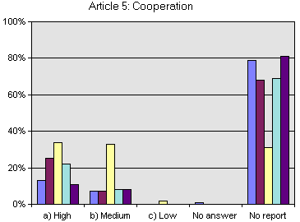 | 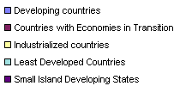

Figure 39

Relative priority afforded to implementation of Article 12
and associated decisions

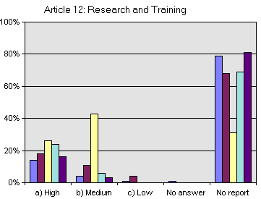

Figure 40

Relative priority afforded to implementation of Article 16
and associated decisions

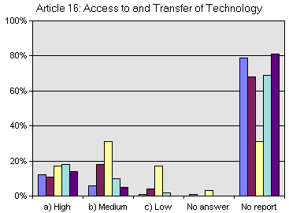

Figure 41

Relative priority afforded to implementation of Article 17
and associated decisions

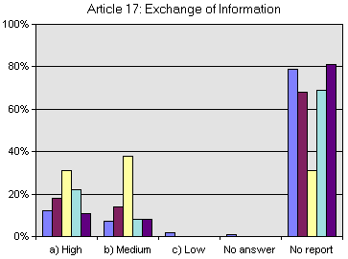

Figure 42

Relative priority afforded to implementation of Article 18
and associated decisions

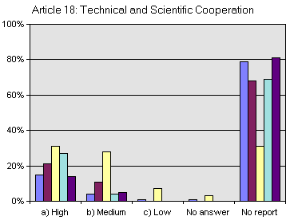

- However, the availability of adequate resources to meet obligations and recommendations is a serious concern for many countries. Only industrialized countries stated in significant numbers that resources were adequate for most articles, with the notable exception of research and training (in response to Article 12, approximately 13 developed Parties out of 20 (65%) reported that resources were limiting). The data in Figures 43 to 47 suggest that the lack of available resources, regardless of the priority afforded by countries, is a major obstacle impeding countries from implementation of obligations and recommendations. Arguably, the need for effective capacity building initiatives becomes imperative.

Figure 43

Adequacy of available resources for meeting the obligations and recommendations
for work programme on Article 5

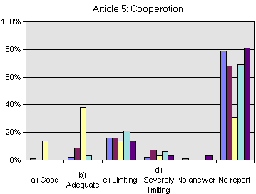

Figure 44

Adequacy of available resources for meeting the obligations and recommendations
for work programme on Article 12

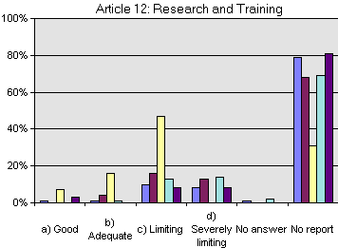

Figure 45

Adequacy of available resources for meeting the obligations and recommendations
for work programme on Article 16

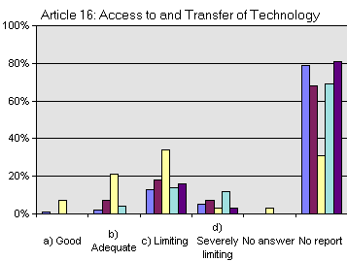

Figure 46

Adequacy of available resources for meeting the obligations and recommendations
for work programme on Article 17

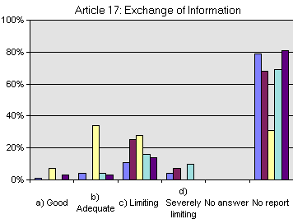

Figure 47

Adequacy of available resources for meeting the obligations and recommendations
for work programme on Article 18

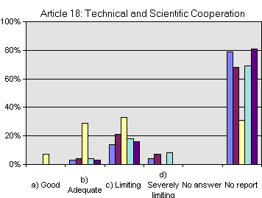

4. Cooperation (Article 5)

  - To date, the Conference of the Parties has not explicitly addressed Article 5. It has, however, made a number of references to bilateral and regional cooperation between Parties in its decisions. This section, therefore, will offer an analysis specific to Article 5 and Articles 12, 16, 17 and 18 where appropriate.

  - In response to question 13 on Article 5, on whether Parties are actively cooperating in areas beyond national jurisdiction for the conservation and sustainable use of biodiversity, most Parties answered affirmatively to cooperation in the three areas outlined: bilateral cooperation, international programmes and international agreements. Figure 48 suggests significant support for bilateral and international programmes and agreements.

Figure 48

Degree to which countries are actively cooperating with other Parties
in respect of areas beyond national jurisdiction
for the conservation and sustainable use of biological diversity (Article 5)

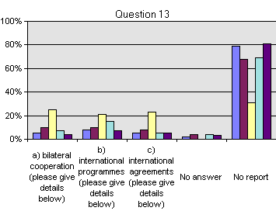

- More specifically to education and training, question 176, Article 12 (Research and Training) requested information on whether Parties have provided support for education and training to other Parties for the identification, conservation and sustainable use of biodiversity. With the exception of industrialized countries, which overwhelmingly stated “yes” (18 out of 20 or 90%), most Parties answered no. However, the number of non-industrialized countries answering “yes” is still significant; 12 out of 32 (37%) for developing countries, 5 out of 15 (33%) for least developed countries and 3 out of 7 (42%)for small island developing states. Note that all countries with economies in transition answered no to this question (9 out of 9). Figure 49 illustrates the divide between industrialized countries and other Parties suggesting once again the need for cooperative initiatives to build national capacities.

Figure 49

Extent to which countries have provided support to other Parties
for education and training in measures for the identification, conservation
and sustainable use of biological diversity and its components (Article 12a)

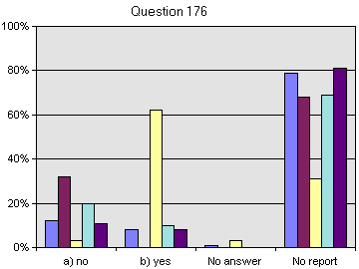

- With regard to Article 16, access to and transfer of technology, question 240 requested Parties to provide information on whether measures have been taken to facilitate access to, and transfer of technologies to other contracting Parties for the conservation and sustainable use of biodiversity or make use of genetic resources and do not cause significant damage to the environment. Of interest is that many countries have some measures in place. Few countries, however, have potential measures under review and only industrialized countries have comprehensive measures in place. However, a significant number of developing countries have some measures in place (approximately 11 out of 32 or 34%) perhaps indicating support for this article (see Figure 50 below). These results may indicate the need for a more active role by the Secretariat to act as a facilitator or broker in facilitating access to and transfer of technologies.

Figure 50

Extent of measures taken by countries to provide or facilitate access for and transfer
to other Contracting Parties of technologies that are relevant
to the conservation and sustainable use of biological diversity,
or make use of genetic resources
and do not cause significant damage to the environment (Article 16(1))

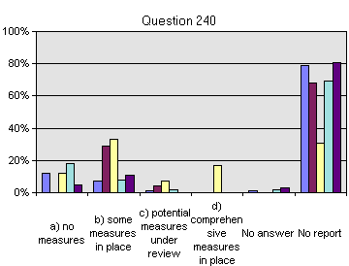

- A related question was asked under Article 18 (Technical and Scientific Cooperation) where Parties were asked if measures have been taken to promote international technical and scientific cooperation for the conservation and sustainable use of biodiversity. Of interest is that only 4 developing countries, 1 country with an economy in transition, 2 least developed countries and 1 small island developing state stated that no measures had been taken. More importantly is that 22 out 32 (68%) developing countries answered that some measures are in place, 4 answered that potential measures are under review and 2 answered that comprehensive measures are in place. It is worth speculating why the discrepancy of answers as illustrated by Figures 50 and 51 (for example, in question 240, 18 developing countries stated that no measures had been undertaken whereas in question 254 only 4 answered so). Perhaps the addition of genetic resources to question 240 unduly influenced responses.

Figure 51

Extent of measures taken by countries to promote
international technical and scientific cooperation
in the field of conservation
and sustainable use of biological diversity (Article 18(1))

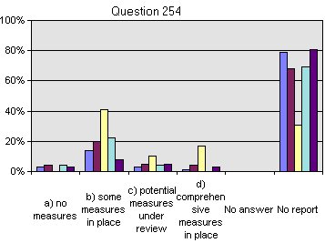

- Other questions under Article 5 (Cooperation) dealing with bilateral and international programmes and agreements include questions 14 through 17. Answers to these questions, summarized in Figures 52 to 55, have some similarities with previous responses on cooperation. For example, in response to questions 14 and 15, there appears to be some correlation, particularly in the case of developing countries. As well, most Parties, including those in the industrialized countries group, answered that collaboration has occurred to a limited extent in response to question 16. Also encouraging is that most countries responded positively to question 17 on whether they were planning to highlight and emphasize biodiversity in its contribution to the 10-year review of progress since the Earth Summit. This may indicate strong support for international initiatives and agreements as a vehicle for the conservation and sustainable use of biodiversity.

Figure 52

Extent to which countries have developed effective cooperation
for the sustainable management of transboundary watersheds,
catchments, river basins and migratory species
through bilateral and multilateral agreements (Decision IV/4)

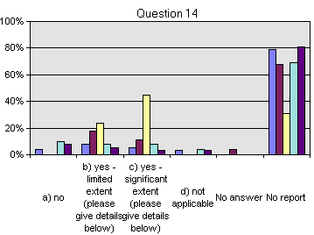

Figure 53

Extent to which countries have developed management practices
for transboundary protected areas (Decision IV/15)

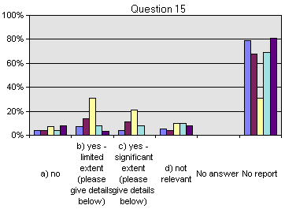

Figure 54

Extent to which countries have collaborated
with the International Biodiversity Observation Year of DIVERSITAS,
and ensured complementarity with the initiative foreseen to be undertaken
by the United Nations Educational, Scientific and Cultural Organization
and the Secretariat of the Convention on Biological Diversity
to increase scientific knowledge and public awareness
of the crucial role of biodiversity for sustainable development

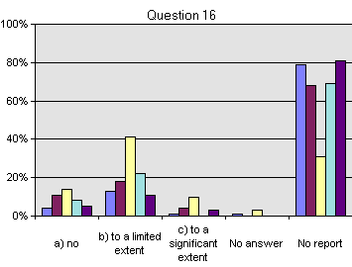

Figure 55

Measure of countries' plans to highlight and emphasize
biological diversity considerations
in their contribution to the ten-year review of progress
since the Earth Summit (Decision V/27)

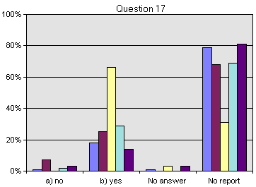

5. Research and Training (Article 12)

- To date, the Conference of the Parties has not addressed the issue of research and training under Article 12 (Research and Training) as a separate agenda item. References to research and training, however, are included in many Conference of the Parties decisions. This section will offer an analysis of the second national reports specific to Article 12 and Article 18 (Technical and Scientific Cooperation) where appropriate. Note that question 176 is discussed under “Cooperation”, above.

- An analysis of Article 12, questions 175, 177 and 178, and Article 18, questions 255, 257 and 258, suggest that most Parties strongly support research and training initiatives. For example, among the Parties that submitted information in response to question 175 on whether programmes for scientific and technical education and training for the identification, conservation and sustainable use of biodiversity, most Parties answered that programmes were in the early stages of development. The exception, and perhaps indicating easier access to resources, is the industrialized country group where approximately 13 countries (65%) answered that programmes where in place. Also, none of the countries with economies in transition answered no, perhaps indicating strong support for these types of initiatives. Finally, approximately 5 developing countries have programmes in early stages of development and approximately 8 programmes in place. As well, 3 small island developing states have programmes in place, that, given the lack of resources, may once again suggest strong support for these types of initiatives.

- Strong support for the encouragement and promotion of research for the conservation and sustainable use of biodiversity is also evidenced in responses to question 177. While only one developing country and one least developed country answered “no” to this question, 21 developing countries (63% of the responding developing countries), 5 countries with economies in transition (62%), 7 industrialized countries (35%), 11 least developed countries (69%) and 4 (57%) small island states answered the question with “to a limited extent.” Many countries also answered that encouragement and promotion where being taken to a significant extent: 10 developing countries (30%), 4 countries with economies in transition (50%), approximately 13 industrialized countries (65%), 3 least developed countries (18%) and 3 small island developing states (42%). Given the lack of resources, these efforts may indicate strong support for activities under this article.

- When asked if there is promotion and cooperation in the use of scientific advances in biological diversity research in developing methods for conservation and sustainable use of biodiversity (question 178), most Parties, including those in the industrialized country group, answered ““yes”, to a limited extent.” Still, approximately 14 developing countries (42%), 5 least developed countries (31%) and 2 small island states (28%) answered ““yes”, to a significant extent.” The exception were countries with economies in transition which out of 9 responses, only one stated that activities are being made to a significant extent. Figures 56 to 61 offer a summary of the above.

- With regard to questions on research and training activities (questions 255, 257, 258), Article 18 (Technical and Scientific Cooperation), it is possible to detect a similar pattern of support, albeit more limited. The data illustrated in Figure 8 suggest a similar pattern of support to the three previous questions. For example, the divergence between industrialized countries and other country groups parallels the previous 3 questions in that lack of resources may inhibit greater investment and cooperation in human resource development, training of personnel and joint ventures. It is also worth noting that, in response to these questions, a greater number of Parties, including a few industrialized countries, answered “no”. It is worth speculating on why Parties face greater obstacles in the implementation of this article. While the lack of resources is an obviously important factor, there may be other elements impacting negatively on Parties’ ability to more effectively implement this Article.

Figure 56

Programmes established by countries
for scientific and technical education and training
in measures for the identification, conservation and sustainable use
of biological diversity and its components (12a)

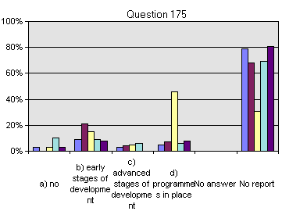

Figure 57

Extent to which countries promote and encourage research,
which contributes to the conservation and sustainable use
of biological diversity (12b)

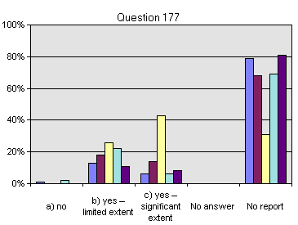

Figure 58

Extent to which countries promote and cooperate
in the use of scientific advances in biological diversity research
in developing methods for conservation and sustainable use
of biological resources (12c)

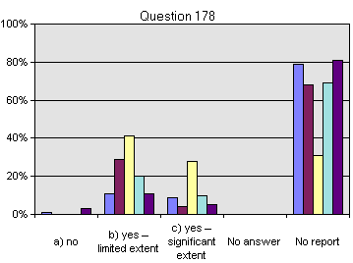

Figure 59

Extent to which measures taken to promote cooperation
with other Contracting Parties in the implementation of the Convention
pay special attention to the development and strengthening of national capabilities
by means of human resources development and institution building (18(2))

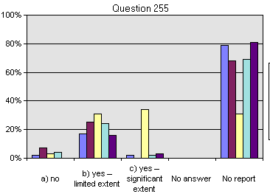

Figure 60

Extent to which cooperation includes
the training of personnel and exchange of experts (18(4))

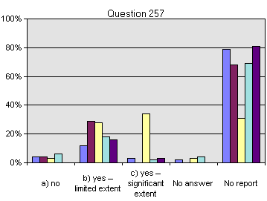

Figure 61

Extent to which countries have promoted
the establishment of joint research programmes and joint ventures
for the development of technologies
relevant to the objectives of the Convention (18(5))

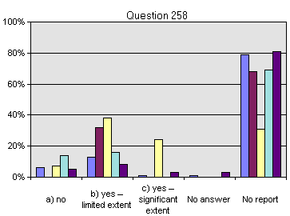

6. Special needs of developing countries

- Special needs of developing countries are discussed explicitly in relation to specific topics under Articles 12 (Research and Training) and 17 (Exchange of Information) and implicitly under Article 16 (Access to and Transfer of Technology). Moreover, the question is posed in terms of developed to developing countries; attention is not made to issues of whether developing countries make efforts to take other developing countries into account. Because many developing countries have a high level of industrialization, it may be of benefit to include in the third national report a question pertaining to cooperation among developing countries.

- In Figure 62, responses to question 179 suggest a strong level of commitment by industrialized countries to the special needs of developing countries. For example, approximately 16 out of 20 industrialized countries (80%) stated that the special needs of developing countries in relation to promotion and cooperation in biodiversity research are taken into account where relevant. Commitment is more circumscribed in responses to question 250 on whether industrialized countries have taken measures to facilitate the exchange of information from publicly available sources. Indeed, 11 industrialized countries (55%) answered that measures are made to a limited extent. Approximately 7 industrialized countries (35%) answered that measures are made to a significant extent. Comparison between these two questions is difficult, however, since different choices are available in each question. Perhaps the stronger commitment suggested in question 179 is the result of a two choice as opposed to a three choice question.

- It is possible to discuss the issue of existing initiatives under which relevant technology is transferred to countries on concessional or preferential terms as a topic related to special needs of developing countries. Of interest is that among countries replying to question 241, a majority in all country groups stated that no initiatives are being undertaken. Given the disparity in development among many regions, Parties may wish to examine this issue in more detail, especially in light of the impact of new technologies in assisting countries to fulfill obligations under the Convention.

Figure 62

Extent to which developed country Parties' implementation of activities
related to research and training
takes the special needs of developing countries
into account (Article 12)

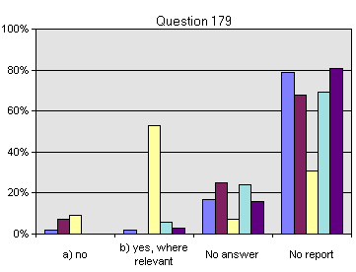

Figure 63

Extent to which developed country Parties
take into account the special needs of developing countries
in matters related to exchange of information (Article 17)

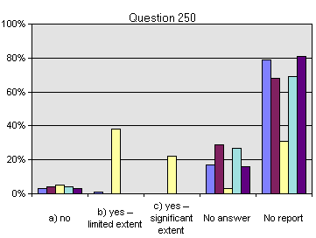

Figure 64

Measure of countries' awareness of initiatives
under which relevant technology is transferred to them
on concessional or preferential terms (16(2))

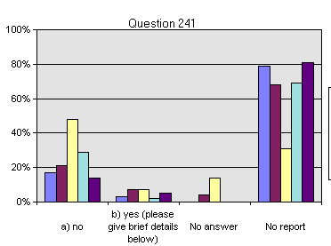

7. Access to and transfer of technology (Article 16)

- Some issues under Article 16 have been discussed previously, indicating the cross-cutting nature of access to and transfer of technology. Indeed, it is difficult to discuss the topic as a single unit because of the many different subjects it encompasses, including transfer of technologies pertaining to genetic resources, the role of the private sector and intellectual property protection. As a result, each topic above is examined independently.

8. Access to and transfer of technologies and genetic resources

- On the question of access to and transfer of technologies which make use of genetic resources, countries replied along equal numbers to all categories. Most developing countries (approximately 12 out of 32 or 37%), for instance, stated that the question was not relevant. However, 8 (25%) stated that this was of relevancy, but no measures had been taken. Approximately 7 (21%) stated that potential measures were in place and approximately 5 (15%) stated that comprehensive measures where in place. Responses by least developing countries follow this pattern where approximately 8 (50%) Parties stated that the question was not relevant. Another 3 (18%) stated that the question is relevant but that there were no measures. Two Parties stated that potential measures were under review and another 2 Parties stated that comprehensive measures where in place. Industrialized countries split their replies almost evenly with approximately 5 Parties (25%) relying per category. The exception was that approximately only 2 Parties stated that comprehensive measures where in place. Perhaps significant is that not a single Party from countries with economies with transition stated that the question had no relevancy. In contrast, 3 small island developing states stated no relevancy to this question.

- Analysis would have been easier had Parties that provide genetic resources been identified particularly since Parties that are centers of genetic origins are for the most part developing countries. It is noteworthy to indicate that 12 developing countries replied that this item is not of relevancy. Still, overall responses by developing countries indicate that a majority of Parties do consider this item to be of importance, suggesting the need for more target capacity building programs in support of this theme.

Figure 65

Measures taken by countries
so that Contracting Parties that provide genetic resources
are provided access to, and transfer of technology
which makes use of those resources, on mutually agreed terms (16 (3))

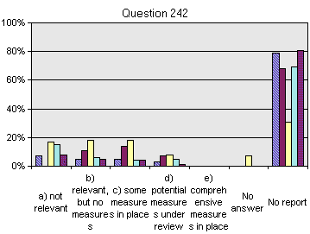

Figure 66

Types of measures taken by countries
so that Contracting Parties that provide genetic resources
are provided access to and transfer of technology
which makes use of those resources, on mutually agreed terms (16 (3))

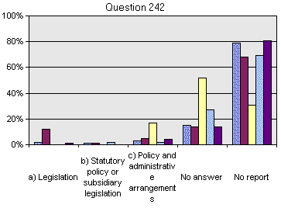

- Few Parties replied, or were able to reply, to the question on which measures had been taken in response to the above question. Only countries with economies in transition replied in significant numbers, approximately 5 out of 9 (55%) to this question, again suggesting strong interest to this issue by this country group. Also of interest is that only 5 industrialized countries (25%) replied that measures for policy and administrative arrangements had been taken. 15 Parties out of 20 (75%) declined to answer.

9. The private sector

- Most countries, including the industrialized, stated that no measures had been taken to enable the private sector to develop and transfer relevant technologies for the benefit of developing countries. Indeed, approximately 21 developing countries, 6 countries with economies in transition, approximately 13 industrialized countries, 10 least developed countries and 4 small island developing states answered “no” to question 243 (see Figure 67). As a result, few countries replied to the second component of the question that asked about the type of measures taken, which indicates that few measures are in place. Those that did reply stated in the majority that most measures were policy and administrative. The exception were countries with economies in transition which answered in equal numbers that measures taken were either legislation or policy and administrative.

Figure 67

Extent of measures taken by countries
so that the private sector facilitates access to joint development
and transfer of relevant technology
for the benefit of government institutions
and the private sector of developing countries (16(4))

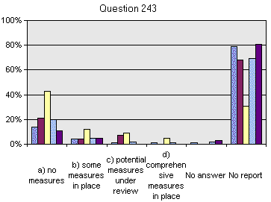

Figure 68

Types of measures taken by countries
so that the private sector facilitates access to joint development
and transfer of relevant technology
for the benefit of government institutions
and the private sector of developing countries (16(4))

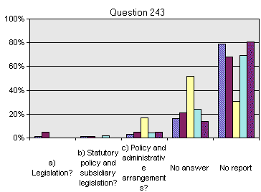

10. Intellectual property protection

- With the exception of small island developing states, country groups answered in the majority as to whether they had national systems for intellectual property rights protection. Industrialized countries were the only country group where all Parties had a national system. Countries with economies in transition were the next highest group with 8 Parties having a national system. Among developing countries 23 (69%) stated that they had a national system followed by 11 (68%) Parties in the least developed countries group.

- When asked whether the national system for intellectual property rights covered biodiversity, only countries with economies in transition and industrialized countries answered “to a significant extent”. Indeed, approximately 13 (65%) industrialized countries answered “to a significant extent” and approximately 5 (25%) “to a limited extent”. Of interest is that 2 industrialized countries replied no. Among developing countries, 12 (36%) answered no, 13 (39%) “to a limited extent” and 7 (21%)did not reply. Only one country in the countries with economies in transition group answered no followed by 4 (50%) answering “to a limited extent”, 3 (37%) answering “to a significant extent” and one Party not answering. Five least developed countries replied no while 7 (43%) replied “to a limited extent” and 7 (43%) did not reply. Finally, only one small island developing state replied no, 2 (28%) replied “to a limited extent” and 4 (52%) did not reply. These results are summarized in Figures 69 and 70.

- The discrepancy between industrialized countries and other groups is significant. Indeed, the fact that all industrialized countries and 8 out of 9 countries with economies in transition count on a national system for intellectual property right protection indicates the importance of this item. That more that 4 out of 7 (57%) of small island states and 8 out of 32 (24%) of developing countries do not have national systems suggests the urgent need for the development of national capacities.

Figure 69

Extent to which countries have a national system
for intellectual right protection (16(5))
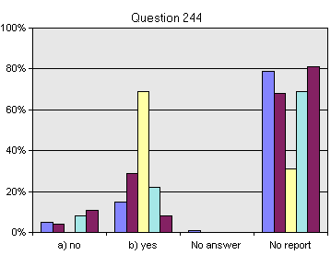

Figure 70

Extent to which a country's national system
for intellectual property right protection (16(5))
covers biological resources (for example, plant species)

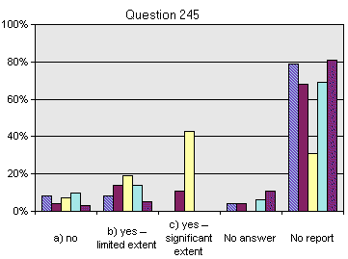

- A vast majority of Parties have not conducted and/or not provided to the Secretariat case studies on the impacts of intellectual property rights on the achievements of the Convention's objectives (see Figure 71). For example, 30 developing countries (90%) answered “no” and only 1 answered some and many. All countries with economies in transition answered “no”. Approximately 17 industrialized countries (85%) answered “no”; 2 answered “some” and 1 answered “many”. All least developed countries answered “no”. Small island developing states paralleled the above with 6 (85%) answering “no” and only one Party answering “some”. Arguably, Parties should be advised of the need to report on this important issue.

Figure 71

Degree to which countries have conducted
and provided to the Secretariat case-studies of the impacts of intellectual property rights
on the achievement of the Convention's objectives

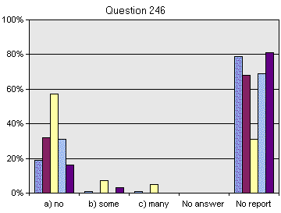

11. Exchange of information (Article 17)

- With the exception of industrialized countries, lack of resources affected all country groups’ ability to take measures to facilitate the exchange of information from publicly available sources. Most developing countries replied that they were restricted by the lack of resources although 11 (33%) also replied that some measures were in place and approximately 3 (9%) answered that comprehensive measures were in place. Countries with economies in transition were almost evenly split with some stating a lack of resources and others stating that some measures were in place. Most developed countries stated either that some measures were in place or that comprehensive measures were in place. A majority of least developed countries stated restrictions due to lack of resources. However, approximately 5 (31%) answered that some measures were in place, 1 answered that potential measures were under review and 1 replied that comprehensive measures were in place. Summaries of the above results are available in Figure 72.

- Information exchange is one of the areas where the Secretariat is able to assist Parties, particularly in the exchange of new information technologies and protocols and in the use of new information technologies, assuming the availability of sufficient resources. Arguably, because information exchange impacts on all areas of activities and encompasses training, research, transfer of technologies and intellectual property rights issues, due urgency should be given to this item.

Figure 72

Extent of measures taken by countries
to facilitate the exchange of information from publicly available sources (17(1))

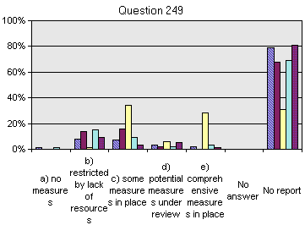

12. Indigenous and traditional technologies

- The question of obligations pertaining to indigenous and traditional communities is more fully discussed under Article 8(j) Traditional knowledge and related provisions. Of the five articles analysed in this document, only Article 18 includes a question with issues on indigenous and traditional technologies.

- The responses to this question may suggest a growing commitment by Parties to encourage and develop methods of cooperation for the development and use of indigenous and traditional technologies. For example, as illustrated in Figure 73, most Parties replied that methods of cooperation are either in early or advanced stages of cooperation. Also reflective of the need for capacity building, and more effective inclusion of indigenous and traditional communities in reaching the objectives of the Convention is the fact that only 4 (12%) developing countries and 1 least developed country have advanced stages of development. These numbers suggest the need for more targeted national efforts to meet the needs of indigenous and traditional communities. It may also point to the need for the Secretariat to inform parties more effectively on the need to develop said methods.

Figure 73

Degree to which countries have encouraged and developed
methods of cooperation for the development and use of technologies,
including indigenous and traditional technologies
in pursuance of the objectives of this Convention (18(4) )

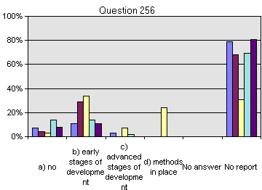

13. The Clearing-house Mechanism

- The Clearing-house Mechanism was established pursuant to Article 18.3 of the Convention to promote and facilitate technical and scientific cooperation. Decisions by the five meetings of the Conference of the Parties have guided the development and establishment of the Clearing-house Mechanism, including a pilot phase and an independent review. Indeed, aside from its consideration of the Clearing-house Mechanism, the Conference of the Parties has not addressed specifically the issue of technical and scientific cooperation under Article 18. This may be indicative of the importance afforded to the Clearing-house Mechanism by the Conference of the Parties.

- Having completed its pilot phase, and having implemented its information exchange mechanisms, the Clearing-house Mechanism is now focusing on the promotion and facilitation of technical and scientific cooperation in support of the objectives of the Convention. In support of this objective, 143 Parties (74%) have established Clearing-house Mechanism national focal points. Of these, 112 (58%) have access to email and 54 (28%) have established a web site.

14. Analysis

- The vast majority of countries in all country groups answered “yes” as to whether they were cooperating in the development and operation of the Clearing-house Mechanism. Perhaps reflective of the importance given to the work of the Clearing-house Mechanism is that 26 out of 32 developing countries (81%) answered “yes”. In addition, 17 out of 20 industrialized countries (85%) also answered “yes”. Close behind are least developed countries with 12 out of 16 (75%). These answers may suggest that countries place high priority in the development of the Clearing-house Mechanism and that the Secretariat is well advised to continue its efforts to assist in the development and implementation of new national and regional Clearing-house Mechanism. Figure 74 below offers a summary of the above figures.

Figure 74

Cooperation in Development of Clearing House Mechanism

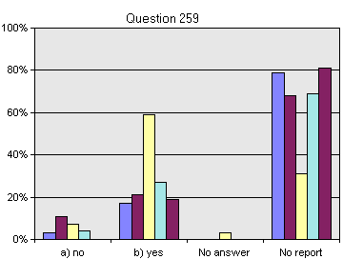

- In replying to question 260, the majority of countries answered “yes – to a limited extent”. Most of the industrialized countries, however, replied “yes – to a significant extent” (5 out of 20) (see Figure 75). Arguably, and similar to previous answers, these responses may indicate recognition of the importance attached to the development of national capabilities related to information exchange. These answers may also point to the need for more concise answers as to the obstacles countries face, including industrialized countries with resources and expertise, when attempting to develop these types of initiatives to a significant extent.

Figure 75

Degree to which countries are helping to develop national capabilities
through exchanging and disseminating information
on experiences and lessons learned in implementing the Convention

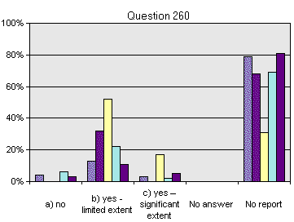

- An important number of countries answered “yes” to whether they had designated a national focal point for the Clearing-house Mechanism: developing countries 29 out of 32 (87%); countries with economies in transition 7 out of 9 (77%); industrialized countries 18 out of 20 (90%); least developed countries 14 out of 15 (93%); and small island developing states 7 (100%). Arguably, this may indicate the importance given to the establishment of national Clearing-house Mechanism and for the need for this type of mechanism. It may also offer the Secretariat support in its efforts to assist Parties in the development and implementation of national Clearing-house Mechanism and in using the existing national Clearing-house Mechanism national infrastructure to develop initiatives in support of the Convention’s objectives. Finally, these replies also suggest the need for the Clearing-house Mechanism to act more aggressively as a broker or facilitator as discussed under questions 240 and 243 of Article 16 (Access to and Transfer of Technology). A summary of the above is presented in Figure 76.

- When asked if they were providing resources for the development and implementation of the Clearing-house Mechanism, most country groups, with the exception of small island developing states, answered positively “at the national level”. It is interesting to speculate why a high percentage of small island developing states answered “yes at the national and international level” (3 out of 7). Also of interest is the number of industrialized countries (4 out of 20) that are not providing resources. Given the limited resources found in developing countries, it is surprising that approximately 19 out of 32 answered “yes, at the national level”, indicating the degree of importance given to the establishment of national Clearing-house Mechanism. Again, these results may offer further support to the Secretariat in its efforts to assist in the development and establishment of national Clearing-house Mechanism.

Figure 76

Measure of resources provided by countries
for the development and implementation of the Clearing-House Mechanism
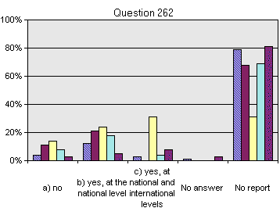

- The question on facilitation and participation in workshops and other expert meetings to further the development of the Clearing-house Mechanism at international level also pointed to the need for programs to develop national capacities. Not surprisingly, only industrialized countries answered in the majority to supporting some meetings and participating (9 out of 20 or 45%). More worrisome is that 5 out of 20 (25%) of industrialized countries answered no, suggesting that many countries with the greatest technical and expert resources are not contributing to the development of Clearing-house Mechanism. Also of interest is that the majority of other country groups answered “participation only”, suggesting the need to assist these countries to contribute as well as participate. Figure 77 summarizes these results.
Figure 77

Degree to which countries are facilitating and participating
in workshops and other expert meetings
to further the development of the Clearing-house Mechanism at international levels
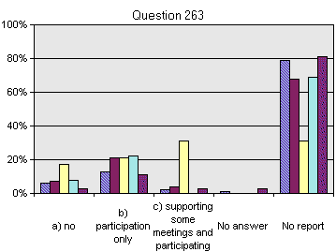

- The majority of countries answered “under development” or “yes” when asked whether their Clearing-house Mechanism was operational. This may suggest the importance afforded to the development and implementation of national Clearing-house Mechanism. Industrialized countries (14 out of 20 or 70%) answered “yes”. However, 3 out of 20 (15%) answered “no”, a significant number given that these countries have access to needed expertise and resources. This may also suggest that the Secretariat requires a more targeted information program encouraging the establishment of Clearing-house Mechanism nodes. Moreover, 9 out of 33 (27%) developing countries answered “yes”, a modest number given the benefits of establishing such nodes. Again, this may indicate that the Secretariat needs to initiate more focused programs encouraging and supporting the development of national Clearing-house Mechanism nodes, particularly in developing areas.

Figure 78

Measure of Clearing-house Mechanism operationalization

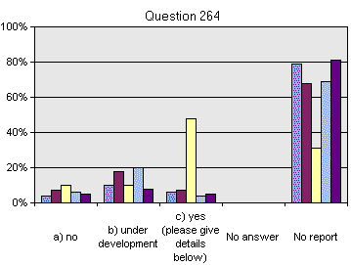

- Parties were then asked whether their Clearing-house Mechanisms were linked to the Internet, a particularly important development given the role and impact of new information technologies and the Internet in biodiversity research and policy decision-making. Negative answers in this category from non-industrialized countries are not surprising: (a) 10 developing countries out of 32 (30%); (b) 4 countries with economies in transition out of 9 (44%); (c) 4 least developed countries out of 16 (25%); and (d) 5 small island developing Parties out of 7 (71%). It is less clear why approximately 7 industrialized countries have not linked their Clearing-house Mechanism to the Internet. One may speculate on how countries interpreted “linked” (email, web or other Internet-based protocols). These answers may suggest that non-industrialized countries require adequate resources to link their Clearing-house Mechanism nodes to the Internet, and that the Secretariat needs to reach out to those industrialized countries that are not connected to the Internet and more effectively explain the benefits for them to do so. Finally, there may be a misunderstanding as to what “linked” to the Internet means. Email, for example, offers a link to the Internet, albeit an asynchronous one. The above analysis is illustrated in Figure 79.

Figure 79

Measure of Clearing-house Mechanism linkage to the Internet

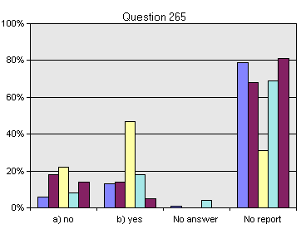

- The majority of countries in all country groups answered negatively to whether they had established a multi-sectoral and multi-disciplinary Clearing-house Mechanism steering committee or working group at the national level. The answers to the questionnaire contained in the second national reports do not explain the reasons why an important number of Parties have not established such a committee. A number of inter-related factors could influence a Party’s decision, including lack of resources and expertise, other Clearing-house Mechanism-related priorities or a perceived lack of need. It may be useful for the Secretariat to contact Clearing-house Mechanism national focal points and request more information on this item. Figure 80 offers an illustration of the results received for this question.

Figure 80

Extent to which countries have established a multi-sectoral
and multi-disciplinary Clearing-house Mechanism steering committee
or working group at the national level

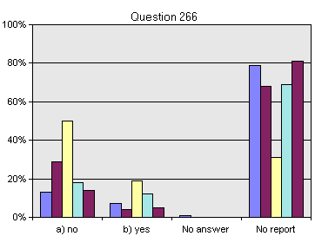

- Decision V/14. Scientific and technical co-operation and the clearinghouse mechanisms
(Article 18)

- Among countries replying to whether a review had been undertaken of priorities identified in Annex I to decision V/14 and whether they sought to implement the decisions, a majority of developing countries, least developed countries and small island developing states answered that a review had not been undertaken. As well, the next highest response was that priorities had been reviewed but not implemented. Industrialized countries were almost evenly split in their responses (see figure 81). This situation may reflect lack of access to needed resources and expertise.

Figure 81

Extent of review and implementation by countries
of priorities identified in Annex I to Decision V/14

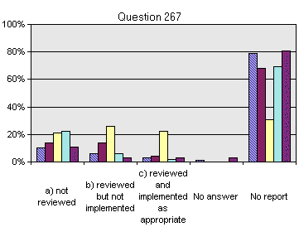

16. Conclusion

- This analysis points to strong support by Parties for the implementation of obligations related to cooperation (Article 5), research and training (Article 12), access to and transfer of technology (Article 16), exchange of information (Article 17) and technical and scientific cooperation (Article 18). Indeed, throughout the second national reports, it is possible to sense implicit and explicit recognition by Parties of the value and potential impact of these five inter-related complementary Articles.

- With the exception of industrialized countries, a significant majority of Parties indicated insufficient resources as a major obstacle. It is safe to assume that this problem will not be resolved in the immediate or short-term future. However, by emphasizing its broker and facilitator role, a need identified in the analysis, the Secretariat would be able to more effectively match supply with demand, and better encourage joint initiatives. In support of these goals, the Clearing-house Mechanism, because of its mandate and experience, would be able to adopt a more proactive programme of work to facilitate and promote national capacities initiatives and a more effective technical and scientific collaboration.

- Finally, the sample of second national reports was small, signaling the need to remind Parties of the need to complete these reports along with other obligations. Although it is difficult to ascertain national and regional trends with a high degree of certainty, the results in this document indicate the value of national reporting and demonstrated the use and value of analytical tools such as the Second National Reports Analyser. The lessons learned can be applied to improve the format of the third national report, and used to convince Parties to invest in a useful exercise.

- Handling of biotechnology and distribution of its benefits (Article 19)

1. Introduction

- Article 19 of the Convention on Biological Diversity addresses the handling of biotechnology and its benefits. Paragraphs 1 and 2 address issues of access and benefit-sharing, and therefore have been considered in the context of the discussion that took place during the fourth and fifth meetings of the Conference of the Parties. Paragraphs 3 and 4 of Article 19 address the need for, and modalities of a Biosafety Protocol, which was developed following decision II/5 of the Conference of the Parties.

- The second national reports include five questions related to Article 19. The first two address the relative priority given to Article 19 and the availability of resources to address issues related to it. The third question addresses measures to provide for the effective participation in biotechnological research activities by those Contracting Parties that provide the genetic resources for such research (Article 19.1). The fourth questions asks whether practicable measures have been taken to promote and advance priority access on a fair and equitable basis by Contracting Parties to the results and benefits arising from biotechnologies based upon genetic resources provided by those Contracting Parties (Article 19.2). The last question asks whether the Parties have signed and/or ratified the Biosafety Protocol.

- The following sections address these five questions, using information available by the end of January 2002. Five different country groupings were analysed, among which the rate of submission of second national reports has varied as follows:

• Developed countries: 20/29 (20 reports received, total number of countries 29)
• Developing countries: 32/156
• Least developed countries: 15/49
• Countries with economies in transition: 9/28
• Small island developing states: 7/37∗

- In future, when more national reports have been submitted, it may also be useful to analyse responses geographically within the above groupings. For example, it might be interesting to determine if resource availability is more or less limiting for developing countries in particular regions. These types of analysis have not been completed at this stage, as sample sizes are too small to provide meaningful results.

2. Relative Priority of Article 19 (Handling of Biotechnology and Distribution of its Benefits)

- In response to the question “What is the relative priority afforded to implementation of this Article and the associated decisions by your country?”, the responses did not appear to differ significantly among country groups. Specifically, 47% (9/19)∗ of developed countries give the Article high priority versus medium or low priority, while 54% (17/31) of developing countries give the Article high priority. The results of 67% (10/15) for least developed countries, 44% (4/9) for countries with economies in transition, and 43% (3/7) for small island developing states appear to be similar, although sample sizes are somewhat small for drawing definitive conclusions.

3. Availability of Resources

- On the other hand, in response to the question “To what extent are the resources available adequate for meeting the obligations and recommendations made?”, the responses were quite different among country groups. Indeed, while 58% (11/19) of developed countries stated that resources are good or adequate, only 12% (4/29) of developing countries stated that resources are good or adequate. The results for least developed countries (1/19), countries with economies in transition (1/9), and for small island developing states (1/7) are all indicative of limited resources.

4. Measures to Provide for Effective Participation in Biotechnological Research

- Regarding Article 19.1, the question asked in the second national report was “Has your country taken measures to provide for the effective participation in biotechnological research activities by those Contracting Parties which provide the genetic resources for such research (19(1))”?

- Results to date show that 44% (8/18) of developed countries have measures in place or under review, while 48% (15/32) of developing countries have measures in place or under review. The result for least developed countries of 58% (9/15) appears to be similar to the broader group of developing countries. For countries with economies in transition and for small island developing states, with results of 7/9 and 5/7 respectively, sample sizes are small for making comparisons. Overall, it appears that approximately half of countries have made progress in the implementation of Article 19.1. As well, these preliminary data suggest that there are not major differences in implementation of this article among developed and developing countries.

5. Measures to Promote and Advance Priority Access to Results and Benefits from Biotechnologies

- Regarding Article 19.2, the question asked in the second national report was “Has your country taken all practicable measures to promote and advance priority access on a fair and equitable basis by Contracting Parties to the results and benefits arising from biotechnologies based upon genetic resources provided by those Contracting Parties (19(2))”?

- Results to date show that 74% (14/19) of developed countries have measures in place or under review, while 48% (15/31) of developing countries have measures in place or under review. The result for least developed countries of 47% (7/15) appears to be similar to the broader group of developing countries. For countries with economies in transition and for small island developing states, with results of 5/9 and 3/7 respectively, sample sizes are too small to make meaningful comparisons. These preliminary data suggest that the majority of developed countries, and about half of developing countries and countries with economies in transition have made progress in the implementation of Article 19.2.

6. Participation in the Cartagena Protocol on Biosafety

- The final question in the second national report related to Article 19 was “Is your country a Contracting Party to the Cartagena Protocol on Biosafety”? For this question, we have information for all of the Parties, and therefore are not restricted to analysis of those countries which have submitted national reports. Of the 181 countries that are Parties to the Convention, 103 have signed the Biosafety Protocol. Of those countries which are Parties to the Convention:

• 76% (22/29) of developed countries have signed the Protocol;
• 53% (67/126) of developing countries have signed the Protocol, including 48% (22/46) of least developed countries and 33% (12/36) of small island developing states;
• 46% (12/26) of countries with economies in transition have signed the Protocol.

- These results suggest that a lower percentage of developing countries and countries with economies in transition have signed the Protocol in comparison to developed countries. As of 24 January 2002, 11 countries had ratified or acceded to the Protocol, including three developed countries, six developing countries, and two countries with economies in transition.

7. Conclusions

- Regarding the implementation of Article 19 of the Convention, the key observation from analysis of the second national reports is the extent to which implementation by developing countries and countries with economies is resource-limited. In addition, comments received with the national reports seem to indicate that many developing countries do not have adequate capacity for implementation of Article 19.

- General Measures for Conservation and Sustainable Use (Article 6)

1. Introduction

- On General Measures for Conservation and Sustainable Use, each Contracting Party shall, in accordance with its particular conditions and capabilities: (a) develop national strategies, plans or programmes for the conservation and sustainable use of biological diversity or adapt for this purpose existing strategies, plans or programmes which shall reflect, inter alia, the measures set out in this Convention relevant to the Contracting Party concerned; and (b) integrate, as far as possible and as appropriate, the conservation and sustainable use of biological diversity into relevant sectoral or cross-sectoral plans, programmes and policies.

- This analysis is based on the 62 second national reports received by the end of January 2002, which represent only a third of the total number of the Parties to the Convention.

2. Level of priority and resources availability

- Although the majority of countries of each group gives a high relative priority to the implementation of general measures for conservation and sustainable use, the resources available for meeting the obligations and recommendations made are limiting and severely limiting in most countries, especially developing countries, least developed countries and small island developing states, but also in half of the countries with economies in transition as well as for half of the industrialized ones. Figure 82 illustrates the situation of different groups of countries in the availability of the resources for the implementation of Article 6.

Figure 82
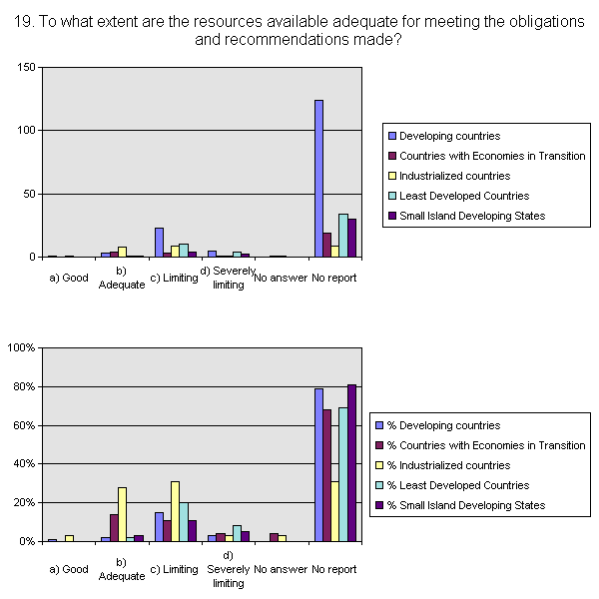

3. Status of National Biodiversity Strategies and Action Plans

- In regard to the status of national biodiversity strategy, 36 out of 61 responding Parties (59%) have completed their national biodiversity strategies (14 of them – 23% -- have adopted the strategies). 6 Parties (6%) are in the early stages of developing such a strategy and 13 Parties (21%) are in the advanced stage of development. Only 2 Parties indicate that they have not developed their national strategy. 4 Parties (7%) indicate that they have made available the reports on implementation of their national biodiversity strategies.

- In terms of the status of national biodiversity action plan, 23 out of 62 responding Parties (37%) have completed their national biodiversity action plans. 9 Parties (15%) have made available the reports on the implementation of their national action plans. 14 Parties (23%) are in advanced stages of developing their action plan and 12 Parties (19%) are in the early stage of action plan development. Only 4 Parties (6%) have not developed their action plan yet.

- When asked about whether the national strategies and action plans cover all articles of the Convention, 44 out of 60 responding Parties (73%) indicated that their national strategies and action plans had covered most articles of the Convention. 8 Parties (13%) reported that their national strategies and action plans had covered all articles, and 8 Parties (13%) that their national strategies and action plans had covered some articles of the Convention.

- Two thirds of the Parties (40 out of 60 responding Parties) indicated that their national strategies and action plans had covered integration of activities all major sectors. 10 Parties (17%) had covered the activities of some sectors in their national strategies and action plans. Only 8 Parties (13%), most of them the countries from WEOG (5) and GRULAC (2), reported that the activities of all sectors had been covered in their national strategies and action plans. Only 2 Parties did not cover the integration of other sectoral activities.

4. Implementation of Decisions II/7 and III/9

- More than two-thirds of the Parties (45 out of 62 responding Parties) are taking some actions to exchange information and share experience on the national action planning process with other Contracting Parties, half of them through sharing of strategies, plans and/or case studies and half of them through regional meetings. Less than one third (17 Parties) are taking little or no action in this regard.

- Over two thirds of the countries have strategies and action plans which include an international cooperation component, and the proportion is also reflected, as in the above case, per country group; only the small island states show a result of almost 50/50.

- More than half of the Parties developed their national strategies and action plans through coordination with those of neighboring countries, but only in some areas. A full coordination has not been reported. As results are very different from group to group, the entire situation is detailed in the graphic below.

Figure 83

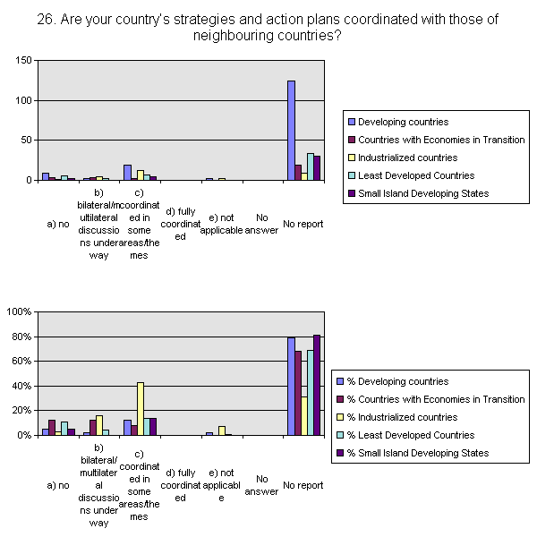

- When asked about whether measurable targets have been set within their national strategies and action plans, only 7 Parties (12%) indicated that they had made available the reports on implementation of their national strategies and action plans. 8 Parties (13%) reported that they had put relevant programme in place for this purpose. More than half of the Parties are in either early or advanced stages of developing such measurable targets (27 Parties in early stages and 8 Parties in advanced stages). 12 Parties (20%) declared that they had not included measurable targets in their national strategies and action plans.

- A large majority of developing countries and countries with economies in transition (39 or 65% of respondents) reported that they had received financial support from the Global Environment Facility for preparation of their national strategies and action plans.

5. Coordination for implementation of biodiversity-related Conventions at the national level

- The national focal points for the Convention and the competent authorities for the Ramsar Convention, Bonn Conventions and CITES cooperate in the implementations of these Conventions to avoid duplication in most of the countries irrespective of economic status. They do so to a significant extent in over half of them. The situation is as follows, by country groups: the small island developing states split to a 50/50 ratio between “limited” and “significant extent”; developing and least developed countries, over half to a “limited extent”; whereas industrialized countries and countries with economies in transition concentrate on a “significant extent”.

Figure 84

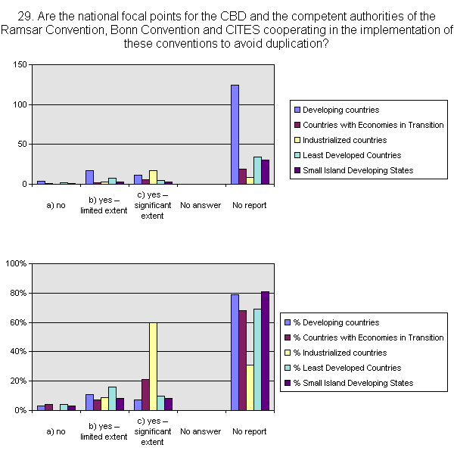

6. Conclusions

- As mentioned in the introduction, due to insufficient reports received on the topic, existing data are not enough for an accurate analysis. In spite of this, the most important concern to emerge is the lack of resources across countries of all economic groups. The encouraging aspect is that many of these countries have developed and are developing their national biodiversity strategies and action plans, and the coordination at the national level for the implementation of biodiversity-related Conventions is improving.

- Financial Resources and Mechanism

1. Introduction

- The Open-ended Inter-Sessional Meeting on the Strategic Plan, National Reports and Implementation of the Convention on Biological Diversity requested the Executive Secretary to undertake a full assessment of the information contained in the second national reports, including the identification of progress made by Parties in implementation of the Convention and of constraints to implementation they have encountered, and to submit this assessment to the sixth meeting of the Conference of the Parties; and include in this assessment information on the specific experiences of small island developing Parties and least developed countries in the implementation of the Convention. This note has been prepared in line with the above request and has a focus on financial resources and mechanism.

- This note mainly contains the following two sections: assessment of the information concerning financial resources and mechanism, and progress made by Parties in implementation, as well as constraints to implementation of the Convention. The results of the assessment are summarized in the final section.

2. Assessment of the Information Concerning Financial Resources and Mechanism

- As of the end of January 2002, the Secretariat had received 62∗ second national reports from Parties and one Government. Figure 85 demonstrates the overall distribution of Parties that have submitted their second national reports and that have not submitted their reports. The number of Parties that have submitted their second national reports accounts for only around one-third of all Parties to the Convention. Additional efforts are clearly needed to expedite the reporting process.

- A disaggregated analysis of the status of submission of first and second national reports shows that among 62 submissions from Parties, only 6 Parties (10%) have not submitted their first national reports. The overall tendency is that Parties that have submitted their first national reports will most likely be in a position to submit their second national reports. With appropriate support, some sixty-six Parties that have only submitted their first national reports can be expected to make a submission within a proper time frame. A noticeable gap exists for those Parties that have submitted neither the first national reports nor the second national reports. The percentage of no submission appears very high in the Group of Asia and the Pacific and GRULAC. Even within WEOG, 15 per cent of Parties have never submitted any national reports. Efforts are clearly needed to identify the reasons why these Parties have never reacted to this obligation.

- One hypothesis is that national submissions of developing countries and countries with economies in transition might be greatly facilitated with external financial support. Figure 87 in general supports this hypothesis. The chance for a developing country to make a national submission without financial support seems to be very low. Only five percent of submissions were from Parties that have not received financial support from the Global Environment Facility. This does not mean that these Parties have not received financial support from other sources. Over sixty percent of national submissions from the developing world were completed with financial support from the Global Environment Facility. Equally important, the number of developing country Parties that have received Global Environment Facility financial support but have not made their first submissions appear relatively high in the Group of Asia and the Pacific and GRULAC.

- The format of the second national reports contains the following two sections: multiple choice questions and further comments. A valid response to the questionnaire should encompass the following features: (i) no blank left for any question; (ii) no answer provided to a question that is not applicable to the Party; (iii) responses to any question or related questions should be consistent. A sufficient response to the request for further comments should provide available additional information that reflects the progress made since the first national report. Thus, any reference to the information contained in the first national reports does not adequately serve the purpose of the second national reports.

- The quality of submitted questionnaires were judged using the above features and answers to the questions concerning financial resources and mechanism, that is from question 273 to 292. Surprisingly, only twenty responses out of 62 (32%) included in the National Report Analyser can be considered as not questionable. Figure 88 gives out the results of the analysis. Responses from developed countries are only slightly better than those from developing world. Three possibilities might lead to such a large number of errors: (i) the questionnaire itself should be improved; (ii) the respondents need to invest appropriate time in reading the questionnaire; and (iii) training should be provided to those who are responsible for completing the questionnaire.

- Additional space for comments was provided for in the second national reports so that Parties could report in more detail on financial resources and mechanism. This expectation was largely unmet. Among the 62 submissions included in the National Report Analyser, only 10 national reports (16%) provided comments concerning the financial mechanism, and 30 (48%) concerning financial resources. In general, further comments were of only limited information value. For this reason, it seems that future reports would require better design of the section on financial resources and mechanism.

3. Progress made by Parties in, and constraints to, implementation of the Convention

- There are 20 questions addressing issues related to financial resources and mechanism in the second national reports. The questions can be broadly grouped into the following categories: priority awarded to Article 20 (Financial Resources) and availability of resources, national financing measures; new and additional financial resources; development cooperation for biological diversity; strengthening of financial institutions in support of biological diversity; standardization of information and monitoring; priority afforded to the financial mechanism and level of resources; participation in the review of the effectiveness of the financial mechanism. A preliminary brief analysis of sampled second national reports was already provided in document UNEP/Convention/Conference of the Parties/6/14. This section will provide additional assessment using the Second National Reports Analyser.

4. Priority to Article 20(Financial Resources) and availability of resources

- In its preamble, the Convention on Biological Diversity acknowledges that substantial investments are required to conserve biological diversity, and that the provision of new and additional financial resources and appropriate access to relevant technologies can be expected to make a substantial difference in the world’s ability to address the loss of biological diversity. Article 20, paragraph 4, clearly states that “The extent to which developing country Parties will effectively implement their commitments under this Convention will depend on the effective implementation by developed country Parties of their commitments under this Convention related to financial resources and transfer of technology and will take fully into account the fact that economic and social development and eradication of poverty are the first and overriding priorities of the developing country Parties.” Financial resources, together with financial mechanism, have been a standing item on the agenda of the ordinary meetings of the Conference of the Parties. Given this understanding, priority afforded to financial resources matter should be reasonably high.

- Questions 273 and 274 requested Parties to consider the relative priority afforded to the implementation of Article 20 and relevant decisions and the extent to which the resources available are adequate for meeting the obligations. As Figure 89 shows, only slightly over fifty percent of submissions indicated that high priority has been given the provisions of Article 20 on financial resources, with African countries well above the average. Financial importance for implementing the Convention was not clearly revealed in the submissions from other developing regions. A large number of responses from developing country Parties afforded only medium or even low priority to financial resources matter.

- The reasons for not prioritizing financial resources for the implementation of the Convention seem to be the following:

  - Ongoing national economic and financial difficulties;
  - Lack of national biodiversity strategies and action plans to justify funds from Governments;
  - High reliance on external financial support for the implementation of the Convention;
  - Great gaps in funds despite enormous domestic efforts;
  - Reduction of public expenditures;
  - Lack of revenues generated by biodiversity sectors;
  - Low awareness or appreciation of the importance of biodiversity loss;
  - Insufficient international financial support;
  - Existing programmes not funded;
  - Lack of legislations and regulations to ensure budgetary allocations to biological diversity;
  - Unique difficulties in the period of economic transition;
  - Mechanisms for stimulating investments still under elaboration.

- The constraints of limited financial resources are widely reported in the second national reports, though it appears more severe in descending order of level of development. Over fifty percent of African reports indicated that financial resources are severely limited, while reported financial constraints appears more modest in Asia and the Pacific. The Group of Central and Eastern European Countries unanimously reported that available financial resources are either limited or severely limited. More than half reporting countries of the Western Europe and Others Group indicated that available financial resources are good or adequate, thus implying good potential for further supporting the implementation of the Convention. 56% of the GRULAC countries find the financial resources available limited and 44% of GRULAC countries find financial resources severely limited. A substantial increase of international financial support and easier flow of such resources were called for in a number of national submissions.

5. National financing measures

- Under Article 20, paragraph 1, each Party undertakes to provide financial support and incentives in respect of those national activities which are intended to achieve the objectives of the Convention. Question 275 addressed this provision, and the distribution of responses can be found in Figure 91. The majority of submissions, i.e. around eighty-five percent of reporting Parties, indicated that certain financing measures, including either direct financial support or indirect support through incentives or both, have been taken to encourage national biodiversity activities. However, detailed information concerning these measures is generally not available. The Conference of the Parties could encourage Parties to exchange information and national experience in providing financial support and incentives.

6. National financing measures: tax exemption

- The Conference of the Parties at its fifth meeting urged Parties to promote the consideration of tax exemptions in national taxation systems for biodiversity-related donations (decision V/11, paragraph 16). A good number of Parties reported that tax exemptions for biodiversity-related donations are in place or under development. An almost equal number of Parties have not started to consider tax exemptions, and only six submissions, all from developing countries, indicated that tax exemptions for biodiversity-related donations are not appropriate to their national circumstances. Sharing of information and experience appears to be crucial for wider application of this provision.

7. National financing measures: private sector

- One of the recurring issues in the previous decisions of the Conference of the Parties was a call for promoting the involvement of the private sector in the implementation of the Convention. In decision V/11, the Conference of the Parties noted the cross-cutting nature of the involvement of the private sector, and invited Parties to include in their second national reports information on the involvement of the private sector. Question 287 asked Parties whether their countries have compiled information on financial support provided by the private sector. Only one country provided a positive answer. The involvement of the private sector clearly appears to be a gap in the implementation of the Convention.

8. New and additional financial resources

- Developed country Parties, by Article 20, paragraph 2, are committed to provide new and additional financial resources to enable developing country Parties to meet the agreed full incremental costs to them of implementing measures that fulfill the obligations of the Convention and to benefit from its provisions. The questionnaire offered two questions to developed and developing countries respectively. There are a number of error occurred in the submissions with respect to these questions. Among the 17 valid responses from developed countries, only one indicated that no new and additional financial resources were provided. However, developing countries provided a very mixed response. More than half of developing countries do not think that they have received new and additional financial resources. Different perspectives on the term “new and additional financial resources” are believed to contribute to the division of opinion.

9. Development cooperation for biological diversity

- Article 20, paragraph 3, states that developed country Parties may provide financial resources related to the implementation of the Convention through bilateral, regional and other multilateral channels. Again, questions were raised to developed and developing countries separately. Among the 16 answering reports, all developed country Parties except one stated that they are providing financial resources related to implementation of the Convention through bilateral, regional and other multilateral channels. In contrast with their responses on new and additional financial resources, more than eighty percent of developing country Parties tended to agree with developed country Parties on financial resources being provided by developed country Parties through bilateral, regional and other multilateral channels. Better information and coordination of such support were also suggested.

10. Strengthening of financial institutions in support of biological diversity

- Article 21, paragraph 4, stipulates that the Contracting Parties shall consider strengthening existing financial institutions to provide financial resources for the conservation and sustainable use of biological diversity. The Conference of the Parties has adopted several decisions that call upon Parties, Governments, international organizations and/or bilateral, regional and multilateral donors to provide support for activities to implement the Convention. Decision III/6 urged all funding institutions, including bilateral and multilateral donors, as well as regional funding institutions and NGOs, to make their activities supportive of the Convention. It requested the Executive Secretary to explore ways of collaborating with funding institutions to facilitate these efforts, and invited institutions to provide information to the Secretariat on their relevant activities. Decision V/11 reaffirmed the need for the provision of information. It further urged developed country Parties to promote support for implementation of the Convention in the funding policy of their bilateral funding institutions and those of regional and multilateral funding institutions, and urged developing countries to incorporate ways and means to support implementation of the objectives of the Convention into their dialogue with funding institutions.

- Four questions, i.e. question 280, 285, 286 and 291, were designed to assess the progress in this field. Questions 280 and 291 are similar, and thus inconsistent answers would not be considered as a valid submission. Unfortunately, one-third of the submissions answered the two questions in an opposite way. Questions 285 and 286 were addressed to developed and developing countries separately. Major confusions occurred in the answers to these two questions. A total of 19 developing countries answered the question addressed to developed countries, and one developed country did the opposite.

- Overall, around two thirds of the submissions demonstrated that their countries have worked to strengthen existing financial institutions to provide financial resources for the conservation and sustainable use of biological diversity. The proportion has increased significantly in responding the question regarding ongoing efforts to ensure that all funding institutions striving to make their activities more supportive of the Convention (see Figure 93). All reporting developed countries indicated that their countries promote support for the implementation of the objectives of the Convention in the funding policy of their bilateral funding institutions and those of regional and multilateral funding institutions. A few developed country Parties reported that they initiated partnerships with the World Bank and regional development banks to strengthen the capacity and to integrate biodiversity consideration in the policies of the banks. The majority of developing countries’ submissions also indicated that their countries discuss ways and means to support implementation of the objectives of the Convention in their dialogue with funding institutions.

11. Standardization of information and monitoring

- The lack of funding information has been identified as a major barrier for planning, assessing and advancing the implementation of the Convention. Thus, by decision III/6, the Conference of the Parties urged developed country Parties to cooperate in the development of standardized information on their financial support for the objectives of the Convention, and where possible to submit this in their national reports. The fifth meeting of the Conference of the Parties further decided to establish a database on biodiversity-related funding information. Accordingly, the Conference of the Parties, by decision V/11, urged developed country Parties and encouraged developing country Parties to establish a process to monitor financial support to biodiversity.

- In response to these requests, four questions, i.e., 281, 282, 283, 284, were included in the second national reports. Questions 281 and 284 concerning standardized information and financial support in other countries were designed primarily for developed country Parties, but all reporting developing countries provided their answers. All submissions from developed country Parties stated that details regarding their financial support to biodiversity activities in their own countries and in other countries are available though some not in a standardized format. However, among the 19 submissions, only eight Parties (42%) indicated that their countries are cooperating in efforts to develop standardized information on financial support for the objectives of the Convention, in particular, in the OECD pilot study on aids targeting at the three Rio Conventions. The limited number of participating countries provides an explanation why they have not yet developed standardized information on financial support.

- The responses from developing countries to question 283 deliver a promising message for future efforts to collect and monitor financial support for the Convention. As shown in Figure 94, seventy-seven percent of submissions from developing countries indicated that details of financial support to national biodiversity activities are available. This points to the possibility of collecting information of financial flows from recipient countries.

- As regards the establishment of a process to monitor financial support to biodiversity, the second national reports from developing countries presented a variety of scenarios. Over one third of reports showed that even without a process to monitor financial support to biodiversity, details of such support are available anyway. Fifteen percent of reports demonstrated that no detailed information is available probably due to the lack of a monitoring process. Nearly half of the submissions indicated that a process to monitor financial support is being established and details of financial support to national biodiversity activities are thus available though not in any standardized format. Only one submission reveals that despite a process to monitor financial support is being established, detailed information on financial support is still not available. The need to establish a monitoring process is dependent upon national circumstances.

12. Financial mechanism: priority and level of resources

- Questions 289 and 290 address the relative priority afforded to implementation of Article 21 on financial mechanism, and the adequacy of available resources of the financial mechanism. All submissions from developed countries indicated high or medium priority attached to Article 21. Over half of them considered that the resources available through the financial mechanism are adequate or even good. Still a significant number of developed country Parties stated that the available resources are limited or even severely limited. The submission indicating that the resources are severely limited afforded medium priority to Article 21. Half of the six submissions that perceived available resources as limiting gave high priority to Article 21, and the rest have medium priority. Thus, it is not clear whether relative priority and the availability of resources to financial mechanism have inherent relationship or not.

- Thirty-seven developing countries answered question 289 concerning relative priority attached to Article 21. Figure 96 provides the distribution of these answers. In general, seventy percent of the submissions attached high priority to Article 21, implying high level of acceptance of the Global Environment Facility as the financial mechanism of the Convention in accordance with Article 21, paragraph 1. A noticeable number of developing countries (around thirty percent) indicated that medium or low priority has been granted to Article 21. Among them, one was from the African region, five from Asia and the Pacific, and another five from Eastern and Central Europe. Two Asian countries are not receiving funding from the financial mechanism due to their high level of development, and thus their lower priority to Article 21 is not a surprise. Other countries with lower priority to Article 21 are mainly known as countries with economies in transition or relatively higher middle-income developing countries. Thus, it can be fairly concluded that the poorer a country is, the higher priority the country attaches to Article 21.

- Despite the different degree of priority afforded to Article 21, submissions from developing countries unanimously stated that the resources available for meeting the obligations and recommendations made are either limited or severely limited. All the least developed countries and small island developing Parties indicated that such resources are severely limited. This reinforces other decisions of the Conference of the Parties that requested special attention to be given to the needs of the least developed countries and small island developing Parties.

13. Financial mechanism: review

- Question 292 was derived from decision III/7 regarding the first review of the effectiveness of the financial mechanism. In accordance with decision III/7, the first review should draw upon the information provided by the Parties on their experiences gained through activities funded by the financial mechanism. In this regard, questionnaires, interviews and field visits should be used to collect such information. However, the multiple choice question started with whether there are any activities, and then asked whether there are submissions through the previous national report, case studies or other means. It does not reflect the provisions of decision III/7. As a result, eight submissions from developed countries indicated that there were activities funded by the financial mechanism in their countries, and fifteen submissions from developing countries provided “No” answers while these countries are in receipt of financial support from the financial mechanism. The ill-designed question led to wasted efforts to collect relevant information.

14. Conclusion

- The results of the above assessment can be summarized as follows:

- Only one-third of all Parties to the Convention have submitted their second national reports, and thus additional efforts are clearly needed to expedite the reporting process, in particular in certain regional groups;
- A significant number of Parties have neither submitted their first national reports nor submitted their second national reports. These Parties should be requested to act to their own decisions, or at least to identify the reasons why such submissions have not been possible;
- The chance for a developing country to make a national submission without necessary financial support seems to be relatively low. The Secretariat should explore with the financial mechanism ways and means to better facilitate national submissions by developing countries;
- The questionnaire contained some ill-designed questions. The quality of the questionnaire should be improved if the format will be followed in the future;
- A large number of responses to the questionnaire can be considered questionable. Training should be provided to those who are responsible for completing the questionnaire;
- Further comments provided are in general of only limited information value. Better design of the section on financial resources and mechanism is imperative;
- Contrary to the general impression that reasonably high priority would be afforded to financial resources, slightly over fifty percent of submissions indicated that high priority has been afforded to Article 20 due to specific circumstances of reporting Parties;
- More than half of the submissions from developed countries indicated that available financial resources are good or adequate, implying good potential for further advancing the implementation of the Convention;
- Status of priority afforded to financial resources does not match with the adequacy of available resources, implying certain commitments may not necessarily be backed up by necessary financial resources;
- The majority of reporting Parties have put in place financial measures to support national biodiversity activities. The Conference of the Parties could encourage exchange of information and national experience in providing financial support and incentives;
- Progress has been already made in considering tax exemptions in national taxation systems for biodiversity-related donations. Sharing of relevant information and experience may promote a wider application of this financial instrument;
- A gap in implementation of the Convention is the insufficient involvement of the private sector;

- The different perspectives on “new and additional financial resources” still persist;
- Progress has been made in the provision of financial resources through bilateral, regional and other multilateral channels. Better information and coordination of such efforts were suggested;
- Good progress has been made to strengthen financial institutions in support of biological diversity;
- The progress made to develop standardized information on financial support is not satisfactory due to the lack of participation of relevant Parties;
- The need to establish a process to monitor financial support is dependent upon national circumstances. Detailed financial information is already available in a large number of reporting countries;
- It is possible and necessary to involve developing country Parties in further efforts to develop and collect standardized information on financial support;
- There is a tendency that the poorer a country Party is, the higher priority the country afforded to the financial mechanism;
- Submissions from developing countries unanimously stated that the resources available through the financial mechanism are either limited or severely limited.

------

* UNEP/CBD/COP/6/1 and Corr.1/Add.1.
 It is important to note that, although 66 second national reports were received by the end of January 2002, 62 second national reports are the subject of this assessment. As the Second National Reports Analyser was used to extract the information contained in this report, a Word version of the report was required so that national data could be entered and processed by the database. In view of this, the data of the 4 Parties that had not submitted a Word version of their report at the time this assessment was being prepared are not reflected in this assessment.
 Please note that some of these categories overlap (e.g. developing countries and least developed countries). The absolute figure for reports received by the end of January 2002 is 62 reports.
∗ Please note that not all countries reply to all questions. The statistical figures are calculated using the number of countries that effectively replied to the question.
 See footnote on page 2.

