 |  | CBD
 |  |  |  | Distr.  GENERAL  UNEP/CBD/SBSTTA/14/INF/37  30 April 2010  ENGLISH ONLY
SUBSIDIARY BODY ON SCIENTIFIC, TECHNICAL AND TECHNOLOGICAL ADVICE
Fourteenth meeting
Nairobi, 10-21 May 2010
Item 3.4 of the provisional agenda

Progress in developing linked indicator sets for improved tracking of biodiversity targets

Note by the Executive Secretary

- The Executive Secretary is circulating herewith, for the information of participants in the fourteenth meeting of the Subsidiary Body on Scientific, Technical and Technological Advice, a note on the approach to join up sets of indicators and their placement in a logical framework.
- This report has been prepared by the United Nations Environment Programme World Conservation Monitoring Centre (UNEP-WCMC), the University of Cambridge, and BirdLife International and forms an output of the 2010 Biodiversity Indicators Partnership.
- The document is circulated in the form and language in which it was received by the Secretariat of the Convention on Biological Diversity.

Progress in developing linked indicator sets for improved tracking of biodiversity targets

Summary
An important function of indicators is to assess progress towards targets. ‘Linked’ or ‘joined-up’ sets of indicators offer a more logical and effective framework for this than do individual indicators on their own or as an unstructured set. Linked sets of biodiversity indicators help to develop a clearer understanding of the relationships between policy actions, anthropogenic threats, the status of biodiversity and the benefits and services that people derive from it.
Building on the outputs of the recent International Expert Workshop (July 2009, Reading, UK), sets of biodiversity indicators can be structured and linked in a Response-Pressure-State-Benefit framework. Such an approach is useful at global, regional, national and local scales for measuring progress in tackling biodiversity loss after 2010.
Two examples are outlined here to show how a linked indicator framework could be applied to i) humid tropical forests and ii) marine fisheries.
Introduction
Targets in the new CBD Strategic Plan for addressing biodiversity loss after 2010 will require sets of indicators with which to track progress, building on the existing CBD indicators. While the existing framework has been adopted widely, it is not always obvious how the constituent indicators can be used in combination to inform and monitor policies for stemming biodiversity loss.
The International Expert Workshop on the 2010 Biodiversity Indicators and Post-2010 Indicator Development (July 2009, Reading, UK) made a number of recommendations about strengthening the current indicator set. Specific suggestions included modifying and simplifying the framework to cover four ‘focal areas’: Threats to Biodiversity, State of Biodiversity, Ecosystem Services, and Policy Responses; and to explain much more clearly the relationships between indicators from different focal areas.

This recommendation is particularly important when using indicators to help guide and drive policy. Biodiversity indicators are easier to understand, communicate and act upon when linked together in a set that connects policies to outcomes. As recommended by the Reading expert meeting, four kinds of indicators are needed to make a joined-up set:
- Responses — indicators measuring the implementation of policies or actions to prevent or reduce biodiversity loss,
- Pressures — indicators monitoring the extent and intensity of the threats to biodiversity that responses aim to address,
- State — indicators tracking the condition of biodiversity,
- Benefits — indicators measuring trends in the benefits and services that humans derive from biodiversity
Linking indicators of these four types together makes it clear if, and how, policy responses are making a difference. A number of such indicator sets are now under development. Here, the utility and practicality of this approach is illustrated with examples for two sectors: humid tropical forests and marine fisheries. In each case, indicators can be used to measure the implementation of policies, their effect on the pressures on biodiversity, the consequences for the state of biodiversity, and the impacts on the availability of benefits (ecosystem services) that people derive from biodiversity.
The indicators presented here are not intended to be definitive, but are rather to illustrate how the approach may be applied in practice. The framework for the linked indicator set and its rationale are shown schematically below. Not all individual indicators in the sets are yet available: some are still being developed or obtained.

In humid tropical forests, indicators of responses monitor the degree to which policies and actions intended to reduce pressures on tropical forest biodiversity have been implemented. Such indicators could include the areas of forest under sustainable management, designated for conservation, or protected, and the coverage of tropical forest Important Bird Areas by Protected Areas (as a measure of the extent to which Protected Area networks cover a critical set of sites for biodiversity conservation). To determine the impact of such policies in reducing pressures, appropriate indicators could include the Ecological Footprint for human resource demands on forests, the area of land converted to crops such as oil palm and soybeans (major drivers of tropical deforestation) and the incidence of fire in humid tropical forests. The impact of these pressures on the state of biodiversity in humid tropical forests can be measured in many ways, including, for example the area of tropical primary forest, trends in the populations of wild vertebrates in tropical forests (as measured by the Living Planet Index), and the extinction risk of tropical forest species (as measured by the Red List Index). Finally, to determine if policies aimed at improving the state of biodiversity are leading to impacts on the benefits (ecosystems services) that people derive from tropical humid forests, one could monitor volumes of timber and fuelwood extracted sustainably, numbers of people employed in sustainable forestry and levels of carbon sequestered and stored in these forests.
In marine fisheries, indicators to monitor the implementation of policy responses include the cumulative extent of marine protected areas and ‘no take zones’, the proportion of fish taken by fisheries certified as sustainably managed, and the degree of implementation of actions to reduce bycatch. To measure the impact of such policies in reducing the pressures on the biodiversity of this system, indicators include the combined power of fishing fleets, the proportion of fish stocks that are over-exploited, and (as measures of climate change impacts on the marine environment) average sea temperatures and ocean acidity. Indicators tracking the impact of pressures on the state of biodiversity in the marine fisheries system include trends in the populations of wild marine vertebrates (as measured by the Living Planet Index), the number of ‘dead zones’ (caused by eutrophication), and the extent of habitats that are important as fish nurseries (mangroves, seagrasses and coral reefs). Finally, to determine the effectiveness of policies addressing biodiversity loss in marine fisheries and whether they are leading to improvements in the supply of benefits to people, one could monitor the quantity of fish sustainably caught and landed for human and industrial use, levels of employment in sustainable fisheries, and value of the recreational fishing industry.
Many other examples of indicators could be chosen for each of Response, Pressure, State and Benefit in these two sectors. Those chosen here are intended simply to illustrate the principle.

EXAMPLE 1: HUMID TROPICAL FORESTS
EXAMPLE 2: MARINE FISHERIES
Conclusions
This approach can be applied to any sector or system, and at any scale from local to global. Sets of linked indicators should be established first at the scales most appropriate to decision-making and management. These vary according to the system: for terrestrial habitats such as forests it is often the scale of individual nations, while marine fisheries are often managed by many states, at a larger scale. Here we show mainly global indicators for the purposes of illustration, but these indicators can be broken down, as needed, to smaller scales (regional, national and local). Where data are limited, we have used regional or national examples, or proxy indicators, to illustrate the overall approach.
As biodiversity targets are set for the post-2010 era, and indicators developed for these targets, adoption of the Response-Pressure-State-Benefit approach demonstrated here will help to maximise the usefulness and cost-effectiveness of indicator reporting. Similarly, as countries strengthen their efforts to address biodiversity loss, national indicators would benefit enormously from being framed as linked sets. Only by establishing the linkages and storylines between different types of indicators can we provide decision-makers with the tools they need to tackle biodiversity loss effectively.

This work-in-progress project is a collaboration between the United Nations Environment Programme World Conservation Monitoring Centre, the University of Cambridge, and BirdLife International, funded by the Cambridge Conservation Initiative. It forms an output of the 2010 Biodiversity Indicators Partnership (www.twentyten.net) which has stimulated and coordinated the development and synthesis of biodiversity indicators. For further information see www.twentyten.net/linkedindicators or contact info@twentyten.net

Tim Sparks, Department of Zoology, University of Cambridge
Rhys Green, Department of Zoology, University of Cambridge & RSPB
Andrew Balmford, Department of Zoology, University of Cambridge
Matt Walpole, UNEP-WCMC
Damon Stanwell-Smith, UNEP-WCMC
Stuart Butchart, Birdlife International
Leon Bennun, Birdlife International
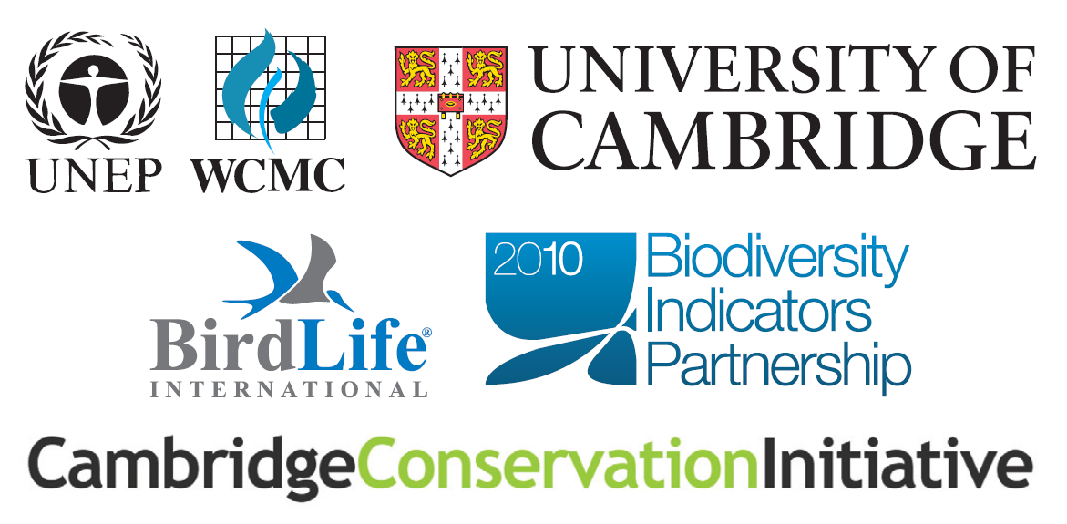
Further information on individual indicators used in the illustrative examples
Humid Tropical Forest | Notes and sources
- Area Designated Primarily for Conservation  - Carbon Storage  - Employment in Forestry  - Forest Area  - Primary Forest Area | FAO Global Forest Resources Assessment FRA2005 data from 41 countries designated by DeFries et al. 2010. Extrapolated to 2010 using assumptions based on FRA2010 Key findings. 2010 data to be confirmed, earlier data to be reassessed.
- Area under FSC Certification | Forest Stewardship Council
- Proportion of Forest in Protected Areas  - Proportion of Forest Important Bird Areas in Protected Areas | Data on spatial extent of humid tropical forest provided by Philippe Mayaux (European Commission Joint Research Centre Ispra). Data on Important Bird Areas provided by BirdLife International. Data from the World Database on Protected Areas provided by by Bastian Bomhard (UNEP-WCMC).
- Crops in Humid Tropical Countries | FAO (FAOSTAT) data from 41 countries designated by DeFries et al. 2010.
- Area Affected by Fire | FRA2005 data from 41 countries designated by DeFries et al. 2010.
- Proximity to Human Impact | To be developed
- Forest Footprint | Living Planet Report 2008. WWF, Gland, Switzerland
- Roundwood and Fuelwood | FAOSTAT data from 41 countries designated by DeFries et al. 2010.
- Provision of Clean Drinking Water | To be developed
- Tropical Forest Vertebrate Living Planet Index | Ben Collen (IoZ, ZSL)
- Red List Index | BirdLife International and IUCN
Marine Fisheries
- Marine Protected Areas | Data from the World Database on Protected Areas provided by Bastian Bomhard (UNEP WCMC)
- Tonnage of Fish from Certified Fisheries | To be developed
- Reduction in Bycatch | To be developed
- No Take Zones | To be developed
- Fleet Capacity Index | World Bank and FAO (2008). The sunken billions: The economic justification for fisheries reform. Agriculture and Rural Development Department. The World Bank, Washington D.C.
- Proportion of Fish Stocks Overexploited, Depleted or Recovering | FAO (2005). Review of the State of World Marine Fishery Resources. FAO Fisheries technical paper 457 and subsequent data from Jorge Csirke (FAO)
- Global Sea Surface Temperature | Hadley Centre
- Ocean pH | BATS
- Employment in Fisheries | SOFIA
- Global landings from Marine Fisheries | FAOSTAT
- Recreational Fisheries | To be developed
- Ecotourism | To be developed
- Marine Vertebrate Living Planet Index | Ben Collen (IoZ, ZSL)
- Number of Dead Zones | Diaz, R. J., & Rosenberg, R. (2008). Spreading Dead Zones and Consequences for Marine Ecosystems. Science, 321, 926-929. and updates.
- Pelagic Seabird Red List Index | BirdLife International
- Coral Condition | John Bruno (UNC) and Megan Tierney (UNEP_WCMC)
- Mangrove and Seagrass Extent. | Megan Tierney (UNEP WCMC), Michelle Waycott (JCU).
Reference
DeFries, R.S., Rudel, T., Uriarte, M. & Hansen, M. (2010). Deforestation driven by urban population growth and agricultural trade in the twenty-first century. Nature Geoscience, 3, 178-181.

UNEP/CBD/SBSTTA/14/1.
The meeting report is available at http://www.cbd.int/doc/?meeting=EMIND-02 and a summary forms Information Document UNEP/CBD/SBSTTA/14/INF/14

