 |  |  | CBD
 |  | CONVENTION ON  BIOLOGICAL DIVERSITY |  |  | Distr.  GENERAL  UNEP/CBD/WG8J/3/3  28 September 2003  ORIGINAL: ENGLISH
AD HOC OPEN-ENDED INTER-SESSIONAL WORKING GROUP ON ARTICLE 8(j) AND RELATED PROVISIONS OF THE CONVENTION ON BIOLOGICAL DIVERSITY
Third meeting
Montreal, 8-12 December 2003

Item 3 of the provisional agenda*

PROGRESS REPORT ON THE IMPLEMENTATION OF THE PROGRAMME OF WORK ON ARTICLE 8(j) AND RELATED PROVISIONS

Note by the Executive Secretary

I. INTRODUCTION
- In paragraph 6 of decision VI/10, the Conference of the Parties requested the Executive Secretary to prepare a report on progress on the implementation of the programme of work on Article 8(j) and related provisions based on information submitted in national reports, and other relevant information, for the next meeting of the Ad Hoc Open-ended Inter-Sessional Working Group on Article 8(j) and Related Provisions.
- In accordance with the above decision, the present note is based on information in the second national reports under Article 26 of the Convention on Biological Diversity. The format used for the preparation of these reports contained 22 questions pertaining to Article 8(j) and related provisions, mainly addressing decisions III/4, IV/9 and V/16. It should be noted that no questions were developed to address specifically the elements of the programme of work adopted at the fifth meeting of the Conference of the Parties. Therefore, the information presented on specific elements of the programme of work in the present note was derived from additional information provided by Parties in their submissions, as well as from other sources.
- Section II of the note presents a general overview of activities undertaken by Parties in order to implement the provisions of Article 8(j) at the national level. In particular, this section elaborates on: (i) priority allocated to the implementation of the article in national agendas; (ii) existing or new legislation and strategies addressing issues related to Article 8(j); and (iii) constraints identified by countries to the implementation of this article.
- Section III reports on steps undertaken at the international and national levels for the implementation of priority tasks of the programme of work, as identified by the Conference of the Parties in Annex to decision V/16. It reports on activities undertaken for the implementation of tasks 1, 2, 4, 5, 8, 9 and 11, which are included in the first phase of the programme of work.
- Section IV contains suggested recommendations that the Ad Hoc Open-ended Working Group on Article 8(j) and related provisions may wish to transmit to the seventh meeting of the Conference of the Parties.

II. GENERAL OVERVIEW OF THE IMPLEMENTATION OF ARTICLE 8(j) AND RELATED PROVISIONS

A. Priority allocated to the implementation of the Article 8(j)
- The implementation of Article 8(j) and related provisions at the national level is still a challenge for many countries. However, a number of countries, especially those with a large indigenous population, give a high priority to its implementation, as they have or are in the process of developing policies and programmes to promote the role of indigenous communities in the conservation and sustainable use of biodiversity (figure 1). Those countries with a long history of agricultural activities appear to pay high attention to the collection, maintenance and use of traditional knowledge accumulated throughout the years in their local communities, through the development of specific policies and programmes.
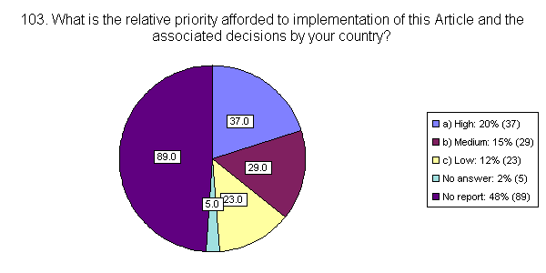
Fig. 1: Responses to question 103 for the second national report, indicating the relative
priority afforded by countries to the implementation of Article 8(j) and associated decisions.
- In addition, more than half of reporting countries have taken some measures to ensure that the traditional knowledge, innovations and practices of indigenous and local communities are respected, preserved and maintained, although only a few Parties have taken comprehensive measures in this regard.
- Some countries, such as Australia, have recorded some advances in recent years in the inclusion of indigenous knowledge, and cooperation with indigenous peoples, in land management and cultural heritage activities. In Indonesia, where this issue has not been give a high priority in the past, the existence and importance of traditional knowledge is being recognized. Similarly, Saint Lucia has recognized the need to place greater emphasis on traditional knowledge as it is evidenced by the development of the national cultural policy and the support given to the inclusion of traditional and indigenous knowledge among the factors for the protection of the national cultural and historical heritage.
- In general, countries that have a rather homogeneous population in terms of ethnicity and customs, and therefore consider that the notion of indigenous populations does not apply to their social and geographical situation, do not afford a high priority to the implementation of Article 8(j) and its provisions. For some such countries, such as Germany, the Netherlands and the United Kingdom, the issue may be of limited interest as far as national implementation is concerned, but it assumes higher importance in the context of international development cooperation programmes.
- In countries with no indigenous communities as such, the provisions of Article 8(j) are considered important for the preservation of available traditional knowledge. This is, for instance, the case of farmers in less favoured regions as well as organic farmers in Austria. In the European Community, although the number of indigenous peoples is small and limited to two or three member States (e.g., Finland, Sweden, and the overseas departments of France), the contribution of traditional knowledge to the conservation and sustainable use of biodiversity, and the need to afford suitable protection to this knowledge, is recognized. In particular, Council resolution of 30 November 1998 on Indigenous Peoples Within the Framework of the Development Cooperation of the Community and the Member States “reiterates the political will of the EU and its Member States to participate actively in the initiatives in the framework of the Convention on Biological Diversity for supporting local and indigenous peoples in their contribution to the conservation and sustainable use of biological diversity”.

B. National legislation supporting the implementation of Article 8(j)
- More than half of reporting countries are at various stages of developing national legislation and strategies for the implementation of Article 8(j), as indicated in figure 2.
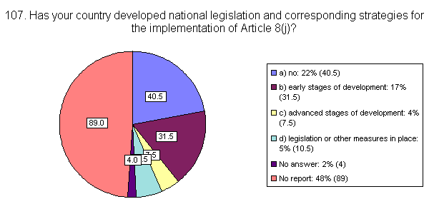

Fig. 2: Responses to question 107 for the second national report, on the development of
national legislation and corresponding strategies for the implementation of Article 8(j).
- The late 1990s marked the establishment of a series of national legal instruments and agreements addressing issues contained in Article 8(j) and related provisions. In 1998, for example, the European Community addressed the issue of the legal protection of biotechnological innovations. Directive 98/44/EC constitutes a non-binding requirement on member States to give particular weight to Article 8(j) when bringing into force the laws, regulations and administrative provisions necessary to comply with it. Other previous legislation includes a Protocol to the Instrument of Accession of Sweden and Finland to the European Community, which allows for exclusive rights to be granted for the indigenous Sami people to reindeer husbandry within traditional areas, with the possibility for the extension of such rights linked to their traditional lifestyle.
- In Panama, in 1998, Bill 41 established the general provisions of the Environmental Law of the Republic and creates the National Environmental Authority. In section VI entitled “De las Comarcas y Pueblos Indígenas”, addressed the respect, preservation and maintenance of knowledge, innovations and practices of indigenous and local communities embodying traditional lifestyles and promoting the sustainable use of biodiversity.
- In the Philippines, in October 1997, the Congress enacted the Indigenous People’s Rights Act (IPRA). Under IPRA, “the State shall recognize, respect and protect the rights of indigenous peoples to preserve and develop their cultures, traditions, and institutions”. The rights referred to include the right to claim “ancestral domains”, which include not only the physical environment but also the spiritual and cultural bonds associated with it. In return, the indigenous peoples have the responsibility of maintaining the ecological balance and restoring damaged areas. The Act also protects the right of the indigenous peoples to exclude others in exploiting natural resources within their ancestral domain. It requires that, before granting access the resources, free and prior informed consent of the community be obtained in accordance with the customary laws. The regulations governing bioprospecting further require that benefits derived from the utilization of biological and genetic resources be shared fairly and equitably with the community.
- In Africa, Ethiopia, together with the Organization of African Unity (OAU), developed a model law for regulating access to biological resources and for enforcing the protection of the rights of local communities on their knowledge, technologies innovations and practices, and their biological resources, in line with Article 8(j). This model law was adopted by the OAU summit that took place in Ouagadougou in June 1998 and it is now in the process of being assessed and utilized by OAU member countries. Ethiopia’s national law is based on it and the law is now being finalized for further submission to the Chamber of Deputies (Parliament). In the Comoros, a draft law addressing the use and management of natural resources and equitable benefit-sharing states that “the State respects, preserves, maintains and values the development of knowledge, innovations and practices of local communities embodying traditional lifestyles which are interested in the conservation and sustainable use of biodiversity”. The draft law establishes the modalities for the larger application of such knowledge and the consequent sharing of benefits.
- In Lebanon, although the national strategy was not meant to directly implement this article, the recently adopted Law for the Protection of the Environment signals an important first step in addressing indigenous knowledge related issues. In particular, the Law affirms the importance of traditional knowledge in rural areas and requires that indigenous information be taken into consideration in the absence of available scientific information.

C. Constraints to implementation
- A number of countries provided information on constraints they experienced in the implementation of Article 8(j) and related provisions. Widespread constraints are the lack of human, technical and, above all, financial resources. Indeed, resources available for meeting the obligations and recommendations made under the programme of Article 8(j) were considered limiting by almost 50 per cent of the respondent countries and severely limiting by 25 per cent of them. As indicated in figure 3, almost 50 per cent of the respondent countries also indicated that their country did not provide appropriate financial support to the implementation of the programme of work. Also, a very small percentage of the respondent countries (4 per cent) have fully identified resources for funding the activities set out in the decisions.
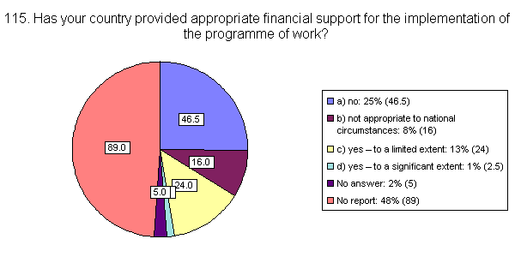

Fig. 3: Responses to question 115 for the second national report addressing
the issue of financial support for the implementation of the programme of work
- In general, all developing countries or countries with economies in transition stressed that financial resources for the fulfilment of the requirements of the programme of work are rather limited. In Bulgaria, especially limiting are the financial resources that the municipalities can earmark for this purpose. Municipalities also lack qualified staff able to work on the implementation of Article 8(j) of the Convention. The Government has to rely mostly on financial assistance from international sources rather than on internal ones for the implementation of relevant projects.
- Among African countries, Burkina Faso reported that financial and human resources are severely limiting. Ethiopia highlighted the great imbalance between the high recognition given to the value of community knowledge in the collection, conservation and utilization of biological resources and the scarce resources deployed to attempt any comprehensive work in this area. Gambia observed that, given the severe limitation of local resources, it is unlikely that this article would receive any attention within the second-order priority actions of national biodiversity strategy and action plan. Zimbabwe reported that it has not been able to put more resources to meet the obligations of this article, as is the case with many other African developing countries, since resources are generally channelled to mitigate drought and combat poverty and cover other immediate and urgent humanitarian needs.
- Among Asian countries, China considers that resources available for meeting the obligations and recommendations made on this article are limiting due to the lack of policies and mechanisms for sharing the benefits that could derive from the use of traditional knowledge, innovations and practices as well as the inadequacy of the financial capacity of the country. In Nepal, both financial and human-resource constraints remain limiting factors in the area of documenting traditional knowledge and its preservation and promotion. The Marshall Islands, like other countries, has established facilities, including museums, to maintain and transmit traditional knowledge, but they do not have adequate resources to maintain the facilities in operation. In Sri Lanka, a country which gives very high priority to this article as it has a very rich traditional knowledge base, the shortage of trained manpower, financial assistance, and weak legislation have affected the successful implementation of the article. Progress in implementation is affected by the limited personnel and financial resources available also in Vanuatu where, despite the high profile and public commitment given to the article, progress remains slow, measures remain fragmented, and there is a need for strengthening capacities and administrative capabilities.
- Among developed counties, Canada reported that it has committed limited new resources specifically to the implementation of Article 8(j). However considerable resources have and continue to be funnelled into programmes and projects that would be consistent with the intent of this article. Currently, Canada is assessing the number, impact and investments being made into such activities as well as the manner in which indigenous peoples in Canada participate and/or lead in their implementation.
- In Lebanon, the lack of trained experts able to analyse both the direct and indirect consequences of integrating the traditional history of indigenous people with a modern philosophy of biodiversity and conservation is considered one of the major constraints to implementation. Indeed, a few countries have also identified constraints other than financial ones. For example, some countries have not established proper regulations, policies or institutions to deal with related issues even if they are aware of the need to take some actions to protect and maintain traditional knowledge. Some other countries indicated that they are short of expertise in this field even if they are aware that traditional knowledge is disappearing.

III. PROGRESS IN THE IMPLEMENTATION OF PRIORITY TASKS OF THE PROGRAMME OF WORK

A. Overview of progress in implementation
- From responses received through the second national reports, it is possible to conclude that, at the national level, the review of the programme of work on Article 8(j) and related provisions is still at an early stage; only 3 per cent of the Parties have actually reviewed the programme of work and identified how to implement those tasks which are considered appropriate to the national circumstances (see figure 4). Consequently, only 3 per cent of the Parties are integrating such tasks in their ongoing programmes, taking into account the identified collaboration opportunities. Only the same small percentage of Parties are taking full account of existing instruments, guidelines and codes and other relevant activities in the implementation of the programme of work. It is also estimated that 19 per cent of Parties have not yet undertaken any activities to mainstream relevant tasks in other programmes of work.
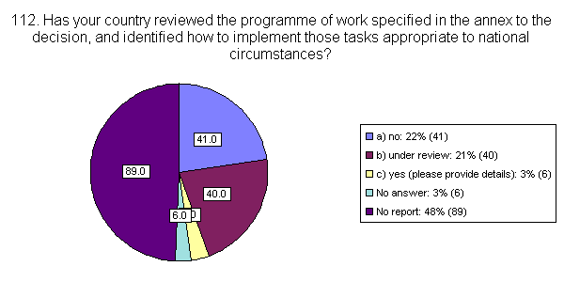

Fig. 4: Responses to question 112 for the second national report, illustrating the percentage of Parties that have reviewed the programme of work on Article 8(j) and identified how to implement those tasks at the national level.
- At the international level, the Conference of the Parties decided to give priority to tasks 1, 2, 4, 5, 8, 9 and 11, as well as tasks 7 and 12, in the implementation of the programme of work. These tasks cover the first phase of the programme of work.
- The Conference of the Parties also directed that tasks 7 and 12 should be initiated following the completion of tasks 5, 9 and 11. Documents on each of these three tasks have been prepared by the Executive Secretary for the consideration of the Working Group on Article 8(j) at its second meeting and are under consideration by the third meeting. Tasks 7 and 12 will therefore not be initiated until the Working Group has completed its deliberations and forwarded its recommendations to the seventh meeting of the Conference of the Parties on the aforementioned three tasks. Progress in the implementation of tasks 7 and 12 is therefore not considered in the present note.
- It should be noted, however, that task 7 requires the Working Group on Article 8(j) to develop guidelines for the development of mechanisms, legislation or other appropriate initiatives to ensure: (i) that indigenous and local communities obtain a fair and equitable share of benefits arising from the use and application of their knowledge, innovations and practices; (ii) that private and public institutions interested in using such knowledge, practices and innovations obtain the prior informed approval of the indigenous and local communities; (iii) advancement of the identification of the obligations of countries of origin, as well as Parties and Governments where such knowledge, innovations and practices and the associated genetic resources are used.
- It should be noted that these matters are closely related to the work of the Ad Hoc Open-ended Working Group on Access and Benefit-Sharing. As a result of the work of that Working Group the Bonn Guidelines on Access to Genetic Resources and Fair and Equitable Sharing of Benefits arising out of their Utilization were adopted by the Conference of the Parties at its sixth meeting, in April 2002.
- In this context, and taking into account paragraph 10 of decision VI/24 A, in which the Conference of the Parties requested the Ad Hoc Open-Ended Working Group on Article 8(j) and related provisions “to consider the Bonn Guidelines as relevant to its ongoing work”, the Working Group may wish to take into account the Bonn Guidelines when addressing task 7 with a view to further develop the component pertaining to benefit sharing arrangements for indigenous and local communities.

B. Task 1: Strengthen indigenous and local community capacity to be involved in decision-making related to the use of their traditional knowledge
- In line with task 1 of the programme of work, the Conference of the Parties, in paragraph 23 of decision VI/10, urged Parties and Governments to strengthen their efforts to support capacity-building aimed at the full and effective participation of indigenous and local communities, particularly women, in decision-making processes regarding the preservation, maintenance and utilization of traditional knowledge relevant for the conservation and sustainable use of biological diversity at all levels (local, national, regional and international); and, where indigenous and local communities and Parties and Governments deem appropriate, promote their participation in the management of biological diversity.
- It has been suggested that relevant national institutions, such as research organizations and universities, collaborate with indigenous and local communities to identify the research and training needs of indigenous and local communities in relation to the conservation and sustainable use of biological diversity. More detailed information on the implementation of paragraph 23 of decision VI/10 is contained in Section III of the note by the Executive Secretary on mechanisms to promote the effective participation of indigenous and local communities in matters related to the objectives of article 8(j) and related provisions (UNEP/CBD/WG8J/3/6), which focuses on capacity-building for effective participation in decision-making and management of biological diversity and for access to national and international laws for the protection of traditional knowledge.

C. Task 2: Develop and/or strengthen measures to promote effective indigenous and local community participation in decision-making, policy planning and development and implementation of the conservation and sustainable use of biological diversity at all levels
- In paragraph 20 of decision VI/10, the Conference of the Parties invited Parties, Governments and relevant international, non-governmental and indigenous and local community organizations, to submit to the Executive Secretary information on their national experiences, case-studies, best practices, and lessons learned concerning participatory mechanisms for indigenous and local communities in matters related to the objectives of Article 8(j) and related provisions of the Convention. In paragraph 21 of the same decision the Conference of the Parties requested the Executive Secretary to prepare a synthesis report based on the aforementioned submissions in order to make available to Parties information which could support the establishment and strengthening of participatory mechanisms at the national and local levels in decision-making pertaining to traditional knowledge and biodiversity.
- Section II of the note by the Executive Secretary on mechanisms to promote the effective participation of indigenous and local communities in matters related to the objectives of Article 8(j) and related provisions (UNEP/CBD/WG8J/3/6), provides a synthesis of the information submitted in response to that request. It also addresses the issue of indigenous and local community participation in decision making processes regarding the preservation, maintenance and utilization of traditional knowledge and explores potential sources of funding to facilitate the full and effective participation of indigenous and local communities in meetings organized within the framework of the Convention, as requested in paragraph 22 of decision VI/10.
- Another matter concerning indigenous and local community participation identified in paragraphs 25 and 26 of decision VI/10, namely a multi-convention approach with regard to such participation in relation to the maintenance and application of traditional knowledge, is dealt with in the note by the Executive Secretary on the consultation on cooperation and collaboration among environmental conventions concerning the participation and involvement of indigenous and local communities in the maintenance and application of traditional knowledge relevant for the conservation and sustainable use of biological diversity (UNEP/CBD/WG8J/3/6/Add.2), prepared for the consideration of the Ad Hoc Working Group on Article 8(j) at its third meeting.
- At the national level, almost 40 per cent of respondent countries reported that they are facilitating the active participation of the representatives of indigenous and local communities in relevant working groups and meetings. Over 50 per cent of respondent countries reported on taking measures, to a limited or significant extent, to facilitate the full and effective participation of indigenous and local communities in the implementation of the Convention, as indicated in figure 5. However, a major constraint to full and effective participation, as also indicated by the submissions reflected in the note by the Executive Secretary on mechanisms to promote the effective participation of indigenous and local communities (UNEP/CBD/WG8J/3/6), is the lack of funds and financial support available.
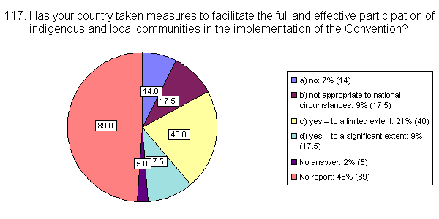

Fig. 5. Responses to question 117 for the second national report, indicating to which extent the country has taken measures to facilitate the full and effective participation of indigenous and local communities in the implementation of the Convention.

D. Task 4: Develop mechanisms to promote the full participation of indigenous and local communities, with specific provisions for the participation of women, in all elements of the programme of work
- Almost half the countries that submitted their second national report indicated that they have fully incorporated women and women’s organizations in the activities undertaken to implement the programme of work on Article 8(j) and related provisions and other relevant activities under the Convention, as indicated in figure 6.
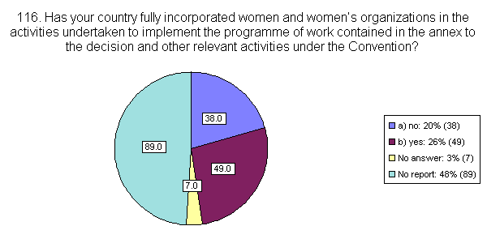
Fig 6: Responses to question 116 for the second national report indicating the percentage of Parties that have fully incorporated women and women’s organizations in the activities undertaken to implement the programme of work on Article 8(j) and other relevant activities under the Convention.
- In Australia, although the legislation was not specifically developed to reflect the objectives of Article 8(j), the 1999 Environment Protection and Biodiversity Conservation Act refers to involvement of indigenous Australians in biodiversity conservation. Women are an integral part of the transfer of ethnobiological knowledge to younger generations and are therefore incorporated into the programme in areas such as food and crafts. In the Bahamas, women are involved in the implementation of the Convention but no work has begun as yet on the implementation of the programme of work on Article 8(j).
- In Burkina Faso, there is an explicit policy to integrate women and women’s organizations in the implementation of the programme of work, and it has been remarked that this integration is progressing. Similarly, in Cameroon policies and programmes within the Ministry of Women’s Affairs and the Ministry of Social Affairs promote culture traits, and value especially those that are identifiable within rural women throughout the country.
- In Ethiopia, the Ethnobiology Department of the Institute of Biodiversity Conservation and Research (IBCR) has been studying the role of women in the development, maintenance and sustainable utilisation of biological resources with emphasis on food crops and cosmetic plants. Likewise, the IBCR Forest Department has established a “focus group” that works on gender issues. The Prime Minister’s Office has a Department of Women’s Affairs and all ministries and large agencies have their respective Departments of Women’s Affairs. One of their main goals is the improvement of the conditions of rural women, in their role as managers and conservers of biological diversity, and as generators and users of the associated biological knowledge.

E. Task 5: Preparation of the outline of the composite report on the status and trends regarding indigenous and local community traditional knowledge
- In accordance with task 5 of the programme of work, in paragraph 8 of decision VI/10 the Conference of the Parties adopted the outline of the composite report on the status and trends regarding the knowledge, innovations and practices of indigenous and local communities embodying traditional lifestyles relevant to the conservation and sustainable use of biological diversity as a basis for proceeding with the first phase of information-gathering and reporting, as contained in annex I of the decision VI/10.
- In paragraph 9 of the same decision, the Conference of the Parties requested the Executive Secretary to undertake the first phase of the composite report and to submit the first-phase report to the third meeting of the Working Group on Article 8(j) and Related Provisions. The note by the Executive Secretary on the first phase (UNEP/CBD/WG8J/3/4) also includes recommendations for the subsequent phases. The document is based on information presented in a series of regional reports addressing the same issue, which are being made available to the third meeting of the Working Group as information documents (UNEP/CBD/WG8J/3/INF/3-10).

F. Task 8: Identification of a focal point within the clearing-house mechanism to liaise with indigenous and local communities
- Task 8 of element 5 of the programme of work, which addressed the exchange and dissemination of information, requested that a focal point be identified within the clearing-house mechanism to liaise with indigenous and local communities. In accordance with task 8, in paragraph 28 of decision VI/10 the Conference of the Parties requested the Executive Secretary to establish a technical expert group to develop the roles and responsibilities of the thematic focal point within the clearing-house mechanism of the Convention on issues related to Article 8(j) and related provisions. In addition, in paragraph 24 of the same decision, the Conference of the Parties urged Parties and Governments and, as appropriate, international organizations, to encourage and support the development of communication mechanisms, such as the Indigenous Biodiversity Information Network (IBIN), among indigenous and local communities in response to their need for better understanding of the objectives and provisions of the Convention on Biological Diversity and for supporting discussions on guidelines, priorities, timelines and the implementation of the thematic programmes of the Convention.
- Pursuant to the aforementioned decisions, the meeting of the Ad Hoc Technical Expert Group on Traditional Knowledge and the Clearing House Mechanism was held in Santa Cruz de la Sierra, Bolivia, from 25 to 26 February 2003. The Group identified the roles and responsibilities of the thematic focal point within the clearing-house mechanism on issues related to Article 8(j) and related provisions, including: (i) the objective; (ii) principles of operation; (iii) characteristics; (iv) functions; and (v) elements for a work programme.
- The Technical Expert Group also considered the development of communication mechanisms, such as the Indigenous Biodiversity Information Network (IBIN), among indigenous and local communities. Emphasis was laid on the relevance of identifying key networks and focal points from already existing communication networks (local, national and regional) and potential relationships with emerging global networks, to enable the thematic focal point within the clearing-house mechanisms to develop links and communications as soon as possible.
- In this context, the Ad Hoc Open-ended Working Group on Article 8(j) may wish to consider the suggestions/recommendations contained in annex I to the report of the Technical Expert Group (UNEP/CBD/AHTEG/TK-CHM/1/3), which address the roles and responsibilities of the thematic focal point, as well as the development of communication networks, with a view to transmitting them to the Conference of the Parties at its seventh meeting.

G. Task 9: Development of guidelines or recommendations for the conduct on cultural, environmental and social impact assessments for developments proposed to take place on sacred sites and on lands and waters occupied or used by indigenous and local communities
- At its sixth meeting, the Conference of the Parties adopted recommendations for the conduct of cultural, environmental and social impact assessment regarding developments proposed to take place on, or which are likely to impact on, sacred sites and on lands and waters traditionally occupied or used by indigenous and local communities (decision VI/10, annex II). In paragraph 13 of decision VI/10, the Conference of the Parties requested that the Ad Hoc Open-ended Inter-Sessional Working Group on Article 8(j) at its third meeting should carry out further work on guidelines for the above-mentioned impact assessments.
- Pursuant to this decision, the Executive Secretary has prepared a note containing a set of draft guidelines for the consideration of the third meeting of the Ad Hoc Open-ended Inter-Sessional Working Group on Article 8(j) (UNEP/CBD/WG8J/3/5). The note also contains recommendations on how to use the guidelines and suggests actions and further work to be undertaken to address this issue.
- The draft guidelines, which would be voluntary and subject to national legislation, incorporate and build on the recommendations adopted by the sixth meeting of the Conference of the Parties in paragraph 12 of decision VI/10. As requested in paragraph 13 of the same decision, the guidelines take into account the Guidelines for Incorporating Biodiversity-related Issues into Legislation and/or Processes and in Strategic Environmental Assessment, endorsed by the Conference of the Parties at its sixth meeting in paragraph 1 of decision VI/7.

H. Task 11: Assessment of existing instruments, and particularly intellectual property rights instruments, which may have implications for the protection of traditional knowledge
- The second national reports highlighted that Parties are still at an early stage in the development of instruments for the protection of traditional knowledge. In general, countries are exploring and assessing the possibility to develop registers of traditional knowledge, innovations and practices of indigenous and local communities. It should be noted that a number of countries have reported that they do not support the development of such registers, as they are concerned registers may potentially be harmful to the interest of indigenous and local communities (figure 7). This issue is being examined by Intergovernmental Committee on Intellectual Property and Genetic Resources, Traditional Knowledge and Folklore of the World Intellectual Property Organization.
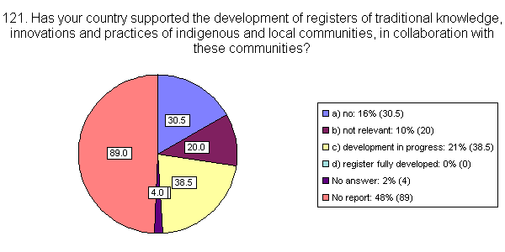
Fig. 7: Responses to question 121 for the second national report. The chart shows the percentage of countries that support the development of registers of traditional knowledge, innovations and practices of indigenous and local communities in collaboration with these communities.
- Australia is in a rather advanced stage in the attempt to identify measures that will help the preservation and maintenance of traditional knowledge. The Government is running two pilot projects entitled “Ethnobiological Project—Indigenous Knowledge of Biodiversity 2000–2001”, which aim to develop protocols and guidelines/ methodologies for the protection and transmission of traditional ethnobiological knowledge between generations. Case-studies were also provided to the WIPO fact-finding mission on indigenous property and traditional knowledge. The Queensland Government will also explore measures to promote the conservation and maintenance of knowledge, innovations and practices of indigenous and local communities during the development of the Queensland BioAcess Policy.
- The European Community is also involved in deliberations of the WIPO Intergovernmental Committee on Intellectual Property Rights, Genetic Resources, Traditional Knowledge and Folklore, and encouraged WIPO to develop an international regulatory system for the protection of traditional knowledge in synergy with the Convention on Biological Diversity and other international bodies. Action 11 of the European Community Biodiversity Action Plan for Economic and Development Cooperation states that the Community will support national capacity-building on intellectual property rights in relation to biodiversity and to develop supportive laws for equitable benefit-sharing. Within the European Union, Portugal, is currently preparing a draft legal document addressing this issue. It constitutes a legal framework for the registration, conservation and legal protection and the transfer of autochthonous material with relevant or potential value for agriculture, agro-forestry and landscape, including the local varieties and related wild material, as well as the associated traditional knowledge.
- In Latin America, Cuba has reported establishing an inventory of existing genetic resources, and El Salvador, within the PROGOLFO project, has conducted a basic assessment of resources, which resulted in a list of plants and their respective traditional uses. This list will be eventually developed into an inventory of uses and their geographical location and will serve as the basis for a management strategy.
- In Africa, some measures have been taken to support the Ethiopian National Traditional Medicine Preparation and Therapy Association in recording medical knowledge, innovations and practices of healers in local communities. Some individual healers who are also members of the Association have signed mutually agreed contracts with the Ethiopian Health and Nutrition Institute (EHNI) of the Ministry of Health to release their medical knowledge.
- Namibia supports the concept of a register of traditional knowledge in principle but with certain reservations. Based on a consultation with the various stakeholders, Namibia has concluded that the register may not necessarily be the best medium through which traditional knowledge can be protected. Namibia stressed that, before fully endorsing the register concept, a number of issues need to be clarified and questions answered. For example, the issues of responsibility for recording of the information in the register, access to the information database, relation of the register to the regime on intellectual property rights should be addressed. It should also be clarified whether the traditional knowledge sources and data, once documented, should become public domain information and how the rights of the owners of this knowledge could be protected.
- In Israel, the Israel Gene Bank (IGB), under the Ministry of Science, Culture and Sport and the Ministry of Agriculture, is responsible for the implementation of a strategy for national genetic resources conservation. Its responsibilities, include, inter alia, the search for plants potentially suitable for extraction of beneficial substances, the collection, preservation, documentation and evaluation of genetic resources of crop plants and their relatives, including landraces and primitive cultivars, and the development of in situ and ex situ conservation techniques.
- In Nepal, a draft Bill on Access to Genetic Resources and Benefit-sharing provides for documentation and registration of traditional knowledge associated with biological resources. The Ministry of Law, Justice and Parliamentary Affairs (MLJPA) is seeking Cabinet approval for tabling the Bill in Parliament. Currently, the process of biodiversity documentation and registration including indigenous knowledge and traditional skills and technology has started at village level. In Fiji, non-governmental organizations work closely with indigenous communities, and registries on certain aspects of plants used for medicinal purposes have been completed.
- India has reported on a series of measures and instruments used to register and protect traditional knowledge. Documentation of local people’s knowledge on the status, uses and management of biological resources is provided through the “people’s biodiversity registers” (PBRs). PBRs envisage the creation of a decentralized country-wide database on the status of biological resources. Databases also include local knowledge on properties and uses of biodiversity resources, for example, drought resistance of certain varieties, methods of preservation of foods, or use of certain plants in treating human or livestock diseases.
- India reports several cases of unlawful use of traditional knowledge. In view of the above, India has now initiated the preparation of an easily navigable electronic computerized database of documented traditional knowledge relating to use of medicinal and other plants. It is proposed that a “traditional knowledge digital library” (TKDL) be created covering 35,000 Ayurvedic formulations involving medicinal plants. The TKDL will include details of international patent classification and traditional knowledge resource classification, key words on plants and formulations, synonyms, dictionary of equivalent for Ayurvedic terminology, concepts and definitions, and references to documents. TKDL would be created in English, German, French and Japanese. This database will be sent to patent offices of the United States of America, the European Union, Japan and other countries to enable them to search and examine any prevalent use/prior art, and thereby prevent unlawful appropriation of traditional knowledge.
- Realizing the need to ensure that the holders of traditional knowledge not yet in the public domain should be able to get the benefits arising from the use of such knowledge, an enabling provision has been introduced in the proposed biodiversity legislation developed by the Ministry of Environment and Forests of India, with a view to ensuring the protection of such knowledge. A section of the legislation provides for protection of knowledge of local people relating to biodiversity through measures such as registration of such knowledge, and development of a sui generis system. With a view to ensuring the equitable sharing of benefits arising from the use of biological resources and associated knowledge, sections 19 and 21 of the Biodiversity Bill 2000 stipulate prior approval of the National Biodiversity Authority (NBA) before their access. While granting approval, NBA will impose terms and conditions that secure equitable sharing of benefits. Section 6 provides that anybody seeking any kind of intellectual property rights on research based upon biological resource or knowledge obtained from India needs to obtain prior approval of the NBA. The NBA will impose benefit-sharing conditions. Section 18(iv) stipulates that one of the functions of NBA is to take measures to oppose the grant of intellectual property rights in any country outside India with respect to any biological resource or associated knowledge obtained from India.
- In order to protect bio-resources and associated knowledge, the Patents (Second Amendment) Bill 1999, contains provisions for mandatory disclosure of source and geographical origin of the biological material used in the invention while applying for patents in India. Provisions have also been incorporated to include the non-disclosure or wrongful disclosure of the same as grounds for opposition and for revocation of the patent, if granted. To prevent the issuance of patents based on knowledge that is not always documented, provisions have been incorporated to include anticipation of invention by available local knowledge, including oral knowledge, as one of the grounds for opposition and revocation of patent, if granted.
- The second national reports also reveal that, although only few countries have submitted case-studies on methods and approaches concerning the preservation and sharing of traditional knowledge, and the control of that information by indigenous and local communities, information sharing on these issues among countries is increasing. Almost 20 per cent of respondent countries are sharing experience regarding national legislation and other measures for the protection of the knowledge, innovations and practices of indigenous and local communities with specific countries, and another 20 per cent make the information available through a series of available means. Only 4 per cent of respondent countries use the clearing-house mechanism of the Convention for this purpose.
- At the international level, the Conference of the Parties, in paragraph 34 of decision VI/10, requested the Ad Hoc Open-ended Inter-Sessional Working Group on Article 8(j) and Related Provisions to address the issue of sui generis systems for the protection of traditional knowledge, focusing in particular on the following issues:
- Clarification of relevant terminology;
- Compiling and assessing existing indigenous, local, national and regional sui generis systems;
- Making available this compilation and assessment through the clearing-house mechanism of the Convention;
- Studying existing systems for handling and managing innovations at the local level and their relation to existing national and international systems of intellectual property rights to ensure their complementarity;
- Assessing the need for further work on such systems at the local, national, regional and international levels;
- Identifying the main elements to be taken into consideration in the development of sui generis systems;
- The equitable sharing of benefits arising from the utilization of traditional knowledge, innovations and practices of indigenous and local communities, taking into account the work carried out by the Intergovernmental Committee on Intellectual Property and Genetic Resources, Traditional Knowledge and Folklore with a view to promote mutual supportiveness, and existing regional, subregional, national and local initiatives.
- Pursuant to that request, the Executive Secretary has prepared a note (UNEP/CBD/WG8J/3/7) on the development of elements of a sui generis system for the protection of traditional knowledge, innovations and practices addressing the above issues for the consideration of the the Ad Hoc Open-ended Inter-Sessional Working Group on Article 8(j) at its third meeting.
- Also of relevance to the protection of traditional knowledge is the issue of disclosure or the origin of relevant traditional knowledge in applications for intellectual property rights. In decision VI/10, paragraph 46, and in decision VI/24 C, paragraph 2, related to access and benefit-sharing, the Conference of the Parties invited “Parties and Governments to encourage the disclosure of the origin of relevant traditional knowledge, innovations and practices of indigenous and local communities relevant to the conservation and sustainable use of biological diversity in applications for intellectual property rights, where the subject matter of the application concerns or makes use of such knowledge in its development”.
- In paragraph 3 of decision VI/24 C, the Conference of the Parties also recognized that further work was needed on a number of issues related to the disclosure of origin of genetic resources and relevant traditional knowledge in applications for intellectual property rights and requested the Executive Secretary to carry out further work on this issue. In response to this request, a note by the Executive Secretary was prepared for the second meeting of the Ad Hoc Open-ended Working Group on Access and Benefit-sharing (UNEP/CBD/WG-ABS/2/3), which will take place immediately prior to the third meeting of the Working Group on Article 8(j). An analytical study on the feasibility and efficacy of requirements for disclosure of country of origin and prior informed consent in intellectual property rights applications in monitoring compliance with access provisions was also carried out and made available as an information document (UNEP/CBD/WG-ABS/2/INF/2). These two studies will be made available to the Working Group on Article 8(j).
- In addition, in paragraph 4 of decision VI/24 C, the Conference of the Parties invited WIPO to prepare a technical study, and to report its findings to the Conference of the Parties at its seventh meeting, on methods consistent with obligations in treaties administered by the World Intellectual Property Organisation for requiring the disclosure within patent applications of, inter alia: (i) Genetic resources utilized in the development of the claimed invention; (ii) The country of origin of genetic resources utilized in the claimed inventions; (iii) Associated traditional knowledge, innovations and practices utilized in the development of the claimed inventions; (iv) The source of associated traditional knowledge, innovations and practices; and (v) Evidence of prior informed consent. In response, WIPO has prepared a technical study to be approved by the WIPO General Assembly in September 2003 for onward transmission to the seventh meeting of the Conference of the Parties.

IV. RECOMMENDATIONS
- The Ad Hoc Open-ended Working Group on Article 8(j) and Related Provisions may wish to recommend that the Conference of the Parties at its seventh meeting:
(a) Requests the Executive Secretary to continue to report on progress on the implementation of Article 8(j) and related provisions based on information submitted in national reports, and other relevant information, for the next meeting of the Ad Hoc Open-ended Inter-Sessional Working Group on Article 8(j) and Related Provisions;
(b) Decides that next meeting of the Ad Hoc Open-ended Inter-Sessional Working Group on Article 8(j) and Related Provisions be organized prior to the eighth meeting of the Conference of the Parties in order to ensure further advancement of the implementation of the work programme on Article 8(j) and related provisions.

---

* UNEP/CBD/WG8J/3/1.

