Biodiversity Indicators Partnership (BIP) Dashboard
Tracking Trends for Conservation

Users can access the BIP dashboard to support the development of their 6th National Reports by clicking the Dashboard tab on the Biodiversity Indicators Partnership website (https://www.bipindicators.net) or via a direct link (http://bipdashboard.natureserve.org/bip),

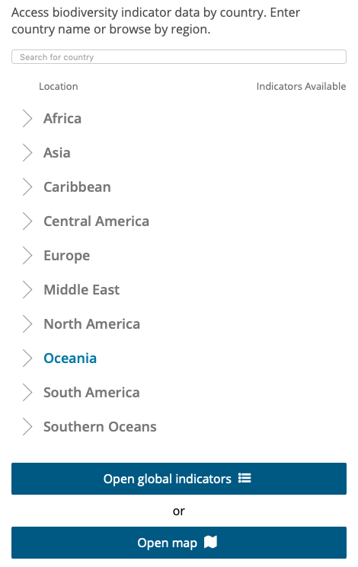
The dashboard’s front-page allows users to access biodiversity indicator data by country and region. Users can enter and select the country of their choice, or they can browse global indicators by directly opening the map. While looking through the list of countries on the front page, users can also see how many indicators are available for each country.

After choosing a country, users are taken to an indicator selection page, where they can either search directly for the indicator they’re looking for or browse by theme. These themes include Agriculture, Marine and Freshwater Habitats, Terrestrial habitats, Policy and Conservation Actions, Species etc. By clicking on the drop-down menu under each theme, the listed indicators are also tagged by the corresponding Aichi Biodiversity Targets, Sustainable Development Goals (SDGs) and Multilateral Environmental Agreements (MEAs).

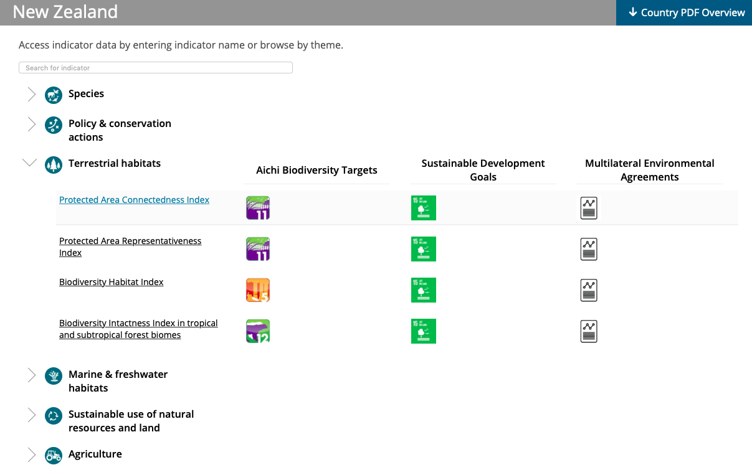
The selected indicator will then be visualized on a spatial map representing the country in question alongside an information bar that includes a time-series chart. Indicators can be visualized either depicting annual change or by most recent year of measurement. For those indicators with sub-national or basin-level data (e.g. the Protected Area Connectedness Index), they can also be visualized at the basin scale by clicking the ‘Show Basin’ button on the map window. Each selected basin or region on the map will be shown with a time series chart for the years available, along with a description of the indicator and options to download the visual information in either a chart or a map form.
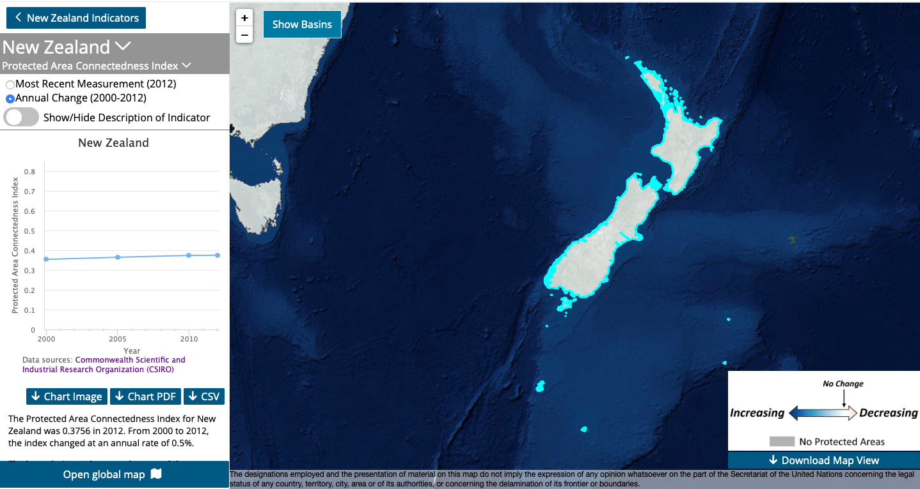
Users can also learn more about the indicator in question by selecting the ‘Show/Hide Description of the Indicator’ feature near the top of the time-series chart. This will provide a short description of the indicator along with a link to the metadata for more detailed information on the indicator’s methodology, data sources used, limitations and further information.
Finally, users can download the map view by clicking this feature on the bottom right corner of the screen which allows a download of the current view within the map pane.
Additional indicators will be added to the BIP Dashboard over the coming months and additional features such as the ‘Country PDF Overview’ and comparison features will also be added. We welcome all feedback and are here to answer any questions regarding the use of the BIP Dashboard. You can contact either:
Katherine Despot-Belmonte (katherine.despot-belmonte@unep-wcmc.org) or
Mike Gill (mike.gill@natureserve.org)

