Action Plan for Implementing the Programme of Work on Protected Areas of the Convention on Biological Diversity
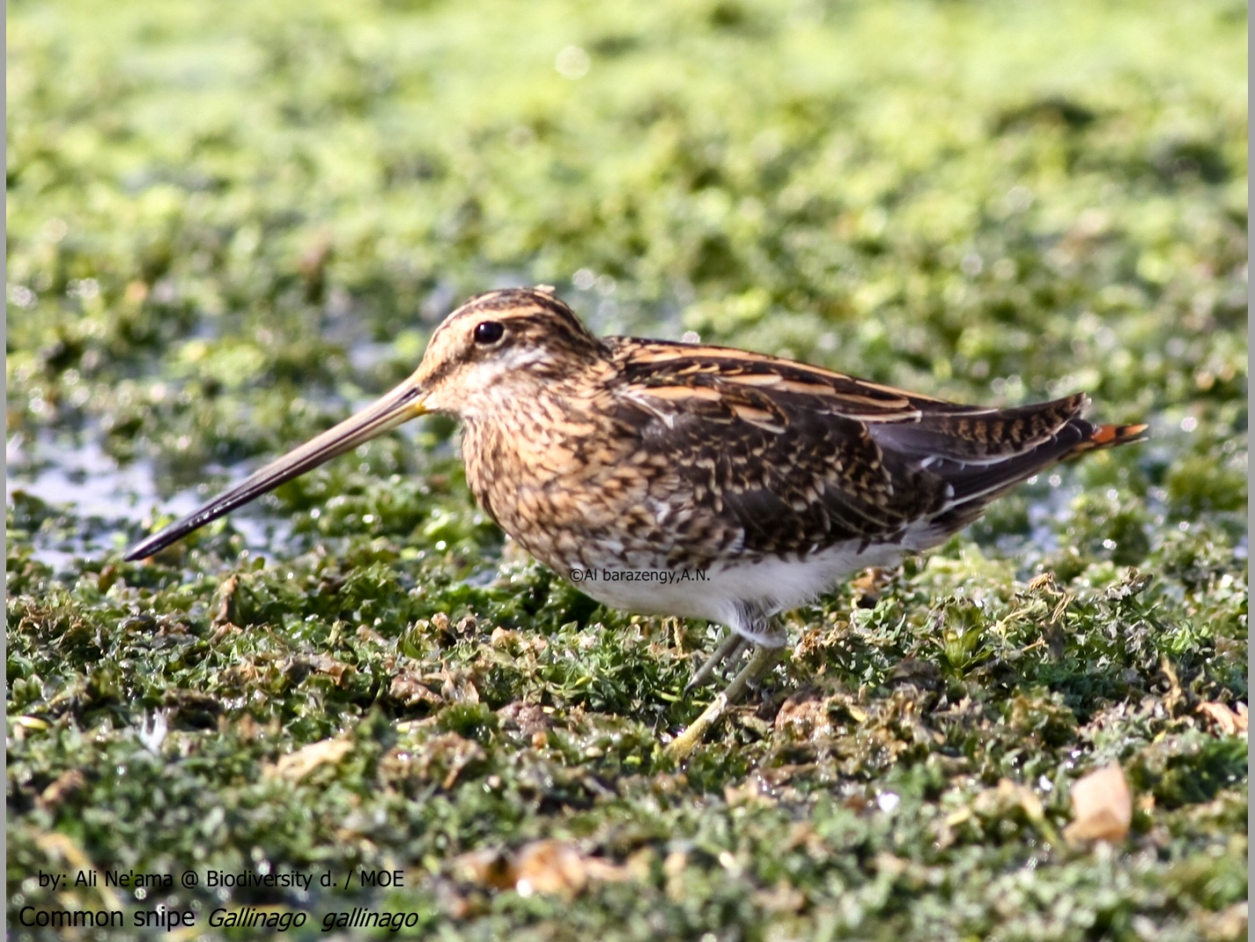

Iraq

Submitted to the Secretariat of the Convention on Biological Diversity [20 May 2012]

Protected area information:

PoWPA Focal Point
Dr. Ali Al-Lami, Ph.D.(Ecologist)
Minister Advisor; Ministry of Environment of Iraq
Email: aaza59@yahoo.com

Lead implementing agency:
Ministry of Environment of Iraq

Multi-stakeholder committee:
In Iraq there are several national Committees that were established to support the Government in developing policies, planning and reporting on different environmental fields.
As for Protected areas, two national committees are relevant:
- The National Committee for Protected Areas
- Iraq National Marshes and Wetlands Committee

National Committee for Protected Areas
A National Committee for Protected Areas was established in 2008 for planning and management of a network of Protected Areas in Iraq.
This national inter-ministerial Committee is lead by the Ministry of Environment and is formed by the representatives of the following institutions:
- Ministry of Environment (Leader)
- Ministry of Higher Education & Scientific Research
- Ministry of Water Resources
- Ministry of Science & Technology
- Ministry of Municipalities & Public Works
- Ministry of State for Tourism & Antiquities
- Ministry of Agriculture
- Ministry of Education
- NGO representative Nature Iraq Organization

Iraq National Marshes and Wetlands Committee (RAMSAR Convention)
The Ramsar Convention on Wetlands was ratified by Iraq in October 2007 and entered into force on February 18th, 2008. An Iraq National Marshes and Wetlands Committee (INMWC) was established in 2008 to assist the Government of Iraq in its implementation of national Ramsar Convention responsibilities.
This national inter-ministerial Committee is lead by the Ministry of Water Resources and is formed by the representatives of the following institutions:

- Ministry of Water Resources
- Consultants institution
- Members form Governorate Council (Missan, Basrah, Thi Qar)
- Ministry of Environment
- Ministry of Science & Technology
- The Iraqi Media Body
- NGO representative Nature Iraq Organization

Description of protected area system
Coverage
According to the current information, the total extent of existing or planned natural Protected Areas of Iraq is about 284,022 ha (2,840 km²) that corresponds to 0.65% of total land area of Iraq (43,737,000 ha). No protected areas are established or planned in the sea territorial waters of Iraq.
Protected Area Type | Number | Area | Ecoregion
National Protected Areas
National Park | 1 proposed | Approx. 141,615 ha  (1416 km²) | PA0906, 441
Other types of PA | 1 established (informal Barzan Tribal Protected Area) | 4707 ha  (47.07km²) | PA0446, 442
International Protected Areas
Ramsar Sites | 1 established (Hawizeh Marsh) | 137700 ha  (1377 km²) | PA0906, 441
TOTAL | 3 | 284022 ha  (2840 km²)

The following Table provides existing or planned PAs as a percentage of the area of the ecoregions that is encompassed within Iraq.
ecoregion | Protected AreaS  (km²) | % of Total Area
Terrestrial Ecoregions
Tigris-Euphrates alluvial salt marsh (PA0906) | 2,793 km² | 9.6 %
Arabian Desert and East Sahero-Arabian Xeric Shrublands (PA1303) | 0 | 0%
Mesopotamian Shrub Desert (PA1320) | 0 | 0%
Middle East Steppe (PA0812) | 0 | 0%
Eastern Mediterranean conifer-sclerophyllous-broadleaf forest (PA1207) | 0 | 0%
Red Sea Nubo-Sindian Tropical Desert and Semi-Desert (PA1325) | 0 | 0%
South Iran Nubo-Sindian Desert and Semi-Desert (PA1328) | 0 | 0%
Gulf Desert and Semi-Desert (PA1323) | 0 | 0%
Zagros Mountains Forest Steppe (PA0446) | 47 km² | 0.15 %
Freshwater Ecoregions
441 Lower Tigris and Euphrates River Basin | 2,793 km² | 0.64 %
442 Upper Tigris and Euphrates River Basin | 0 | 0%
440 Arabian Interior | 0 | 0%
445 Orumiyeh | 0 | 0%
Marine Ecoregions
90 The Gulf | 0 | 0%

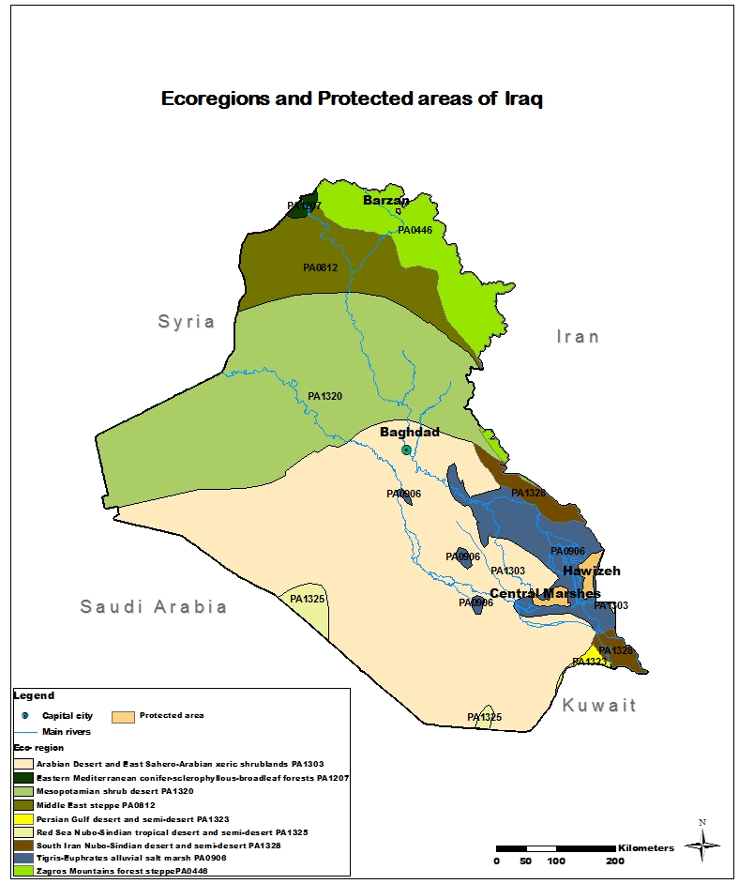
Figure 1 – map of Protected Areas and Ecoregions of Iraq

Description and background

The (proposed) Mesopotamia Marshlands National Park
The program for the establishment of the Mesopotamia Marshlands National Park (MMNP) started in April 2006 within the New Eden Project carried out and funded by the Italian Ministry of the Environment, Land and Sea.
A Feasibility Study was developed in 2007 as the preliminary document to assess the real possibility of creating a protected area in the Marshlands of Southern Iraq. The consequent draft version of the Management Plan for the Iraqi Mesopotamia National Park was developed in 2008 and submitted for approval to the National Committee for Protected Areas. The draft Management Plan was then integrated by the outline of an Operational Program in 2008-2009, and by an updated version of the National Park’s Management plan in 2010.
The Park area comprises land from three Governorates and five districts: Missan (45.67%) in the North (districts of Al Majar Al Kabeer and Al Maimona), Thi-Qar (45,68%) in the West (districts of Nassiriyah and Chibayish), and Basrah (8,65 %) in the East (district of Mudainah). The area covers an extent of 139,654 hectares, with a maximum length of 51 km and a width of 36 km.
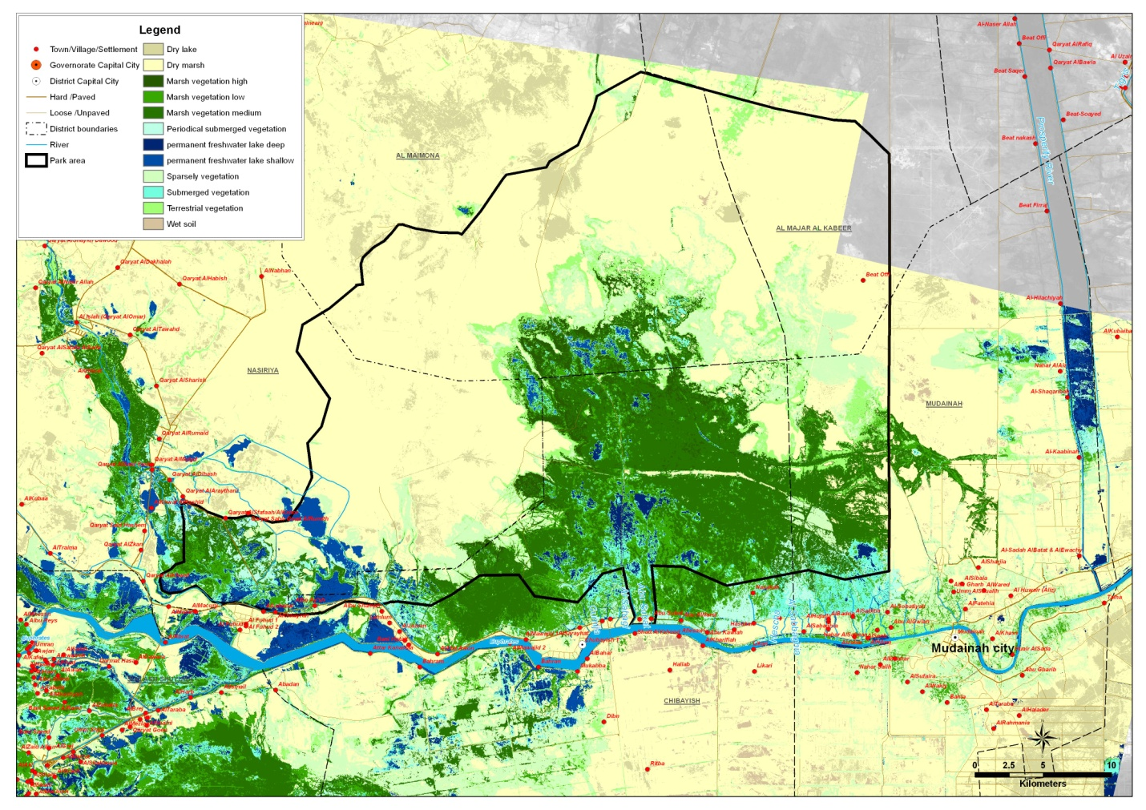
Figure 2 – map of the proposed Mesopotamia Marshlands National Park in southern Iraq (source: draft Management Plan -Interim Report 2010)

The overall aim was to provide the southern marshes of Iraq with a plan to ensure the restoration and protection of the environmental and cultural heritage of the Central Marshes, while ensuring a sustainable development of the area and increasing the values of its unique features, so that they can be enjoyed by present and future generations.
The peculiar bio-geographical situation of the lower Mesopotamia Marshlands provides a kind of bridge between the African region (the so-called “Arabic region of the African plate”) and Eurasian region (e.g. through the Miocene-Pliocene-Pleistocene fusion of Angara with Paleoeurope). This situation explains the presence of many endemic species in the Iraqi territory as well as the high ecological value of the lower Mesopotamia wetlands, both at regional and international level. Among the Iraqi endemic species we find many important species of aquatic and terrestrial fauna and flora, of which some are unique to this area: bird species like Tachybaptus ruficollis iraquensis; Anhinga rufa chantrei; Acrocephalus Griseldis; Turdoides Altirostris, mammals like Lutra perspicillata maxwelli, Erythronesokia bunnii and Gerbillus mesopotamiae, fish species like Barbus Sharpeyi.
Although currently within the proposed area of the National Park there are few scattered small villages, before the drainage the marshlands were densely populated and natural resources of the territory used for the livelihood of a population that, it is estimated, was around 500,000 inhabitants. The existence of important tribes that exercise their customs on precise areas of the territory, the use of traditional natural resources handed down from generations, the legends and the historical facts related to particular sites are part of a heritage strongly shared and supported. Furthermore, the presence of more than documented 60 archaeological sites still unexplored gives an historic importance throughout the area that, although still to assess, will certainly exert great interest for all the international community and attract, in the future, the interest of tour operators.
In October 2009 the members of the National Committee for Protected Areas expressed their approval on the draft Management Plan and the documents were forwarded to the General Secretariat of the Ministries Council. As of May 2012, the MMNP official approval procedure is not completed yet.

Ramsar Site: Hawizeh Marshes
The Hawizeh Marshes was designated as the first Ramsar site of Iraq in 2007, with an area of 137,700 hectares (1,377 sq. km.).
The Hawizeh Marsh forms part of the Mesopotamian Marshes which used to be the largest freshwater marshlands in Western Eurasia. The site is internationally important for biodiversity, supporting numerous threatened species, e.g. the endangered Basra Reed Warbler Acrocephalus griseldis and the White-headed Duck Oxyura leucocephala; acting as a staging and wintering area for at least 79 species of waterfowl and nine species of raptors; and as a critical nursery area for freshwater fish. The Marsh is also of great cultural significance, providing a home for up to some 400,000 Ma'dan or Marsh Arabs for at least five thousand years, who are dependent on the resources of the marsh for survival.
In 2008 a draft Management Plan for the Hawizeh Marsh Ramsar Site was prepared by the NGO Nature Iraq for the Iraq National Marshes and Wetlands Committee.
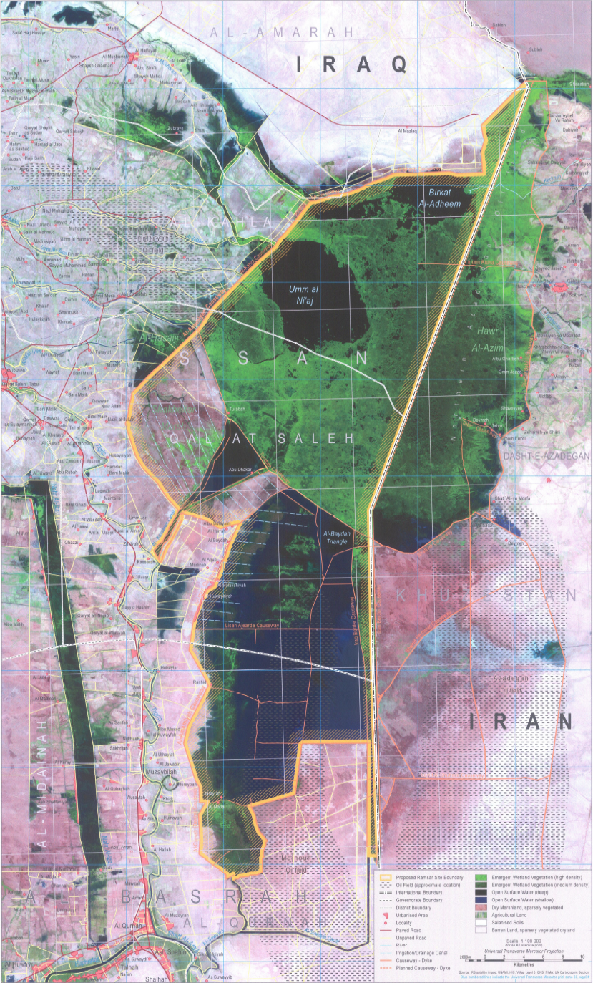
Figure 3 – map of the Hawizeh Marsh Ramsar site in southern Iraq (source: M anagement Plan for the Hawizeh Marsh Ramsar Site of Iraq, 2008)

The Vision for the Hawizeh Marsh is:
Hawizeh Marsh is an integral component of the natural and human landscapes of Iraq and the Middle East, that has for millennia and will continue to provide sustainable livings and a healthy, natural environment with peace and security for generations now and in the future.
The MP set 5 Strategic Goals:
- Maintain the ecological character of the Hawizeh Marsh, focusing on those features that justify its designation as a Wetland of International Importance. These include:
- Represents a marsh ecosystem typical of the Middle East, which is today rare in its geographical setting due to habitat destruction, and a wetland now existing as a relatively natural area and refuge to wildlife;
- Supports an appreciable assemblage of rare, vulnerable and endangered species of plant and animal life, notable migratory and endemic bird species, and is of special interest for maintaining genetic and ecological biodiversity in the Middle East.
- Maintain the natural biological diversity of this area at a landscape, community and species scale.
- Restore wildlife populations and needed habitats for birds, fish and other species at risk.
- Establish a safe, and secure living environment for people living here and using natural resources in this area.
- Promote sustainable economic opportunities for local people in their ongoing use of water, wetland and terrestrial environmental resources in this area.
The Hawizeh Marsh Ramsar has been placed on the Montreux Record by the government of the Republic of Iraq on 28 April, 2010. This is as a result of lowering water level in the marsh due to excessive drainage in the 1990s which subsequent restoration efforts have not been able to fully reverse, the construction of upstream dams that have decreased the flow from the rivers that enter the marsh, a lack of agreement with riparian states over the sharing of water that enters the marsh, all of which has been exacerbated by a decrease in rainfall in the catchment due to climate change.
As of May 2012, the Management Plan of the Hawizeh Ramsar site has not been implemented.

Barzan Tribal Protected Area
The Barzan valley, near the Turkish border on the Greater Zab, is a very important site for Kurds and particularly for the Kurdish Barzani tribe. This area has a long history of tribal governance, and it is particularly important because Barzani tribe established a sort of tribal reserve in this part of Iraqi Kurdistan in the early 20th century. This site is a protected area located on the northeast of Erbil City which represents mountains with woodlands of Oak tree with the presence of some streams. The most important river near to this site is Barzan River which comes from Turkey through Musaka Village then it mixes the water from the Bekhal and Jundyan forming the Big Zab.
In the past decades the Sheikhs of Barzan attempted to enforce certain regulations to maintain a clean environment, that still exist, such as prohibition of:
- Cutting down fruit trees and other trees that stood along the pathways which provided shade for travelers;
- Taking out excessive honey from hives to endanger the bees;
- Killing the non-poisoned snakes;
- Fishing with dynamites;
- Hunting during reproduction seasons; and,
- Killing animals when drinking water.
These regulations were enforced during a period when people during the revolt of 1961-1975 had access to guns, they were firing at Partridges and other animals for fun. The animals were on the verge of extinction, as there lacked a sense of responsibility within people to preserve the environment.
Although Barzan area has not yet been established as a Protected Area under the national legislation, it area is recognized as a regional reserve that is subject to tribal management and control. Due to its important natural and biodiversity values in 2009 this site has been classified as a KBA by the NGO Nature Iraq. Birds of conservation concern are: eastern rock Nuthatch (Sitta tephronota), Finsch’s Wheatear (Oenanthe finschii), Lesser Kestrel (Falco naumani), European Roller (Coracias garrulous), Masked Shrike (Lanius nubicus), and Hooded Crow (Corvus corone cornix).
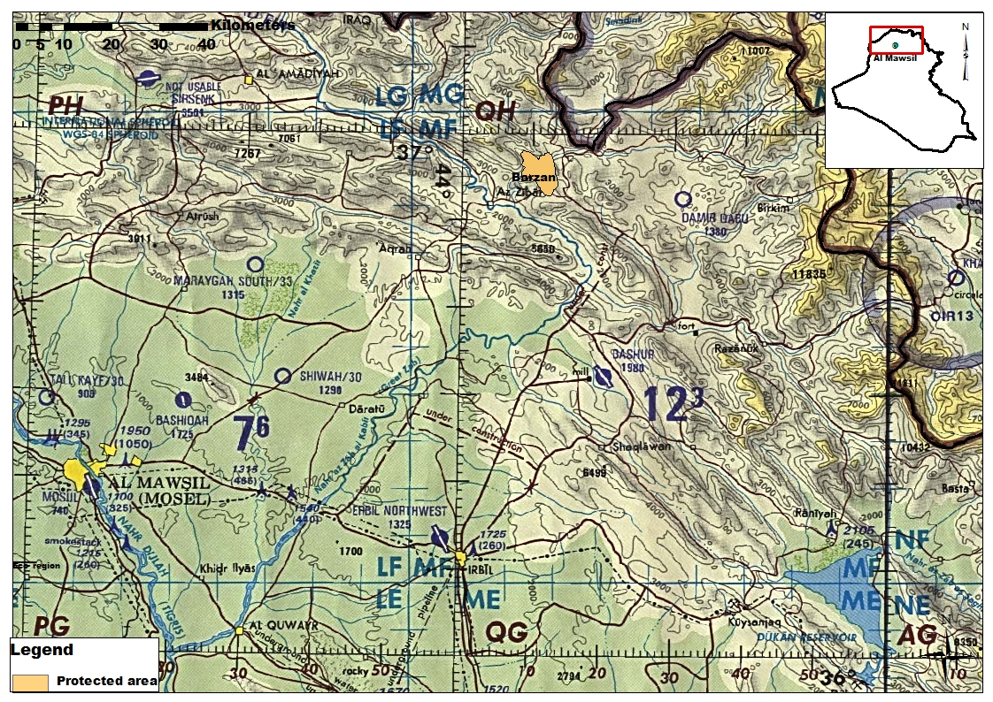
Figure 4 – map of the Barzan KBA site in Iraqi Kurdistan (source: Nature Iraq, 2012)

Among conservation issues the Urbanization (such as road construction) and grazing that have affected some parts of this site are highlighted.

Proposed KBAs and Protected Areas
As set out in Annex 1.

Governance types
In Iraq there is no legislation on Protected Areas. The old Environment Law of 1997 assigned the competence on Protected Areas to the Ministry of Irrigation and Agriculture, but after the institution of the Ministry of Environment in 2010, this law became outdated. In recent years a new institutional framework has been delineated for the management of PAs, with the assignment of the competence on Agricultural Protected Areas to the Ministry of Agriculture and of Natural Protected Areas to the Ministry of Environment. In 2008, the Ministry of Environment submitted a draft Regulation on Protected Areas for to the State Advisory Council for starting the approval procedure. As of May 2012, the legal review process is still ongoing. It is foreseen that the new Regulation on Protected Areas will be approved by the Iraqi Ministers Council not sooner than year 2013.
Although some protected areas have been designated, few protection measures are applied, thus sites often are protected only on paper. The proposed Mesopotamian Marshlands National Park is the most comprehensively studied site. Little information is known about regional and local efforts concerning parks and protected areas. Sites that have informal protection are not delimited and are poorly studied in many cases. Protected Area legislation and support is needed.
Key threats
Main threats to protected areas in Iraq have been partially identified in the fourth national report, as pressure indicators for biodiversity status, some of the most common and widespread in Iraq include: unsustainable fishing and hunting, land mines, oil extraction and mining activities, desertification, agricultural pollution and runoff, infrastructures construction.
 | THREATS | Central Marshes | Hawizeh Marshes | Barzan
 | Agricultural Expansion & Intensification Threats | Low | Low | High
 | Residential and commercial development | Medium | Medium | Medium
 | Energy Production and mining (gravel mining, oil development, electrical towers, etc.) | Medium | High | Low
 | Transportation & service corridors (development of roads and shipping corridors) | Low | Low | Medium
 | Over-exploitation, persecution and control (logging, hunting, over-fishing, etc.) | Medium | Medium | Low
 | Human intrusions and disturbance - Effects related to non-consumption of biological resources – recreational activities, war, military exercises, work and other activities | High | High | Medium
 | Natural systems modification (dams and changes water mgmt, filling in wetlands, drainage, dredging, canalizations | High | High | Medium
 | Invasive or other problematic species | Not evaluated | Not evaluated | Not evaluated
 | Pollution (municipal and industrial waste and garbage, noise, air, light, & thermal pollution). | Medium | Medium | Medium

Barriers for effective implementation
The major obstacles to the effective implementation of Protected Areas in Iraq are:
- Weakness of legal framework
- Financial mechanism
- Lack of technical experience
- Lack of coordination between ministries (horizontal) and between national local government (vertical)
- Lack of information available
- Lack of control and enforcement of existing laws
- Lack of transboundary coordination
- Lack of public awareness.

National Targets and Vision for Protected Areas
The Aichi target of reference is provided: “By 2020, at least 17 per cent of terrestrial and inland water areas, and 10 per cent of coastal and marine areas, especially areas of particular importance for biodiversity and ecosystem services, are conserved through effectively and equitably managed, ecologically representative and well connected systems of protected areas and other effective area-based conservation measures, and integrated into the wider landscapes and seascapes”.
The Table below lists the specific Goals and Targets of PoWPA that are addressed in the present Action Plan:
GOAL OF POWPA |  | TARGET
Goal 1.1 | To establish and strengthen national and  regional systems of protected areas integrated into a  global network as a contribution to globally agreed  goals | By 2010, terrestrially / and 2012 in the marine area, a global network of comprehensive, representative and effectively managed national and regional protected area system is established as a contribution to (i) the goal of the Strategic Plan of the Convention and the World Summit on Sustainable Development of achieving a significant reduction in the rate of biodiversity loss by 2010; (ii) the Millennium Development Goals - particularly goal 7 on ensuring environmental sustainability; and (iii) the Global Strategy for Plant Conservation.
Goal 1.4 | To substantially improve site-based  protected area planning and management | All protected areas to have effective management in existence by 2012, using participatory and science-based site planning processes that incorporate clear biodiversity objectives, targets, management strategies and monitoring programmes, drawing upon existing methodologies and a long-term management plan with active stakeholder involvement.
Goal 1.5 | To prevent and mitigate the negative impacts  of key threats to protected areas | By 2008, effective mechanisms for identifying and preventing, and/or mitigating the negative impacts of key threats to protected areas are in place
Goal 3.1 | To provide an enabling policy, institutional  and socio-economic environment for protected areas | By 2008 review and revise policies as appropriate, including use of social and economic valuation and incentives, to provide a supportive enabling environment for more effective establishment and management of protected areas and protected areas systems.
Goal 3.2 | To build capacity for the planning,  establishment and management of protected areas | By 2010, comprehensive capacity building programmes and initiatives are implemented to develop knowledge and skills at individual, community and institutional levels, and raise professional standards

Progress in and plans for achieving the goals of the Programme of Work on Protected Areas
Progress: 0 = no work, 1 = just started, 2 = partially complete, 3 = nearly complete, 4 = complete

Goals of the Programme of Work on Protected Areas | Progress  0-4
- Progress in establishing and strengthening national and regional systems of protected areas (1.1) | 1
- Progress in integrating protected areas into broader land- and seascapes and sectors so as to maintain ecological structure and function (1.2) | 0
- Progress in establishing and strengthening regional networks, transboundary protected areas (TBPAs) and collaboration between neighbouring protected areas across national boundaries (1.3) | 0
- Progress in substantially improving site-based protected area planning and management (1.4) | 2
- Progress in preventing and mitigating the negative impacts of key threats to protected areas (1.5) | 2
- Progress in promoting equity and benefit-sharing (2.1)  - Progress in assessing and implementing diverse protected area governance types (2.1) | 1
- Progress in enhancing and securing involvement of indigenous and local communities and relevant stakeholders (2.2) | 2
- Progress in providing an enabling policy, institutional and socio-economic environment for protected areas (3.1)  - Progress in assessing the contribution of protected areas to local and national economies (3.1) | 0
- Progress in building capacity for the planning, establishment and management of protected areas (3.2) | 3
- Progress in developing, applying and transferring appropriate technologies for protected areas (3.3) | 0
- Progress in ensuring financial sustainability of protected areas and national and regional systems of protected areas (3.4) | 1
- Progress in strengthening communication, education and public awareness (3.5) | 1
- Progress in developing and adopting minimum standards and best practices for national and regional protected area systems (4.1) | 1
- Progress in evaluating and improving the effectiveness of protected areas management (4.2) | 1
- Progress in assessing and monitoring protected area status and trends (4.3) | 2
- Progress in ensuring that scientific knowledge contributes to the establishment and effectiveness of protected areas and protected area systems (4.4) | 2
- Progress in marine protected areas | 0
- Progress in incorporating climate change aspects into protected areas | 1

Priority activities for fully implementing the Programme of Work on Protected Areas:
Activities | Timeline
- Approve the Law on Protected Areas | 2012-2013
- Establish 10 new PAs by 2020 | 2014-2020
- Establish a set of time-bound and measurable performance indicators for PAs | 2012-2014
(Insert more as needed)

Action Plans (detailed steps) for completing priority activities for fully implementing the Programme of Work on Protected Areas:

  - Activity 1: Approve the Law on Protected Areas
Key steps | Timeline | Responsible agencies | Indicative budget
Follow up with the State Advisory Council on the review of draft Law | 2012 | MOE | ---
Follow up with the General Secretariat of the Ministers Council on the Approval of draft Law | 2013 | MOE | ---
Approval by the Ministers Council | 2013 | Minister Council | ---
Enforcement of the Law | after approval | MOE | ---
Develop Instructions for implementation | 2014 | MOE | ---

  - Activity 2: Establish 10 new PAs by 2020
Key steps | Timeline | Responsible agencies | Indicative budget
Printing and publishing the Inventory of KBA sites of Iraq | 2012 | MOE | 40.000 USD
Preparation of the Management Plan for each proposed site | 2013-2020 | National Committee for PAs | 500.000 USD
Assignment of the Manager of each site and proclamation of PAs | 2013-2020 | National Committee for PAs | Up to 150.000 USD (yearly)
Securing budget for establishment and management and surveillance of each site | 2013-2020 | Ministry of Planning (for public PAs) | TBD

The following table provides a list of 10 KBA sites that have been proposed as future Protected Areas of Iraq.
n. | PROPOSED SITES | ECOREGION
 | Dalmaj | Arabian Desert and East Sahero-Arabian Xeric Shrublands (PA1303)
 | Mosul Lake | Middle East Steppe (PA0812)
 | Peramagroon Mt. | Zagros Mountains Forest Steppe (PA0446)
 | Razzaza Lake | Arabian Desert and East Sahero-Arabian Xeric Shrublands (PA1303)
 | Tharthar Lake | Mesopotamian Shrub Desert (PA1320)
 | West Hammar | Tigris-Euphrates alluvial salt marsh (PA0906)
 | Khor Az-Zubayr | South Iran Nubo-Sindian desert and semi-desert (PA1328)
 | Qara Dagh | Zagros Mountains Forest Steppe (PA0446)
 | Wadi Al-W'eir | Arabian Desert and East Sahero-Arabian Xeric Shrublands (PA1303)
 | Haditha Wetlands & Baghdadi | Mesopotamian Shrub Desert (PA1320)

  - Activity 3: Establish a set of time-bound and measurable performance indicators for PAs
Key steps | Timeline | Responsible agencies | Indicative budget
Capacity building for National Committee for PAs | 2012 | MOE | 25.000 USD
Perform national protected-area capacity needs assessments | 2013 | MOE | 50.000 USD
Establish capacity building programmes for national and local staff on the basis of these assessments including the creation of curricula, resources and programs for the sustained delivery of protected areas management training | 2013-2014 | MOE | TBD
Establish a programme for exchange of lessons learnt, information and capacity-building experiences with neighbouring countries of the Middle East | 2013-2015 | MOE | TBD

(Insert more as needed)

Key assessment results
Ecological gap assessment (insert summary findings if available)

Management effectiveness assessment (Insert summary findings if available)

Sustainable finance assessment (Insert summary findings if available)

Capacity needs assessment (Insert summary findings if available)

Policy environment assessment (Insert summary findings if available)

Protected area integration and mainstreaming assessment (Insert summary findings if available)

Protected area valuation assessment (Insert summary findings if available)

Climate change resilience and adaptation assessment (Insert summary findings if available)

(Insert other assessment results if available)

http://www.worldwildlife.org/science/ecoregions/item1267.html

