Action Plan for Implementing the Convention on Biological Diversity’s
Programme of Work on Protected Areas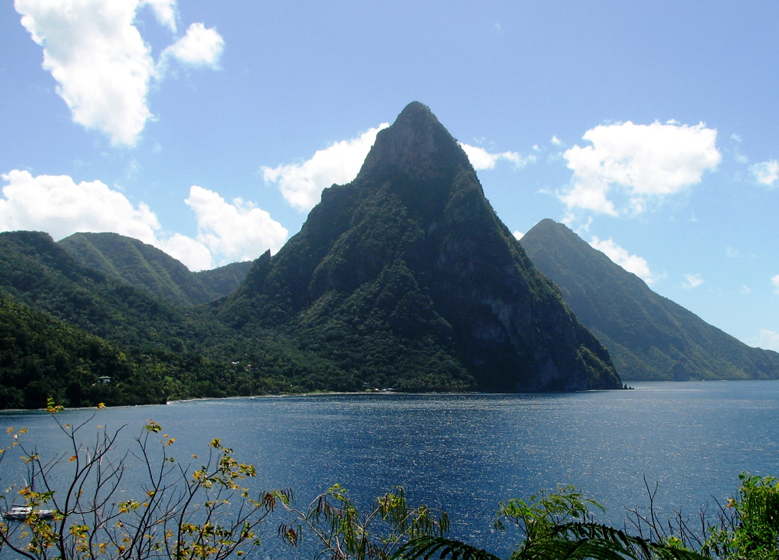
(SAINT LUCIA)

(INSERT PHOTO OF COUNTRY)

Submitted to the Secretariat of the Convention on Biological Diversity [DATE]

Protected area information:

PoWPA Focal Point: (Name, contact details)

Lead implementing agency: (Ministry of Sustainable Development, Energy, Science and Technology)

Multi-stakeholder committee: (Government agencies including Department of Fisheries in the Ministry of Agriculture; Department of Forestry and Piton Management Area Agency in the Ministry of Sustainable Development; and the National Conservation Authority in the Ministry of Social Transformation. Quasi government institution/NGO Saint Lucia national Trust, Add description)

Description of protected area system

National Targets and Vision for Protected Areas

The rationale for this Systems Plan is to provide a framework for the designation, protection and effective management of a comprehensive network of protected areas across Saint Lucia. Protected areas are seen as an essential part of the process of securing a sustainable environmental, social and economic future for Saint Lucia. As part of identifying areas of ecological importance for protection for developing the Protected Area Systems Plan, an Ecological Gap Analysis was conducted. in the absence of site assessments.

The lack of information on the status and distribution of some key habitats and species was a key problem during the gap analysis and resulted in their exclusion from the target list. In some cases, the local knowledge of workshop participants could be used but there remained many gaps in knowledge which were seen as a priority for future research.

The Ecological Gap Analysis generated a list of critical conservation ‘targets’ for Saint Lucia. These ‘targets’ defined ‘the elements of biodiversity and related cultural features that should be the focus of conservation and management planning efforts, encompassing both marine or terrestrial environments’. Local experts attending the workshops then agreed, for each ‘target’, a specific conservation ‘goal’ which represents the minimum level of protection that should be sought. Each ‘target’ was then spatially mapped on a GIS system so that it could be manipulated using Marxan software.

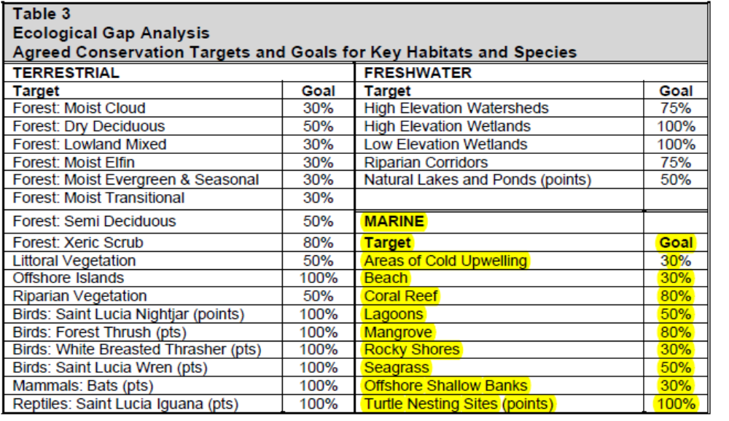

Coverage Marine Management Areas

It is proposed that three Marine Management Areas (MMAs) should be established along Saint Lucia’s Coastline: i.e. East Coast MMA, Laborie MMA and West Coast MMA. Collectively, these would encompass approximately 70% of this coastline. In addition, it is proposed that a Marine Management Area should be declared over the core of the ‘Cold Upwelling’ off the west coast, which is understood to be of critical importance to the productivity of the island’s west coast fisheries (see Map 1).

The process of developing this Systems Plan has revealed that there are significant gaps in the bathymetric data for the seas around Saint Lucia. Marine specialists have indicated that the seaward boundary of the three coastal MMAs should extend to 75 metres in depth or 300 metres from high water, whichever is the greater. This criterion also applies to the extent of the MMA around offshore islands. At the present time, there is insufficient bathymetric data to plot this line. Therefore, Map 1 includes a provisional seaward boundary at a standard distance of 500 metres from high water, both from the mainland and around offshore islands. It is believed that in most areas, and especially on the west coast, this will encompass all of the proposed MMA plus a buffer. This line should be treated as the temporary boundary of the MMA until such time as bathymetric data is available which allows the correct 75 metre/300 metre boundary to be plotted.

- East Coast Marine Management Area
The East Coast MMA extends from Pigeon Island in the north and along the east coast to Mathurin Point near the southern tip of the island. From a point just to the north of Giromon Point in Anse Louvette Bay to the Fond D’Or River in Fond D’Or Bay, this MMA forms a part of the Iyanola National Park.

The east coast of Saint Lucia tends to be quite considerably shallower than the west coast and therefore, this MMA is likely to extend a greater distance out sea than in the other two coastal MMAs. The presence of several offshore islands along this east coast (e.g. Dennery Island, Praslin Island, Scorpion Island and the Maria islands) will tend to accentuate this. The MMA is believed to encompass all or a part of 12 Marine Reserves, most of which are of importance for the protection of mangroves and turtle nesting beaches:
• Marquis Mangroves Marine Reserve
• Anse Pointe Sable - Mankoté Marine Reserve
• Maria Islet Reef Marine Reserve
• Savannes Bay Mangrove Marine Reserve
• Esperance Harbour Mangrove Marine Reserve
• Praslin Mangrove Marine Reserve
• Fond d’or Beach and Mangrove Marine Reserve
• Louvette Mangrove Marine Reserve
• Grand Anse Beach and Mangrove Marine Reserve
• Cas-en-bas Mangrove Marine Reserve
• Moule-a-Chique Artificial Reef Marine Reserve
• Caesar - Mathurin Reefs Marine Reserve

- West Coast Marine Management Area

The West Coast MMA extends from Marigot Point in the north to near Morne Sion in the south (a point that is coincident with the southern boundary of the Pitons National Park). From the southern edge of Canaries to Morne Sion, the MMA forms part of proposed Pitons National Park.

The seabed along this west coast slopes quite steeply and therefore the 75 metre depth contour is likely to be quite close to the shore. Once detailed bathymetric surveys have been completed, it is likely that a significant part of the MMA boundary will be pulled back to 300 metres from high water. The MMA is believed to encompass all or part of 8 Marine Reserves, all of which are of importance for the protection of natural or artificial reef ecosystems:
• Anse Cochon Artificial Reef Marine Reserve
• Anse Galet Reefs Marine Reserve
• Rachette Reefs Marine Reserve
• Anse Chastenet Reefs Marine Reserve
• Rachette Reefs Marine Reserve
• Petit Piton Reefs Marine Reserve
• Gros Piton Reefs Marine Reserve
• Anse la Verdure Artificial Reef Marine Reserve

The MMA also encompasses two Local Fisheries Management Areas (LFMAs): the Soufriere LFMA and the Anse la Raye/Canaries LFMA.

- Laborie Marine Management Area

The Laborie MMA includes the section of the south coast between Laborie and Choiseul. There is relatively little information about marine ecosystems along this coast but is believed that there are extensive areas of significant conservation interest. Survey work is required to confirm the nature and extent of the area of interest.

This MMA does not include any existing Marine Reserves but one area from Laborie Bay to the mouth of the River Dorée has been flagged up as a potentially important reef which warrants further research and could potentially be worthy of designation as a Marine Reserve.

- Cold Upwelling Marine Management Area

This MMA covers an extensive area to the west of Saint Lucia which is understood to be of significant importance for the fishing industry as an upwelling of mineral rich waters.

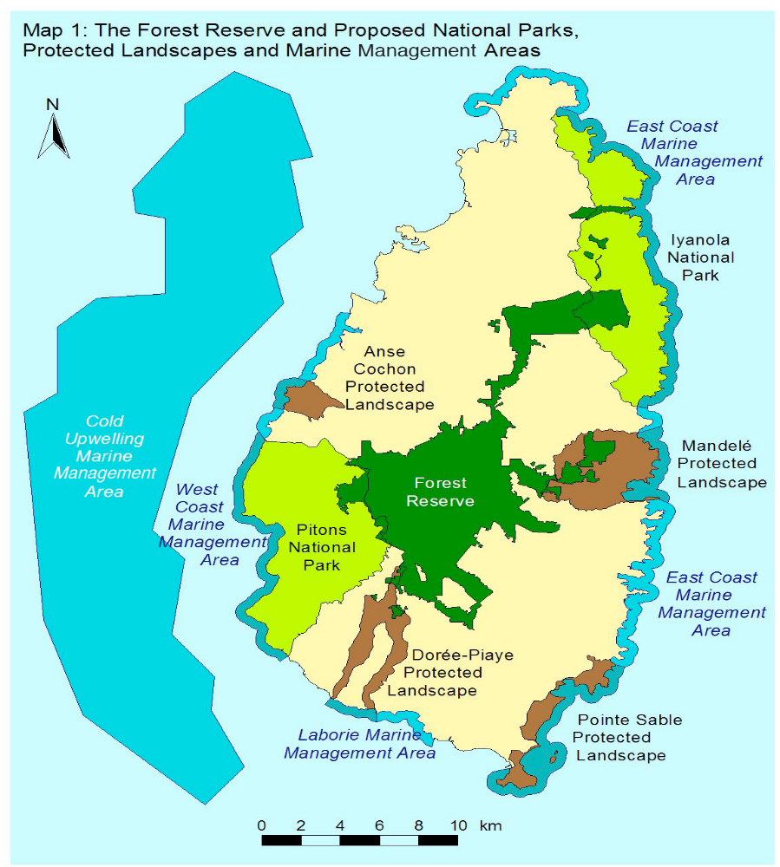
Terrestrial Protected Areas
Forest Reserves and Protected Forests
There are currently 12 Forest Reserves and 24 Protected Forests covering about 15% of the island. The Forest Reserves generally to occupy the centre of the island at higher elevations, whilst the Protected Forests tend to form a buffer around the periphery. The majority of these Forests form a single contiguous unit with a large central core and ‘spurs’ running towards the north-east coast (the Castries Waterworks Reserve) and the east coast (Dennery Waterworks Reserve). There are also a small number outliers, primarily in the north east quarter of the island (e.g. Marquis Forest Reserves).

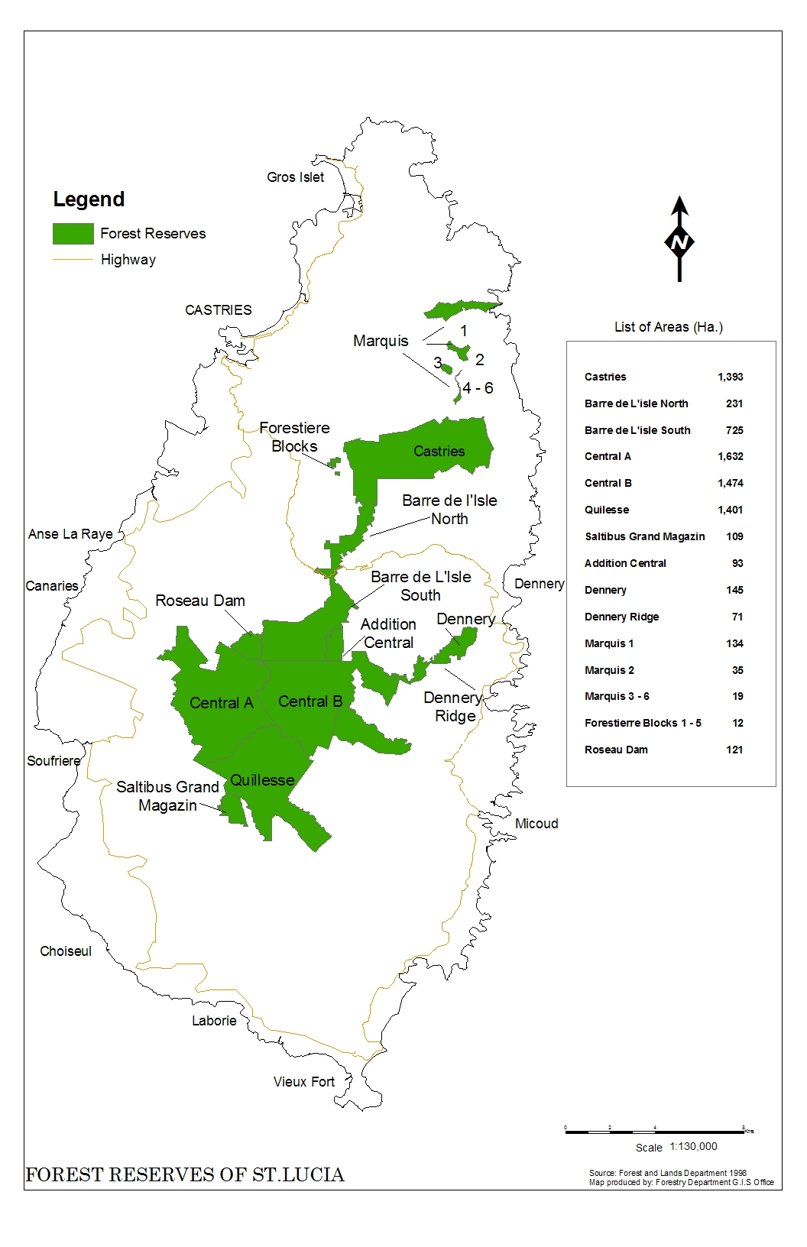
LOCATION | Hectares
Barre D'Isle North | 373
Barre De Isle South | 840
Castries Waterworks | 1425
Central Forest A | 1913
Central Forest B | 1609
Dennery Ridge | 168
Dennery Waterworks | 145
Fond Estate acquisition | 350
Forestiere Blocks | 24
Marquis 1 | 133
Marquis 2 | 35
Marquis 3 | 15
Marquis 4-6 | 11
Quilesse | 1518
Roseau Dam | 154
Saltibus Grand Magazin | 338
Area | 9051

These forests encompass a wide range of rich and diverse habitats which support many rare and endemic species such as the St Lucia parrot (Amazona versicolor). They also fulfill an extremely valuable function in controlling run-off and soil erosion, providing a sustainable source of timber, and ensuring a clean and reliable source of water for the island’s people.

Small sections of the Forest Reserve lie within other proposed protected areas:

• the eastern section of the Marquis Forest Reserve lies within the proposed Iyanola National Park

• the western edge of the Central Forest Reserve cuts into the proposed Pitons National Park;

• the eastern section of the Dennery Waterworks Reserve lies within the proposed Mandale Protected Landscape

It is understood that the Forestry Department is currently investigating opportunities to increase the number of Protected Forests. This is to be commended since it will expand and strength the network of forests that are sustainably managed and which further the interests of wildlife and landscape conservation.

National Parks
It is proposed that two National Parks should be designated: the Pitons National Park in the south west and the Iyanola National Park in the north east (see Map 1). In addition to the land areas, both of these National Parks include the Marine Protected Areas along their coastal boundaries.

Alongside the Forest Reserve, these National Parks would represent the ‘jewels in the crown’ of St Lucia’s protected area network and will serve not only to protect some of the island’s finest landscapes and ecosystems but will also provide the foundation for a new, more sustainable approach to the development of its tourism market.

(a) Pitons National Park
The proposed Pitons National Park encompasses two of the National Parks proposed in the 1992 Systems Plan (Qualibou and Canaries), together with the intervening area around Bouton and Blanche Point. It also includes the section of the proposed West Coast Marine Protected Area [see (d) below] between the Park’s northern boundary at the Canaries River and its southern boundary near Morne Sion.

The southern section of the Park encompasses the spectacular, iconic and world famous landscapes around Gros Piton and Petit Piton, the active volcanic site at Sulphur Springs, and St Lucia’s highest mountain, Mount Gimie. The topography is one of steep sided hills and deep valleys, with the vegetation cover being mostly secondary forest, although some areas of primary forest, including rainforest and elfin woodland, still exist. Along the coast, the land drops precipitously into the sea to either side of the sheltered and sandy bay at Soufriere. Most of the population of the Park lives in the town of Soufriere, St Lucia’s former capital, although there are a number of smaller settlements in the valleys that run inland from Soufriere. Much of this southern section of the Park has been designated as a World Heritage Site

The northern section of the Park is centred on the valley of Canaries River and is characterized by a landscape of high and inaccessible forests cut through by deep canyons running down to the island’s rugged west coast. The vegetation cover is mostly secondary subtropical wet forest and rain forest, with elfin woodland at the highest elevations. The main centre of population is the coastal village of Canaries, which lies just outside the northern boundary of the Park and is linked to Soufrieres by the west coast highway. Compared to many parts of the west coast, this area has few roads and a relatively small population, and retains a strong sense of wilderness, tranquility and naturalness.

This Park includes all of the current Pitons Management Area: this designation should be rescinded, concurrently with the designation of the National Park.

The marine section of the Park (also designated as a Marine Protected Area) encompasses the Soufriere Local Fisheries Management Area (LFMA) and the Canaries/Anse la Raye Local Fisheries Management Area. These FMA designations should be retained and hopefully, in due course, the success of Soufriere Marine Management Association in promoting the sustainable management of the Soufrieres LFMA can be rolled out to the Canaries/Anse la Raye LFMA and to other sections of St Lucia’s coastline, especially those within the proposed Marine Protected Areas.

The pressures upon the area encompassed by the Pitons National Park are immense, especially from large/medium scale tourism development. The attractiveness of this area as an international tourism destination stems from the natural beauty and unspoilt character of its landscapes combined with its atmosphere of peace and tranquility. These qualities are now under threat from the tourism pressures that they generate and unless this issue is addressed, the economic, environmental and social consequences could be irreversible.
Other threats to the character and quality of this area arise from:
• marine pollution, primarily from runoff/siltation and untreated/inadequately treated waste water;
• tree felling, land clearance for agriculture, and deforestation;
• unregulated expansion of settlements and new developments in hitherto undeveloped areas
(b) Iyanola National Park
The proposed Iyanola National Park encompasses three of the designated areas proposed in the 1992 Systems Plan: Grande Anse National Park, Esperance Protected Landscape and Fond D’Or Protected Landscape. It also extends further inland near Babonneau and Marquis so as to encompass critical ecosystems omitted from the 1992 designation and to create a protected area with a greater measure of coherence and integrity.
This National Park covers an area of approximately 5090 hectares in the north east of the island (see Map 1) and will serve to protect the only extensive area of undeveloped coastline remaining in St Lucia. This area encompasses most of the island’s intact dry forest ecosystems and is critical to the continued survival of some of its most rare and threatened endemic species, most notably iguanas and turtles.
The Park is characterized by rolling hills, steeps cliffs and deeply incised bays. The dry forests of this area create a very distinctive landscape which contrasts sharply with the wetter and more tropical forests in the south and west of the island. The sandy beaches of the major bays, such as Fond D’Or and Grand Anse, are of national importance, not only for their natural beauty but also because they are the islands two most important breeding sites for sea turtles. Despite its proximity to the major population centres and tourist areas of the north west coast, this area has few roads or settlements, no tourism infrastructure development and is subject to minimal tourism pressure, except occasional wildlife tours and safaris. There are relatively few areas of cultivated land and the main activities are fishing and extensive livestock grazing.
With increasing pressures for tourism development in St Lucia, this area is already being seen as a potential growth area. In terms of creating a genuinely sustainable tourism product, to submit to these pressures would be a major step backwards. The establishment of this National Park offers perhaps the last opportunity to safeguard this beautiful and untouched area for future generations. This could provide local communities within and around the Park with the opportunity to promote genuinely environmentally friendly patterns of recreation and tourism activity that provide social and economic benefits without adverse impacts on the quality and character of the environment.
Protected Landscapes
It is proposed that four Protected Landscapes should be designated: Anse Cochon, Dore-Piaye, Mandale and Point Sable (see Map 1). In addition to the land areas, all of these Protected Landscapes include the Marine Protected Areas along their coastal boundaries.

The 1992 Systems Plan proposed the designation of 4 National Parks and 10 Protected Landscapes. Some of these areas have been incorporated in the Pitons National Park and the Iyanola National Park, whilst others are retained as one of the four Protected Landscape proposed in this Systems Plan and described below. It is important to recognize, however, that several of the 1992 Protected Landscapes are no longer worthy of designation, due primarily to the impact of tourism and residential development; e.g. Anse Galet, Marigot, Bois D’Orange and Fairview. In other cases, the Protected Landscapes are retained but it is clear that their character and quality has been eroded over the intervening 17 years. The message appears to be clear: that failure to designate and statutorily protect the National Parks and Protected Areas identified in this Plan will inevitably lead to further losses in the future.
(a) Anse Cochon Protected Landscape
The Anse Cochon Protected Landscape comprises 410 hectares of land to the south of Anse la Raye on the west coast. The area is characterized by rolling hills covered with scrub vegetation and rising to about 650 feet in altitude, that are cut through by the valleys of the Anse Galet and Anse Cochon rivers. There are no major settlements, except the Ti Kaye tourist resort at Anse Cochon, and the area is bisected by the west coast highway.
The accessibility of this area, its proximity to Anse la Raye and the popularity of the reefs for diving are all putting pressure on this area and, without protection and effective management, there are significant risks that there will be a gradual attrition of the intrinsic beauty, biodiversity (both marine and terrestrial) and tranquility of this area.
(b) Dore-Piaye Protected Landscape
The Dore-Piaye Protected Landscape is 1120 hectares in area and comprises the twin valleys of the River Dore and the River Piaye which both run down from Mount Grand Magazin to the south coast. These valleys are steep sided and densely wooded and contain some of the most diverse and intact natural ecosytems on the island, including many rare and endangered plant and animal species.
The area has a good network of roads and includes several villages such as Saltibus, Doree and Gertrine. However, the main areas of ecological importance are the more inaccessible and deeply incised river valley where there are few settlements and development and agricultural pressures are limited.
(c) Mandelé Protected Landscape
The proposed Mandelé Protected Landscape is 2060 hectares in extent and is roughly circular in outline, including the section of coastline from Martelly Point in the south to the Dennery River in the north. The landscape of gentle rolling hills is characterized by dry deciduous forest and scrub vegetation which supports the largest surviving population of white breasted thrasher – one of St Lucia’s most distinctive and endangered bird species. The area also encompasses a large part of the Dennery Waterworks Forest Reserve and several sites of historic and cultural significance. The marine area is quite shallow, with some small reef patches and an extensive mangrove in Praslin Bay.
In recent years consent has been given for a major golf course and hotel/villa development at Praslin: this is still in its early stages of construction. The inclusion of this site within the proposed Protected Landscape is justified on the grounds that the area still retains significant ecological interest and is critical to the ecological and geographical integrity of the Protected Landscape. It is also hoped that the designation will lend weight to arguments that the development and future management of the area should give greater weight to the protection of terrestrial and marine habitats and the area’s visual appearance.
(d) Point Sable Protected Landscape
The proposed Point Sable Protected Landscape is a narrow strip of coastline at the south-eastern tip of the island, stretching from the Canelles River in the north to the Moule a Chique peninsula in the south. The terrestrial component is characterized by long sandy beachs, tropical dry forest and open grassland, interspersed with coconut groves, scrub and mangroves – with the latter including the Savannes Bay and Man Kote mangroves which are St Lucia’s only two RAMSAR sites. Offshore, the seas are shallow and encompass several coral reefs, an offshore sand bank, Scorpion Island and the Maria Islands. The Maria Islands support two endemic species that occur nowhere else in the world: the kouwès (a grass snake Liophis ornatus) and the zandoll tè (Maria islands ground lizard Cnemidophorus vanzol).
The population of this area is low, with the main activities being livestock grazing, fishing and recreation. The Coconut Beach Hotel, just to the north of Hewanorra Airport is the only major tourism development, although Anse de Sables to the south is popular for day trips, picnic and watersports. The presence of shallow seas and long sandy beaches backed by a flat coastal plain means that the area is potentially a prime site for hotel development and it is understood that, in recent years, a number of proposals have been put forward.
The proposed Protected Landscape is virtually identical to the Point Sable Environmental Protection Area, although the boundaries of the latter have yet to be finally defined. The establishment of the Protected Landscape would mean that the EPA designation should be rescinded.

Vegetative Classes
Cloud Montane Rainforest
This vegetation class is found on the high summits of the Mount Gimie range, including Piton Troumassée (although not in the most windy spots), at an elevation of 700m or higher and possibly the eastern interior end of Mount Tabak ridge and a small area on the western end of the La Sorciere ridge (Figure 30b). The canopy is about 8m high with occasional much taller trees of Freziera undulata. Terrestrial ferns, anthuriums, bromeliads, and epiphytes are very common; moss cover is often several centimetres thick (Figure 31a). Cloud and mist cover, with heavy rainfall, is predominant, with only occasional and short periods of sunshine.

Deciduous Seasonal Forest
This vegetation class covers large areas in Saint Lucia from the coast to the summit of Petit Piton, although it is virtually all secondary and much of it degraded. It merges inland with the Semi-evergreen Seasonal Forest: the upper slopes of high hills are often covered by Deciduous Seasonal Forest and their lower slopes, leading to ravines, covered by Semi-evergreen Seasonal Forest
This class is defined as deciduous because the taller trees tend to lose all their leaves in most dry seasons, although the smaller trees and shrubs are evergreen. Its overall appearance during a normal dry season is of a more or less leafless canopy. There is no moss or cover of ground ferns. Vines and herbaceous ground cover are present, particularly in the more disturbed areas, where more light passes through canopy during the wet season. This forest class reaches an elevation of 700m on Petit Piton
Littoral Evergreen Forest and Shrubland
Behind sandy beaches, rocky cliffs and pavements, an evergreen forest or shrubland is found, especially on the Atlantic coast. The harsh conditions caused by wind, salt-spray, often a thin soil and a water deficit even during most of the wet season, favour an evergreen arborescent flora with thick leathery leaves. Coccoloba uvifera (wézen, siwiz, sea grape) is commonly present in this vegetation class.
Littoral Scrub, With or Without Cacti
This type of vegetation is found in a narrow zone between littoral rock and cliff vegetation and Deciduous Seasonal Forest or Littoral Evergreen Forest. It consists of shrubs, cacti and sometimes grassy spaces.
Littoral Unconsolidated Sand Vegetation
Mainly herbaceous, salt-tolerant vegetation, growing on loose sand on beaches and adjacent low dunes. The pioneer species are trailing rooting herbs, with succulent species slightly further inland. In some locations, shrubs appear on low sand dunes a few metres inland of high tide
Semi-evergreen Seasonal Forest
Synopsis
Semi-evergreen Seasonal Forest occupies the zone between Deciduous Seasonal Forest and Lower Montane Rainforest. It is characterized by upper canopy trees with rather thin, often broad, and quite often compound leaves, which may lose some, but not all, of their leaves during a dry spell. There are no, or very few, epiphytes, ground ferns and mosses. Elevation ranges from almost sea-level in ravines to the summit of Gros Piton.
In comparison with Deciduous Seasonal Forest, this forest class has a higher canopy and greater canopy cover and trunks with a greater girth. It occurs in less windy areas, and generally at a higher elevation.

Lower Montane Rainforest
Lower Montane Rainforest merges with Semi-evergreen Seasonal Forest at lower elevations and with Montane/ Cloud Montane Rainforest at higher elevations. Trees are evergreen because there is no water deficit most years in any month. In general, trees of all heights are found, without clear divisions into separate canopy layers. Although there may be a shrub, fern and herbaceous (mainly Anthurium) ground cover, this forest class is easy to walk through (if one ignores the incline) except where the canopy has been destroyed and ferns, vines and shrubs colonise the clearing.
In comparison to Semi-evergreen Seasonal Forest, the mean canopy height, wind, and incline are greater and there is a greater abundance of vines, epiphytes, ferns and mosses. The trees are more tightly packed, and the trees can be much wider in girth. This forest class has been recorded from 100-680m above sea level.
Montane Rainforest
Montane Rainforest is on the western side and sheltered eastern slopes of the Mount Gimie Range, including Piton Troumassée, above 650m. Slopes are extremely steep, rainfall is very heavy, there is little wind and landslides are very common. The steepest areas are covered with tree ferns and palms, with canopy height of about 4-6m, with some scattered taller trees on slightly less steep areas
Elfin Shrubland
In the windiest spots on the Mount Gimie/ Troumassée ridges and peaks, at an elevation above 700 metres, a shrubland vegetation class dominates. The canopy is up to 2m tall, but often less, with an occasional slightly taller Prestoea acuminata palms. Cloud and mist cover, with heavy rainfall, is predominant with occasional short periods of sunshine
Relatively few species are found in this vegetation type: mainly a mixture of bromeliads, sedges and grasses and shrubs, with many Lesser Antillean endemics.

Description and background
Marine
The inshore waters of Saint Lucia encompass some exceptionally diverse and productive marine ecosystems which are not only of intrinsic ecological value but are also a vital recreational resource and are of critical importance in supporting the livelihoods of those involved in the fishing and tourism industries. The purpose of the Marine Management Areas (MMAs) will be to safeguard those marine areas that are considered to be of a high quality and/or threatened by coastal development. The key objectives of Marine Management Areas are:
- promoting the conservation and sustainable use of marine resources;
- safeguarding the biodiversity, quality and productivity of marine ecosystems;
- facilitating public enjoyment of the area’s special qualities, provided this does not conflict with the above objectives;
- raising understanding and awareness of marine ecosystems.
Marine Reserves are designated under Section 22 of the Fisheries Act, No. 10, 1984 and can be declared both over ‘fishery waters’ and ’any adjacent or surrounding land’. This provision has allowed the Marine Reserve designation to be applied not only to reefs and other marine habitats but also to mangroves and beaches. The purposes of Marine Reserves, as defined by the 1984 Act, are:
- to protect flora and fauna (especially species in danger of extinction);
- to protect the breeding grounds and habitats of aquatic life;
- to allow the regeneration of depleted species;
- to promote scientific study and research and
- to preserve areas of natural beauty.

Terrestrial
Saint Lucia‟s terrestrial protected areas perform essential functions in safeguarding and regulating the island‟s water supply, preventing soil erosion and landslides, storing carbon, and supporting the country‟s present and future renewable fuel supply. The forests also support, and are maintained by, a rich diversity of animals and plants, many of which are unique to this island.
Saint Lucian endemic species |  | Indigenous  species |  | Alien  species |  | Total  species
Seed-bearing plants | 10 |  | 1,009 |  | 282+ |  | 1,291
Ferns | 0 |  | 138 |  | 7 |  | 145
Mammals | 1 (+1 subsp.) |  | 10 |  | 7 |  | 17
Birds | 5 (+13 subspp.) |  | 132 |  | 2 |  | 134
Reptiles | 7 (+5 subspp.) |  | 13 |  | 6 |  | 19
Amphibians | 1 |  | 2 |  | 3 |  | 5
Butterflies & Moths | ? |  | 84+ |  | ? |  | 84+
Beetles | 154 |  | 793+ |  | 39+ |  | 832
Dragonflies | 0 |  | 26 |  | 0 |  | 26
Flies | 19 |  | c.134 |  | ? |  | 134
Total species | 197 |  | >2,341 |  | >346 |  | 2,687

Governance types
(Summary matrix of governance types)
Governance typed based on IUCN Categories

 | GOVERNANCE TYPE | Governance by Government | Shared Governance | Private Governance | Governance by Indigenous People
AREA
PSEPA  - Savannes Bay  - Mankote Mangrove  - Maria Island Marine Reserve |  |  | Ministry responsible for Fisheries.  Saint Lucia National Trust NGO/Membership Organization.
SMMA/CAMMA |  |  | Ministry responsible for Fisheries.  Soufriere Marine Management Association
Marine Reserves  Marine Management Areas |  | Ministry responsible for Fisheries.
Forest Reserves |  | Department of Forestry | Department responsible for Forestry

Key threats
(Description of key threats, and maps, if available

Key threats include:

Human Induced Direct Threats:

Poorly planned and uncontrolled development, which would include:

- marine pollution, primarily from runoff/siltation and untreated/inadequately treated waste water and sewage;
- high level of indiscriminate disposal of solid waste along roadside, rivers and coastal areas.
- unregulated construction and dredging along coastal areas, unregulated beach nourishment activities so as to meet the growing demand of the tourism market.
- illegal sand mining activities.

Encroachments
- Construction of hotels, restaurant facilities, public laundries and other infrastructure on beaches with little consideration to the dynamics of habitat types continues to result in the degradation and loss of shorelines.

Exploitation

Uncontrolled exploitation of marine and coastal resources is the prime cause of biodiversity loss;
- nearshore fisheries and habitats are under considerable stress from pollution and this is compounded by fishing pressures;
- illegal exploitation, such as unapproved foreign fishing, fishing in marine reserves, collection of coral souvenirs and use of illegal fishing methods results in the loss of species and habitat diversity.

Management of Human Resources
- Growth in the tourism sector has created a high demand for diving, snorkeling and other water based and fishing with little regard to carrying capacities and sustainable yield. This drastically conflicts with the concept of sustainable development.
- Efforts to manage marine and coastal resources are many but with the lack of manpower and adequate facilities results in inadequate enforcement.
- Inadequate education and public awareness is the prime reason for persons having negative attitudes towards management regulation. The idea that the sea is “common property” where everything is free for all and the resources are endless often comes to the forefront.
Political Issues
- While the Government recognizes that there is a number of threats to its natural resources, the ever increasing economic pressure to provide the basic needs, such as jobs and services, has led to the sacrifice of some the island’s natural resources and has put the remainder at risk of development
Global Threat
- Global climate change is one of the major long- term challenges. The anticipated global warming and consequent changes in sea level, sea surface temperature, wind and water currents have serious implications for small island states like Saint Lucia, where economics depend heavily on their coastal resources.
- General Assessment of Threats to Saint Lucia‟s Forested Areas (Daltry – Biodiversity Assessment )
 |  |  |  |  |  | Score
 |  |  |  |  |  | Outside Forest Reserves
1. RESIDENTIAL AND COMMERCIAL DEVELOPMENT
Housing and Urban Areas |  |  |  | 0 |  |  |  |  |  | 3  Urban development plans in North East quarter (deciduous seasonal forests).
Commercial and Industrial Areas |  |  |  | 0 |  |  |  |  |  | 2  Cul de Sac (important wetland and freshwater swamp forest) at risk. Landfill in Deux Glo.
Tourism and Recreation Areas |  |  |  | 1 |  |  |  |  |  | 3  Le Paradis development, marinas, high-footprint developments planned at Louvet and Grande Anse.
2. AGRICULTURE & AQUACULTURE
Annual and Perennial Non-Timber Crops |  |  |  | 2  Marijuana gardens in secondary forest in Forest Reserves. |  |  |  |  |  | 3  Conversion of mid-level forests [lowland montane rainforest and semi-evergreen seasonal deciduous forest] to gardens.
Wood and Pulp Plantations |  |  |  | 1  Selective and well-managed. |  |  |  |  |  | 0
Livestock Farming and Ranching |  |  |  | 1  Some problems in Northern Range. |  |  |  |  |  | 3  Free-ranging cattle and pigs are a major problem in places such as Grande Anse.
Marine and Freshwater Aquaculture |  |  |  | 0 |  |  |  |  |  | 0
3. ENERGY PRODUCTION AND MINING
Oil and Gas Drilling |  |  |  | 0 |  |  |  |  |  | 1  Proposed oil refinery.
Mining and Extraction |  |  |  | 1  Soil mining. |  |  |  |  |  | 2  Quarries, soil mining and, on beaches, sand mining (affecting turtle nesting beaches e.g. Grande Anse.
Renewable energy |  |  |  | 0 |  |  |  |  |  | 1  Geothermal exploration in Sulphur Springs.
4. TRANSPORTATION AND SERVICE CORRIDORS
Roads and Railroads |  |  |  | 3  Proposed tunnel at Barre de Lisle. |  |  |  |  |  | 3  Ravine poison disaster during road construction in 1965.
Utility Lines |  |  |  | 1  (monitored) |  |  |  |  |  | 1  (monitored)
Shipping Lanes |  |  |  | 0 |  |  |  |  |  | 0
Flight Paths |  |  |  | 2  Helicopter tours over island disturb parrots during breeding season. |  |  |  |  |  | 1  Helicopter tours disturb parrots.
5. BIOLOGICAL RESOURCE USE
Hunting and Collecting Terrestrial Animals |  |  |  | 2  Species targeted included protected species e.g. agouti (non-native), opossum (non-native) and birds. The full extent and intensity is not known. |  |  |  |  |  | 2  As left.
CATEGORY/  Subcategory | Score
Gathering Terrestrial Plants and Plant Products |  |  | 2 - 3  Collection of gum resin (Dacryodes excelsa), vines, bamboo, poles (for making brooms), and latannyé palm leaves (to make brooms). Score of 3 specifically given to collection of L’encens, Protium attenuatum resin, which can kill the tree. |  |  |  |  |  | 2  Collection of gum resin (Dacryodes excelsa), vines, bamboo, poles (for making brooms), and latannyé palm leaves (to make brooms).
Logging |  |  | 1  Some harvesting of poles. |  |  |  |  |  | 3  Harvesting of mangroves e.g. Mankòtè (Pointe-Sable National Park)
Fishing and Aquatic Resource Harvesting |  |  | 2  Use of toxins to poison water sources to catch crayfish and fish. |  |  |  |  |  | 2  Use of toxins to poison water sources to catch crayfish and fish.
6. HUMAN INTRUSIONS AND DISTURBANCE
Recreational Activities |  |  | 1  Risks from fires |  |  |  |  |  | 2  e.g. cooking fires on offshore islands and beaches presents a risk of forest fires.
Work and Other Activities |  |  | 2  Eradication of marijuana fields. |  |  |  |  |  | 2
War, Civil Unrest and Military Exercises |  |  | 0 |  |  |  |  |  | 0
7. NATURAL SYSTEM MODIFICATIONS
Fire & Fire Suppression |  |  | 1  As right, but less frequent. |  |  |  |  |  | 3  Linked to recreation and agriculture. Some deliberate burning in specific areas
Dams & Water Management/Use |  |  | 1 |  |  |  |  |  | 3  e.g. for golf courses. Private lands with their own water sources are at a high premium.
Other Ecosystem Modifications |  |  | 0 |  |  |  |  |  | 3  Diversion and desilting of rivers, drainage of swampy areas impacting on bird life. Hotel developments; quarrying – all impacting on wildlife. [NB some duplication with categories above]
8. INVASIVE AND OTHER PROBLEMATIC SPECIES AND GENES
Alien Invasive Species – animals |  |  | 3  Feral pigs, mongooses, feral cats, rats. Also alien anole lizard (Anolis wattsi) displacing native anole lizard (Anolis luciae). |  |  |  |  |  | 3  Feral pigs, mongooses, feral cats, rats. Also alien lizard (Anolis wattsi) replacing native lizard. Alien green iguana (Iguana iguana) threatens native iguana. Feral monkeys?
Alien Invasive Species – plants |  |  | 1  Bamboo |  |  |  |  |  | 3  e.g. Coccinia grandis and the glue tree Cordia obliqua.
Problematic Native Species |  |  | 0 |  |  |  |  |  | 2  Saint Lucia amazon parrot raids fruit farms. Bats are a nuisance in houses. Shiny cowbird impacts other birds.
Introduced Genetic Material |  |  | 0 |  |  |  |  |  | 0
Species Hybridization |  |  |  |  | 0 - 3  (Score of 3 specifically given to alien green iguana, which has potential to hybridize with the endemic iguana)
9. POLLUTION
Household Sewage and Urban Waste Water |  |  | 0 |  |  |  |  |  | 3  Affects mangroves and rivers, harming aquatic life.
Industrial and Military Effluents |  |  | 0 |  |  |  |  |  | 1  Pumice mining and minor industrial chemical waste
Agricultural & Forestry Effluents |  |  | 1 |  |  |  |  |  | 3  Agrochemicals, especially on banana plantations. Effluent from pig and poultry farms.
Garbage & Solid Waste |  |  | 2 |  |  |  |  |  | 3  Block drains and causes flooding. Associated with rodents.
Airborne Pollutants |  |  | 0 |  |  |  |  |  | 0
Excess Energy (heat, light, noise etc) |  |  | 0 |  |  |  |  |  | 1  [Participants cited helicopter noise, but this was covered under category 4]
10. GEOLOGICAL EVENTS
Volcanoes |  | 1  Potentially massive threat, but unlikely/ infrequent. |  |  |  |  |  | 1  Potentially massive threat, but unlikely/ infrequent.
Earthquakes and Tsunamis |  | 0  Potentially big threat, but unlikely/ infrequent. |  |  |  |  |  | 0  Potentially big threat, but unlikely/ infrequent.
Landslides and Avalanches |  | 1  Natural hazard |  |  |  |  |  | 2  Exacerbated by human activities.
11. CLIMATE CHANGE AND SEVERE WEATHER
Habitat Shifting and Alteration |  | 3  Climate Change could/will lead to changes in habitats and hence species composition, including loss of montane habitats (and their species). |  |  |  |  |  | 3  Climate Change could/will lead to changes in habitats and hence species composition, including loss of montane habitats (and their species).
Climate Variability |  | 2  Causes change in species composition. |  |  |  |  |  | 2  Causes change in species composition.
No. of subcategories classed as Major Threats |  | 4 |  |  |  |  |  | 16
No. of subcategories classed as Moderate Threats |  | 7 |  |  |  |  |  | 10
To construct a clearer overview of the current factors that threaten forests, and their relative importance, the author facilitated a workshop at the Forestry Department on 15 October 2009 to gather the expert opinions of senior Forestry Department personnel and other experts from the environmental sector. To ensure no major threats were overlooked, a list of all possible threat categories were taken from IUCN‟s Conservation Measures Partnership.
Scores for assessing each threat
0 | Not a threat.
1 | Minor threat (requiring monitoring, but not specific management).
2 | Moderate threat (requiring specific management actions to address it).
3 | Major threat (requiring immediate and intensive management
What is most striking from this assessment is the relatively low number of major threats (subcategories scoring 3) affecting forests in the Forest Reserves compared with forested areas on private land. This tells us that the Forest Reserve is working remarkably well to achieve its purpose of protecting forests, and areas within this network are reasonably secure. This exercise has been conducted for protected areas worldwide, and such a low number of major threats is unusual in an area of this size and proximity to many settlements. This finding is to the credit of the Forestry Department and demonstrates the value of ongoing management efforts in the Forest Reserve.
Table 7 suggests that forested areas outside of the Forest Reserves are at approximately four times more risk from major threats, a significant and alarming difference. Preserving forests and forest resources on private land now warrants as much if not more attention than the Forest Reserves to avoid catastrophic losses.
Nevertheless, any threats that scored two or three in either location are, according to the workshop

Priority areas for biodiversity conservation within the Forest Reserve
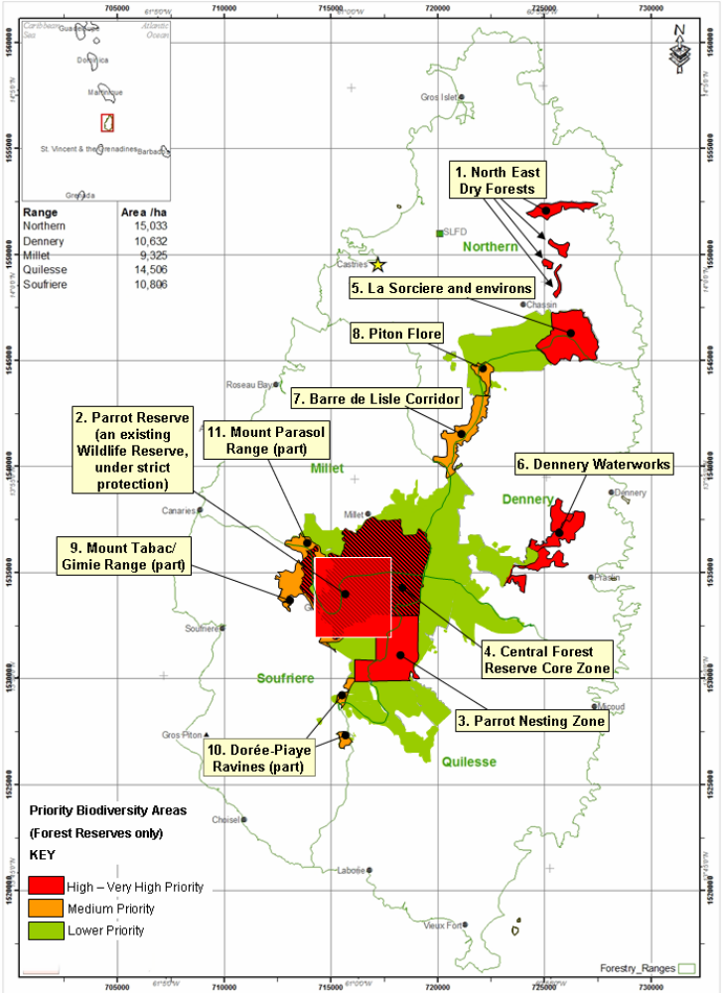

Priority areas for biodiversity conservation outside the Forest Reserves
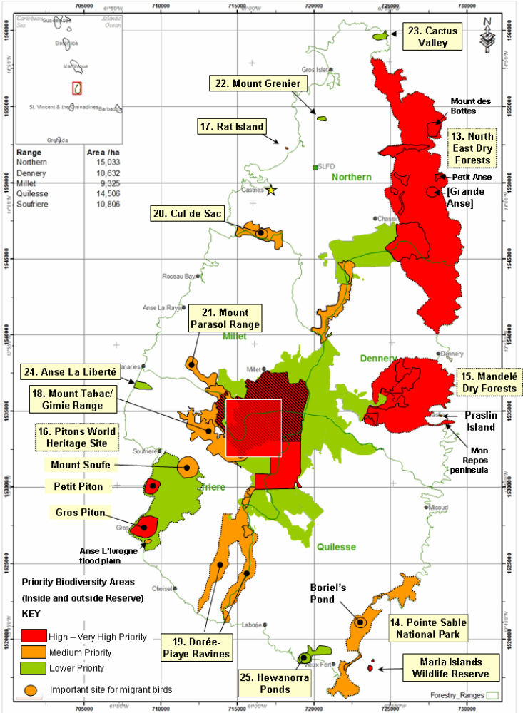

Barriers for effective implementation
The strengths and weaknesses of existing protected areas in Saint Lucia was examining during the development of the Protected Area Systems Plan. Table below summarises the strengths and weaknesses of each component of this network in terms of their physical extent, their effectiveness in protecting natural and cultural resources, and the degree to which they adequately represent St Lucia’s landscapes and ecosystems.

Table 4: Strengths and Weaknesses of Protected Area Network Components
Designation | Strengths | Weaknesses
Forest Reserve & Protected Forest | • Good coverage of moist forest types  • Effective protection and management of forest ecosystems | • Lack of coverage of dry forest types  • Shortage of resources, especially to promote educational initiatives and recreational opportunities
Wildlife Reserve | • Intent is to afford protection to wide range of animal groups and species | • Inadequate geographical coverage.  • Inadequate ecosystem/species coverage  • No protection of plants and habitats
Marine Reserve | • Intent is to afford protection to habitats (especially reefs, beaches and mangroves) and related species  • Designation of significant number of sites | • Designation process omits essential site information  • Designations largely ignored at all administrative/political levels  • Complete lack of effective policing and enforcement  • Significant gaps in coverage
Marine Management Area | • An effective mechanism for zonation and management of potentially competing interests and activities | • Inadequate geographical coverage  • Inadequate resources
Environmental Protection Area | • Intent is to provide protection to species, habitats and wider landscapes across reasonably extensive areas | • Inadequate geographical coverage  • Inadequate resources for effective management  • Inadequate/ineffective controls over development  • Limited value as protected area designation due to compensation clause in legislation
World Heritage Site | • Internationally recognised and high profile designation | • Lack of political commitment to protection of special qualities
Ramsar Site | • Internationally recognised and high profile designation | • All weaknesses highlighted above for ‘Marine Reserves’

The above review, combined with the findings and conclusions of the ‘Gap Analysis’ and ‘Effectiveness Assessment’ point to the need to strengthen St Lucia’s protected areas network in the following ways:
• incorporate a number of large and nationally significant ‘landscape-scale’ protected areas encompassing both terrestrial and marine environments;
• increase the geographical coverage of threatened ecosystems, especially at lower altitudes and along the coast;
• increase the number of specific ‘reserves’, both terrestrial and marine, designated to protected valued species and habitats;
• increase the number of marine management areas to strengthen the protection and sustainable management of marine resources;
• provide protection to sites/areas of historic, archaeological and historic importance;
• increase the resources allocated to protected area management, especially in relation to personnel, staff training and funding;
• ensure that all protected areas are adequately surveyed, mapped, described, and documented;
• ensure that protected areas are adequately policed and that their legal protection is enforced at all political and administrative levels.
- While there are a significant number of Reserves, these designations are currently of little, if any, conservation value because:
  - none of the existing Marine Reserves have been mapped and therefore have an imprecise location, no identifiable boundaries and no spatial dimensions;
  - there is no current data on their status or condition;
  - there is no active management, no enforcement of their statutory protection and no regime of inspection or policing – even for some of the most important Marine Reserves such as Grand Anse;
  - planning permission for developments that will damage or destroy Marine Reserves is granted with little apparent attempt to avoid or mitigate adverse impacts (e.g. Praslin), whilst in other cases damaging activities, such as beach sand extraction (e.g. Grand Anse), are seemingly ignored by the relevant authorities.

Institutional Arrangements Proposed in the 2007 Review of Frameworks

The conclusions of the 2007 ‘Frameworks’ study with regard to the strengths and weaknesses of current institutional arrangements are highly relevant to this Systems Plan. Key points are summarised below:
- except for forests reserves managed by the Forestry Department, staffing levels are inadequate in the majority of protected areas management institutions and, as a consequence, activities such as enforcement, research, monitoring and evaluation are not consistently undertaken;
- given the small pool of expertise, there are gaps in the necessary skill sets in relation to the design, development and management of protected areas;
- financial resources are inadequate;
- constraints experienced by institutions can arise from factors outside of their control.

The report also highlighted a number of ‘the most urgent institutional issues that have to be addressed to effect an improvement in the management of protected areas in Saint Lucia:
- there is a general lack of information and reporting on the state of protected areas and the status of programmes and there is no legislation requiring such reports to be prepared;
- there is no overall institutional coordinating mechanism for protected areas management and no single lead agency has been designated.

Status, priority and timeline for key actions of the Programme of Work on Protected Areas

Status of key actions of the Programme of Work on Protected Areas
Status of key actions of the Programme of Work on Protected Areas | Status
- Progress on assessing gaps in the protected area network (1.1) | 4- Ecological Gap Assessment conducted at three day workshop as part of preparation of Saint Lucia Protected Area Systems plan
- Progress in assessing protected area integration (1.2) | 0
- Progress in establishing transboundary protected areas and regional networks (1.3) | 0
- Progress in developing site-level management plans (1.4) | 2- most PA’s do not have management plans while some sites consist of draft or outdated management plans PSEPA has a management plan thru OPAAL
- Progress in assessing threats and opportunities for restoration (1.5) | 1 PSEPA baseline environmental and cosio-economic assessments did threats analysis for that area
- Progress in assessing equitable sharing of benefits (2.1)  - Progress in assessing protected area governance (2.1) | 0  1- Process started in SMMA. Process to help contribute to the development of 5 year Strategic Plan
- Progress in assessing the participation of indigenous and local communities in key protected area decisions (2.2) | 1-Stakeholder assessments were done in PSEPA and also for SMMA previously and this would include their role to date in management, etc
- Progress in assessing the policy environment for establishing and managing protected areas (3.1)  - Progress in assessing the values of protected areas (3.1) | 4- process completed as part of Saint Lucia Protected Area Systems Plan.
- Progress in assessing protected area capacity needs (3.2) | 3 Capacity/training needs assessment done for SLU under OPAAL for PA development and management
- Progress in assessing the appropriate technology needs (3.3) | 2 Sustainable lansan project in Forest Reserves and latannye and Mauby project in the Forestry Department  Fish aggregating devise (FAD) adopted by the Department of Fisheries
- Progress in assessing protected area sustainable finance needs (3.4) | 2 in marine protected areas. However, the UN Forum on Forest have been providing guidance for sustainable forest financing planning
- Progress in conducting public awareness campaigns (3.5) | 3 Forestry department and The Saint Lucia National Trust have dedicated staffed units dedicated to development and implementation activities
- Progress in developing best practices and minimum standards (4.1) | 2 Sustainable lansan project in Forest Reserves and FADs
- Progress in assessing management effectiveness (4.2) | 4- This assessment was conducted through a peer review workshop using the ‘Rapid Assessment  and Prioritization of Protected Areas Management’ (RAPPAM) methodology to determine the  strengths, weaknesses and management challenges of existing protected area systems.
- Progress in establishing an effective PA monitoring system (4.3) | 3- not for majority of MPA.
- Progress in developing a research program for protected areas (4.4) | 3 Flora and Fauna Research Unit in Forestry Department responsible for development and implementation of research activities in forest reserves and other existing and proposed terrestrial parks
- Progress in assessing opportunities for marine protection | 0
- Progress in incorporating climate change aspects into protected areas | 1 Forest restoration and rehabilitation work past hurricane Tomas have included aspect to build resilience to climate change by diversifying species and restoring endangered species of forest trees
Status: 0 = no work, 1 = just started, 2 = partially complete, 3 = nearly complete, 4 = complete
(Insert notes as appropriate)

Priority actions for fully implementing the Programme of Work on Protected Areas:
(Insert priority actions) 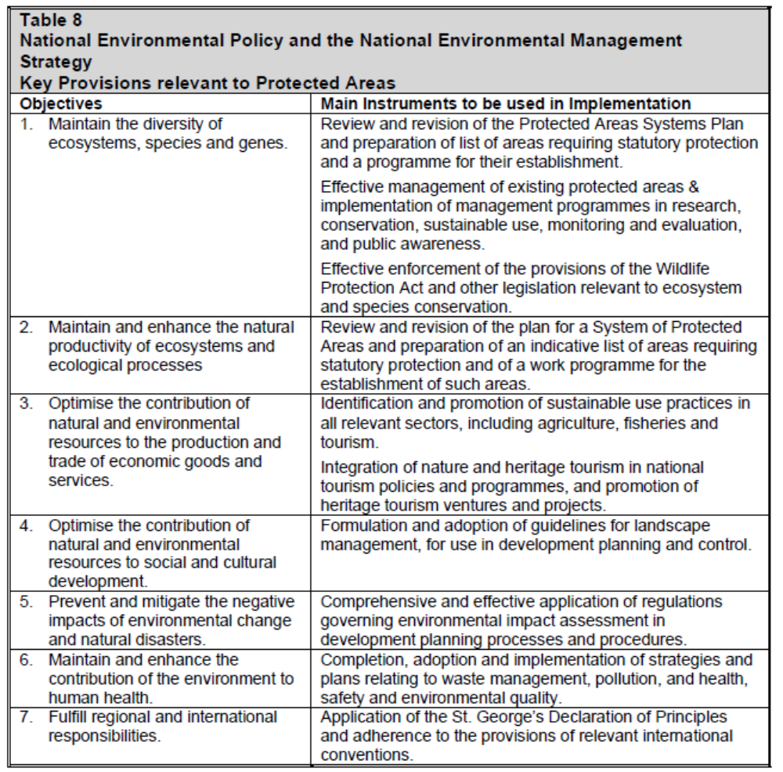

Timeline for completion of key actions
(Insert timeline)
At this stage in the process of Plan preparation, when it has yet to receive formal cabinet approval, it is not possible to be precise about the timescale for the completion of the various steps but the goal should certainly be to have effected the statutory designation of all protected areas and established all management and governance structures within 5 years from the date of approval of the Plan. (Based on Saint Lucia Protected Area Systems Plan)

Action Plans for completing priority actions of the Programme of Work on Protected Areas
(Insert detailed action plans)

Action 1: (Maintain the Diversity of Ecosystem, Species and Gens)
Key steps | Timeline | Responsible parties | Indicative budget
 | ongoing

Action 2: (Prevent and Mitigate the Negative Impact of Climate Change and Natural DisasterDescribe action)
Key steps | Timeline | Responsible parties | Indicative budget
Develop biodiversity offset policies for the energy Sector | 5 YRS | Min of Sus Dev | Ck sded
Develop land use policies that protect coastal areas | Consult with physical planning ck Karen Augustin, George james, liz soomer
Incorporate mechanisms for payment of environmental services | Iwcam pig farmers initiatives- use to project cost and timeline. Water resourse agency.  2yrs
Comprehensive and effective applications of regulations governing environmental impacts assessment in development planning and processes | 3yrs | Physical planning | ?
Forest Restoration and rehabilitation | 4 | Forestry department | $1,405,287.00

Action 3: (Optimize the Contribution of Natural and Environmental Resources to the Production and Trade of Economic Goods and Services Describe action)
Key steps | Timeline | Responsible parties | Indicative budget
Identification and promotion of sustainable use practices in all relevant sectors, including agriculture, forestry, fisheries and tourism | ongoing | All relevant agencies responsible
Integration of nature and heritage tourism in national tourism policies and programmes and promotion of nature tourism plans and projects | ongoing | Min of tourism, | ?

(Insert more as needed)

Key assessment results
.Ecological gap assessment (insert summary findings if available)
The output of this stage of the GAP Assessment was a list of critical conservation targets for Saint Lucia. Local experts then set conservation goals for each target and each target was spatially mapped so that it could be manipulated through the Marxan software. These targets and goals are presented in the Table below:
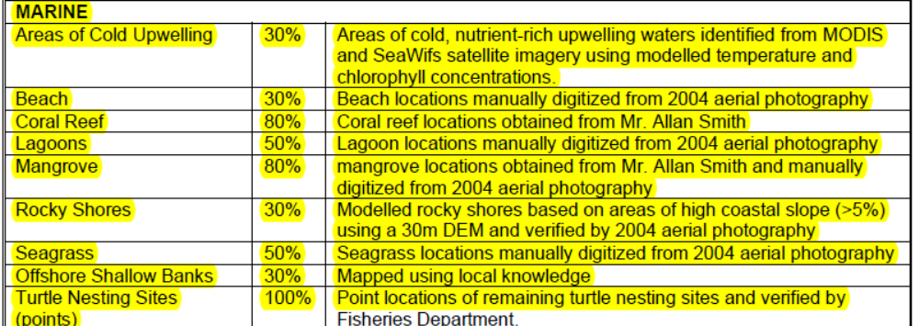

Management effectiveness assessment (Insert summary findings if available)
Management Challenges at the Site Level
Planning Issues
- many sites have no management plans or management plans need to be updated;
- conservation objectives are often not supported by local communities;
- enforcement of site protection is limited due to the lack, or absence, of staff and financial resources;
- planning is strong in some areas such as PMA, SMMA and St. Lucia Forest Reserve, while very weak in Other Marine Reserves, mangroves and Grande Anse.

Inputs
- the analysis of inputs to protected area management in relation to staffing, communication, infrastructure and facilities, and financing reveals a system lacking resources at practically all levels of management;
- financing is the most critical issue, and is linked to the low level (or absence) of staffing and poor infrastructure;
- inputs are high Marine Reserves, mangroves and Grande Anse.

Processes
- most protected areas do not have a management plan, while others have draft or outdated management plans, and in many cases there are no work plans or strategies to abate threats;
- while the decision-making process is generally a strong area ,with transparency and participation, decision-making is often limited by poor inter-agency collaboration and communication;
- research and monitoring (social and biological) are poor and suffer from insufficient data: this hampers decision-making and the design of strategies to abate the impact of threats;
- processes to conduct management effectively are strong in the Soufriere MMA whilst are very weak in PMA, other Marine Reserves, mangroves and practically absent in Grande Anse.

Sustainable finance assessment (Insert summary findings if available)

Capacity needs assessment (Insert summary findings if available)

Policy environment assessment (Insert summary findings if available)
Protected Area Policies

Protected area policies are strong in relation to the existence of a comprehensive inventory and ongoing research, although there is still a lack of information and an inventory of all species

Critical issues that need to be addressed are:
- The development of a national protected area policy that clearly articulates a vision, goals, and objectives for the protected area system;
- A demonstrable commitment by relevant authorities to protecting a viable and representative protected area network,
- The definition and establishment of restoration targets for under-represented and/or greatly diminished ecosystems;
- Periodic review of the protected area system to address gaps and weaknesses;
- Increased emphasis on training and capacity building.

Protected Area Policy Environment
• key strengths are the complementary nature of laws relating to protected area objectives and the degree of communication between natural resources departments, especially in the field.
• key weaknesses are insufficient funding, a lack of effective law enforcement, and weak
national policies to promote sustainable land use and land conservation.
Protected area integration and mainstreaming assessment (Insert summary findings if available)

Protected area valuation assessment (Insert summary findings if available)

Climate change resilience and adaptation assessment
ASSESSMENT OF IMPACT OF HURRICANE TOMAS ON SAINT LUCIA’S FORESTS (unpublished research paper by Adams Toussaint)

The forest disturbance caused by Hurricane Tomas is of great concerned to the Forestry Department. More so, due to the frequency of disturbance to the forests ecosystem in the past 30 years, including Hurricane Allen, Tropical Debbie, Dean and Hurricane Tomas, respectively, reducing the capacity of the forest to achieve steady state (biomass accumulation = biomass loss). It is worth noting that periodic disturbances caused by tropical storms is part of the natural development of forests ecosystems in Saint Lucia, and in the presence of such forces, effective recovery mechanism are put into effect by the vegetation. However, it is also worth noting that the effects of climate change can exacerbate the frequency and intensity of tropical storms and posses new challenges to vulnerability and adaptation of forests ecosystems to the effects of climate change.
Increase disturbances can create persistent increase in light gaps in the forest canopy, resulting in:
- Increase in colonization and density of forest stands by pioneer species such as Bwa Cannon (Cecropia Peltata), mahoe cochon (Sterculia caribaea), Bwa laglu (Sapium caribaeum) and other species of low merchantable timber value, thereby, reducing the value of forest stands. The following table containing a list of stems per hectare (SPH) of 20 timber tree species from 1949, 1983 and 2009 inventory.
SPH of 20 tree species from 1949, 1983 and 2009 inventory
Tree Species | Beard SPH (1949)* | Piitz SPH (1983) | Tennant SPH (2009)
Dacryodes excelsa | 24.21 | 16.80 | 16.25
Sloanea caribaea | 11.61 | 6.92 | 6.54
Sterculia caribaea | 18.28 | 29.89 | 102.77
Licania ternatensis | 17.78 | 9.88 | 14.04
Aniba ramageana | 2.72 | 0.99 | 0.78
Talauma dodecapetala | 2.22 | 1.48 | 1.47
Tapura antillana | 26.68 | ##### | 10.00
Guatteria caribaea | 6.42 | 10.87 | 16.18
Simarouba amara | 2.22 | 2.72 | 9.58
Tovomita plumieri | 14.08 | 8.40 | 13.03
Protium attenuatum | 10.37 | 10.13 | 22.34
Swartzia caribaea | 5.19 | ##### | 12.17
Micropholis crotonioides | 5.19 | 4.20 | 2.54
Chimarrhis cymosa | <1.0 | 5.93 | 3.95
Ocotea leucoxylon | <1.0 | 5.68 | 21.78
Sapium caribaeum | <1.0 | 5.19 | 10.93
Pouteria multiflora | 15.31 | 8.65 | 4.33

Note: For example, an increase in SPH for Sterculia caribaea, a pioneer species and reeducation in SPH for Pouteria multiflora a primary rainforest species. Beard’s study was based on a very light sample of some 20ac (8 ha) out of 14, 799 ac (6023 ha), approximately a 0.14% sample. Piitz’s inventory was based on a 1.8% sample. Tennant inventory was based on stratified random strip in which he sampled 22.64 ha out of 8940ha, approximately a 0.25% sample.
- Reduce the ability for gradual transformation back to primary or climax species and the consequent reduction in biodiversity.
- Reduction in diameter classes for diversity of forest species and reduce reproduction opportunity for many species of forest trees that require long time period for maturity and reproduction.
- Reduction in the diversity of fruiting trees and the capacity of the forest to sustain some wildlife species.
- The integrity of forests watersheds to conserve soil and water can be compromised due to lack of mature trees with established roots systems and the lack of below ground roots stratification to anchor soils, increase water percolation into the soils and to sustain aquifers during the dry periods.
- Increase forest susceptibility to the vagaries of wildfires.

Disturbance theory has generally distinguished between catastrophic, large-scale disturbance and small-scale, within-community disturbance. Large scale disturbance which created high frequency and magnitude in gaps due to landslides, in the case of Hurricane Tomas, is also a major problem for forest management. species composition due to gap openings depend upon the size of the gap; small opening less than 1 acre (0.4 ha) often permit seedlings and saplings of the primary forest for development free from suppression by weeds, and for new seedlings to become established from nearby dominants.
On the other hand, if gaps are large, microclimatic changes are severe enough to cause the death of all or most of the young primary forest plants. This larger gap then becomes areas of large exposed devoid of soils and or large areas of swamp soils, thus natural succession is set back considerably. These areas provide ideal grounds for the proliferation of invasive flora species.
A basic understanding of this natural rejuvenation system of the mature primary forest is essential to prepare a rational and ecological sound forest management plan for building forest resilience, current recovery and restoration process. These factors of tropical storm disturbance and vulnerability and adaptation to climate change will have a definite implication for the silvicultural prescriptions for both natural and manmade forests in St. Lucia.
Recommendation call for both social and ecosystem approach including the inter alia:

- Strengthen local and national understanding and support for sustainable forest management, with special attention to vulnerability and adaptation to climate change.

- Foster the development of civil society organizations as a tool for lobbying for and enhancing financing, participation in sustainable forest management.

- Establish policies and plans with clear objectives for the future forest and biodiversity under climate change, which must include both in situ and ex situ conservation strategies for wide diversity of flora and fauna germplasm and other forest resilience factors.

- Allocation of resources to develop the capacity to determine the vulnerability (sensitivity, adaptive capacity) of forest ecosystems and biodiversity, as well as society to impact of climate change.

- Conduct applied research to inform and monitor to determine the state of the forest and identify when critical thresholds are reached.

- Economic evaluation of ecosystem services of forest biodiversity and payment for environmental services.

- Develop strategic plans to reduce vulnerability and speed recovery of forest ecosystems and biodiversity after disturbance.

Insert summary findings if available)

(Insert other assessment results if available)

