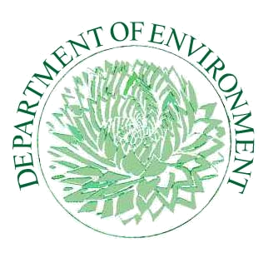
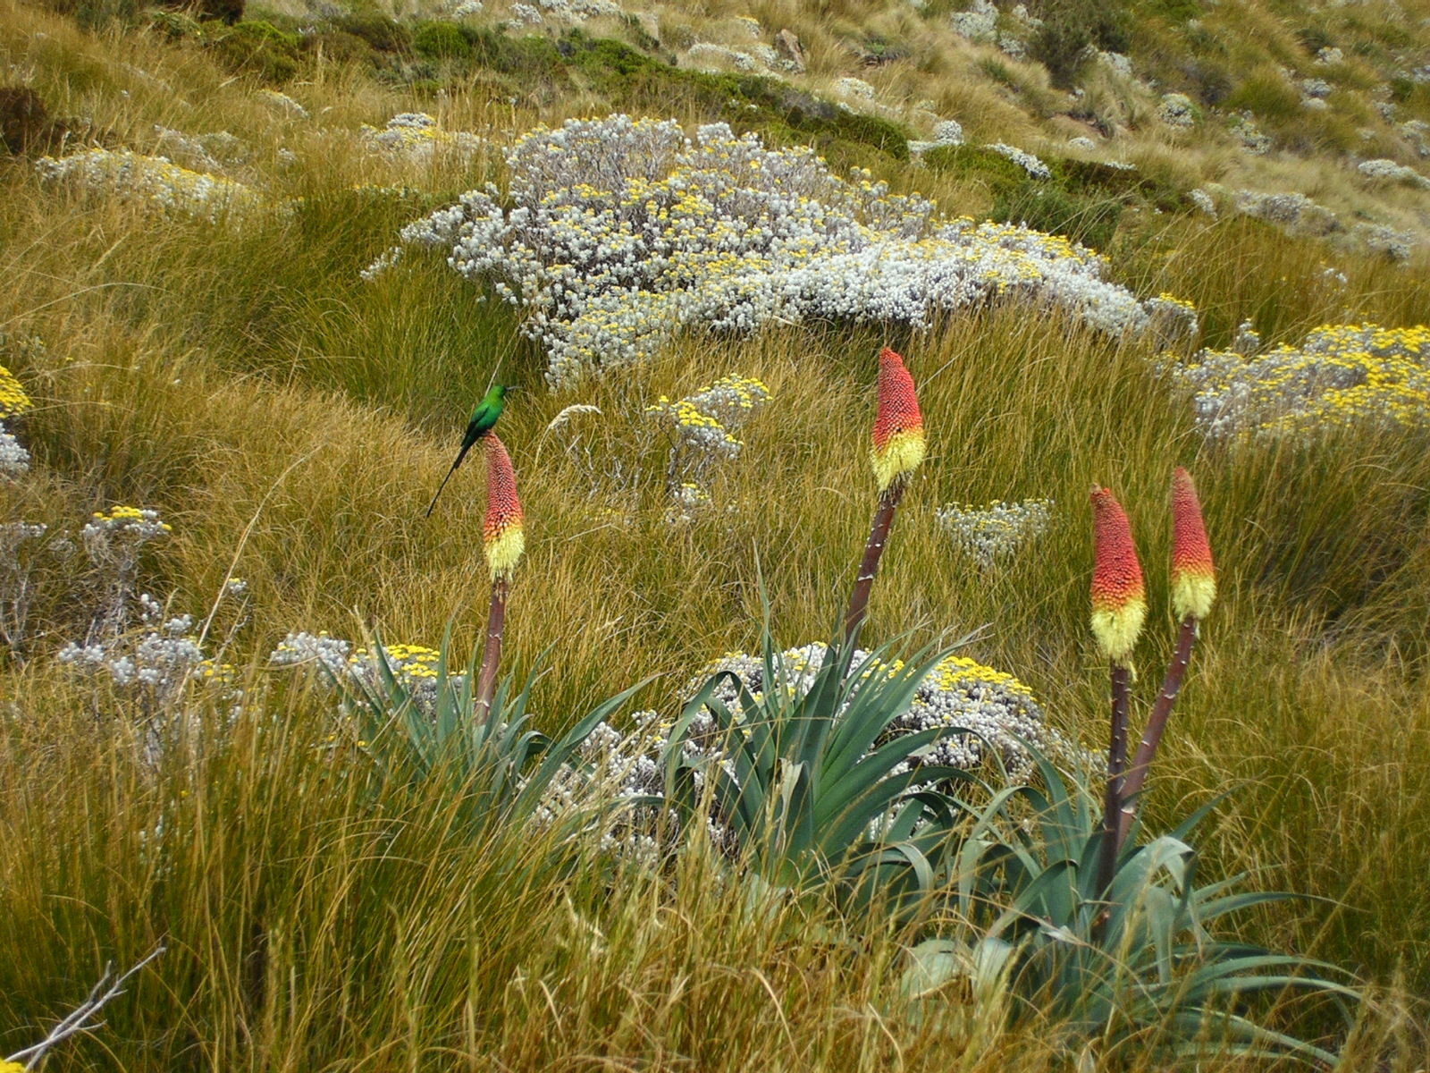



Lesotho Fourth National Report
On Implementation of Convention on Biological Diversity

December 2009
LIST OF ABBREVIATIONS AND ACRONYMS

ADB African Development Bank
CBD Convention on Biological Diversity
CCF Community Conservation Forum
CITES Convention on International Trade in Endangered Species
CMBSL Conserving Mountain Biodiversity in Southern Lesotho
COP Conference of Parties
CPA Cattle Post Areas
DANCED Danish Cooperation for Environment and Development
DDT Di-nitro Di-phenyl Trichloroethane
EA Environmental Assessment
EIA Environmental Impact Assessment
EMP Environmental Management Plan
ERMA Environmental Resources Management Area
EMPR Environmental Management for Poverty Reduction
EPAP Environmental Policy and Action Plan
EU Environmental Unit (s)
GA Grazing Associations
GCM Global Circulation Model
GEF Global Environment Facility
GMO Genetically Modified Organism (s)
HIV/AIDS Human Immuno Virus/Acquired Immuno-Deficiency Syndrome
HNRRIEP Highlands Natural Resources and Rural Income Enhancement Project
IGP Income Generation Project (s)
IUCN International Union for Conservation of Nature and Natural Resources
LHDA Lesotho Highlands Development Authority
LMO Living Modified Organism (s)
Masl Meters above sea level
MDTP Maloti-Drakensberg Transfrontier Conservation and Development Project
MEAs Multi-lateral Environmental Agreements
MOU Memorandum Of Understanding
MRA Managed Resource Area
NAP National Action Plan
NBF National Biosafety Framework
NBSAP National Biodiversity Strategy and Action Plan
NEAP National Environmental Action Plan
NES National Environment Secretariat
NGO Non-Governmental Organization (s)
NPGRC National Plant Genetic Resources Centre
NUL National University of Lesotho
PA Protected Area
PELUM Participatory Ecological Land Use Management
PIU Project Implementation Unit
PRS Poverty Reduction Strategy
RAMSAR Convention on wetlands of International Importance Especially as Waterfowl Habitat Ramsar (Iran)
RMA Range Management Area
SACU Southern African Customs Union
SADC Southern African Development Community
SEA Strategic Environmental Assessment
SNP Sehlabathebe National Park
SPGRC SADC Plant Genetic Resources Centre
SWACAP Soil and Water Conservation and Agro-forestry Project
TBPA Trans-Boundary Protected Areas
UDP uKhahlamba Drakensberg Park
UNCCD United Nations Convention to Combat Desertification
UNCED United Nations Conference on Environment and Development
UNDP United Nations Development Programme
UNFCC United Nations Framework Convention on Climate Change
YWCA Young Women Christian Association
Table of Contents
List of Tables vi
List of Figures vii
and programs using a 'food security lens' vii
List of Maps vii
Executive Summary viii
Chapter I –Overview of Biodiversity Status, Trends and Threads 1
1.1 Introduction 1
1.1.1 The key Purpose of chapter is to deliberate on the following: 2
1.2 Overview of Biodiversity: 4
1.3 Biodiversity Status 5
1.3.1 Highveld Grassland Zone: 6
1.3.2 Afromontane Grassland Zone 9
1.3.3 Afroalpine Grassland Zone 11
1.3.4 Wetlands 14
1.3.5 Plant Taxa: 16
1.3.6 Conservation Categories: 18
1.3.7 Invasive Alien Species: 21
1.3.8 Criteria for Classification of Species: 24
1.4 Trends 24
1.4.1 Vegetation 25
1.4.1.1 Status and Trends 25
1.4.2 Birds: 26
1.4.2.1 Status and Trends 26
1.4.2.2 RED DATA LIST: 31
1.4.3 Mammals: 32
1.4.3.1 Status and Trends 32
1.4.4 REPTILES: 35
1.4.4.1 Status and Trends 35
1.4.5 Amphibians: 37
1.4.5.1 Status and Trends 37
1.4.6 FISH: 39
1.4.6.1 Status and Trends 39
1.5 Main threats to biodiversity 41
1.5.1 Uncontrolled use of biological resources 41
1.5.1.1 Overgrazing 41
1.5.1.2 Unsustainable harvesting 42
1.5.2 Uncontrolled fire 43
1.5.3 Encroachment 43
1.5.3.1 Settlements 43
1.5.3.2 Cultivation 43
1.5.4 Alien Invasive 44
1.5.5 Pollution 45
1.6 Implications of Changes on Human wellbeing 46
Chapter II - Current Status of National Strategy on Lesotho’s Biological Diversity: Conservation and Sustainable Use. 47
2.1 Background 47
2.2 National Biodiversity Strategy and Action Plan Priority Activities 49
2.3 Domestic and International Funding for Priority Activities 65
2.4 Review of Successes, Obstacles and Lessons Learned 66
2.4.1 Successes 66
2.4.2 Lessons Learned 67
2.4.3 Obstacles 68
2.5 Effectiveness of NBSAP 70
2.5.1 Whether the observed changes in biodiversity status and trends mentioned in the report are as a result of measures taken to implement NBSAP and the Convention. 70
2.5.2 Whether the current NBSAP is adequate to address the threats to biodiversity identified in Chapter 1: 71
2.5.3 How implementation of NBSAPs may be improved, where necessary, including suggestions of possible ways and means to overcome identified obstacles. 72
2.6 Response to COP 8 Decisions (Progress in achieving participation of local communities) 75
2.6.1 Decision VIII/5(Article 8j) 75
2.6.2 Decision VIII/24(Protected Areas) 76
2.6.3 Decision VIII/28(Impact Assessment) 77
CHAPTER III – Sectoral and Cross-Sectoral Integration or Mainstreaming of Biodiversity Considerations 78
Background 78
The National Forestry Policy, 2008 80
Water and Sanitation Policy, 2007 81
Lesotho Food Security Policy, 2005 82
Energy Policy for the Kingdom of Lesotho (Draft) 83
Transport Sector Policy, 2006 84
Environmental Education Strategy towards 2014: A Strategic Plan for Education for Sustainable Development in Lesotho (2009) 84
Lesotho Electricity Company: Safety, Health, Environmental and Quality (SHEQ) Management System 85
Gender and Development Policy 85
Mechanisms for Integration of Biodiversity into Sectoral Strategies 86
Mainstreaming Biodiversity through Ecosystem Approach 87
CHAPTER IV – Progress toward the 2010 Target and Implementation of the Strategic Plan 88
Introduction 88
Obstacles on the achievement of the 2010 Target. 102
Conclusions 104
Lessons Learned Regarding Implementation 106
Future Priorities and Capacity Building 108
Regional and Global Actions for enhancement of Convention Implementation at National level 108
Reporting Format 108
Regional coordination of reporting 108
Scope of Interventions 109
Appendix I – Information concerning reporting Party and preparation of national report. 110
Appendix II - Progress towards Targets of the Global Strategy for Plant Conservation and Program of work on Protected Areas 113
REFERENCES 120

List of Tables

Table 1: Vegetation Types 6
Table 2: Typical Highveld Grassland Flora and Fauna 8
Table 3: Typical Afromontane Grassland Flora and Fauna 10
Table 4: Typical Afroalpine Grassland Flora and Fauna 12
Table 5: Wetland Types 14
Table 6: Wetlands and Rivers Flora and Fauna 14
Table 7: Showing known Lesotho Plant Taxa 17
Table 8: Recorded Fauna and Flora of Lesotho 17
Table 9: Species Endemism 18
Table 10: Current Conservation Categories 19
Table 11:Invasive Species found in Lesotho 22
Table 12: Classification Creteria 24
Table 13: Checklist of Lesotho's Birds 28
Table 14: Red Data Book Bird Species occurring also on the Lesotho Checklist 31
Table 15: Checklist of Lesotho Mammals 33
Table 16: Status of Mammals in Lesotho 34
Table 17: Red Data Book species also Occuring on Lesotho Checklist 34
Table 18: Checklist of Lesotho's Reptiles 36
Table 19: Status of Reptiles in Lesotho 36
Table 20: Red Data Book Species occurring also on the Lesotho Checklist 37
Table 21: Checklist of Lesotho Amphibians 38
Table 22 Status of Lesotho's amphibians 38
Table 23: Red Data Book Species occurring also on the Lesotho Checklist (Lesotho status given in parentheses after species names) 38
Table 24: Checklist of Lesotho Fish 40
Table 25: Fish Status of lesotho 40
Table 26: Red Data Book Species occurring also 40
Table 27: NBSAP Performance Matrix 51
Table 28: Indicative Funding Levels by Donors and Government 65
Table 29: Summary of Obstacles impeding implementation of NBSAP 69
Table 30: Program of work on Protected Areas 76
Table 31: Framework of Goals, targets and indicators to assess progress towards the 2010 Biodiversity Target 89
Table 32: Goals and Objectives of the Strategic Plan and Provisional Indicators for assessing progress. 97
Table 33: Steering Committee for UNCBD 4th National Report 111
Table 34: Progress towards Targets of the Global Strategy for Plant Conservation 113

List of Figures

Figure 1: Overgrazing Figure 2: Colonisation by chrysocoma 42
Figure 3: Overharvesting of Medicinal Plants 42
Figure 4: Encroachment of Rangeland by Cultivation 44
Figure 5: Industrial Discharge 45
Figure 6 legal notice no.93 of 2004 63
Figure 7 Legal notice no.38 0f 2006 64
Figure 8: Area rehabilitated through tree planting under Social Forestry 81
Figure 9: Relationship between the Food Security Policy and other policies, strategies and programs using a 'food security lens'. 82

and programs using a 'food security lens'

List of Maps
Map 1: Major Ecological Zones 5
Map 2: Distribution of Protected Areas 21

Executive Summary
Ratification of the Convention on Biological Diversity (CBD) implied commitment by Lesotho as Contracting Party to comply with the provisions contained in there to undertake activities towards achievement of biological diversity as the main objective of the Convention. One of the provisions (Article 26) requires regular reporting by Contracting Parties for the Secretariat to evaluate achievement towards global target, to substantially reduce biodiversity loss by 2010. This, the fourth report in the sequence, on the implementation of the Convention, aims to fulfill this requirement.
An advance in the approach to biodiversity conservation that aims to achieve on the three CBD objectives in an integrated manner, with national development aspects, as well as incorporation (where possible) of bilateral/multilateral elements is the systems approach. This does not focus on biodiversity components alone, but establishes the conservation plan, in which biodiversity priorities are identified and mapped according to value system accredited through probability of irreplaceability in the inevitability of transformation by threats. The result is a mosaic of priority areas that can be addressed using a range of implementation tools or conservation strategies (implementation mechanisms = Biosphere model around existing protected areas, sustainable livestock management, MRA’s, new protected areas, Maboella etc. constituting the range of IUCN categories of protection). The current situation in Lesotho is such that needs have been identified on biodiversity conservation, for which the National Biodiversity Strategy Action Plan has been developed and approved as a key document for conservation of natural resources and mainstreaming of biodiversity into all sectors. The history of implementation of the NBSAP is dotted with projects or interventions that ought to have been guided by an umbrella body for coordination and monitoring, to ensure achievement on the NBSAP, and advice on new initiatives to address areas that have not been adequately addressed.
The biodiversity conservation status, with the above implications, is patchy, as it is informed from research work and uncoordinated implementation on the ground. Due to the fact that biodiversity is the basic support to community livelihoods, there is a range of threats associated with community actions that apply considerable stress on the biodiversity components. Coupled with these, is the fact that interventions have also experienced implementation hurtles that curtailed their efficacy to produce desired outcomes. This implies that biodiversity conservation in this context is not just a challenge, but is still a mammoth task.
Biodiversity
The traditional concepts of conservation have been informed by the criterion that prioritizes the rangeland as rangeland for livestock, followed by homestead construction materials, then aspects of support to livelihoods, in terms of medicinal and food supplements may feature here and there. This has resulted in marginalization of other biodiversity values to the extent that some biodiversity components are reported under historical categories or even endangered and, if not extinct altogether, or relocated to more conducive environment and habitat, especially for fauna. The biodiversity components that have been considered are: Vegetation, Birds, Mammals, Reptiles, Amphibians and Fish.
Limitations
The issue of biodiversity data gathering through either coordinated surveys or regular monitoring as a limitation on the accuracy of the report cannot be overemphasized, as it has been reiterated in a number of similar reports. Therefore available data does not allow accurate reflection of species status and trends.
Vegetation
Status and Trends
Lesotho is part of the Southern African grassland biome, which is classified under three categories (Highveld, Afromontane and Afroalpine) influenced mainly by altitude. The key plant constituencies within these categories are grasses, flowering plants and trees. Transcending all the categories are wetlands ecosystems with varying diagnostic vegetation and associated fauna. The vegetation has endured tremendous stress from key threats that have been identified (Overgrazing, Over harvesting, Uncontrolled fire, encroachment by settlements and cultivation on the rangeland, Invasive Aliens and pollution), that contributed to the deterioration of conditions in general by continually transforming the environment. The overall trend in the vegetation status, with the foregoing, is that of decline. The conservation efforts, through projects and other interventions, have served largely to reduce the perceived rate of decline.
Birds
Status and Trends
Transformation of the environment indicated above has resulted in the degradation of habitat quality, which has noticeably affected bird species negatively. Large birds such as vultures’ breeding pairs have declined. The conservation efforts such as forestry interventions have however, contributed positively in addressing the habitat loss, to the extent of attracting new bird species. Based on this observation, the trend of decline in bird populations and diversity is somewhat stabilizing.
Mammals
Status and Trends
The large mammals of Lesotho are mentioned largely under historical and archaeological categories. This demonstrates that the rate of decline intensified long time ago. The conservation strategies such as the establishment of Protected Areas, are contributing in bringing some of the well forgotten species like the Eland and Oribi back, even if on short durations. It is considered that the trends are still declining and the efforts are only reducing the rate of decline at the moment.
Reptiles
Status and Trends
While the status of reptiles has declined because of habitat transformation and to a certain extent through use for medicinal purposes, the largest contributor is the traditional mindset (of extreme phobia) against reptiles, especially snakes that are instantly killed on sight. The main assumption that, every snake is poisonous, has been proved otherwise, which needs to be inculcated to transform this mindset. Improvement of the vegetative cover and attendant fauna will attract populations and diversity of reptiles.
Amphibians
Status and Trends
The species populations for amphibians, of two groups of frogs and toads, under one category or order, are considered to be very high, compared with other parts of the world. Their survival is dependent on wet environmental conditions. Therefore the improvement on the range and protected area conditions coupled with tree planting will increase the populations even if diversity of amphibians remains constant.
Fish
Status and Trends
The fish species are categorized as the smallest of all classes of vertebrates. Indigenous species are largely endemic and endangered (especially Maloti Minnow, which is also the indicator of good water quality). In search for protein supplement and recreation, two trout species were introduced, which unfortunately appear to threaten the indigenous species. Consequently the overall trend points to a decline in species diversity and populations.
Implications to human well being
Dependency of humans on the biological diversity for food, shelter and medicinal purposes cannot be overemphasized. Deterioration of the environment, which resulted in decline in species populations and diversity of fauna and flora, impacted negatively on the human well being. Substitution of natural products by synthetic materials proved costly and had inherent side effects.
Implementation of NBSAP
Following acknowledgment of alarming rate of biodiversity loss at local and international levels, Lesotho became Party to the Convention on Biological Diversity – CBD, developed and adopted the NBSAP as a tool for mainstreaming biodiversity in the national developmental programs to ensure implementation of its key objectives of ‘Conservation of biological diversity, Sustainable use of its components and Equitable sharing of the benefits derived out of genetic materials. The implementation is multi-faceted (incorporating various IUCN conservation categories), ranging from traditional conservation measures (Maboella) to more conventional strategies of Protected Areas, Range Management Areas and Woodlots. Coordination of this implementation has been and remains a challenge, which requires revamping and revitalization for effectiveness and efficiency. The current implementation modality results in patchy outputs, with little or no monitoring, to evaluate achievement of the desired state. This undermines the Target planning approach that is emphasized in the CBD. The intent to contribute towards biodiversity conservation is demonstrated by mobilization of interventions, enactment of enabling legislation and institutional re-orientation to incorporate environmental planning. On the whole, implementation has initiated in the right direction. Of critical concern are coordination, monitoring and evaluation, which provide a measuring stick on the sectoral and other stakeholders’ performance on target achievement.
Mainstreaming of Biodiversity Considerations
The Lesotho Constitution (Section 36) has highlighted the need for environmental consciousness in developmental initiatives, through appropriate policies, to ensure sound environmental management to sustain human health and well being. Manifestation of this concept is reflected in the National Vision and sectoral policies’ (Lesotho Vision 2020; National Forestry Policy, 2008; Water and Sanitation Policy, 2007; Lesotho Food Security Policy, 2005; Transport Sector Policy, 2006; Energy Policy for the Kingdom of Lesotho (draft); Environmental Education Strategy towards 2014: A Strategic Plan for Education for Sustainable Development in Lesotho, 2009) adaptation of environmental management statements, which in turn, inform the strategies and plans.
Progress toward the 2010 Target and Implementation of the Strategic Plan
To ensure implementation of NBSAP, Conference of Parties established 2010 as the year which marks significant achievement on reduction of biodiversity loss, through achievement of goals and sub-targets that are to be integrated into the program of work of the Convention. Achievement (in the three objectives of the Convention) would be measured by means of indicators (some of which were proposed at international level) adopted at national level, while others have been suggested nationally, where none had been proposed. This is facilitated through analyses of sector programs and interventions identified in the previous chapter that incorporate various aspects of biodiversity conservation. A level of achievement has been attained through re-orientation of sectoral policies, enactment of legal frameworks and institutional restructuring to ensure incorporation of environmental considerations into programs implementation and actual implementation of interventions (projects) such as RMAs, MRA (ERMA), PAs, Social Forestry and preservation of indigenous genetic materials (through SPGRC and NPGRC)
The Strategic Plan sets an adaptive management framework at the international level to address issues of cooperation, coordination, capacity building, resource mobilization (financial) and technical support, monitoring and evaluation to facilitate implementation of the national biodiversity strategies and action plans. The Strategic Plan encompasses all aspects of NBSAPs including building of synergies, identification of cross-cutting priority issues and capacity constraints across the five multi-lateral environmental agreements (UNCBD, UNCCD, CITES, UNFCC and RAMSAR).
The implementation of NBSAP through sectoral strategies, plans and actions, including several interventions and/projects aimed at assisting biodiversity conservation, has not been a smooth landing, but bisect with obstacles that posed challenges to implementation summarized in the table below.
Focal Area | Obstacle Category
Government of Lesotho – GOL | - Poor coordination of NBSAP interventions.  - Insufficient database on biodiversity  - Inadequate information dissemination  - Inadequacy of project monitoring and evaluation mechanisms  - Indistinctive role of conservation authority  - Implementation of interventions through PIU vs. integration into Sectoral departments  - differential interpretation of biodiversity conservation between technocrats and community
Donor Community | - Pre-designed projects  - lack of community intricacies appreciation
Legal Instruments | - Inadequacies of Local Government Act 1997  - Poor management of CPAs (inadequacy in Local Government Act 1997)
Community | - Poor economic status, which leads to:  - Prioritization of range over other biodiversity components  - Focus on immediate returns, which undermines long-term objectives associated with interventions  - Communal land tenure system precipitates an entitlement mindset, which relegate interventions to a subjective rather than objective realm

Lessons Learned
Uncoordinated approach to implementation of NBSAP starting at the sectoral level through to the grass roots level. This may be addressed through re-introduction of unified extension services approach. This entails the subject matter specialists approaching the stakeholders in unison with one voice. The umbrella body or the Conservation Authority ought to disaggregate the functions of coordination, facilitation, monitoring and evaluation from implementation in order to properly perform its responsibilities more effectively.

Chapter I –Overview of Biodiversity Status, Trends and Threads

Introduction
In the year 1995, Lesotho ratified the Convention on Biological Diversity (CBD), in so doing, acknowledging the observation that it is loosing biological diversity at an alarming rate, and is committing to the international intent to achieve, by 2010, a significant reduction of this loss, as contribution to poverty reduction and to the benefit of all life on earth. Conforming to Article 26 of the Convention, Lesotho as the Contracting Party, has to compile the fourth report for submission to the Secretariat for assessment of the Global Contribution towards implementation of the provisions of the Convention, as the means to achieve the objectives of the Convention, namely: the conservation of biological diversity; the sustainable use of its components; access, and the fair and equitable sharing of the benefits arising out of the utilization of genetic resources. Fulfillment of the reporting requirement has been undertaken in the following frequencies: 1st Jan 1998, 2nd May 2001, 3rd May 2005 and the current fourth report in 2009. The reports generally provide two perspectives: the first is the measure of Lesotho’s performance against set targets and indicators. The second one is the measure of Lesotho’s capability and preparedness to actualize the Convention at national level. The objective of the report is to provide implementation of the Convention provisions in the achievement of biodiversity conservation, in accordance with the guidelines provided by the Secretariat for the compilation of the Fourth National Report. The report is sub-divided into three tiers:
- Biodiversity Status and Trends;
- National Implementation Modalities
- Secretariat support to facilitate Parties in the implementation: through mobilization of resources (financial and technical) in this chapter, information on Lesotho’s biodiversity, although limited, is provided to reflect the status, trends and threads. There has been discussion as to what would have been the “natural” vegetation of Lesotho, the vegetation of the country without having been altered by human actions and or livestock (the Indigenous Forests of Lesotho their former occurrence E.D.May 2000). To this end the vegetation of the country has commonly been referred to as predominantly natural grassland. The discussion of status, trends and threads would largely be centered on the three vegetation zones of Low & Rebelo (1996), namely Highveld grassland, Afromontane grassland and Afroalpine grassland, within these are also found some patches of indigenous forests and plantations. While the zones are generally classified as grasslands, May (2000) transforms this notion into 12 vegetation types as indicated in table 1, below.
With regard to trends, it is necessary to allude to the fact that there is currently no existence of well-planned and systematic data collection schedule (biodiversity Monitoring) to assist us to substantiate some of the arguments, however it is still strongly believed that the information would go a long way to assist in decision making at policy Level .

The key Purpose of chapter is to deliberate on the following:
- Overview of biodiversity
- Status and trends (Endemism, plant taxa and Red Data list)
- Conservation Categories
- Threats to biodiversity in the country
- Implications of the changes to the human well-being pursuant to the implementation of the Convention on Biological Diversity, and cognizance of the following three main objectives,
  - Conservation of Biological Diversity;
  - Sustainable use of biological resources; and
  - Fair and Equitable sharing of benefits arising from the use of genetic resources.
Lesotho embarked on a process towards production of National Strategy of Biological Diversity. Several events that occurred earlier on contributed tremendously to the production of the Strategy and Action Plan. The 1989 National Environmental Action Plan (NEAP), whose key intention was to provide a framework for incorporating environmental considerations into the nation’s economic development, laid a profound foundation for integrated approach to environmental management. Subsequent to, and in cognizance of the NEAP, government developed the National Action Plan as an adoption of the international Agenda 21 in 1994, which improved on the NEAP through incorporation of strategies, means of implementation and sectoral program priorities. In the year 2000 the Government of the Kingdom of Lesotho, through the National Environment Secretariat of the then Ministry of Environment, Gender and Youth Affairs published the National Strategy on Biological Diversity: conservation and sustainable use.
Research and monitoring of Biodiversity was identified as a category that required strengthening and expansion by this strategy. Its implementation however, has largely been the prerogative of the parastatals, while government’s efforts mainly focused on agricultural crops, which renders monitoring data relegated to and depended on internationally funded projects. The task of establishment of trends is therefore, mostly patchy and is rather haphazard in this scenario.
Limitations
The issue of biodiversity data gathering through either coordinated surveys or regular monitoring as a limitation on the accuracy of the report cannot be overemphasized, as it has been reiterated in a number of similar reports. Therefore available data does not allow accurate reflection of species status and trends. While there may be interventions or activities under various sectors and stakeholders, contributing to the implementation of the Convention, restricted flow of information on these, to the coordinating agency becomes a limitation to the production of comprehensive document.

Overview of Biodiversity:
Lesotho is a landlocked country of some thirty thousand three hundred square kilometers (30,300 KM²) and for its size it is said to have remarkably rich variety of plants and animals, a significant number of which are endemic (National Strategy on Lesotho Biological diversity: Conservation and Sustainable Use National Environment secretariat 2000). Accurate data on biodiversity status and trends is dependant on long term scientific research; Lesotho like many other developing countries lacks resources to embark on such activities, as a result it is yet to be thoroughly researched. However biological investigations for area specific projects have contributed tremendously to the data available currently. As already mentioned there are three major ecological zones identified as the Highveld Grassland, Afromontane Grassland and the Afroalpine Grassland after, (Low and Rebelo 1996) as indicated on Map1, some authors refer to the fourth zone (the Senqu Valley Zone, after Douglas & Tennant 1952), with a varying degree of admission that the fourth zone is ill-defined. They all fall within the Grassland Biome (Lesotho Government, National Environment Secretariat, Biological Diversity in Lesotho: A country Study, Maseru 2000). The Grassland Zones are home to a variety of grasses, trees, shrubs, flowering plants and associated fauna. Within these grasslands there are wetlands and indigenous forest patches that also host a wide range of species. Overtime, the grasslands conditions and species composition have been substantially transformed by factors emanating largely from human activities. Although interventions have been introduced, it has not been possible to restore the status quo.
Map 1: Major Ecological Zones
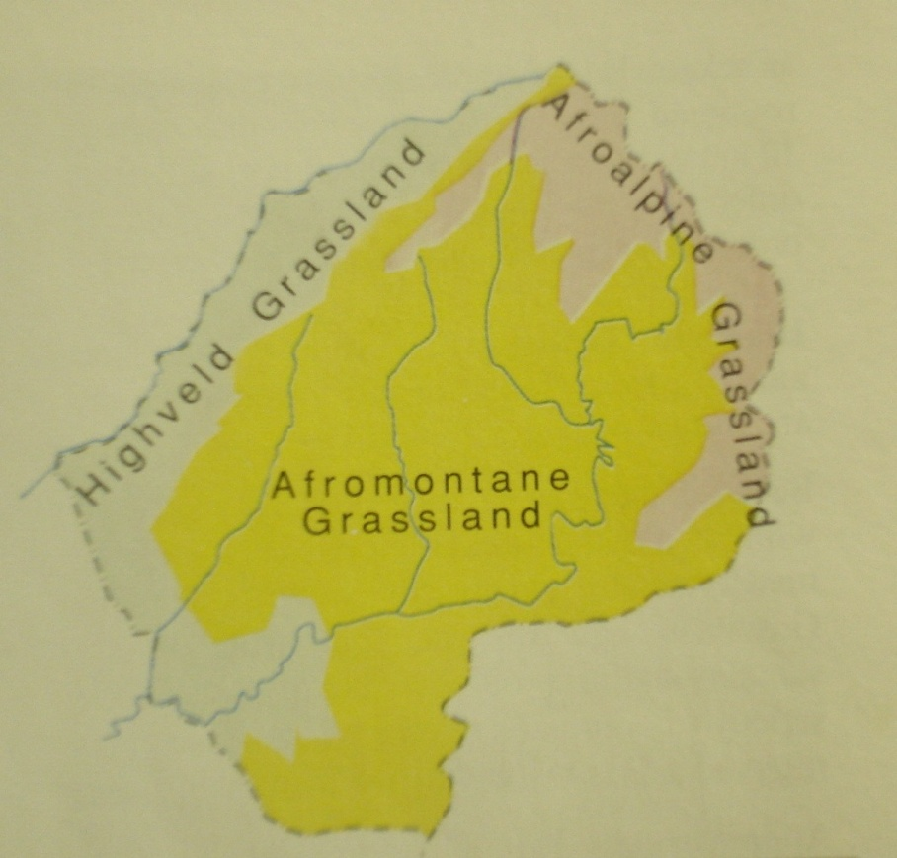
Map sourced from Lesotho Government, National Environment Secretariat, Biological Diversity in Lesotho: A country Study, Maseru 2000

Biodiversity Status
The grasslands zones distribution map, reflecting the three zones has also been described into twelve vegetation types “The indigenous Forests of Lesotho, their former occurrence E.D.May 2000” as informed by Range Management Division Inventory as shown in table 1 below. The vegetation type distribution within these zones is somewhat affected by altitude and aspect as described below.
Table 1: Vegetation Types
Type | Vegetation type | Area (ha)
1 | Hyparrhenia Grasslands | 350,190
2 | Eragrostis/Aristida Grasslands | 147 555
3 | Themeda Grasslands | 474 797
4 | Festuca Grasslands | 358 316
5 | Chrysocoma/Artimesia Low Scrublands | 359 680
6 | Leucosidea Scrublands | 131 201
7 | Rhus Scrublands | 110 771
8 | Merxmuellera Grasslands | 106 356
9 | Shallow rock lands | 158 202
10 | Residential Areas | 69 431
11 | Cultivated Fields | 765 512
12 | Bog lands | 2 224
Total Area (ha) |  | 3 034 235
Source: The Indigenous Forests of Lesotho, their former occurrence E.D.May 2000

Highveld Grassland Zone:
This zone spans the western lowlands of Lesotho starting at the lowest point (1400 m.a.s.l) which includes the southern region of the Senqu valley and extends to about 1800 m.a.s.l. Its main vegetative cover consists of typical grass species, the bulk of which are the Hyparrhenia hirta or thatching grass as is commonly known; Eragrostis curvula – Weeping Lovergrass; Themeda triandra – Red Grass that is mainly livestock fodder and Cymbopogon plurinodis – Bushveld Turpentine Grass. The typical trees and shrubs consist of Salix babylonica – Weeping Willow (exotic), Acacia dealbata – Blue Wattle (exotic), Rhus dentata – Nanaberry, Buddleja salviifolia – Wild Sage that are largely sourced for firewood and construction; Rosa eglanteria – Sweet Briar (exotic) used as food supplement; Olea europaea subsp. africana – Wild Olive that is harvested for religious purposes. Cussonia paniculata – Mountain Cabbage Tree known for its medicinal properties, Nicotiana glauca – Wild Tobacco (exotic), Rhamnus prinoides – Dogwood and Euclea crispa – Blue Guarri. Scattered within this zone are typical flowering plants such as Homeria pallida – Weed Iris used in rope weaving, Papaver aculeatum – Wild Poppy and Wahlenbergia androsacea – Harebell that are food supplements, Argemone mexicana – Mexican Poppy (exotic) and Datura stramonium – Thorn Apple (exotic) that are alian invasives; Oxalis depressa – Common Pink Sorrel that is medicinal and the variants of Aloe (Spotted Aloe Aloe maculata var. ficksburgensis , Common Soap Aloe, –) that feature in cultural rituals and medical implications. Associated with the highveld vegetation, especially the fauna, are: - Bubulcus ibis – Cattle Egret mainly frequenting livestock especially cattle; Streptopelia capicola – Cape Turtle Dove that ranges the whole zone; Pycnonotus nigricans – Redeyed Bulbul, Onychognathus morio – Redwinged Starling on hill sides, Procavia capensis – Rock Dassie, Mabuya striata punctatissima – Striped Skink that are associated with rocky places; Corvus albus – Pied Crow that has taken to scavenging, Rhabdomys pumilio – Striped Mouse in grassy and cultivated areas and Bufo rangeri – Raucous Toad in moist patches. The typical flora and fauna within the Highveld Grassland is more elaborated in table 2 below. The approach adopted whenever possible is that of starting with the English or common species name, then the scientific and lastly the local or Sesotho name where applicable.
Table 2: Typical Highveld Grassland Flora and Fauna
English Name | Scientific Name | Sesotho Name
Typical Grass Species
Red Grass  Bushveld Turpentine Grass  Thatching Grass  Weeping Lovegrass | Themeda triandra  Cymbopogon plurinodis  Hyparrhenia hirta  Eragrostis curvula | Seboku  Patiane  Mohlomo  Matolo
Typical Trees and Shrubs
Weeping Willow (exotic)  Blue Wattle (exotic)  Sweet Briar (exotic)  Wild Tobacco (exotic)  Mountain Cabbage Tree  Nanaberry  Dogwood  Blue Guarri  Wild Olive  Wild Sage | Salix babylonica  Acacia x dealbata  Rosa eglanteria  Nicotiana glauca  Cussonia paniculata  Rhus dentate  Rhamnus prinoides  Euclea crispa  Olea europaea subsp. Africana  Buddleja salviifolia | Moluoane  Boloukatlele  ‘Morobei  Tabakabume  Motśetśe  Mabelebele  Mofifi  Mohlakola  Mohloare  Lelothoane
Typical Flowering Plants
Weed Iris  Wild Poppy  Harebell  Mexican Poppy (exotic)  Thorn Apple (exotic)  Common Pink Sorrel  Common Soap Aloe,  Spotted Aloe | Homeria pallida  Papaver aculeatum  Wahlenbergia androsacea  Argemone mexicana  Datura stramonium  Oxalis depressa  Aloe maculata  var. Ficksburgensis | Teele  Sehlohlo  Tenane  Hlabahlabane  Letjoi  Bolila  Lekhala-la-thaba
Typical Fauna
Cattle Egret  Cape Turtle Dove  Redeyed Bulbul  Redwinged Starling  Pied Crow  Rock Dassie  Striped Mouse  Striped Skink  Raucous Toad | Bubulcus ibis  Streptopelia capicola  Pycnonotus nigricans  Onychognathus morio  Corvus albus  Procavia capensis  Rhabdomys pumilio  Mabuya striata punctatissima  Bufo rangeri | Leholosiane  Lekunkuroana  Hlakahlothoana  Letśoemila  Mohakajane  Pela  Khoana  Mokholutsoane  Marokolo
Adopted from Lesotho Government, National Environment Secretariat, Biological Diversity in Lesotho: A country Study, Maseru 2000.

Afromontane Grassland Zone
This zone extends from the foothills, about 1800 m.a.s.l, includes the foothills, upper Senqu valley to the watershed, covering most of the Maloti Mountain range in the middle, and parts of the Drakensberg mountain range in the Eastern side of the Senqu valley about 2500 m.a.s.l., It is worth a mention here that the range of some of the grasses, shrubs and fauna transcend more than one zone. This is the case with the Themeda triandra – Red Grass and Eragrostis curvula – Weeping Lovegrass that straddle the Highveld and Afromontane Zones. Kniphofia– Red-hot Poker variants, fauna such as Jackal Buzzard, Lanner Falcon, Grey Rhebok and Ice Rat that is common to both Afromontane and Afroalpine zones (Lesotho Government, National Environment Secretariat, Biological Diversity in Lesotho: A country Study, Maseru 2000). For the purpose of the exercise then the typical flora and fauna within the Afromontane Grassland is outlined in table 3 below.

Table 3: Typical Afromontane Grassland Flora and Fauna
English Name | Scientific Name | Sesotho Name
Typical Grass Species
Red Grass  Goat Fescue  Mountain Broom Grass  Weeping Lovegrass | Themeda triandra  Festuca caprina  Merxmuellera macowanii  Eragrostis curvula | Seboku  Letsiri  Moseha  Matolo
Typical Trees and Shrubs
Cape Willow  Broom Karee  Common Wild Currant  Oldwood  Cape Myrtle  Bitter Grape  Mountain Sage  Bitterbush | Salix mucronata  Rhus erosa  Rhus pyroides  Leucosidea sericea  Myrsine Africana  Rhoicissus tridentata  Buddleja loricata  Chrysocoma ciliate | Moluoane, Lebelete  Tsinabele  Kolitsana  Cheche  Morokapheleu  Morara-oa-thaba  Lelora  Sehalahala

Typical Flowering Plants
Gladiolus  Red-hot Poker  Everlasting Flowers  Agapanthus  Wand Flower, Harebell  Birdlime, Cushion Euphorbia  Spiral Aloe (endemic) | Gladiolus (several species)  Kniphofia (several species)  Helichrysum (many species)  Agapanthus campanulatus subsp. Patens  Dierama robustum  Euphorbia clavarioides  Aloe polyphylla | Khahla  Leloele  Phefo, Tooane  Leta-la-phofu  Lethepu  Sehloko  Kharatsa
Typical Fauna
Jackal Buzzard  Lanner Falcon  Bald Ibis  Whitenecked Raven  Rock Pigeon  Bearded Vulture  Grey Rhebok  Black-backed Jackal  Sloggett’s Rat, Ice Rat  Southern Rock Agama | Buteo rufofuscus  Falco biarmicus  Geronticus calvus  Corvus albicollis  Co,umba guinea  Gypaetus barbatus  Pelea capreolus  Canis mesomelas  Otomys slogetti  Agama atra | Khajoane  Phakoe  Mokhotlo  Lekhoaba  Leeba-la-thaba  Ntsu-kobokobo  Letsa  Phokojoe  Leboli-leqhoa  ‘Mampharoane
Table adopted from Lesotho Government, National Environment Secretariat, Biological Diversity in Lesotho: A country Study, Maseru 2000

Afroalpine Grassland Zone
This zone extends from 2500 m.a.s.l. and above. It is essentially the summit plateau of the Drakensberg in the East and its northern junction with the Maloti or Thaba-Putsoa range, generally limited to the >1000 mm rainfall influenced by the orographic conditions of this environment. Typical grasses of this zone are more or less similar to those found in the Afromontane, composed of the likes of Festuca caprina-goat fescue and Merxmuellera disticha, in addition to Pentaschistis oreodoxa-Mountain glory. Typical shrubs and woody plants that are associated with this zone are Chrysocoma ciliate-betterbush a plant commonly found on overgrazed rangelands, Erica dominans-Alpine heath and Euryops evansii-Strap leafed Daisy. Typical flowering plants occurring here include Kniphofia caulescens,helichrysum trilineatum and Dierama robustum previously described as occurring in Afromontane Zone as well, with an addition of Zaluzianskaya ovata-Mountain drumsticks and Large –flowered Lesotho pink Dianthus basuticus var.grandiflorus. Summit plateau are a home to a number of faunal species due to reduced human population and activities.
Comparatively, typical faunal types population and numbers are higher than in the other two zones, such as Buteo rufofuscus –Jackal buzzard, Falco biarmicus, anthus hoeschi, Ciconia ciconia,Otomys sloggetti , pseudocordylus spinosus and many other as reflected on table 4 below:
Table 4: Typical Afroalpine Grassland Flora and Fauna
English Name | Scientific Name | Sesotho Name
Typical Grass Species
Goat Fescue  Mountain Wiregrass  Mountain Glory | Festuca caprina  Merxmuellera disticha  Pentaschistis oreodoxa | Letsiri  Moseha  Letsoiri-le-lenyenyane
Typical shrubs and woody plants
Bitterbush  Alpine Heath  Strap-leafed Daisy | Chrysocoma ciliate  Erica dominans  Euryops evansii | Sehalahala  Lekhapu  Sehlakoana
Other Typical Flowering Plants
Red-hot Poker  Alpine Everlasting  Wand Flower, Harebell  Mountain Drumsticks  Large-flowered LesothoPink | Kniphofia caulescens  Helichrysum trilineatum  Dierama robustum  Zaluzianskaya ovata  Dianthus basuticus var. grandiflorus | Leloele-la-loti  Hukobetsi, Phefshoana-ea-loti  Lethepu  Lebohlollo, theleli  Tlokofiloane
Typical Fauna
Jackal Buzzard  Lanne Falcon  Rock Pigeon  Bearded Vulture  Orangebreasted Rockumper  Sentinel Rock Thrush  Drakensberg Siskin  Mountain Pipit (in summer only)  Wite Stork (in summer only)  Grey Rhebok  Sloggett’s Rat, Ice Rat  Spiny Crag Lizard | Buteo rufofuscus  Faco biarmicus  Columba guinea  Gypaetus barbatus  Chaetops aurantius  Monticoa exploratory  Pseudochloroptila symonsi  Anthus hoeschi  Ciconia ciconia  Pelea capreolus  Otomys sloggetti  Pseudocordylus spinosus | Khajoane  Phakoe  Leeba-la-thaba  Ntsu-kobokobo  Molisa-lipela  Thume  Soasoi  Tśaase-ea-loti  Mokotatsie  Letsa  Leboli-leqhoa  Sefelekoane-sa-loti
Table adopted from Lesotho Government, National Environment Secretariat, Biological Diversity in Lesotho: a Country Study, Maseru 2000

Wetlands

Transcending all the three grassland zones are Wetlands, described as natural water bodies that also attract a large variety of aquatic biota. They have a regulatory quality of storing water during rainy seasons and releasing it incessantly at a slower rate, to recharge ground water and streams. They also check floods in heavy rains and reduce sedimentation, thus producing substantially compacted organic matter (peat). They are categorized as follows:-

Table 5: Wetland Types
Name | Character | Some Examples | Location
Marshes | Typically with reedbeds | Tebetebeng,  Mohlaka-oa-tuka,  Koro-koro | Berea  Maseru  Maseru
Tarns | Shallow pools and pans  without external drainage on sandstone outcrops | Qeme Plateau,  Boleka,  Kolo,  Sehlabathebe | Maseru  Mafeteng  Mafeteng  Qacha’s Nek
Bogs and sponges (also called mires) | Midslope and valleyhead fens | At sources of streams and rivers | Throughout the Maloti and the Drakensberg Mountain ranges
There are however, other wetland features such as Tśa-kholo (Mafeteng) that fit the description of Tarns with no external outlet, though they are not necessarily on sandstone outcrops. Wetlands are an important ecological niche for a variety of plants and animals as indicated in table 6 below.

Table 6: Wetlands and Rivers Flora and Fauna
English Name | Scientific Name | Sesotho Name
Typical Grass Species
Mountain Bluegrass  Mountain Broom Grass  Common Reed (Lowlands) | Poa binata  Merxmuellera macowanii  Phragmites australis | Joang-ba-lintja-bo-boholo  Moseha  Lehlaka
Typical Trees
Weeping Willow (exotic)  Cape Willow  Camdeboo Stinkwood (river banks)  Star Apple (river banks) | Salix babilonica  Salix mucronata  Celtis Africana  Diospyros lycioides | Moluoane  Moluoane, Lebete  Molutu  Lehlajoa
Other Typical Plants of the Water Edge or Shallow Water
Yellow Nut Grass  Common sedge  Horsetail  Cat’s Tail Bulrush (Lowlands)  Marsh Buttercup | Cyperus esculentus  Mariscus congestus  Equisetum ramosissimum  Typha latifolia subsp. Capensis  Ranunculus meyerii | Monakalali  Qoqothoane  Lehlaka-pothoane  Mositla  Tlhapi-ea-metsi-e-nyenyane
Typical Floating Plants
Swimming Crassula  Wateruintjie  Pondweed  ‘Floating Stars’ | Crassula natans  Aponogeton junceus  Potamogeton thunbergii  Limosella capensis | Mokhoabo  Lijo-tsa-lihohoana  Sesesi  Boliba

Typical Fauna
Heron  Hamerkop  Hadeda Ibis  Duck  Blacksmith Plover  Giant Kingfisher  Red Bishop, Golden Bishop  Cape Clawless Otter  Water Mongoose  Common Brown Water Snake  Common Platanna  Berg Stream Frog  Ice Rat | Ardea (several species)  Scopus umbretta  Bostrychia hagedash  Anas (several species)  Vanellus armatus  Ceryle maxima  Euplectes orix, E. afer  Aonyx capensis  Atilax paludinosus  Lycodonomorphus rufulus  Xenopus laevis  Strongylus hymenopus  Otomys sloggetti | Kokolofitoe  ‘Mamasianoke  Lengaangane  Letata  Mo-otla-tśepe  Seinoli-se-seholo  Thaha-khube, Thaha-tśehla  Qibi, Thene  Molube  Tlatlametsi  Lentsoeta  Serarana-sa-linoka  Leboli Leqhoa
Table adopted from Lesotho Government, National Environment Secretariat, and Biological Diversity in Lesotho: a Country Study, Maseru 2000

Plant Taxa:
A series of plant surveys were undertaken in various locations in Lesotho (Phillips 1917, Jacot Guillarmod, 1971, Schmits 1984, Kali & Hargreaves 1985, Leslie 1992 (A & B), Arnold & de Wet 1993, Loxton Venn & Associates 1993, May 1994, Duckett 1995, Rubbright 1995 and AfriDev Consultants 1996 …..) which culminated in the compilation of plant taxa (families, genera, species, subspecies and varieties) of Lesotho. The table 7 below demonstrates the species diversity and richness of the country, which reaffirms the importance of regular Botanical surveys.

Table 7: Showing known Lesotho Plant Taxa
Category | NO. of Families | NO. of Genera | NO. of Species | NO. of Subspecies | NO. of Varieties
Thallophytes  (Algae &Fungi) | >32 | 74 | 132 | - | -
Bryophytes  (Liverworts & Hornworts) | >10 | 39 | 60 | 1 | 1
(Mosses) | >28 | 102 | 219 | 2 | 6
Pterridophytes  (Ferns & Fern allies) | 20 | 32 | 85 | 1 | 15
Gymnosperms | 6 | 16 | 62 | 1 | 8
Angiosperms  (Monocotyledons) | 24 | 187 | 776 | 43 | 72
(Dicotyledons) | 106 | 466 | 1759 | 129 | 158
TOTALS | >226 | 916 | 3093 | 177 | 260
Sourced from Lesotho Government, National Environment Secretariat, Biological Diversity in Lesotho: a Country Study, Maseru 2000

Complementary to table 7 above, the combined species records are indicated in table 8 below. The table shows the known status and the historical figures interpreted as those that existed over Fifty years back, currently considered extinct in Lesotho.

Table 8: Recorded Fauna and Flora of Lesotho
Group | No of Current Species | No of Historical Species | Total
Mammals | 63 | 19 | 82
Birds | 318 | 22 | 340
Reptiles | 40 | 3 | 43
Amphibians | 19 | - | 19
Freshwater Fish | 14 | - | 14
Invertebrates | 1279 | - | 1279
Plants | 2961 | - | 2961
Thallophytes | 132 | - | 132

Of the total plants recorded in Lesotho, thirty percent (30%) found in the Maloti/Drakensburg hot-spot area are endemic that is they are found nowhere else in the world. The table below shows extends of endemism.

Table 9: Species Endemism
Maloti/Drakensberg Species Endemism
Family | Endemic Species | Non endemic Species | Total Species | Percent Endemic
Total Flora | 373 | 898 | 1271 | 29.3
Endemism significantly higher than total flora
Asteraceae (Daisy family)  Scrophulariaceae (Snapdragon family)  Ericaceae (Heathers) | 118  36  15 | 167  43  11 | 285  79  26 | 41.4  45.6  57.7
Endemism similar to total flora
Liliaceae sensu lato (Lily family)  Fabaceae (Pea family)  Iridaceae (Iris family)  Cyperaceae (Sedges)  Asclepiadaceae (Milkweed family)  Campulanaceae (Lobelia family)  Apiaceae (Parsley family)  Gentianaceae (Gentian family)  Crassulaceae (Crassula family)  Geraniaceae (Cranebill family) | 20  14  20  14  13  9  7  6  6  5 | 64  51  45  45  31  16  14  15  14  15 | 84  65  65  59  44  25  21  21  20  20 | 23.8  21.5  30.8  23.7  29.5  36.0  33.3  28.6  30.0  25.0
Endemism significantly lower than total flora
Poaceae (Grasses)  Orchidaceae (Orchids) | 19  15 | 89  68 | 108  83 | 17.6  18.1
Table sourced from Lesotho Government, National Environment Secretariat, Biological Diversity in Lesotho: a Country Study, Maseru 2000

Conservation Categories:
Information articulated so far, largely covers the country on randomly selected samples. The status is not necessarily a reflection of a uniform set of conservation parameters, but a contribution from categories of conservation efforts.
There are six categories namely:
- Maboella category that constitutes a traditional management tool for livestock grazing control throughout the country.
- The Range Management Area category as a conservation strategy, exclusively used by organized livestock farmers, has through recent innovations been transformed into ‘Environmental Resources Management Areas’ category to incorporate all resource users.
- Botanical Gardens network as a category have also come into being.
- The indigenous forest patches.
- And newly introduced forest plantations for a category of forest reserves.
- Since Lesotho has become party to the CBD, protected areas network as a conservation strategy has been initiated and has somewhat advanced and contributed tremendously to in-situ conservation efforts compensating the ex-situ conservation efforts.
The table 10 below is an illustration of the various categories that inform the country’s conservation status in accordance with the International Union for the Conservation of Nature and Natural Resources classification (IUCN). The distribution is shown on map 2, which shows a relatively small impact compared to the CBD recommendation to cover at least ten percent (10%) of the land area.
Table 10: Current Conservation Categories
IUCN Categories | Name | Area (ha) | Management Objectives
II | Sehlabathebe National Park | 6475 | Economic and biodiversity functioning of the region, ecosystem protection and recreation.
II | Tsehlanyane Nature Reserve | 5333
II | Bokong Nature Reserve | 1972
II | Masitise Nature Reserve | 20
III | Thaba-Bosiu Mountain | 150 | Managed mainly for conservation of specific natural or cultural features
III | Liphofung Cave, Cultural and Historical Site | 4
III | NUL Botanical Garden | 1.5
III | Min. of Agric. Arboretum | 0.1
III | Katse Botanical Garden | 17
VI | Maboella Areas |  | Managed mainly for sustainable use of natural resources.
VI | Khomo-phatsoa MRA | 33000 | Managed mainly for sustainable use of natural resources.
VI | Mokhotlong/Sanqebethu MRA | 52000 | Managed mainly for sustainable use of natural resources.
VI | Liseleng ERMA | 8385 | Managed mainly for sustainable use of natural resources.
VI | Mofolaneng ERMA | 14988 | Managed mainly for sustainable use of natural resources.
VI | Khubelu ERMA | 140488 | Managed mainly for sustainable use of natural resources.
VI | Ramatseliso ERMA | 10082 | Managed mainly for sustainable use of natural resources.
VI | Forest reserves | 12995.70 | Managed mainly for sustainable use of natural resources.
Table adapted from MDTP 2007.Spatial assessment of Biodiversity Priorities in the Lesotho Highlands: Technical Report, Department of Environment: Tichnical Report,Maseru,Lesotho.

The conservation categories mentioned in table 10 above, contribute significantly to biodiversity conservation, especially the protected areas at the IUCN Category II, who’s pristine and wilderness zones are highly regulated against trespassing. Under category VI, the management approaches other than ‘Maboella, have started with the key concept as Range Management Areas (RMA). The management objective of RMAs was improvement of rangeland for specific interest groups of livestock farmers. Over time, growing interest as a result of other natural resources benefits accruing out of such conserved areas resulted in the transformation of this concept, to accommodate several user groups.
This has now become known as Managed Resource Areas and Environmental Resources Management Areas synonymously. The history behind the RMAs was one of entitlement mindset for interest groups. This has largely influenced the slow pace of acceptance and proliferation of the new approach. Map 2 below shows location of some key protected areas.
Map 2: Distribution of Protected Areas
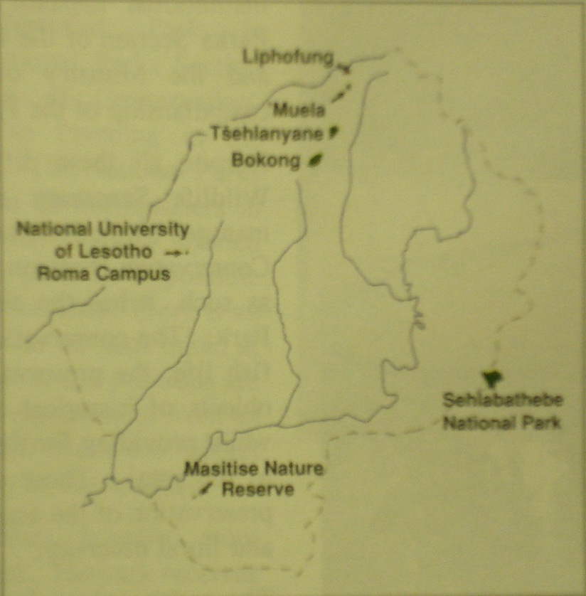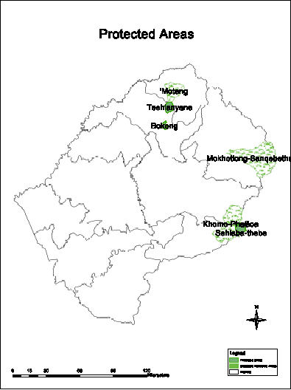
Map sourced from Lesotho Government, National Sourced from Department of Environment
Environment Secretariat, Biological Diversity in (Database)
Lesotho: a Country Study, Maseru 2000

Invasive Alien Species:
The nature of the Biodiversity status in the country is such that there are commonly acknowledged naturally existing species. There are also those that are exotic to the biome that managed to successfully adapt and propagate, so well that they have invaded or out-competed the native species. These are classified ‘Invasive Species, defined as: ‘Invasive alien species (plant or animal life) that have been introduced deliberately or unintentionally outside their natural distribution, where they have the ability to establish themselves, invade, out compete native species and take over environments, or ecosystems and threaten biological diversity (Invasive Alien species in Lesotho, distribution report 2007). Invasive Alien species are acknowledged as chief threat to biodiversity, riding on the globalization wing of rapidly increasing human trade and tourism, transporting such species over their natural geographic barriers. They have both harmful and beneficial characteristics. In fact the majority of species used in agriculture, forestry and fisheries are alien species (Wittenberg, R., Cock, M.J.W. (eds.) 2001. It could also be concluded that the decline in the native species has partly been contributed to, by alien species introduction and invasion, while a degree of interference with natural environment has also been observed to result in the invasion of certain species by others (e.g., overgrazing and construction). In order to better appreciate the nature of Alien and often invasive species in Lesotho efforts have been made to establish the status of invasive alien species in table below (Invasive Alien species in Lesotho, Status report 2005).
Table 11: Invasive Species found in Lesotho
Aquatic Species |  | Terrestrial Species
Weeds | Fish | Trees and Shrubs | Grasses | Weeds | Birds and Insects
Parrot feather  Mycophyllum aquatinum | Common carp  Cyprinus carpio  (kapore) | Gery poplar  Populars canescens  (Populiri e putsoa) | Kikuyu grass  Pennisetum clandestinum  (Mohloa-Tsepe) | Spiny cocklebur  Xanthium spinosum  (Shobashobane) | European starling  Sturnus vulgaris
Red water fern  Azolla fillicodes | Rainbow trout  Oncorhynchus mykiss  (Terautu) | Silver wattle  Acacia dealbata  (Keketsa / Boloukatlele) |  | Large cocklebar  Xanthium stramonium  (Shobashobane) | Rebreasted Sparrowhawk
Typha capensis  Motsitla | Large-mouth bass  Micropterus salmoides  (Base) | Euculyptus camalduleness  (Boloukomo) |  | Striga asiatica | Wattle bag work  Chaliopsis junodi
 |  | Aleppo pine  Pinus halepensis  (Phaena) |  | Russian tumbleweed  Salsola kali | Bagrada bug  Bagrada hilaris  (Mapepana)
 |  | Pinus pinastor  (Phaena) |  | Avena fatua  (Belete) | Snout biitle  Gonipterus scultellatus
 |  | Sesbania punicea |  | Cosmos  Bidens Formosa  (Moonyane) | Elegant grasshopper  Zonocerus elegans  (Tsie balimo)
 |  | Nicotiana glauca |  | Large thorn apple  Datura ferox  Letjoi
 |  | Sweetbriar  Rosa rubiginosa  (Khunoane / Rosi) |  | Common dodder  Cuscuta capenstris
 |  | Ailanthus altissima |  | Mexican Poppies  Argemone ochroleuca  (Hlabahlabane e putsoa)
 |  | Yellow firethorn  Pyragantha angustifolia |  | Khaki bush  Tagetes minuta  (Letekatse / Lechuchutha / Monkhankhane)
 |  | Robinia pseudoaccacia |  | Sour fig  Carpobrotus edulis  (Lichips)
 |  | American bramble  Rubus culneifolius  (Monokotsoai) |  | Large thorn apple  Datura stramonium  (Letjoi)
American agave
Agave Americana
(Lekhala kappa / Kharambomo)
Sweet prickly pear
Opuntia ficas-indica
(Torofe-i-ee)
Queen of the night
Cereus jamocara
Table sourced from Invasive Alien species in Lesotho, Status report: National Environment Secretariat 2005).

Criteria for Classification of Species:
The general criteria used for classification of species especially indicating status is as shown in the table below.
Table 12: Classification Creteria
Abreviated Indicator | Decription | Interpretation
A | Abundant | Species which are likely to be encountered in significant or even large numbers throughout Lesotho or in certain areas of Lesotho
C | Common | Species frequently encountered
U | Uncommon | Species infrequently encountered or common only in very restricted locations.
R | Rare | Species for which there are less than 10 reliable records since 1950
S | Single Record | Species for which there has only been a single Lesotho record, which must have been since 1950
N | No Reliable Record | Species which may occur or have occurred but for which the available evidence is at present insufficient to establish a reliable record.
H | Historical | Species for which all records are earlier than 1950
Table developed after David Ambrose institute of Education national University of Lesotho 1999.

Trends
Existence of species in general within the Lesotho environs as classified under the criteria given in the above table, assumes either ideal or most tolerable conditions favoring its existence. From oral history, early travelers’ diaries and later in archaeological investigations and current literature, there is an indication that species richness has for many reasons undergone decline from some base condition at any given period. Such observations then suggest the need for formal periodic monitoring, in order to establish changes or trends, be it negative or otherwise of species from baseline conditions. This leads to diagnosis of factors driving such changes and ultimately leads to application of remedial action directly by government, and facilitation of other agencies. The current status of species therefore is something of a palimpsest of spatial observations on the one part and later interpretations of the same on the other. The interpretation here has drawn heavily from con-current literary works than any first hand information. Species loss has occurred to a certain extent due to changes in environmental parameters, including intensive agricultural practices drastically changing the soil matrix and extensively encroaching on to the rangeland, animal husbandry in which range management focuses on unorthodox means of fodder production and unplanned human settlement resulting in transformation of rangeland by villages. There are other effects as a result of industrial waste both locally, regionally and internationally that together impact negatively on the environment, as a result most species habitat is transformed faster than its adaptive capacity and is subsequently marginalized. As a result many species either migrate to more tolerable conditions or inevitably vanish.

Vegetation

Status and Trends
The vegetation types shown in the tables above, constituting the grasses, trees and shrubs for both terrestrial and aquatic conditions, have experienced pressure and faced decline in species populations and diversity due to various factors constituting threats, discussed in more detail under biodiversity threats below. Trends in the vegetation cover have for years been in the decline. The perceived recovery due to interventions like Social Forestry, Protected Areas and Managed Resources Areas, only served to reduce the rate of decline.

Birds:

Status and Trends
Birds of Lesotho have been extensively studied by various scholars, and the available information indicates that our birds exhibit most species diversity amongst the vertebrates. In total sum three hundred and forty (340) species of birds have been recorded, representative of twenty three (23) orders and sixty five (65) families. The total is a high proportion of the twenty six (26) orders and ninety one (91) families found in Southern Africa as a whole (Maclean,1993). The figures are inclusive of species that are well established in Lesotho as well as those that have displayed some migratory behaviors. The status is derived from sources that have directly and otherwise drawn from various field surveys spread over a period starting from 1911 right up to 1998. The bird checklists shown in table 13 below as well as the correlation to the Red Data Checklist in table 14 are therefore deductions from direct field surveys by individuals and/or groups in patchy episodes over the country. The checklist developed over a long period as indicated above, is not areas specific, but generally covers the country.

Observations of environmental transformation over the grassland zones, in general have shown that depletion of the range or natural resources (over harvesting, encroachment by villages, agriculture and uncontrolled burning), have resulted in the degradation of the habitat quality and obviously negatively affected the bird species dependent on such habitat. By assumption therefore such habitat change has contributed to the decline of bird population. Species such as the Redbilled Oxpecker (Lesotho Government, National Environment Secretariat, Biological Diversity in Lesotho: a Country Study, Maseru 2000) have noticeably declined significantly. On the other hand, a number of forestry interventions were undertaken through the Lesotho woodlot project whose main aim was to improve wood production and supply, and later the Forestry Division and many other Communities based NON –Governmental Organizations, which have provided opportunities that were conducive for breeding conditions of birds. This has somewhat contributed in mitigating part of habitat loss, and have actually been instrumental to attracting new species of birds, such as the Redbreasted Sparrowhawk and species of barbet notably the Blackcollard and crested Barbets (Lesotho Government, National Environment Secretariat, Biological Diversity in Lesotho: a Country Study, Maseru 2000). One may reasonably come to the conclusion that the bird species status has somewhat stabilized.

Table 13: Checklist of Lesotho's Birds
Order | Family | No of Species
Struthioniformes | Struthionidae | 1
Podicipediformes | Grebes – Podicipedidae | 2
Pelecaniformes | Cormorants – Phalacrocoracidae  Darters – Anhingidae | 2  1
Ciconiiformes | Herons  Egrets – Ardeidae  Bitterns  Hamerkop – Scopidae  Storks – Ciconiidae  Ibises  Spoonbills – Plataleidae (=Threskiornithidae) | 7  3  2  1  4  4  1
Phoenicopteriformes | Flamingos – Phaenicopteridae | 2
Anseriformes | Ducks  Geese - Anatidae  Swans | 7  3  6
Falconiformes | Secretarybird – Sagittariidae  Eagles  Hawks  Buzzards - Accipitridae  Kites  Vultures  Other Raptors  Falcons  Kestrels - Falconidae | 1  3  6  3  3  5  7  3  4
Galliformes | Francolins  Pheasants  Partridges - Phasianidae  Quail  Guineafowl – Numididae | 7  1
Gruiformes | Buttonquails – Turnicidae  Cranes – Gruidae  Rails  Crakes  Flufftails - Rallidae  Gallinules  Moorhens  Coots  Bastards  Korhaans - Otididae | 1  3  1  3  1  2  2  1  2  3
Charadriiformes | Jacanas – Jacanidae  Painted Snipe – Rostratulidae  Plovers – Charadriidae  Sandpipers  Snipe  Stint - Scolopacidae  Phalarope  And similar Waders  Avocets  Stilts - Recurvirostridae  Dikkops - Burhinidae  Coursers  Pratincoles - Glareolidae  Skuas  Gulls - Laridae  Terns | 1  1  6  10  1  1  1  2  2  4
Pterocliformes | Pteroclidae | 1
Columbiformes | Pigeons  Doves - Columbiformes | 3  4
Cuculiformes | Cuckoos  Coucals - Cuculidae  And similar birds | 7
Strigiformes | Barn  Grass Owls - Tytonidae | 7
Caprimulgiformes | Nightjars - Caprimulgidae | 4
Apodiformes | Swifts – Apodidae | 6
Coliiformes | Mousebirds – Coliidae | 3
Trogoniformes | Trogons, Quetsal and similar birds – Trogonidae | 1
Alcediniformes (or Halcyoniformes | Kingfishers – Alcedinidae (or Halcyonidae)  Bee-eaters – Meropidae | 3  1
Coraciiformes | Rollers – Coraciidae  Hoopoe – Upupidae | 2  1
Piciformes | African Barbets – Lybiidae  Honeyguides – Indicatoridae  Woodpeckers – Picidae  Wrynecks – Jyngidae | 4  3  2  1
Passeriformes | Larks – Alaudidae  Swallows  Martin - Hirundinidae  Cuckooshrikes  Minivets - Campephagidae  Drongos – Dicruridae  Old World Orioles – Oriolidae  Crows  Jays - Corvidae  Magpies and similar  Tits – Paridae  Babblers – Timaliidae  Bulbuls – Pycnonotidae  Thushes  Chats - Turdidae  Robins  And similar birds  Warblers  Cisticolas  Prinias - Sylviidae  And similar birds  Old World Flycatchers – Muscicapidae  Wagtails  Pipits - Motacillidae  Longclaws  Shrikes – Laniidae  Starlings – Sturnidae  Oxpeckers – Buphagidae  Sunbirds and Spiderhunters – Nectariniidae  White-eyes – Zosteropidae  Weavers  Sparrows  Bishops - Ploceidae  Widows  And similar birds  Waxbills  Mannikins - Estrildidae  Twinspots  Firefinches and similar birds  Whydahs  Widowfinch - Viduidae  Canaries, Buntings and similar birds - Fringillidae | 12  7  5  1  1  2  3  1  1  1  4  8  2  2  11  6  3  5  8  2  7  1  3  7  1  1  1  5  4  2  4  1  7  1  2  13

RED DATA LIST:
Species abundance is a characteristic of suitability of environmental parameters. Changes brought about by many factors have resulted in population changes to the extent that the species become extinct, either in terms of physical termination from existence, or migration from the native environment. Changes on the species population have since been graded to create awareness and to alert the authorities to institute mitigation where possible. Documentation highlighting biodiversity losses at the species level have come to be known internationally as ‘Red Data’ (Fiedman Y. and Daly B, (editors) 2004. The grading or categorization of species in the Red Data lists is shown in accordance in the species Tables 12 below.

Table 14: Red Data Book Bird Species occurring also on the Lesotho Checklist
(Lesotho status given in parenthesis after species name)
Vulnerable Species | Rare or Near Threatened Species | Of Special Concern | Indeterminate Species
Bald Ibis (C) | Bearded Vulture (U) | Wattled Crane (R) | Black Stock (U)
Cape Vulture (U) | Black Harrier (U) |  | South African longclawed lark (= Rudd’s lark (S)
Lesser kestrel (C) | Drakensburg Siskin (C)
Yellow breasted pipit (U) | Ground Woodpecker (C)
 | Mountain Pipit (C)
 | Orangebreasted Rockjumper (C)
Table sourced from Lesotho Government, National Environment Secretariat, Biological Diversity in Lesotho: A Country Study, Maseru 2000

Mammals:

Status and Trends
The more recent record of mammals found in Lesotho has been provided by Ambrose (1999C), this was an improvement from the work of Lynch (1994). Whose information was based on thirteen (13) field trips over a period of four years (1988 to 1992). This resulted in fifty two (52) species of mammals, to which Ambrose added an additional eleven (11) species. It is assumed that Lynch may have omitted some of the species because of their association with humans, while some of un authenticated records were later confirmed to have been found in Lesotho. Lesotho is regarded as Regional stronghold for the white tailed Mouse (Sksteen, 1997). Therefore the present record of Lesotho’s mammals is taken as sixty three (63) species, as depicted in table 15 below.

The trends of Lesotho mammals are two dimensional. On the one hand, the scenario provided by the grassland zones in association with forest reserves, under the management practice of Maboella Regime (administered through the chieftainship regime) supported a diversity of mammals both large and small. Lesotho Government, National Environment Secretariat, and Biological Diversity in Lesotho: A country study (2000) indicates that at one stage, this grassland biome supported up to 82 species. On the other hand, habitat degradation due to multiple factors reduced this number to 63 species. The large mammals were the most affected by the deterioration of the environment. In the mid-Sixties, Maboella effectiveness as a conservation tool had declined to the point that government introduced another concept of ‘Range Management Areas’ – RMAs and later derivatives of the concept. In the early seventies and onwards, the introduction of woodlots and later ‘Protected Areas’ concepts further increased coverage in areas of special management regimes. While the overall trend of species was on the decline and still is, these concepts have arrested the pace, as demonstrated by return of some antelopes (Eland and Oribi) even though, so far not to the extent of establishing breeding populations (Lesotho Government, National Environment Secretariat, Biological Diversity in Lesotho: A country study, 2000).

Table 15: Checklist of Lesotho Mammals
Order | Family | No of Species
Insectivora | Shrews – Soricidae  Hedgehogs – Erinceidae  Golden Moles – Chrysochloridae | 4  1  2
Macroscelidea | Elephant Shrews – Macroscelididae | 1
Chiroptera | Free-tailed Bats – Molossidae  Vesper Bats – Vespertilionidae  Horseshoe Bats – Rhinolophidae | 1  6  1
Primates | Monkeys  Baboons - Cercopithecidae | 1  1
Lagomorpha | Hare  Rabbit - Leporidae | 2  2
Rodentia | Mole Rats – Bathyergidae  Porcupine – Hystricidae  Springhare – Pedetidae  Dormice – Gliridae  Squirrel – Sciuridae  Rats  Mice - Muridae | 1  1  1  1  1  6  10
Carnivora | Aardwolf – Protelidae  Hyaena – Hyaenidae  Cats – Felidae  Fox  Wild Dog - Canidae  Jackals  Otters  Polecats  Weasels - Mustdelidae  Honey Badger  Mongooses  Civets - Viverridae  Genets  Suricate | 1  2  8  1  1  1  2  1  1  1  5  2  2  1
Tubulidentata | Aardvark – Orycteropodidae | 1
Hyracoidea | Dassies – Procaviidae | 1
Perissodactyla | Zebras – Equidae | 1
Artiodactyla | Pigs – Suide  Hippopotamus – Hippopotamidae  Antelopes  Buffalo - Bovidae | 1  1  16

Table 16: Status of Mammals in Lesotho

Status | No of Species
Abundant (A) | 3
Common (C) | 10
Uncommon (U) | 15
Rare (R) | 27
Single Records (S) | 8
Historical (H) | 19
Total | 82
No authenticated Record (N) | 9

Table 17: Red Data Book species also Occuring on Lesotho Checklist
(Lesotho status given in parentheses after species names)
Extinct Mammals (2)
Quagga  Blue Antelope | (H)  (H)
Vulnerable Species (5)
African Wild Cat  Honey Badger  Antbear  Oribi  White-tailed Mouse | (R)  (H)  (S)  (R)  (U)
Rare Species (8)
S A Hedgehog  Aardwolf  Brown Hyaena  Leopard  Caracal  Hippopotamus  Blue Duiker  Red Duiker | (R)  (H)  (S)  (R)  (S)  (H)  (H)  (H)
Indeterminate Species (3)
Sciater’s Golden Mole  Lesueur’s Hairy or Wing-gland Bat  Winton’s (=De Winton’s) Long-eared Bat | (U)  (S)

REPTILES:

Status and Trends
It would appear that the reptile data is highly extrapolated or very patchy at the most. Original works on reptiles cover the entire southern Africa, as a result of which records pertinent to Lesotho have been verified through visits to regional museums, while some have been deduced by association of existence in places proximal or adjoining Lesotho. The only systematic reptile survey took place in the Lesotho Highlands Phase 1A (Loxton, Venn and Associates 1993) and Phase 1B (Mouton, 1996a) areas, and the downstream along the Senqunyane River into the Senqu River down to the border (Mouton 1996b). A total of 43 species have been recorded in Lesotho, out of which 3 are historical and may be discarded for statistical purposes. Therefore, only 40 species of reptiles are considered to be occurring in Lesotho. This in comparison with a regional figure of 400 species and that of 6550 world wide is extremely low (Branch, 1988a).

Environmental conditions across the southern African region alone cannot account for the differences in species composition demonstrated above. The key contributing factor is the general phobia associated with reptiles in Lesotho, which is actually embedded in the mythology of the people, is that of killing reptiles on sight, specifically snakes. This mindset contributes to the decline of species population and makes research through contribution of rural communities extremely difficult. The use of reptiles for medicinal purposes also contributes to decline in species diversity and populations to certain extend. While conservation efforts could and probably do address the population loss, legal protection so far has only been afforded to tortoises, terrapins and monitor lizards (Ambrose, 1983).

The environmental benefit of agricultural pest control warrants their protection, which is still an overwhelming challenge. It has however been established that, of the entire reptile record, only a few of the snakes species are venomous. The idea of believing that every snake is venomous is somewhat impacting on the tradition of killing every snake on sight. But if the truth of the matter could be well researched and widely publicized the tradition would certainly change.

Table 18: Checklist of Lesotho's Reptiles
Order | Family | No of Species
Chelonians - Chelonii | Land Tortoises – Testudinidae  Side-necked Terrapins – Pelomedusidae | 1  1
Scaled Reptiles - Squamata | Blind Snakes – Typhlopidae  Thread Snakes – Leptotyphlopidae  Phythons and Boas – Boidae  Typical Snakes – Colubridae  Cobras, Mambas & their relatives – Elapidae  Adders & Vipers – Viperidae  Skinks – Scincidae  Old World Lizards or Lacertids – Lacertidae  Plated Lizards, Girdled Lizards & their relatives – Cordylidae  Monitors or Lequaans – Varanidae  Agamas – Agamidae  Chameleons – Chamaelionidae  Typical Geckos – Gekkonidae | 2  2  1  19  2  3  6  6  10  2  2  1  4

Table 19: Status of Reptiles in Lesotho
Reptile Species Status (1999) | No of Species
Abundant (A) | 3
Common (C) | 11
Uncommon (U) | 1
Rare (R) | 16
Single Recorded (S) | 9
Historic (H) | 3
Total | 43
No authenticated record (N) | 19
Table sourced from Lesotho Government, National Environment Secretariat, and
Biological Diversity in Lesotho: a country study, Maseru 2000
Table 20: Red Data Book Species occurring also on the Lesotho Checklist
(Lesotho Status given in parentheses after species name)
Vulnerable Species (2)
African Rock Python  Giant Girdled Lizard | (H)  (R)
Restricted Species (2)
Lang’s Crag Lizard  Spiny Crag Lizard | (S)  (S)

Amphibians:

Status and Trends
The data scenario provided for reptiles above, also applies to amphibians in that, the only systematic surveys for amphibians were those undertaken as part of the Lesotho Highlands water project (Loxten,Venn & Associates,1993; Mouton,1996a & 1996b) contributed to the development of the table, with an additional information from Bourquin & Mosenye (1989) who traced South African museums for specimen from Lesotho, and came up with sixteen(16) species. In addition standard work on Southern African frogs and toads (Passmore and Carruthers 2nd ed.., 1995) produced distribution maps, which often included part or all of Lesotho. The well known species of frogs and toads in Lesotho total nineteen (19), all belonging to a single order Anurans, which by international standards is regarded as of high diversity, compared to other parts of the world. Predictions are that the species diversity is likely to increase, as there are some nine (9) un authenticated species. The figures are based only on baseline biological survey of the Lesotho Highlands project (Loxton, Venn & associates, 1993; Mouton, 1996a & 1996b).

Survival of amphibians is highly dependent on the good quality of environment associated with wet conditions. Improved grassland vegetation offers an ideal environment for water retention and regulation. Increase in applying the innovations of range management concepts, including protected areas as well as woodlots, have a potential to increase species populations, even if diversity remains static.

Table 21: Checklist of Lesotho Amphibians
Order | Family | NO. of Species
Anurans | Toads-Bufonidae | 4
 | Ghost Frogs-Heleophrynidea | 1
 | Tree and Reed Frogs-Hyperoliidae | 3
 | Rain Frogs-Microhylidae | 3
 | Clawed Frogs-Pipidae | 1
 | Typical Frogs-Ranidae | 16

Table 22 Status of Lesotho's amphibians
Amphibian Species Status (1999) | No of Species
Abundant (A) | 6
Common (C) | 2
Uncommon (U) | 4
Rare (R) | 5
Single Recorded (S) | 2
Historic (H) | -
Total | 19
No authenticated record (N) | 9

Table 23: Red Data Book Species occurring also on the Lesotho Checklist
(Lesotho status given in parentheses after species names)
Restricted Species
Aquatic River Frog  Lesotho River Frog | (A)  (U)

FISH:

Status and Trends
We have the smallest class of fish species in Lesotho as compared to other vertebrate class (see table 24). This has been observed as a slight change from the way things have normally happened in other parts of the world. Fish species have commonly been noted as outnumbering other vertebrate classes. Out of a total of thirteen (13) indigenous species that are found in the Orange - Vaal system, only eight (8) have been recorded in Lesotho as reflected in table 25. In addition to the eight, two species of trout have been introduced for sporting purposes in the mountain streams, which are also known to carry invasive characteristics, especially the rainbow trout (Invasive Alien Species in Lesotho, Status Report NES 2005). An important endemic fish species of Lesotho, the Maloti Minnow predominantly found in the headwaters of the Lesotho Rivers and restricted to few localities of pristine conditions, is listed as endangered (see table 26). Conservation of the fish in the Mohale catchment has been subject of a study (Steyn et al., 1996). Introduction of trout in the tunnel between Mohale and Katse dams has been viewed as a threat to the existence of the species. Second to minnow the other threaten species is Rock catfish.
The common Carp-cyprinus carpio mostly found in the lowlands reservoirs, is regarded as an invasive alien species capable of causing severe habitat destruction resulting in negative impacts to the indigenous species. Often the destruction of habitat causes water turbidity which results in obstruction of the sun light most needed for some aquatic plants.
Threats posed by common carp, habitat destruction and the imminent introduction of trout in the tunnel that joins Mohale and Katse dams as well as in other systems (Sehlabathebe National Park) would certainly result in the decline of fish species. A survey undertaken within the park indicated that the ecosystem of the Tsoelikana river separated by a waterfall within the park, consisted of Minnow restricted to the upstream and the Trout below the waterfall, demonstrating the point that they cannot co-exist. In the light of the above the overall trend, points to a decline in species diversity.

Table 24: Checklist of Lesotho Fish
Order | Family | NO. of Species
Isospondyli | Salmon, Trout & Similar Fish – Salmonidae | 2
Ostariophysi | Carp & Carp-like Fish - Cyprinidae | 7
 | Rock catfish – Bagridae | 1
 | Common Catfish-Clariidae | 1
Percomorphi | Sunfish and Bass-Centrarchidae | 3

Table 25: Fish Status of lesotho
Fish Species Status (1999) | No of Species
Abundant (A) | 1
Common (C) | 8
Uncommon (U) | 5
Rare (R) | -
Single Recorded (S) | -
Historic (H) | -
Total | 14

Table 26: Red Data Book Species occurring also
on the Lesotho Checklist
(Lesotho status given in parentheses after species names)
Endangered Species (1)
Maluti Minnow | (U)
Rare / Indeterminate Species (1)
Rock Catfish / Rock Barbel | (C)

Main threats to biodiversity
Diversity of species is often a function of the quality of the habitat that determines the
adaptability threshold of Species. That is: when the quality of the habitat is transformed for the worst, the species population and diversity are negatively affected (e.g. vegetation clearance for road construction and subsequent invasion by more aggressive species
Out-competing the resident vegetation). Ineffective implementation of regulatory systems and declining powers of traditional authorities promotes unsustainable utilization of natural resources. The key drivers or causes of habitat change in this report are applied generally with examples to highlight impact on species.

Uncontrolled use of biological resources

Overgrazing
This is a condition in which range resources mainly, are grazed indiscriminately either through overstocking in a given area, or grazing the same area longer than the species’ natural recovery capability. The mountain soils are thin, young and poorly anchored; mountain environments can be extremely sensitive to disturbance and slow to recover. Overgrazing diminishes the vegetation cover, and reduces the chances of survival of faunal species dependent on the already fragile habitat. In essence this impacts negatively on the flora and fauna species population and diversity. Such a situation increases the chances of erosion of the soil matrix and/or subsequent conquer by invader species e.g. chrysocoma ciliata .
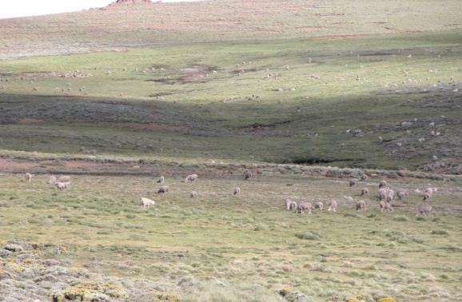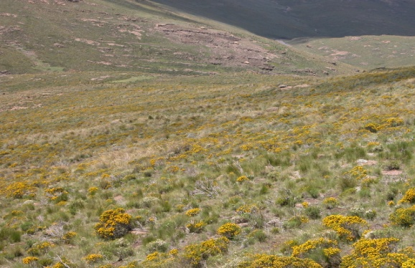
Figure 1: Overgrazing Figure 2: Colonisation by chrysocoma

Unsustainable harvesting
In Lesotho agrarian practices often dictate that people, especially at the rural periphery have high dependency on natural resource base. Lately medicinal plants are over harvested for commercial market, and in the advent of emergence of HIV Pandemic for instance, the use of indigenous herbs has intensified because of the assumed potency in managing the viral conditions, and relatively easier access associated with the herbs against the cost of conventional medication. This phenomenon has created a heavy demand on these herbs, hence their overexploitation of the resource thus invariably deplete some colonies completely. What then takes place is marginalization of the species populations, which ultimately affects the species diversity, because their relatives are subsequently accessed as substitutes.

Figure 3: Overharvesting of Medicinal Plants
The figure demonstrates a once-off consignment of herbs sourced from the rural periphery to provide for insatiable urban demand. The middleman is less concerned with regeneration aspects of the plants, hence colonies are wiped off.

Uncontrolled fire
The presence of fires in the Maloti-Drakensberg mountain ecosystem is a natural occurrence and is in itself not a threat to the biodiversity of the area. However, the rangelands of Lesotho are burnt intentionally annually in late summer to increase the grazing potential of the grass, and not as a conservation measure. This is indiscriminate because it burns the grass species, seeds and all, including associated fauna (eggs, hatchlings). In no time vulnerability sets in and the scenario similar to overgrazing where soil loss and colonization of denuded ground by invader species are experienced.

Encroachment

Settlements
Increase of population either in towns when urban growth expands to the periphery or out in the rural when village settlements are expanded on to the rangeland in an haphazard or unplanned manner. This means that the vegetation is cleared for housing and associated fauna which was as well dependent on the vegetation are negatively affected. Species populations and diversity are diminished. The usual story of settlement expansion is that larger areas than the finite settlement space are utilized to accommodate human movement. Expansive places have been colonized this way. This is even happening in situations where villages and towns expand to cropland.

Cultivation
Concentration of villagers in some convenient area, with settlements expansion as described above have a tendency to demand cropland area to support their subsistence requirements. It is observed occurring randomly all over where small fields are created on marginal land of steep slopes above normal cropland. This undoubtedly diminishes the rangeland and associated flora and fauna

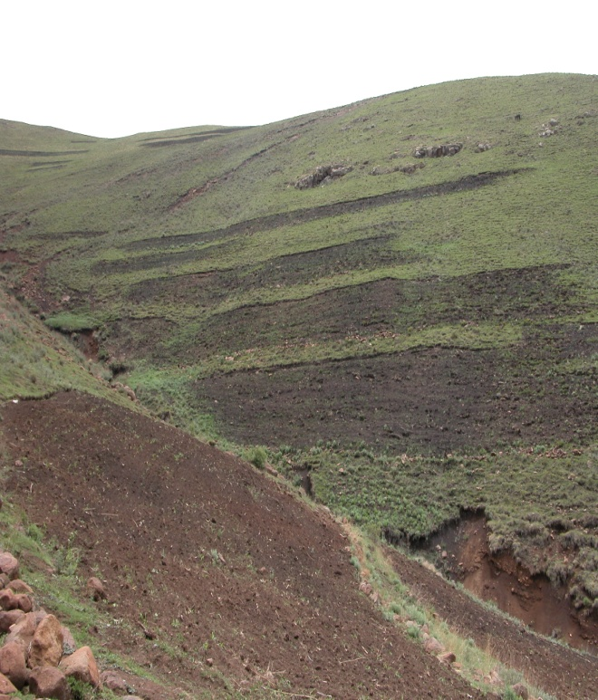
Figure 4: Encroachment of Rangeland by Cultivation

species. Ubiquitous presence of humans in such circumstances drives off animals further away into marginal areas. This also threatens the species populations and diversity, as pressure is created elsewhere and competition is triggered

Alien Invasive
Alien invasive species are organisms that have demonstrated the characteristics of adapting to habitats in a manner that out-compete native species. As indicated above, the potential for transformation of species habitat in Lesotho is fairly high. Extensive areas have already been rendered vulnerable to colonization by alien invasive species, through unchecked malpractices. A survey undertaken in 2005 on alien invasive species, established that there are Sixty-five (65) species found in Lesotho. 51 of these are terrestrial plants, 3 are aquatic plants, 2 birds, 1 mammal, 3 invertebrates, 4 fish and 1 micro-organism (Invasive Alien Species in Lesotho: Distribution Report, 2007). Major physical alterations, changes in species, populations and communities have occurred to ecosystems as a result of colonization by alien invasive species. A clear example is that of the Mirror carp – Cyprinus carpio occurring in many Lowlands Rivers and reservoir, which is very destructive to the habitat as well as eating spawn of other fish (Invasive alien Species in Lesotho Status Report National Environment Secretariat, 2005). It has been recognized that management and eradication of alien invasive species have multiple challenges in Lesotho due to the concept not well understood or appreciated at the rural level.

Pollution
Pollution can be considered to be a condition brought about by circumstances external to the habitat that do not only transform, but render the habitat hostile to native species, leading to immediate and often large scale loss of species. Although not a well researched topic in Lesotho, there are aspects of it that have been highlighted, such as chemical pollution from Agricultural Dip Tanks for livestock, placed close to fresh water courses, and industrial effluent such as seen in the figure below, where the effluent is directly discharged into a fresh water river system, and recommendations for disuse of certain pesticides (DDT), that are long acting and impacting negatively on more than one species.

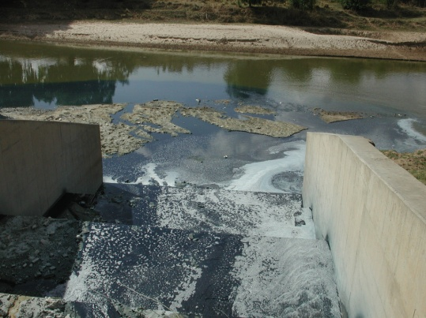
Figure 5: Industrial Discharge

Implications of Changes on Human wellbeing

The majority of rural communities are still largely dependent on natural resources for subsistence. The dependency is multifaceted. That is, some resources are food supplements, some are used for energy (cooking and space warming), and construction of homesteads, medicinal, artifacts and others are used for livestock farming purposes. Any impact on biodiversity that results in reduction on species and population size, affects availability and easy access. The wellbeing of such communities is negatively affected. For instance, insufficiency of the rangeland to support draught animals may lead to hunger or increased cost of cultivation. This also affect protein source from livestock in the form of milk and meat.
Reduction of medicinal plant species, like in the case of protein will increase cost of medication through imported industrial products. The majority of Basotho, especially in the rural setting, have at least one of the household structures roofed with thatching grass. Overgrazing, uncontrolled burning, or colonization of suitable habitat by alien invasive species will as well increase construction cost by increasing cost of acquiring the resource further a field and/or substitution by industrial alternatives. These drain them of meager resources and leave them worse off.
Water quality and quantity are both vital for human well being (cooking, washing, crop production, livestock feeding, construction and as energy source (hydropower)). Anything that affects its availability and quality will affect life expectancy and marginalize the conditions that support human wellbeing. Wetlands destruction therefore may consequently impact negatively on the water quality and quantity.

Chapter II - Current Status of National Strategy on Lesotho’s Biological Diversity: Conservation and Sustainable Use.

Background
Lesotho showed its commitment to sound biodiversity management long before coming into operation of the Convention on Biological Diversity – CBD. In 1989 the National Environmental Action Plan – NEAP was formulated. The basis of its compilation was a comprehensive consultation of all stakeholders whose comments contributed to the final edition of the document. The theme of the Action Plan highlighted the need for involvement of a wide spectrum of stakeholders from technocrats in the centre down to resource users at grassroots level. The Plan emphasizes the need for equitable sharing of benefits derived from sustainable utilization of the biodiversity as a natural resource.
Participation at the United Nations Conference on Environment and Development – UNCED (at the Earth Summit in Reo de Janeiro in 1992, resulted in the adoption of the International Agenda 21, as blueprint), influenced development of the National Action Plan to implement Agenda 21, as an enabling mechanism to incorporate environmental considerations in development activities. The localized Agenda 21 therefore, is an overarching framework in support of on-going and new initiatives for attaining viable economic growth, through sustainable development and improved resource management. In 1994 the Lesotho Government identified the need and established a body (National Environment Secretariat) that took responsibility for identification, assessment and coordination as well as monitoring action plans to ensure sound management and sustainable conservation of the biodiversity as a natural resource. The responsibility was carried out through development of the National Environmental Policy for Lesotho (1998) and enactment of supporting legislation (Environment Act 2001 and its amendment ‘Environment Act 2008’). It has been acknowledged internationally that human civilizations have depended on the biological diversity components as the fundamental base of life support. Sustainable development of such civilizations therefore can only be attained through conservation of this diversity. This is a major challenge that was recognized at the Earth Summit in Reo de Janeiro as well as through the development of the Convention on Biological Diversity – CBD.
Lesotho became full member of CBD in 1995. Ratification of this convention demonstrated a commitment to undertaking national and international measures that aim to achieve the main objectives of the Convention, namely to: Conserve the biological diversity; sustainable use of its components; and the equitable sharing of benefits arising out of the utilization of genetic resources. Lesotho then developed ‘the National Strategy on Lesotho’s Biological Diversity: Conservation and Sustainable Use’, in accordance with Article 6 (a) of the Convention. The strategy outlines long-term ‘biodiversity conservation goals’ that are to be achieved by a set of objectives, attained through a series of actions (National Environment Secretariat, Ministry of Environment, Gender and Youth Affairs, 2000). The strategic approach of establishment of the national conservation agency, enactment of national legislation on environment, bear witness of the intent to achieve sustainable biodiversity conservation as reflected in the long-term national vision 2020 below.
The 2020 vision states:” Lesotho shall be renowned for its environmental management. The country’s diversity of life systems will be supported and protected by a nation which is environmentally conscious and whose people are in balanced existence with the natural environment. Basotho will derive continuing benefits from the conservation and sustainable use of their biological diversity. The several global conventions and treaties that Lesotho has signed and ratified shall be translated into concrete actions which will sustain care and management of the environment at large.

The National Environment Secretariat (now the Department of Environment) adopted National Biodiversity Strategy and Action Plan (NBSAP), as the mechanism for implementation of the provisions of the CBD. In pursuance of Article 26 of the CBD, a matrix of projects and programs intended to address the goals, objectives and actions as contained in the NBSAP, is provided below. While the strategy identifies long-term goals, objectives and recommended actions, it is worth noting that the interventions in the form of projects and programs deal either on a broad spectrum of environmental facets, or with the individual or groups of components. The analyses may therefore show one project addressing more than one goal and/or objective.

National Biodiversity Strategy and Action Plan Priority Activities

Priority activities to enable implementation of biodiversity conservation goals are as follows:-
- Identification of biological diversity components through research and compile inventories to improve biodiversity conservation.
- Identification of processes likely to threaten Lesotho’s biodiversity.
- Identify and implement strategies that ensure sustainable conservation of biodiversity components (PAs, RMAs, ERMAs, Botanical gardens, Maboella).
- Strengthening of legal measures.
- Develop human resources and improve the skills required for biodiversity management.
- Increase participation of rural households in forest activities through their own initiatives, for their own purposes and under their own control.
- Identify and enhance management of Lesotho’s unique wetland systems.
- Reform agricultural practices in Lesotho, manage and constrain human activities that are responsible for destruction of biodiversity.
- Perform Environmental Impact Studies prior to implementation of activities that are likely to affect biological diversity adversely.
- Establish measures of benefit sharing.
- Develop material incentive program to change peoples behavior so that future land title holders make appropriate conservation decisions.
- Engage in international strategies that facilitate security of national and regional biodiversity components.

Table 27: NBSAP Performance Matrix
Goal 1:
Conserve the diversity of landscapes, ecosystems, habitat, populations, species and genes in Lesotho.
Objective to achieve the goal | Means of Implementation | Status | Comments | Targeted CBD Article
Identification of biodiversity components, systems and processes that threaten biodiversity in Lesotho | - Community Based Natural Resources Management – CBNRM.  - A checklist of Lesotho grasses | Project input phase targeted at changing community mind-set is complete. Regular monitoring to determine level of threats and remedial application required. | The key threat (Communal land Allocation under traditional leadership) still exists. However, transformation of administration at the community level into councils with access to technical backstopping will enhance land use planning and more effective implementation governance. | Article 7  Identification and Monitoring
Establish and maintain a system of protected areas | Identification and declaration of protected areas (Sehlabathebe National Park, Tsehlanyane Nature Reserve, Bokong Nature Reserve, Liphofung Cave and Cultural Site, Masitise Nature Reserve, | The aim was to achieve at lease 10% of the land area. Only 6.9% achieved so far. | The main subsistence practice is undertaken on communally accessed land. Designation of portions of the land to protection has connotations of exclusion. It is therefore a challenge to change this mindset. | Article 8  In-situ Conservation
Promote and maintain sustainable use-areas outside protected areas. | RMAs, MRAs and ERMAs and Maboella. | Achievement in establishment of buffer around PAs is low. RMAs, MRAs & ERMAs are stand alone entities. If strategically placed and well managed could effectively achieve the objective. | - Community resistance associated with exclusion mind-set poses a challenge to creation of buffer zones around PAs.  - RMAs targeted specific interest groups. Innovative concept of MRA & ERMA incorporating all resource user groups are still young ideas and would gather momentum, once fully appreciated. | Article 8  In-situ Conservation
Reduce pressure on indigenous plant material; conserve soil and water through establishment of woodlots. | - Community Forestry  - Conservation woodlots  - (individual and groups) | The level of achievement is on the increase. 1.5 million Tree seedlings planted annually at moderate survival rate (60%). | Management regime at the initial stage was largely government. This has been transformed since and communities have been put on a learning curve. | Article 10 (b), (d)  Sustainable Use of Components of Biological Diversity
Promote and sustain measures that minimize threats on wetlands | - LHDA Bokong Wetland project  - Semonkong Wetland Restoration | Declaration of protection around Bokong effectively minimized threats on the wetland. | Wetlands within PAs are well protected, while those outside PAs are still exposed to subsistence activities mainly from livestock (grazing and trampling). | Article 14 (e)  Impact Assessment and Minimizing Adverse Impacts
Implement measures targeted at changing the status of threatened and endangered species | - LHDA (Transplantation of Maloti Minnow)  - Katse Botanical Garden (Propagation of Spiral Aloe)  - Establishment of PAs (Bokong Vulture Restaurant) | - Maloti Minnow transplanted from Mohale catchment to ‘Maletsunyane, Quthing and Makhaleng rivers upstream of respective water falls.  - The Katse botanical Garden continues to produce Spiral Aloe and other seedlings for distribution to community gardens  - Effectiveness of Vulture restaurant as safety net proved positive in retaining breeding pairs | - Transplantation requires complementary activities including declaration of recipient catchments as protected areas, which has not occurred. It also require regular monitoring.  - Pressure on natural Aloe colonies abated since access has been improved.  - Vulture restaurant is a safety net mechanism working in conjunction with other conservation measures such as awareness. | Article 14 (e)  Impact Assessment and Minimizing Adverse Impacts  Article 9  Ex-situ Conservation
Promote and sustain supplementary ex-situ conservation measures. | - Katse Botanical Garden  - Traditional Medicinal Plant satellite Nurseries  - Satellite Community Plant Nurseries  - Qacha’s Nek Snake Park  - Qholaqhoe Herbal Centre  - YWCA - Aloe plantation in Mokhotlong  - Patriot Vision in Action - Bamboo People and the Environment in Lesotho  - Lesotho Aloe Plantation Project  - Serumula Development Association Ts’enekeng Communal Botanical Garden | - Species collection and propagation continues.  - Training of community members on propagation techniques.  - Establishment of community gardens increases.  - Pressure on the natural vegetation is reduced. | 1. The perception that garden species are less efficacious than the wild ones, compromises effectiveness of this strategy.  2. Snakes conservation strongly threatened by phobia associated with them. They are often killed on sight. | Article 9  Ex-situ Conservation  Article 12(a)  Research and Training
Control introduction and spread of harmful alien species | - Alien Species Identification Study, 2005  - Alien Species Distribution Study, 2007 | Studies confirmed existence of alien species in terrestrial & aquatic species (65) | Aliens are still a foreign concept. They are largely regard as weeds and pests. Communal land tenure limits management to interest groups. Legislation is yet to be enacted. | Article 8 (h)  In-situ Conservation
Manage biotechnology on an environmentally sound basis | National Biosafety Framework Project | - National Biosafety Policy (draft)  - National Biosafety Bill  All in place. | - Limited capacity to implement biosafety framework compromises the objective.  - Economic circumstances undermine sound management of biotechnology products. | Article 19  Handling of Biotechnology and Distribution of its Benefits

Goal 2: Attain sustainable use of Lesotho’s biological resources and minimize adverse impacts.
Objective to achieve the goal | Means of Implementation | Status | Comments | Targeted CBD Article
Attain a conservative natural resource use | Conserving Mountain Biodiversity in Southern Lesotho Project (CMBSL) | Project Elements:  - Protected Areas  - Botanical gardens  - RMA’s  - Awareness Program | Lack of clarity on roles between chiefs & community councils created confusion.  Implementation of by laws for management of communally owned resources often encounters resistance. | Article 7  Identification & Monitoring  Article 8  In-situ Conservation  Article 9  Ex-situ Conservation  Article 10  Sustainable use of Components of Biological Diversity  Article 15  Access to Genetic Resources  Article 13  Public Education and Awareness
Eliminate unsustainable land husbandry practices in rangelands, fisheries ,forestry & agriculture to minimize adverse impacts | - Community forestry VS woodlot program  - RMA’s VS MRA’s  - Normal regulations VS Ad hoc proclamation of laws  - Agricultural dip tanks have been relocated away from fresh water courses.  - Discontinued use of DDT | - Woodlots were owned 80/20 by government against community. They are now 20% government and 80% community under community or social forestry.  - RMAs focused on Wool & Mohair farmers, MRAs incorporate all resource user groups  - Normal regulations through Parliament facilitate overall management. Ad hoc proclamations declared by Minister Focus on specific resource.  - Agricultural Dip Tanks placed close to water sources for convenience, have been relocated away from fresh water courses, following impact assessment.  - As part of Stockholm Convention on persistent organic pollutants, implementation, DDT was discontinued in Lesotho. | - 80% of the benefits derived from community forestry are ploughed back to community projects.  - Participation in MRAs has wider coverage than RMAs. MRAs have increasing acceptance and support over RMAs that have largely been vandalized.  - Ad hoc proclamations have arrested erosion of specific natural resources immediately, while amendment of principal laws takes normal course.  - Relocation of dip tanks following impact assessment studies resulted in improvement in the aquatic species populations and diversity. | Article 10  Sustainable use of Components of Biological Diversity
Research programs to enable sustainable use of biological diversity | 1. Range carrying capacity  2. Spacing trials in forestry | 1. determine optimum animal ratio per unit area  2. Applied to balance fuel wood production against species diversity. | - The mentality associated with equal access to communally owned resources restricts applications of ideal research findings.  - At the community level, production of fuel wood takes priority and biodiversity is secondary.  - The research component is very weak | Article 12  Research and Training
Minimize environmental degradation and loss of biodiversity caused by developmental activities | Environmental Impact Assessment – EIA  Environmental Act 2008  - Regulations (draft)  - procedures and guidelines (website)  - Certification and Registration of Environmental Assessment - EA Practitioners) | Application of EIA is effective but on voluntary basis since regulations still in draft form. | The costs associated with EIA report and implementation of Environmental Management Plan – EMP, tent to jeopardize projects.  Capacity to review EIA reports is low and delays implementation of projects.  Capacity to monitor implementation of EMP is lacking, which renders the exercise futile. | Article 14  Impact Assessment and Minimizing Adverse Impacts

Goal 3:
Attain a fair and equitable sharing of benefits arising from the use of genetic resources.
Objective to achieve the goal | Means of Implementation | Status | Comments | Targeted CBD Article
Ensure sustainable use of biological resources and equitable sharing of benefits | - RMA MRA  - PAs  - Forestry program | - Recommended carrying capacity observed and Grazing plan adhered to.  - PA management plan developed in consultation with affected community.  10% of revenue collected is ploughed into community programs  - Harvesting of forest resources undertaken through technical advice. Community share of 80% is ploughed back into community programs | - Membership fee not proportionate to individual livestock holding. This discrepancy threatens viability of this noble approach.  - Membership fee currently established by individual associations has a potential to marginalize other stakeholders, therefore ought to be regulated.  - Previous range management administered through chieftainship was regarded as top-down. The current systems (MRA, PA) are participatory and have wider support.  - Forestry and PAs have potential to sustain and expand due to benefits redistribution.  - Access is currently limited to species and not genetic resources. | Article 15  Access to Genetic Resources
Control access to Lesotho’s genetic resources through establishment of appropriate legislation and institutional structures. | - Local Government Act, 1997 (This is a tool that established local authorities with legal powers to manage natural resources through enactment of by-laws).  - Environment Act 2008 (This tool provides for protection, conservation, management and sustainable use of natural resources. | - The District and Local structures are in place. By-laws have been drafted (mining, land allocation and natural resources management).  - EIA Regulation (draft). PA Management Plans in draft form awaiting sanction by Authorities (Sehlabathebe National Park, Tsehlanyane Nature Reserve, Bokong Nature Reserve and Liphofung Cave and Cultural Site). | - The system is suffering teething problems, due to placement of Local Councils on side-by-side with or superimposed over chieftainship introducing connotations of threat.  - There is an apparent overlap in responsibility of the instruments, which compromises achievement of the objective.  - Access to resources under the Local Government Act is through approved by-laws. Delayed approval leaves the situation untenable. | Article 15 (1)  Access to Genetic Resources

Goal 4:
Expand Lesotho’s capacity to conserve and manage biodiversity.
Objective to achieve the goal | Means of Implementation | Status | Comments | Targeted CBD Article
Develop / improve policies to achieve compatibility between biodiversity conservation, resource use and national development. | - Environment Policy, 1998. Its goal is to achieve sustainable development without jeopardizing existing quality of environment.  - Forestry Policy, 2008. Its goal is to achieve improved social and well-being through participatory and sustainable management of forestry development.  - Lesotho Water and Sanitation Policy, 2007. Its goal is to Protect and conserve water resources and minimize adverse impacts of socio-economic development activities. | - Development is currently guided through EIA process  - Forestry Policy emphasizes empowerment of local community to participate in tree planting and management.  - Protection of the Orange/Senqu Water sources “Sponges” Project aims to:  - Assess potential benefits of wetlands protection.  - Identify functional wetlands and vulnerable people.  - Identify research gaps.  - Develop strategy that accommodates integration of different sectors. | - The costs associated with EIA report and implementation of Environmental Management Plan – EMP, tent to jeopardize projects.  - Capacity to review EIA reports is low and delays implementation of projects.  - Capacity to monitor implementation of EMP is lacking, which renders the exercise futile.  - Participation as the thrust in forestry development is underpinned by “dependency syndrome”, as community is largely incentive driven to take part.  - Protection of wetlands is costly, but sustainability is threatened by common access. | Article 14  Impact Assessment and Minimizing Adverse Impacts  Article 15  Access to Genetic Resources  Article 12  Research and Training  Article 13  Public Education and Awareness
Manage biodiversity through the human environment | - Outreach Program  - Katse Botanical Garden  - Durham Link Environmental Education Project | - Brochures, Newsletter, Pamphlets, and Posters produced and distributed nationally. Outreach program launched in the districts to mainstream environmental issues into sectoral plans.  - Improve capacity of the rural people through attachment to the Katse Botanical Garden | - The Scope of Work for District personnel is too wide to the point that effectiveness is compromised.  - Resources at the disposal of district officers are meager compared to the size of the assignment.  - Educational background for the majority of the District Environment Officers limits their performance.  - Environmental Management as a concept requires multi-skilled team which is still a challenge.  - Staff turn-over at the districts is very high, which compromises continuity of programs.  - Much effort has been concentrated at the physical environment. Teaching programs on environmental aspects at lower to middle school levels has lacked behind.  - While attachment aimed to empower communities, individuals is regarded as job opportunity and the knowledge gained as personal rather than to be applied for community at large.  - Attachment was structured to take individuals up to three months and rotational. However, people preferred longer and maneuvered to circumvent rotation simply because of subsistence allowance that was provided, which they regarded as wage or salary. | Article 13  Public Education and Awareness
Recognize and protect the value of indigenous knowledge of flora and fauna and its patterns of use for sustainable development. |  |  | Substantial Indigenous knowledge is regarded as classified information by the owners. Tapping and utilization of such knowledge it’s impractical. | Article 18 (4)  Technical and Scientific Cooperation

Goal 5:
Create conditions and incentives for biodiversity conservation and sustainable use
Objective to achieve the goal | Means of Implementation | Status | Comments | Targeted CBD Article
Review the land allocation law and the extend of its implication in the degradation of common land | Local Government Act 1997 | Approval of by-laws for management of land and biodiversity delayed. | - The Act confers powers of natural resources management and land allocation through by-laws.  - Effectiveness to achieve the objective of reduction of land degradation and biodiversity loss is yet to be tested.  - Management by Community Councils as against that of Chieftainship, increases participation as there are clear by-laws governing resources. | Article 11  Incentive Measures
Develop material incentive program to ascertain the value of biodiversity components and to change the people’s behavior at the local and national levels | Environmental Management For Poverty Reduction – EMPR | EMPR provided material (on credit) and technical requirements for small income generating projects – IGPs including Tree Seedling Nurseries. | - Allowances provided during training for environmental rehabilitation were perceived as payment. Therefore their participation in IGPs was marginal because they expected payment and not for them to generate own income (e.g., seedling production). This reinforces the observation that provision of incentives generates dependency.  - Incentives mechanisms that we introduce should provide for quick returns. Otherwise provide a mixture of mechanisms incorporating day-to-day economic needs | Article 11  Incentive Measures

Goal 6:
Manage Biodiversity through International Linkages
Objective to achieve the goal | Means of Implementation | Status | Comments | Targeted CBD Article
Develop and adopt a principle and policy of ‘National Ecological Security’ to prevent biodiversity loss through International Trade. | Conservation of Biological Resources through support of legal instruments that allow promulgation of control measures (e.g. Sections 65(2)(e)(f), 68(2) and 113(a)(c)(d) of the Environment Act 2008) | Control of international trade in some economically important plants and animals (e.g. Pelargonium oppositifolium, Aloe ferox, Rose rubbiginosa (see figure 6 & 7 for details)) | The law enables immediate arrest of indiscriminate harvesting, and prevents illegal international trade. This allows for proper investigations and undertaking of appropriate control measures for sustainable use. It also enables us to take measures to ensure proper application of ‘Access and Benefit Sharing’ principle of the CBD. | Article 8  In-situ Conservation
Ensure incorporation of national interests before signing and ratifying international agreements and conventions relevant to biodiversity. | Lipitso(Public Gatherings), entry point to communities and project activities; a noble concept that embraces all the qualities of ‘Participatory Rural Appraisal’. | Wide consultations through Lipitso were undertaken in the development of the National Environmental Action Plan – NEAP, which was a local precursor to engagement at the CBD. There have not been consultations prior to other subsequent agreements. | The importance of proper and wide consultations was recognized long before coming into operation of the convention. However, other immediate national priorities have relegated this intent. | Article 8  In-situ Conservation
Establish inter-state and regional cooperation for the prevention of biodiversity loss through illegal exportation of endangered and threatened species from Lesotho to other countries. | Convention on International Trade in Endangered Species of Wild Flora and fauna - CITES.  Southern African Customs Union – SACU | - In the implementation of CITES, Lesotho has gone as far as establishment of both the Management and Scientific Authorities.  - Legal notice 36 of 1969 as amended by legal notice 93 of 2004 and legal notice 38 of 2006 established a poster (placed at all border posts) listing species for which trade is prohibited | - Implementation is at an early stage. Meaningful contribution to the convention is through conduct of research to support inclusion or grading of species in the Appendices.  - Trafficking of species was reduced, though regular updates required to empower and sensitize customs agency. | Article 22  Relationship with other International conventions
Create Transfrontier linkages in protected areas to ensure that biodiversity rich ecosystems and habitats are not neglected or overexploited. | Maloti-Drakensberg Transfrontier Conservation and Development Project – MDTP | - 20 year Conservation and Development Strategy  - Joint Conservation Management Plan for Sehlabathebe National Park- SNP and Ukhahlamba Drakensberg Park – UDP  - National Tourism Strategy.  - National Awareness Strategy  - National Spatial Biodiversity Assessment  - Fine Scale Plans  - MRAs /ERMAs  - Bilateral Security & safety Strategy  - Five-year Action Plan | Positive results have been realized already: Management approach revised to incorporate communities as co-managers; Tourism infrastructure initiated and training of community around the park to produce products for tourism market. Community also organized into resource user groups to manage areas outside SNP. Full-time jobs have been created as a result of conservation effort within the Park. | Article 5  Cooperation
Integrate biodiversity issues into developmental strategies and activities, to ensure international development assistance becomes a force for biodiversity conservation. | - Environmental Act 2008  - Sections 19 to 27 indicate development projects for which EIA is required.  - Section 15 incorporated environment function into all line Ministries.  - Capacity Building in Environmental Management in Lesotho (DANCED Project, 1998) | - Draft EIA regulations  - Ministerial Planning functions have been re-aligned to environmental elements.  - Capacity for carrying out environmental functions improved through DANCED project. | - Though the regulations are still in draft form, responses by development programs/agents to the EIA requirement are moderate.  - Perception of the engineering fraternity as a key driver for most development initiatives, classifies environment aspects as a deterrent. Thus often environment is accorded low priority. | Article 6 (b)  General Measures for Conservation and Sustainable Use
Enhance International collaboration in scientific and technological research related to biodiversity | Establishment of the Science and Technology Department under the Ministry of Natural Resources. | The Lesotho Science and Technology Policy (2002) have been developed. | While institutions have been initiated, collaboration at the international level is yet to be operationalized. | Article 17  Exchange of Information  Article 18  Technical and Scientific Cooperation

Performance toward attainment of biodiversity conservation goals, targets and indicators has potential for improvement due to implementation of the interventions such as Protected Areas, and other biodiversity conservation initiatives outside formally protected areas like RMAs and subsequently MRAs. The ex-situ interventions such as botanical gardens and community nurseries act to reduce pressure on the natural resources. The challenge lies in the roll-out, or proliferation of these interventions, which in some form or another, are constraint by inadequacies of capacity on one hand and elements of coordination, monitoring and evaluation on the other.
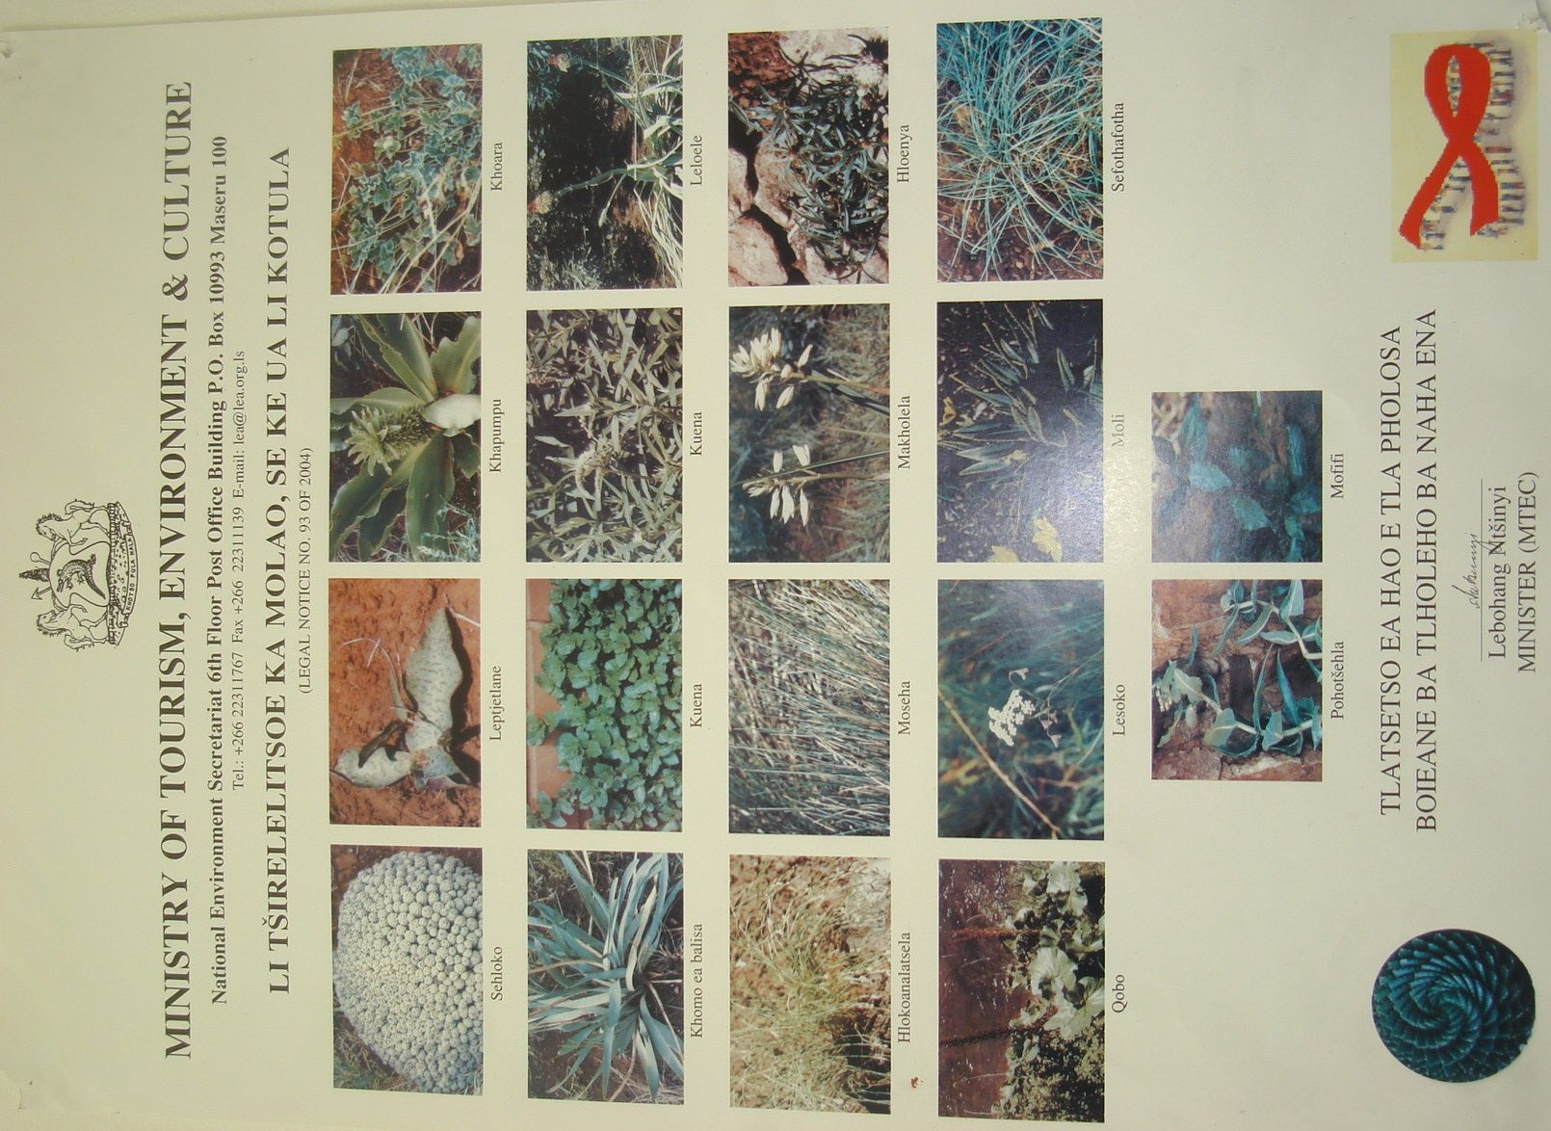
Figure 6 List of protected plants under legal notice no.93 of 2004
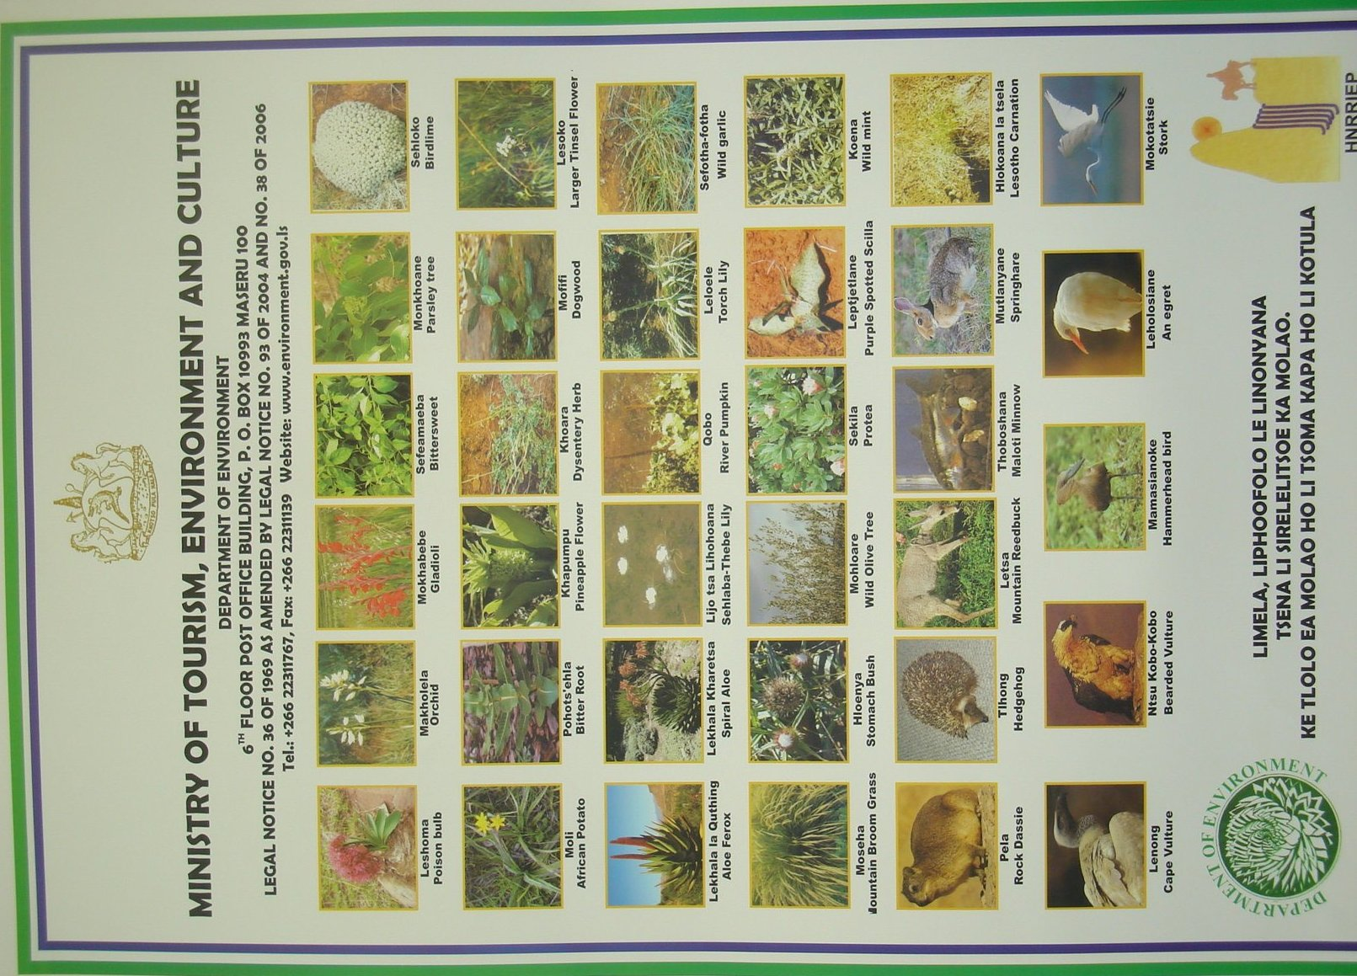
Figure 7 List of protected fauna and flora under Legal notice no.38 0f 2006

Domestic and International Funding for Priority Activities
As alluded to earlier, Lesotho’s commitment to sound biodiversity conservation was demonstrated by development of the National Environment Action Plan. The design of the plan had incorporated input from all national stakeholders to facilitate integration of developmental aspects. The NBSAP priority actions, summarized into the Biodiversity goals aligned to the CBD articles have been structured such that technological advances elsewhere can be translated into biodiversity conservation initiatives that have been harnessed for domestic application. The bulk of projects or interventions have in the light of the above, been implemented in partnership, with substantial portion (+80%) of the finance contributed by donor agencies and counterpart finance targeted at domesticating the processes, to initiate or ensure sustainability. The categories of implementation elements invariably include capital costs, technical support for both execution and technological transfer and community aspects to ensure appreciation and participation to inculcate ownership. The following table provides examples indicating levels of commitment by Donors and Lesotho Government (counterpart).
Table 28: Indicative Funding Levels by Donors and Government
Project / Initiative | Indicative Funding Levels
Project / Initiative | Donor Funding | Counterpart
CMBSL | US$2,485,00 | US$530,000.00
EMPR (2002 figures) | US$260,719.40 | US$222,193.07
MDTP | US$7,300,000.00 | US$1,100,000.00
HNRRIEP | Ua4,490,000.00 | Ua0,990,000.00
DANCED | Kr9,083,228.00 | Kr971,600.00
GEF Small Grants Programme  Operational Cycle 4 | US$500,000.00 | -

Review of Successes, Obstacles and Lessons Learned

Interventions or projects often incorporate a series of components in order to ease implementation. Success of implementation will thus be a measure indicating level of achievement in terms of implementing the components. A certain level of achievement in the implementation of a project does not necessarily imply equivalent achievement in terms of conservation, sustainable use or equitable sharing of benefits. However, an achievement of the NBSAP Goals is a collective responsibility of individual projects.

Successes

The initial stages of success can be traced from the point of ratification of the Convention (1995) which confirmed commitment of Lesotho to sound environmental management, through development of mechanisms and undertaking of measures that would facilitate reduction of loss of biodiversity at the national level. The localization of Agenda 21 (1994) facilitated integration of environmental aspects into developmental initiatives, which necessitated review of national policies, which included the National Environmental Policy for Lesotho of 1996 revised in 1998. The process culminated with development of the National Biodiversity Strategy and Action Plan as the means of implementation. To be able to incorporate a wide spectrum of role players, stakeholders including private sector to infuse or integrate environmental considerations in their programs, the Environmental Act 2008 was promulgated. This established the milestones of compliance through EIA guidelines, regulations, Environment Units across government sectors and introduction of a range of conservation strategies.
A point of success in the process of implementation has been establishment of the Ministry of Forestry and Land Reclamation (2003), to disaggregate the more environmentally focused activities from the otherwise, broad mandate of the Ministry of Agriculture, which also facilitated its re-orientation to Ministry of Agriculture and Food Security.

Lessons Learned
Almost all interventions on biodiversity have to have universal buy-in by all stakeholders. At central government, a project or an intervention is introduced through workshops to ensure synergy and complementarities in government functions. It is also at this stage that aspects of continuity and sustainability beyond project lifetime are considered. Comprehension and acceptance of the project at this level could be taken as a measure of success. From the history of projects it has been realized that this is not necessarily the case, as often representatives at such government forums may not necessarily be decision makers at their respective institutions.
Given the principal land tenure system of communal land ownership, another category of key stakeholders that have to embrace the project are the local communities, where such project will operate. The approach at the community level is a series of Public Gatherings (Lipitso) to articulate the project components and how communities are expected to participate. This approach requires ample time and considerable patience. This is very often compromised because of project time-frames controlled externally. This tends to lead to failure, in attainment of project objectives or goals. The scenario set above has largely resulted in only partial success of projects and/or programs of good intent.
The economic situation or predicament has often compromised long-term implementation of interventions beyond project lifetime, due to cost implications, which dictated prioritization of more pressing social needs against environmental considerations.

Obstacles
Coordination of the project activities at government level has a good intention for information exchange at first, but is mostly for entrenchment of project into government functions for long term sustainability. The observation is that the recipients’ on the one hand, tend to consider coordination, as superfluous because it often does not attract recognition of any form (often financial). On the other hand, the need to establish a project implementation unit – PIU, invariably poses a threat to the substantive implementer’s role, as the PIU often works in competition with the implementer, because of the financial muscle associated with donor funded projects. The Donor community is often not fully aware of the intricacies associated with the impact of disparities in remuneration between project coordination staff and the recipient, which undermines continuity of activities beyond project lifetime. In the same nerve, the complexities associated with community mobilization are often not fully appreciated and understood by Donors, which results in relegation to secondary consideration. Projects are usually designed from the Donors perspective, to be seen to meet certain ‘Internationally set’ conditions. The communities to whom projects are applied, struggle to establish a suitable niche for them, as there is usually very little or no room for modification. As such projects effectiveness in achieving intended objectives are compromised. The key obstacle associated with community, is that of perception, where incentives provided for capacity building within projects, are often read as employment and this induces a dependency syndrome. Information sharing from the project implementers to various stakeholder categories is short-lived, haphazard and sometimes lacking. Availability of information would provide guide in the implementation of future similar projects, as lessons learned would facilitate avoidance of pitfalls. In the context of evaluation, many projects do not have components of stakeholder participation, as such; projects information remains the property of technocrats of the implementing institutions, and has little or no appreciation country-wide.
Successful implementation of interventions or projects on the ground is subject to wholesale application of the Local Government Act 1997. The current situation is that the Cattle Post Areas – CPA are managed through chieftainship, and as such not yet amenable to the provisions of by-laws under the Local Government Act. In summary (see table 29 below), the expected lasting impressions of projects are compromised due to some or all the obstacles discussed above.
Table 29: Summary of Obstacles impeding implementation of NBSAP
Focal Area | Obstacle Category
Government of Lesotho – GOL | - Poor coordination of NBSAP interventions.  - Inadequate information dissemination  - Absence of proper project evaluation mechanisms  - Indistinctive role of conservation authority  - PIU / Sectoral departments
Donor Community | - Pre-designed projects  - lack of community intricacies appreciation
Legal Instruments | - Inadequacies of Local Government Act 1997  - Poor management of CPAs (inadequacy in Local Government Act 1997)
Community | 1. Poor economic status

Effectiveness of NBSAP
Effectiveness of NBSAP in addressing the Conventions Objectives would be enhanced if on an annual basis, the Conservation Authority takes stalk of projects and programs that have a bearing on environment, that are to be implemented. Then undertakes monitoring of implementation, in order to assemble information at the end of the year, that would enable evaluation of collective performance on the NBSAP objectives. This would assist the decision makers on adjustments of on-going projects as well as subsequent ones. This would in addition, also facilitate re-focusing of national efforts in areas not adequately addressed by donor funding. In order to effectively and efficiently determine effectiveness of an intervention on biodiversity, baseline conditions ought to be established. Many projects fell short in this aspect. This has relegated such responsibility either to research initiatives by individuals or agencies for which influence is limited. Therefore actual assessment of effectiveness of NBSAP implementation is more subjective than factual. It relies on few formal reports by independent implementers and a lot of inferences from knowledge of the implementation of certain components of this strategy; however NBSAP as a tool that facilitates streamlined implementation of biodiversity Conservation at National level has been very effective, needless to say operating under set goals, objectives and clear actions paves way for effectiveness.

Whether the observed changes in biodiversity status and trends mentioned in the report are as a result of measures taken to implement NBSAP and the Convention.
  - The one scenario for consideration of the above statement is: Currently there are interventions such as ‘Protected Areas’, and ‘Managed Resource Areas – MRAs’. By virtue of their integrated approach to biodiversity threats (fire management, Alien Invasive species management, erosion control, habitat improvement and control in the harvesting of resources); it can be asserted that changes in biodiversity status and trends are positive results of implementation of NBSAP and the Convention.
  - The other scenario is absence of factual monitoring data in order to assess performance within the PAs and MRAs. Which leads to guess work, but on the overall, it is believed that contributions of NBSAP and the Convention in the improvement of biodiversity are tremendous.

Whether the current NBSAP is adequate to address the threats to biodiversity identified in Chapter 1:
  - The design of the conservation strategies of PAs and MRAs is such that they are to be implemented through specific management plans that integrate control, management and monitoring of biodiversity threats. While the horizon for adequacy of addressing the threats is foreseeable, the challenge is proliferation of these interventions for attainment of the desired minimum threshold of 10% of the land area.
  - Application of the management strategies within existing PAs is not consistent with the global understanding of PA concept and its intended outputs. There ought to be regular updates on species populations and diversity, through establishment of monitoring plots. The concentration of effort on auxiliary elements defeats the purpose of conservation as the key driver for the intervention that would subsequently pave way for sustainable use and distribution of benefits.
  - Under the Local Government Act No6 of 1997, administrative areas under the Rural or Community Councils have been established where management through by-laws (incorporating management of threats) is expected to precipitate desired changes. The bulk of the land area considered to be rangeland available for grazing, is still subject to management by chieftainship as ‘Cattle Post Areas – CPAs’ (meant for seasonal and therefore temporary occupancy, backed by technical information). Management under Principal Chiefs (that of Maboella) is supposed to be beefed up by technical back stopping of Range Technicians. In practice however, access to the area by livestock owners appears to be the key criterion. The aspects of carrying capacity and the duration of occupancy are seriously undermined by establishment of cattle posts on a permanent basis. The area earmarked for CPAs constitutes +2/3 of the land area, in which proper conservation cannot be ascertained. This therefore means the notion of allowing two systems for range managements negates the good intentions of addressing biodiversity threats through implementation of NBSAP.

How implementation of NBSAPs may be improved, where necessary, including suggestions of possible ways and means to overcome identified obstacles.
  - There are three major land use categories currently, the Rangelands constituting the bulk of the land area as the CPA and foothills (the Afro-Montane and the Afro-Alpine zones referred to in the previous chapter); the arable land covering most of the lowlands to the foothills (the Highveld Grassland Zone including Senqu Valley); and the third category is that of settlements of urban, peri-urban and rural villages randomly scattered all over in places of convenience. It is in the last two land use categories that Local Government Act 1997 is rigorously applied. The new management regime of by-laws, under the Local Government Act 1997, by Community Councils appears promising. As a tool for decentralization of government at large, they have more leverage to technical, legal and financial support than it has been the case under the chieftainship. Transformation from RMA (an exclusive conservation strategy) to MRAs or ERMAs that incorporates multiple resource user groups has occurred in the advent of Community Councils, or under the Local Government Act 1997. As alluded to earlier, proliferation of the success stories purported under MRA/ERMAs is the main challenge. A degree of audacity is therefore required to address the CPA scenario to extent the jurisprudence for incorporation of by-laws. Application of the MRA system country-wide will go a long way to overcome disparity in the management of range resources. This would eliminate legal impediments currently recognized. In the same vein, it will facilitate a mechanism for minimization of biodiversity threats identified in the previous chapter.
  - The conservation Authority is currently perceived to carry two distinct but complementary functions, that of implementation and the other as coordination of efforts. The general observation is that the body responsible for coordination function is purported to be carrying out implementation function at times. The general desire is for such an authority to stick to the primary role of overseeing, coordination and facilitation of implementation. This will then ease the coordination obstacle identified above.
  - Information on biodiversity status and trends, as well as that of on-coming interventions is the prerogative of the conservation authority. Monitoring of implementation is expected to build a database upon which improvements on biodiversity trends, or otherwise based on evaluations, ought to be made available to stakeholders. This would facilitate adaptation of lessons learnt into future programs of the implementing agents. Absence of this information inevitably negates the opportunity of experience gained from previous interventions. Information should therefore be made easily available to reduce the apparent repetition of same mistakes through the clearing house mechanism.
  - If implementing agents were accorded their responsibility to fully take on the project components relating to their field of specialization, this would enable infusion of the components into the agent’s long-term programs and sustain interventions beyond projects’ lifetime. It would further minimize impending tensions between PIUs and implementing agents. The shedding of responsibilities would facilitate time and resources for capacity building of the conservation authority to eventually carry out evaluation of projects implementation as well as achievements on the NBSAP. Therefore proper apportionment of responsibilities would definitely improve implementation of NBSAP and remove obstacles associated with PIU VS implementing institutions, and eventually do away with silo mentality.
  - The bottom-up approach in terms of project designs has largely been talk shop. In reality many donor funded projects have to align to criteria determined elsewhere. Time and resources could be optimized if bottom up approach would be applied earnestly and integrated at the time of building of project or program components.
The word or concept of community is often taken to imply homogeneity that may require uniform application of consultation mechanisms and solutions, but infect it is not the case, for this reason the intricacies of community should be studied and well understood before commencement of programs.
The poor economic status, which drives the overall response to interventions, need to be unruffled at the project design rather than super-positioning of the project on community.

Response to COP 8 Decisions (Progress in achieving participation of local communities)

Decision VIII/5(Article 8j)

Facilitation of local communities to participate effectively has been achieved in two ways. The first one was through enactment of the Local Government Act No.6 of 1997, under which Community Councils have been established, as administrative bodies responsible for management of biodiversity through development of by-laws. These by-laws are given effect through approval by the Minister and subsequent publication in the Government Gazette. While this act was passed in 1997, its implementation started in May 2005. This means that we are still in the early stages of the learning curve.
The second is building of capacity at the community to facilitate effective participation of all at grass-roots level. Training workshops are constantly undertaken to enhance Community Council members’ comprehension of the task at hand. Other workshops are directed at the resource user groups to sensitize them on the functions of the Community Councils and how communities are expected to take part in the operations of the Councils. It is at this level where development of various management plans relating to biodiversity management are being facilitated by subject matter specialists, which are then adopted as by-laws by Community Councils.

Decision VIII/24(Protected Areas)

The Lesotho Government entered into a bilateral agreement with the Republic of South Africa to conserve the globally significant biodiversity and to facilitate development of community through nature based tourism. This agreement was funded by the Global Environment Facility – GEF. The project in particular focused on the components listed in table 30 below.
Table 30: Program of work on Protected Areas
Project Components | Achievements
Project management and Transfrontier Cooperation | - Bilateral Memorandum of Understanding  - 20 year Conservation and Development Strategy  - Five-year Action Plan
Conservation and Protected Area Planning | - Spatial Assessment of biodiversity priorities  - Conservation Management Plan for Sehlabathebe National Park- SNP and Ukhahlamba Drakensberg Park
Conservation Management outside Protected Areas | - Fine Scale Plans  - MRAs /ERMAs  - Bilateral Security & safety Strategy
Community Participation | - National Awareness Strategy
Nature Based Tourism | - National Tourism Strategy.
Institutional Development | - Bilateral Security & safety Strategy

The funding further facilitated capacity building of the communities to participate in the implementation of protected area management plan protocols to fulfill their role as co-managers. To further assist in the enhancement of participation in co-management of the protected areas, another project (Highlands Natural Resources and Rural Income Enhancement Project – HNRRIEP), funded by African Development Bank – ADB, facilitated development of eco-tourism aspects, geared towards realization of conservation values.

Decision VIII/28(Impact Assessment)
The national legislation on environment was enacted in 2008 to address issues of environmental management at large and contained therein, is management of environmental impacts as a result of development initiatives, implemented through Environmental Impact Assessment – EIA process. The law enlists the types of projects for which EIA or Strategic Environmental Assessment – SEA is required. Under this law the following milestones have been achieved:
- Draft EIA Regulations
- EIA guidelines
- Certification and registration of environmental assessment Practitioners.
Compliance to EIA requirements is generally positive even though still voluntary.
The thrust of the foregoing has been a demonstration that effectiveness of implementing the NBSAP, in addressing biodiversity threats, is still riddled with challenges. The key challenge is re-orientation of the conservation authority and enhancement of its capacity, to fully take on the role of coordination, monitoring, facilitation and evaluation, and sustain its position as national whip, to ensure effective and efficient implementation of NBSAP.

CHAPTER III – Sectoral and Cross-Sectoral Integration or Mainstreaming of Biodiversity Considerations

Background

All sectors of the economy in Lesotho derive their mandate on environment from the Constitution of Lesotho, section 36, which states that:
Lesotho shall adopt policies designed to protect and enhance the natural and cultural environment of Lesotho for the benefit of both present and future generations and shall endeavour to ensure to all citizens a sound and safe environment adequate for their health and well-being.
The constitution is derived from a premise that all life forms within a given environmental space are fundamentally supported by the diversity of the biological components. Our existence as people today depends on the well being of the individuals as well as collective existence(health, food, education) and the ability to develop into the future, supported by the diversity, should not be constraint by our current interactions with the environment on which the diversity exists. Therefore all sectoral policies’ development ought to take cognizance of this fact to facilitate sustainable development.
In the year 2000, Lesotho took a policy decision to formulate a vision to provide for a long-term perspective within which short to medium term plans could be formulated. To eco this aspiration, so well encapsulated by the commitment in Constitution, the 2020 Vision, in its guiding principle on environmental conservation advocates for empowerment of Basotho to design and manage biodiversity conservation projects relevant to their own communities. It goes on to state that: Environmental Education will be integrated at all levels of learning. There will be Institutional and Legal frameworks to promote and protect healthy and sustainable environment. Every development in the country will be subjected to an intensive environmental impact assessment to gauge its environmental friendliness.
The quest for alignment to sound environmental management, in the design of sectoral policy developments, has resulted in the development of the National Biodiversity Strategy and Action Plan, as a key document from which to bounce all initiatives, in order to assess compliance to the achievement of the desired state. The Poverty Reduction Strategy (2004 -2007) identified eight priority areas and two critical cross-cutting issues, and environment features amongst these priority areas, a clear indication of the desire to systematically address environmental challenges. The underlying notion in support of the poverty reduction strategy is to engage in multi-sectoral approaches in all production activities to minimize danger to biodiversity, as environmental issues cut across various sectors. Commitment to specific strategies targeted at pro-poor, during implementation of the PRS period to ensure improved environmental management include: a) Promotion of environmental conservation for improved productivity, by targeting committed families to be taught to harness water resources, increase ground cover and incorporate conservation and agro-forestry techniques into production; b) Strengthen management of water, solid waste and pollution; c) Strengthen curriculum and media programs on environmental education; d) Reduce biodiversity loss by implementing the Maloti-Drakensberg Trans-Frontier Park, maintaining existing reserves and moving towards the establishment of nature reserves and protected areas; e) Address range management issues by establishing and/or revitalizing grazing associations in collaboration with new local government authorities; and f) Improve the legal, policy and institutional framework, giving particular attention to the capacity of the National Environment Secretariat and implementation of the Environment Act 2001, which has now been revised to Environment Act 2008.
The demonstration of achievement on the objectives of the Convention is made through the sector policies selected according to their relative significance on environment.

The National Forestry Policy, 2008
Its opening statement is rooted in the national policies and goals to reduce poverty, secure livelihoods, protect the environment of Lesotho and enhance participation of marginalized groups through inter alia:
- Increase tree cover on land area (indigenous & exotic) through engagement with individual, groups and private holdings.
- Sensitization and education of the public on the values, purpose and benefits of forestry.
- Promote the use of trees in support of conservation and production of both arable agriculture and rangelands
This is a far reaching document of national importance, relating to all sectors of the economy where trees and forestry could play a part. Forestry has for a long period been an integral component of the Ministry of Agriculture. It was upgraded to the Ministry of Forestry and Land Reclamation in the year 2003. This step has facilitated diversification of strategies to advance the forestry concept. Under the Forestry Policy, the Ministry implements a number of programs such as the Social Forestry Program, which encourages establishment of individual tree nurseries, from which government in turn procures seedlings for wider application of the Community Woodlots. To facilitate implementation of the Community Woodlot program, the local authorities (Community Councils) through technical assistance of the Land use planning function, identify areas appropriate for woodlots establishment. In order to establish a woodlot, community members are mobilized in rosters and provided necessary skills to undertake various steps of tree planting and management. Management of woodlots (regulates grazing and harvesting of tree and other economically important plants) provides tremendous opportunity by arresting erosion and ensuring adequate soil cover, (subject to appropriate species as well as right spacing), providing canopy for re-establishment of biodiversity, as seen in figure 8 below.
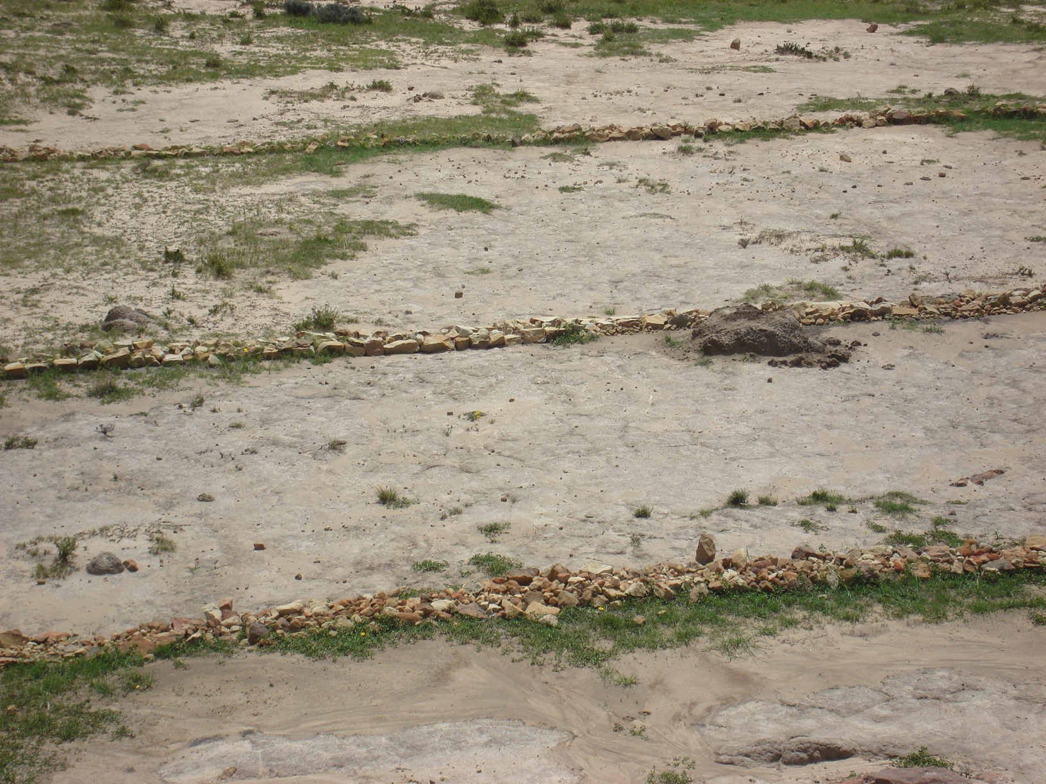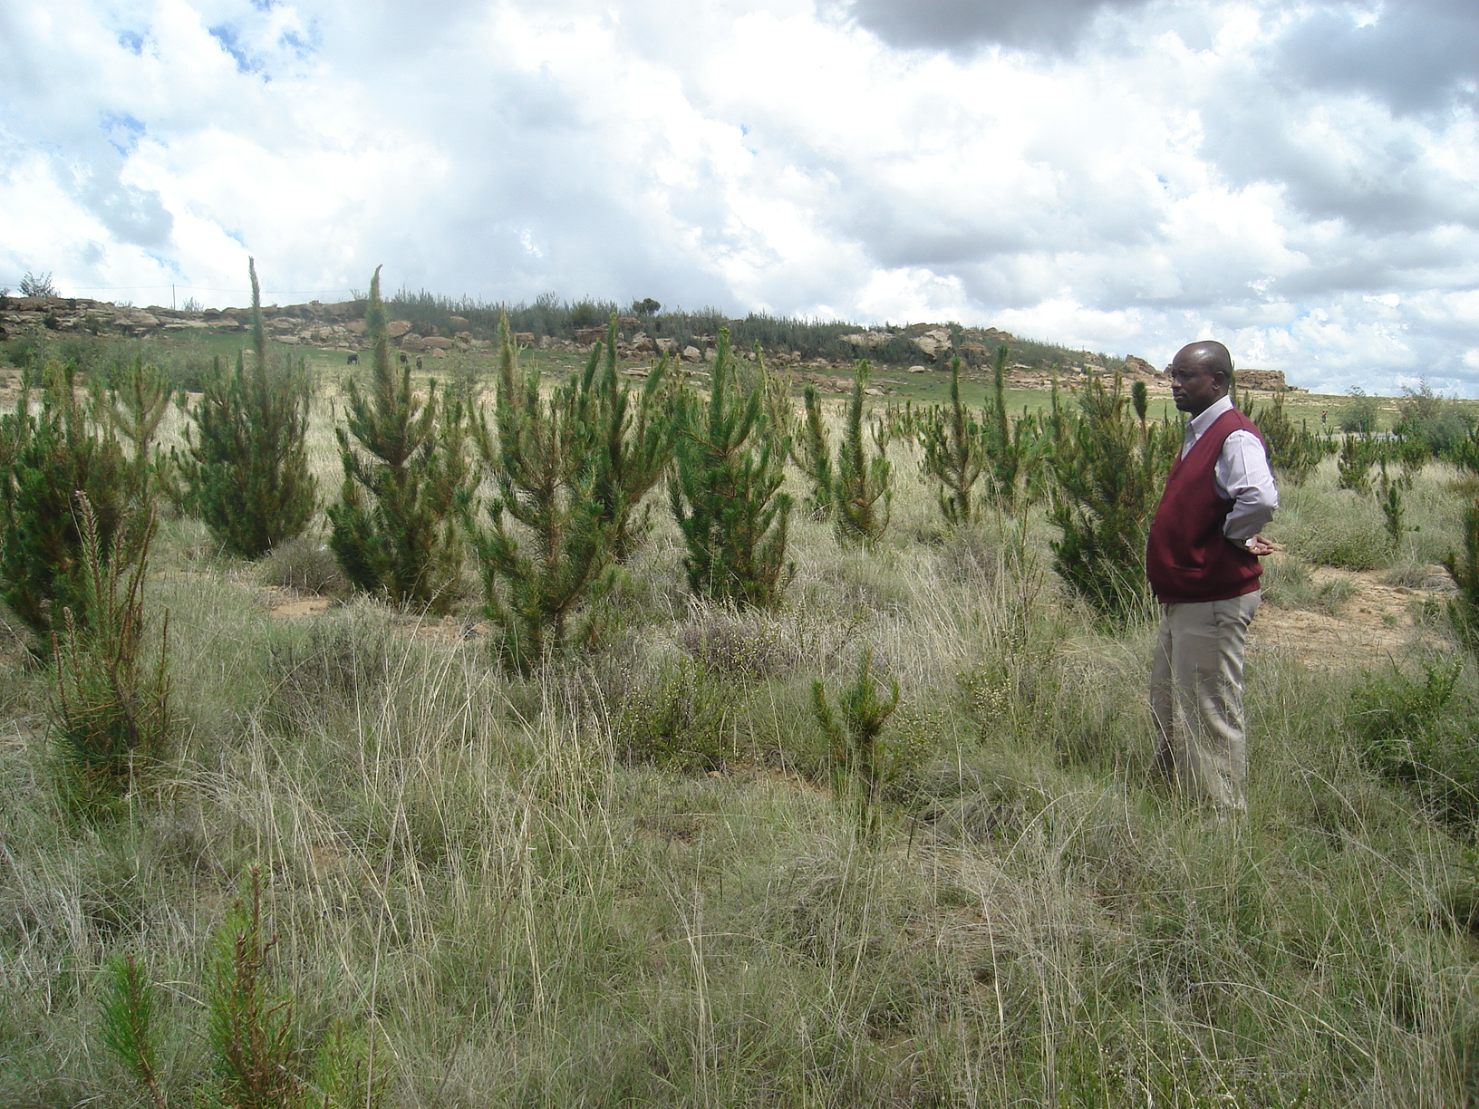
Figure 8: Area rehabilitated through tree planting under Social Forestry

Water and Sanitation Policy, 2007
The document development approach integrates the National Vision 2020, the Poverty Reduction Strategy, the Millennium Development Goals and other related policies such as Decentralization, Energy, Environment, Food Security, Gender, Forestry and Land Reclamation, HIV/AIDS, Industrialization and Science and Technology. It recognizes control of land degradation, sound rangeland management practices, wetlands conservation, pollution and invasive alien species control as its key pillars in the adoption of an integrated catchment management strategy, in order to protect water resources for satisfaction of present needs as well as those of future generations. As a starting point, the Department of Water Affairs has embarked on “the Orange-Senqu Water Sources ‘Sponges’ Project” the main objectives of which are to 1) Establish an accurate information on the extent and state of Wetlands for decision making on wetlands management. This will result in development of an appropriate Action Plan for the sustainable management of wetlands.

Lesotho Food Security Policy, 2005
The policy document is derived from policies and programs aligned to national and International targets and goals to which Lesotho is committed. The core of many of the strategies, policies and programs are portrayed in the lens in figure 9 below, both at the local and international level, is environmental conservation and management.
Figure 9: Relationship between the Food Security Policy and other policies, strategies and programs using a 'food security lens'.
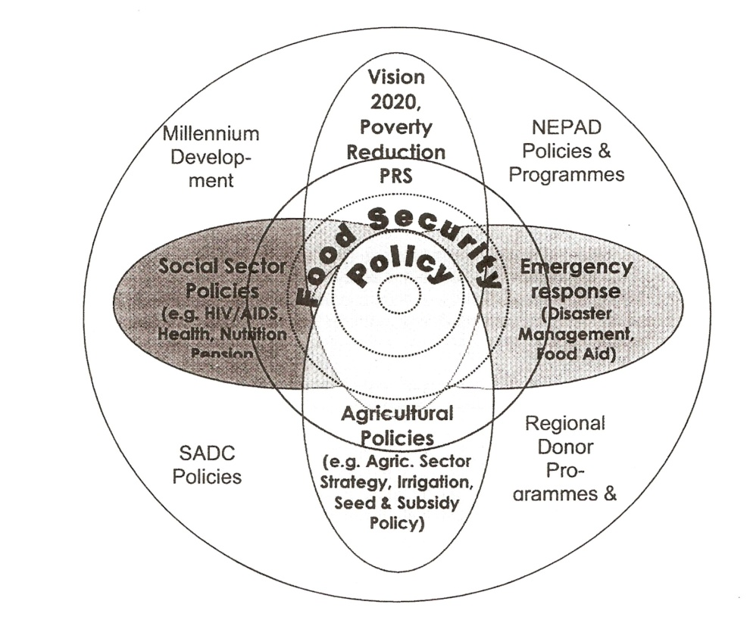
Sourced from Lesotho Food Security Policy and Strategic Guidelines, April 2005.
The document recognizes inextricable cause and effect linkages of poverty to a number of issues of interest to Lesotho Government, including ‘inherently fragile natural environment and climatic variability and the effect of this on livelihoods’ and therefore a need to adopt measures in food security that will prevent further marginalization of the natural environment.
Agriculture and Food Security as a sector implements various strategies including the ‘Seeds and Field Inputs (‘Neheletse) Program. The program is based on traditional ‘Mafisa’ principle (loan of livestock) for short cycle items (sheep, goats, ducks, fish, seedlings, crop seeds, medicinal plants, fodder) with modest capital outlay. The first batch recipients are identified by community members, as well as subsequent beneficiaries to whom the progeny is passed. The program promotes self-reliance and sharing. Targeting the whole community profile of individuals and groups including women, youth, vulnerable groups and also aims to address the HIV/AIDS pandemic. The impact on biodiversity in the implementation of the above is indirect, as it aims to provide, through affordable means, the basic elements for sustaining livelihoods, which could have otherwise been sourced from the natural environment. By reducing pressure in the wild, there is opportunity for recuperation of the natural environment.

Energy Policy for the Kingdom of Lesotho (Draft)
The document has incorporated the statement of intent “The Energy resources will be used in such a way that international, regional and local environmental agreements and protocols are observed”. The policy statement requires further elaboration into strategies to be adopted to facilitate realization of the intent.

Transport Sector Policy, 2006
The document development is anchored in the National Vision 2020, the Poverty Reduction Strategy, the Millennium Development Goals and other related policies. Its commitment is reflected in the Transport Sector Environmental Policy and Action Plan – EPAP, as the statement of intent for:
- Improvement of planning and decision-making processes regarding environmental and social dimensions of the transport sector activities and services.
- Provision of guidance in promoting ecologically sustainable transport.
- Management and mitigation of key biophysical and socio-economic impacts of the transport sector activities.
- Raising awareness by training and otherwise towards mainstreaming environmental and social safeguards.
- Building functional relationships with Transport Sector Partners, the community and the allied transport industries.
The statement principles is given effect through development of a well staffed and equipped Environmental and Social Monitoring section under the Planning Unit, to ensure efficient implementation and updating of the Environmental Policy and Action Plan. The core of the Transport sector activities is infrastructure development, for which environmental compliance is attained through Environmental Impact Assessment – EIA and implementation of mitigation through Environmental Management Plans – EMP under all infrastructure developments. The Planning Section, which is now reinforced with the Environment Unit, ensures this compliance.

Environmental Education Strategy towards 2014: A Strategic Plan for Education for Sustainable Development in Lesotho (2009)
This document is informed by the national policy frameworks such as the National Environmental Policy, Poverty Reduction Strategy, National Vision 2020 as well as international environmental protocols and intergovernmental agreement including Agenda 21. Its approach is establishment of baseline on environmental education initiatives, analysis of that and proposal of Environmental Education and Strategy Implementation Plan that sets the vision attainment to the minimum of 2014. The understanding is that its roll out in production of awareness and education materials will include re-orientation of school curricula to embrace sound environmental conservation across all social cadres.

Lesotho Electricity Company: Safety, Health, Environmental and Quality (SHEQ) Management System
The Company is committed to conducting business in compliance with safety and health of workers, public and the environment. The commitment is manifested in the establishment of a Risk Management Department with full-time environment officer and allocation of resources for surveillance, control and management of risks to ensure compliance to environmental requirements. Implementation is undertaken through Risk Committees which under environment focus on the following:
- Incidences of spillage;
- Incidents of leaking transformers;
- Quantities of different types of waste;
- Ratio of EIAs/EMPs to projects;
- EMP compliance levels by projects.
- Rehabilitation of dongas.
- Tree planting programme.

Gender and Development Policy
The Policy advocates for gender sensitive environmental strategies, through designs and implementation of environmentally sound and sustainable resource management mechanisms, in order to re-orientate the traditional perspective that marginalized other groups.

Mechanisms for Integration of Biodiversity into Sectoral Strategies
The key government documents (National Constitution, Vision 2020, and Poverty Reduction Strategy) make it abundantly clear that biodiversity conservation is central, or integral to development of sectoral policies. It is further indicated in many of the sector policies that environmental conservation is cross-cutting and has to be integrated as far as possible in programs. To ensure integration into sectoral strategies, one process has been the passing of legislation (the Environment Act 2008), which ensures that all programs and projects whose activities have a notable bearing on environment have to be cleared through the ‘Environmental Impact Assessment’ process. This step ensures uniformity in approaching environment in the least. But it is a sharp reminder to all stakeholders to be vigilant on environmental concerns in their activities. The second step has been incorporation of environmental functions within the government ministries, through establishment of Environmental Units. The Units’ staff skills were enhanced and sharpened through a menu of course (Danced, Capacity building in Environmental Management in Lesotho Project Document June 1998) in order to prepare them for the onerous challenge of re-orientation of sector strategies, programs and projects, to integrate environmental compliance in line with EIA guidelines. The National Capacity Self-Assessment Project (2006) was specifically undertaken to identify (per Convention) priority issues, cross-cutting issues, opportunities and synergies across the sectors including the NGOs, then assessment of capacity to deal with all identified issues was made, and an appropriate action plan was developed.

Mainstreaming Biodiversity through Ecosystem Approach
Ecosystem Approach as a concept is marginally applied. It is a concept that is underpinned by the need to understand the importance of a component and its functional relationships with the other ecosystem components. This approach advocates for application of measures in a holistic manner, with an understanding that a component functioning is inextricably linked to, works to support and is supported by smooth functioning of other components. The approach is appreciated and endorsed at sectoral level. Its application however, still remains a challenge. The initial inroads on its application are at project level and have not as yet penetrated, or adapted into sectoral strategies. The Maloti-Drakensberg Transfrontier Conservation and Development Project – MDTP pioneered this approach by undertaking ‘Spatial Assessment of Biodiversity Priorities’ in the Lesotho highlands, as an input into a more comprehensive integrated conservation and development bioregional zoning plan, that would integrate socioeconomic, tourism, cultural/archaeological, and infrastructure constraints and opportunities. Citation of the establishment of the Joint Management Plan and implementing committee for the Sehlabathebe National Park – SNP and Ukhahlamba Drakensberg Park – UDP, to manage otherwise one ecosystem with a political boundary in the middle is a closer example to ecosystem approach.

CHAPTER IV – Progress toward the 2010 Target and Implementation of the Strategic Plan

Introduction
This chapter provides information on the performance toward achievement or attainment of the 2010 Target. This is the bare minimum to which the Parties have committed their efforts to significantly reduce biodiversity loss at the global, regional and national level on the three objectives of the CBD. The chapter provides an analysis in a matrix of progress made towards goals and objectives of the strategic plan in facilitating implementation of the Convention at the national level. The chapter concludes with an assessment or analysis of improvement on biodiversity conservation, sustainable use, and fair and equitable sharing of benefits, as a result of the implementation of the Convention. The analysis of performance at the national level is shown in matrix in table 31 below, while that of the strategic plan implementation by the Secretariat is in table 32 below. The indicators used in the analyses for performance on targets, at the national level have been adopted from the proposed ones in the guidelines. Additional indicators have been developed where none had been proposed in the guidelines. While the progress in the implementation of the CBD toward achievement of the 2010 target aspired a smooth and well coordinated effort, it was punctuated with complications which somewhat compromised the desired output. The discussion on the complications and/or obstacles is undertaken following the analyses matrix.

Table 31: Framework of Goals, targets and indicators to assess progress towards the 2010 Biodiversity Target
Goals and Targets | Relevant indicators |  | Progress
Protect the components of biodiversity
Goal 1: Promote the conservation of biological diversity, of ecosystems, habitats and biomes.
Target 1.1 At least 10% of the world’s ecological regions effectively conserved | - Coverage of Protected Areas |  | Only 6.9% achieved so far. This is well below the recommended figure of 10%. However, there are some measures intended to increase the area of coverage through applications of IUCN category VI due to the land tenure system in the country.
 | - Trends in extend of selected ecosystems
 | - Trends in abundance and distribution of selected species |  | Abundance and distribution of threatened species are declining. The Spiral Aloe colonies are on the decline. The Bearded Vulture breeding sites are becoming deserted and the Bearded Vulture Population and Habitat Viability Assessment (2006) indicates decline in breeding pairs.
Target 1.2 Areas of particular importance to biodiversity protected. | - Trends in extend of selected ecosystems |  | It is not yet possible to indicate trends. The biodiversity priority areas in the Lesotho highlands region (2/3 land area) have only been identified in 2007. This will facilitate conservation of important biodiversity.
 | - Trends in abundance and distribution of selected species |  | Not possible to indicate abundance and distribution of species, since we have only established important biodiversity priorities in 2007.
 | - Coverage of Protected areas |  | The coverage of protected areas has not changed. Areas of particular importance include (Wetland, Maloti Minnow, Spiral Aloe, Bearded Vulture habitats)
Goal 2: Promote the conservation of species diversity
Target 2.1 Restore, maintain, or reduce the decline of populations of species of selected taxonomic croups. | - Trends in abundance and distribution of selected species |  | In certain parts of the country (Katse) spiral aloe populations are on the increase due to innovative propagation on the species in the Botanical Garden. However, in general, where this program is not available, the populations are on the decline
 | - Change in status of threatened species |  | The change is on the decline. Initiatives on propagation to facilitate access and ease pressure on the wild have implications of positive change in the future.
Target 2.2 Status of threatened species improved. | - Change in status of threatened species |  | The change is on the decline. Initiatives on propagation to facilitate access and ease pressure on the wild, have implications of positive change in the future.
Target 2.2 Status of threatened species improved. | - Trends in abundance and distribution of selected species |  | Trends in abundance and distribution declining in general, since species propagation programs are area based, improvements are localized.
Target 2.2 Status of threatened species improved. | - Coverage of Protected areas |  | Threatened species situation in protected areas improved due to management of threats. The overall picture in threatened species is on the decline due to limited application of protection.
Goal 3: Promote the conservation of genetic diversity
Target 3.1: Genetic diversity of crops, livestock, and of harvested species of trees, fish and wildlife and other valuable species conserved, and associated indigenous and local knowledge maintained. | - Trends in genetic diversity of domesticated animals, cultivated plants and fish species of major socioeconomic importance. |  | There has been a tremendous decline in genetic diversity of domesticated animals, cultivated plants and fish due to high rate of hybrids introduction. Low production associated with indigenous species works against conservation of indigenous genes.
 | - Biodiversity used in food and medicine |  | People have to travel long distances now to get some of the plants that were used for medicinal purposes and as food supplements. This is a clear indication that diversity of life forms has declined. Alternatives are sometimes harvested to the detriment of their disappearance.
 | - Trends in abundance and distribution of selected species |  | There has been a downward trend of selected species, though the National Gene bank has doubled efforts in pursuance of conservation of genetic diversity of all forms.
Promote Sustainable use
Goal 4:promote sustainable use and conservation
Target 4.1 :Biodiversity-based products derived from sources that are sustainably managed, and production areas managed consistent with the conservation of biodiversity | - Area of forest, agricultural and aquaculture ecosystems under sustainable management |  | - Thatching grass harvesting managed and regulated by chieftainship still operating smoothly. The traditional system of resting certain areas for purposes of encouraging re-growth of the grass is still adhered to.  - There are imminent signs of over harvesting of mountain broom grass for commercial purposes.
 | - Proportion of products derived from sustainable sources |  | Quantity of products derived from sustainable sources are on the decline, this is proofed by the high costs of indigenous products ( honey, traditional brooms)
 | - Trends in abundance and distribution of selected species |  | Trends are perceived to be negative as a result of decline in management control measures.
 | - Nitrogen Deposition
 | - Water quality in aquatic ecosystems |  | - Application of Managed resource area scheme in parts of the mountain ecosystem sustains the internationally acclaimed, high quality notion of the Lesotho high lands area water.  - Aquatic ecosystems in the vicinity of urban centers have poor water quality.
Target 4.2 : Unsustainable consumption, of biological resources, or that impacts upon biodiversity, reduced | - Ecological footprint and related concepts |  | - Management protocols within specific Management plans for Managed Resource areas schemes provide control devices.
Target 4.3: No species of wild flora or fauna endangered by international trade. | - Change in status of threatened species |  | - Protection of threatened species of interest through declarations facilitates access and benefit sharing principles.  - Awareness raising workshops for customs officials facilitated management of boarder trafficking of economically important wild flora and fauna. Some level of reduction in international trade has been achieved
Address threats to biodiversity
Goal 5: Pressures from habitat loss, land use change and degradation, and unsustainable water use, reduced
Target 5.1 Rate of loss and degradation of natural habitats decreased | - Trends in extent of selected biomes, ecosystems and habitats |  | There is a decline in natural habitats despite the fact that some measures are being applied. This could largely be attributed to narrow focus of interventions.
 | - Trends in abundance and distribution of selected species |  | As a result of above scenario, species distribution and abundance would follow the same pattern of decline.
 | - Marine trophic index |  | Not applicable
Goal 6: control threats from invasive alien species
Target 6.1 Pathways for major potential alien invasive species controlled | - Trends in invasive alien species |  | Trends are on the increase. However, steps towards management of alien invasive species have been undertaken  - established the status of Alien Invasive in 2005  - produced Invasive Alien species distribution report in 2007
Target 6.2 Management plans in place for major alien species that threaten ecosystems, habitats or species. | - Trends in invasive alien species |  | Trends are on the increase. However, management plans for protected areas and MRAs have incorporated protocols for regulation of alien invasive.
Goal 7: Address challenges to biodiversity from climate change and pollution
Target 7.1 Maintain and enhance resilience of the components of biodiversity to adapt to climate change. | - Connectivity / fragmentation of ecosystems |  | Policy review in the Forestry sector, has taken into account, predictions of the Global Circulation Model – GCM of warmer climatic and drier future conditions, by emphasizing use of indigenous trees and shrubs as well as exotics that are suitable for dry conditions.
Target 7.2 Reduce pollution and its impacts on biodiversity. | - Nitrogen deposition
Target 7.2 Reduce pollution and its impacts on biodiversity. | - Water quality in aquatic ecosystems |  | - Lesotho is generally regarded as meeting high water quality standards. This is so due to pristine sources in the highlands with extensive wetland coverage and threat from pollution is marginal.
Maintain goods and services from biodiversity to support human well-being
Goal 8: Maintain capacity of ecosystems to deliver goods and services and support livelihoods
Target 8.1 Capacity of ecosystems to deliver goods and services maintained | - Biodiversity used in food and medicine (indicator under development) |  |  | - Economically important biodiversity products (medicinal plants) now commercialized. This out-competes regeneration capability.  - In protected areas (PAs & MRAs) species population and diversity of natural resources used as food and medicine is improving.  - The general trend of biodiversity used in food and medicine is on the decline, unless drastic measures taken to replicate PA & MRA intervention.
 | - Water quality in aquatic systems |  |  | - The water quality in the aquatic systems of the highlands ecosystem is good. However, efforts to address degradation of the wetlands need to be doubled, as well as integrating them into the greater watershed management.
 | - Marine trophic index |  |  | - Not applicable
 | - Incidence of Human-induced ecosystem failure |  |  | - The human-induced ecosystem failure incidences are on the rise. Wetlands integrity is reduced by overgrazing.  - The indigenous forests have declined due to over-harvesting, which has resulted in scarcity of goods and services from that ecosystem.
Target 8.2 Biological resources that support sustainable livelihoods, local food security and health care, especially of poor people maintained. | - Health and well-being of communities who depend directly on local ecosystem goods and services |  |  | - The cost of health especially of poor people has increased sharply, while human well being in on the decline.
 | - Biodiversity used in food and medicine |  |  | - Distances to natural medicinal and food supplies have increased, and the quantities of these products have also declined.
Protect traditional knowledge, Innovations and Practices
Goal 9 : Maintain socio-cultural diversity of indigenous and local communities
Target 9.1 Protect traditional knowledge, innovations and practices. |  | - Status and trends of linguistic diversity and numbers of speakers of indigenous languages |  |  | - All linguistic groups are still co-existing. However, there are only two official languages. There is no legal effort to formalize all languages. The education curricula fall short of mainstreaming other languages, to the extent that any efforts to marginalize those languages could be successful as they have little or no legal recourse.
Target 9.2 Protect the rights of indigenous and local communities over their traditional knowledge, innovations and practices, including their rights to benefit-sharing. |  | - Legal Framework with clear guidelines that enable them to be institutionalized through trade tests. |  |  | - There is partial acknowledgement of traditional /indigenous knowledge practitioners value which still needs advocating and incorporation into legal framework.
Ensure the fair and equitable sharing of benefits arising out of the use of genetic resources
Goal 10: Ensure the fair and equitable sharing of benefits arising out of the use of genetic resources.
Target 10.1 All access to genetic resources is in line with the Convention on Biological Diversity and its relevant provisions. |  | - Establishment of Access and Benefit sharing guidelines  - Implementation (enforcement) of the guidelines. |  |  | - Environment Act 2008 (68), recognizes the need for development of guidelines, which are still due.  - Local Government Act No.6 of 1997 provides for by-laws as a tool for management of access and benefit sharing at the community level.  - The foundation for ensuring implementation has already been devised.
Target 10.2 Benefits arising from the commercial and other utilization of genetic resources shared in a fair and equitable way with the countries providing such resources in line with the Convention on Biological Diversity and its relevant provisions. |  | - Establishment of Access and Benefit sharing guidelines  - Implementation (enforcement) of the guidelines. |  |  | - In the absence of guidelines, local communities make arrangements (Memorandum of Understanding) with commercial operators (Pelargonium oppositifolium harvesting & export).  - Benefit sharing with countries that are utilizing our resources is still not happening, despite the fact that some countries that are sourcing our natural resources are Parties to the CBD.
Ensure Provision of adequate Resources
Goal 11: parties have improved financial, human, Scientific, technical and technological capacity to implement the Convention
Target 11.1 New and additional financial resources are transferred to developing country Parties, to allow for the effective implementation of their commitments under the Convention, in accordance with article 20 |  | - Official development assistance provided in support of the Convention |  |  | - Funding for implementation of  - Maloti-Drakensberg Transfrontier Conservation and Development Project funded by Global Environment Facility – GEF (2003 – 2009).  - Highlands Natural Resources and Rural Income Enhancement Project funded by African Development Bank – ADB (2003 – 2009).
Target 11.2 Technology is transferred to developing country Parties, to allow for the effective implementation of their commitments under the Convention, in accordance with its article 20, paragraph 4 |  | - Technological capacity imparted to the country |  |  | - No progress  - Pelargonium oppositifolium exported for processing in Germany.  - Rosa Rubiginosa exported for processing in RSA (Bethlehem).

Progress provided against indicators reflects activities at the national level to achieve biodiversity goals designed to off-set the 2010 target of the CBD. The key in-situ conservation strategies have achieved 6.9% out of the targeted 10% of the land area. Ex-situ strategies (Katse Botanical Garden and its satellite community gardens, Vulture Restaurant and Bearded Vulture programme, the Qacha’s Nek snake park and activities such as LEC bird deflectors) still need to be enhanced further and diversified in order to make a meaningful contribution to alleviate pressure on the natural resources. Roll-out or proliferation of these initiatives are still constrained by capacity issues, coordination and monitoring. NPGRC as a preservation initiative could address anticipated effects of climate change successfully, but is equally constrained by current economic predicament where communities prefer fast growing and high yielding species. Control of Alien and Invasive species is currently at its infancy stages and is yet to be mainstreamed. Intensification of tree planting through community forestry at the rate of 260,000 seedlings a year will significantly address the effects of climate change in terms of carbon sinking. The Biodiversity Spatial Assessment recently undertaken to identify priority conservation areas has kick started initiatives on wetlands conservation as one of the priority activities. As a result of this eco-system approach, advance has been made on a bilateral level for joint management of the highlands grassland eco-system between Sehlabathebe National Park and uKhahlamba Drakensberg Park of South Africa, which is also a World Heritage Site. There is no significant advance on the integration of traditional knowledge to upgrade to conventional recognition. In terms of Access and Benefit Sharing (ABS) some advance has been made in the Community Forestry, where 100% is community controlled and in the Government established Woodlots, the previous 20:80 community to government has now been reversed to 80:20 community to government. This has increased the community interest and participation. The challenge still lies with Protected Areas where the suggested proportion of 10:90 community to government is still unsettling. Capacity, coordination, monitoring and evaluation are still major constraints in the achievement of most of the targets.

Table 32: Goals and Objectives of the Strategic Plan and Provisional Indicators for assessing progress.
Objectives | Possible Indicators | Progress
Goal 1: The Convention is fulfilling its leadership role in international biodiversity issues
1.1 The Convention is setting the global biodiversity agenda. | - CBD provisions, COP decisions and 2010 target reflected in workplans of major international forums. | Flow of funding in support of biodiversity initiatives from multi-lateral and bi-lateral donor agencies, indicates dissemination of CBD provisions, COP decisions and 2010 target on a wide spectrum.
1.2 The Convention is promoting cooperation between all relevant international instruments and processes to enhance policy coherence. |  | Participation to the National Capacity Self Assessment Project to establish common issues (cross-cutting & capacity constraints, opportunities, synergies) across multi-lateral environmental agreements (UNCCD, UNFCC, UNCBD, CITES, RAMSAR).
1.3 Other international processes are actively supporting implementation of the Convention, in a manner consistent with their respective frameworks. |  | Participation to the National Capacity Self Assessment Project to establish common issues (cross-cutting & capacity constraints, opportunities, synergies) across multi-lateral environmental agreements (UNCCD, UNFCC, UNCBD, CITES, RAMSAR).
1.4 The Cartagena Protocol on Biosafety is widely implemented. |  | Provision of funding to contracting parties for development of National Biosafety Frameworks (National Biosafety Policy, National Biosafety Law and an administrative framework), ensured wide application of Cartagena Protocol.
1.5 Biodiversity concerns are being integrated into relevant sectoral or cross-sectoral plans, programmes and policies at the regional and global levels. | - Identification of areas of corporation | Southern African Biodiversity Support Programme – SABSP developed:  - Regional Biodiversity Strategy  - Initiated establishment of Centers of Excellence (Alien Invasives, Access and Benefit Sharing).
1.6 Parties are collaborating at the regional and sub-regional levels to implement the Convention. | - Biodiversity integrated into the criteria of multilateral donors and regional development banks to facilitate integration of biodiversity concerns into relevant sectoral or cross-sectoral plans. | GEF Support to implementation of a bilateral biodiversity conservation initiative between Lesotho and South Africa (MDTP)
Goal 2: Parties have improved financial, human, scientific, technical, and technological capacity to implement the Convention.
2.1 All Parties have adequate capacity for implementation of priority actions in national biodiversity strategy and action plans. | - Identification of centers of excellence, research authorities and management authorities | - Numbers of Centres of Excellence, Research Authorities and Management Authorities to facilitate capacity for implementation of priority actions in NBSAP
2.2 Developing country Parties, in particular the least developed and the small island developing States amongst them, and other Parties with economies in transition, have sufficient resources available to implement the three objectives of the Convention. | - Official development assistance provided in support of the Convention (OECK – DAC Statistics Committee) | Some resources have been made available for implementation of the three objectives of the Convention, though not sufficient.  - Funding for implementation of  - Maloti-Drakensberg Transfrontier Conservation and Development Project funded by Global Environment Facility – GEF (2003 – 2009).  - Highlands Natural Resources and Rural Income Enhancement Project funded by African Development Bank – ADB (2003 – 2009).
2.3 Developing country Parties, in particular the Least developed and the small island developing States amongst them, and other Parties with economies in transition, have increased resources and technology transfer available to implement the Cartagena Protocol on Biosafety. |  | Provision of funding to contracting parties for development of National Biosafety Frameworks (NBF) (National Biosafety Policy, National Biosafety Law and an administrative framework), ensured wide application of Cartagena Protocol.  Financial resources for kick starting the process of implementation of the protocol on Biosafety have been made available; the actual implementation would probably be augmented with technology transfer.
2.4 All Parties have adequate capacity to implement the Cartagena Protocol on biosafety. | - Training of trainers’ workshop.  - Technical and technological aspects  - Management aspects  - Biosafety “training tool kit” | - Some level of capacity have been imparted through public awareness materials that were produced during phase 1 of NBF project, targeted at stakeholders, NGOs, Consumer organization and the scientific community through enabling facility of GEF  - A Training workshop on risk assessment and management conducted through support of GEF  - However there is need to convene a training workshop for Parties targeted at Trainers who would facilitate further knowledge dissemination at National level.
2.5 Technical and scientific cooperation is making a significant contribution to building capacity. | - Official technical and scientific cooperation in place | - It is assumed that this is an issue yet to be explored, once subsequent phases of the National Biosafety projects are fast tracked and implemented.
Goal 3: National biodiversity strategies and action plans and the integration of biodiversity concerns into relevant sectors serve as an effective framework for the implementation of the objectives of the Convention.
3.1 Every Party has effective national strategies, plans and programmes in place to provide a national framework for implementing the three objectives of the Convention and to set clear national priorities. | - Official NBSAP that works to re-orientate sectoral policies in place | - National Biodiversity Strategy and Action Plan document in place.
3.2 Every Party to the Cartagena Protocol on Biosafety has a regulatory framework in place and functioning to implement the Protocol. | - Official regulatory framework on Cartagena Protocol in place | The regulatory mechanism initiated in the form of:  - National Biosafety Policy  - National Biosafety Bill
3.3 Biodiversity concerns are being integrated into relevant national sectoral and cross-sectoral plans programmes and policies. | - Re-orientated sectoral policies integrating biodiversity priorities | The following key policy documents are in place:  - National Environmental Policy For Lesotho, 1998;  - National Strategy on Lesotho’s Biological Diversity: Conservation and Sustainable Use, 2000  - Kingdom of Lesotho Poverty Reduction Strategy, 2004-2007  - Lesotho Food Security Policy and Strategic Guidelines, 2005  - Lesotho Water and Sanitation Policy, 2007;  - Lesotho Vision 2020  - National Forestry Policy, 2008  - Lesotho Water and sanitation Policy,2007
3.4 The priorities in national biodiversity strategies and action plans are being actively implemented, as a means to achieve national implementation of the Convention, and as a significant contribution towards the global biodiversity agenda. | - Adherence to requirement of Article 26 of the Convention on Biological Diversity. | First and Third National Reports on implementation of the Convention on Biological Diversity have been submitted to the Secretariat.
Goal 4: There is a better understanding of the importance of biodiversity and of the Convention, and this has led to broader engagement across society in implementation.
4.1 All Parties are implementing a communication, education, and public awareness strategy and promoting public participation in support of the Convention. | - Communication, Education and Public Awareness Strategies in place. | - Environmental Education Strategy Towards 2014: A Strategic Plan for Education for Sustainable Development in Lesotho (June 2009), has been developed.
4.2 Every party to the Cartagena Protocol on Biosafety is promoting and facilitating public awareness, education and participation in support of the Protocol. | - Biosafety Awareness Strategies developed. | The Strategies not yet in place. However, Stakeholders sensitization workshops conducted under the National Biosafety Frameworks Project.
4.3 Indigenous and local communities are effectively involved in implementation and in the processes of the Convention, at national, regional and international levels. | - National Legislative framework for incorporation of Indigenous / Local communities in the implementation of CBD. | - National Environmental Act 2008 (66)(VI)  - Local Government Act No.6 of 1997 (44)
4.4 Key actors and stakeholders, including the private sector, are engaged in partnership to implement the Convention and are integrating biodiversity concerns into their relevant sectoral and cross-sectoral plans, programmes and policies. | - Memorandum of Understanding – MOU for incorporation of key stakeholders including private sector in the implementation of CBD. | - MOU between Bophelo Natural Products, (PTY) Ltd and Nkhono G07 Community Council on the Pelargonium project, in the implementation of “Access and Benefit Sharing” principle.

Obstacles on the achievement of the 2010 Target.
Implementation of protected area conservation strategy was targeted at 10% of the total land area. The main obstacle on achievement of this target is the land tenure system, which dictates that establishment of such areas, is a matter of negotiation with the communities. The core of negotiations is socioeconomic predicament, which takes advantage of the land tenure system as a debatable issue. This has resulted in less than satisfactory performance in rolling out this strategy. Tied to this obstacle is the management approach as indicated earlier that displays inconsistencies between PAs and within the conservation paradigm. The precursor to conservation strategies is development of database and eventual prioritization of areas of special concern. The criteria for classification of areas for particular prioritization often remain the prerogative of technocrats or the elite. The same can also be said concerning specialized programs focused on endangered species. Failure in adequate articulation of the criteria at the community level resulted in community resistance, or low response, who out of destitution, often regards the land and resources thereon, as their last hope, due to communal access. The low response is usually associated with perception for immediate benefits against the level of effort to be expended for achievement of long-term goals. The community also associates structured management with potential to lose immediate services and products currently obtained in identified areas, irrespective of their quality. This attitude militates against achievement of the long-term goals of biodiversity conservation and sustainable use.
Implementation of most conservation strategies is a subject matter for coordination between sectors and facilitators, and a major weakness in the implementation of a lot of initiatives. In recognition of this challenge, the Soil and Water Conservation and Agro-forestry Project – SWACAP promoted a unified extension services concept “subject matter specialists team”, which advocated for a concerted approach to stakeholders mobilization, especially the local communities. This went some way to transform the silo mentality, usually associated with sectoral operations, which undermines coordination and cooperation and impact negatively on the success of programs. The approach was short-lived, as it suffered the funding withdrawal syndrome before wider incorporation and full appreciation by all concerned. This weakness is still rife amongst the sectors who implement different biodiversity components.
In recognition of deficiencies in the implementation of Multi-lateral Environmental Agreements (MEAs), the National Capacity Self Assessment Project was implemented to:
- Review cross-cutting priority issues and link them with other national priorities;
- Review associated capacity constraints
- Identify opportunities for capacity building
- Explore synergies and inter-conventional co-operation
Over exploitation of natural resources and land degradation were found to be key priority issues associated with the 5 MEAs namely (UNCCD, UNFCCC, UNCBD, CITES and RAMSAR). The key challenge in the implementation of the MEAs was insufficient capacity at three levels (individual, institutional and systemic), of particular note was the need to build capacity at the extension workers level, which was transitional to the grassroots, where awareness was of utmost, if not of critical importance. This is still the situation. At systemic level, weak law enforcement resulting in unabated environmental degradation and muddled responsibilities between Chiefs and Community Councils were cited. While this is still the case, some progress has been realized, as most of the sectors whose activities have a bearing on environment have reviewed their policies accordingly, though the majority are still in draft.
The aspect of biodiversity conservation through preservation of genetic materials emphasizes preservation of indigenous species that are considered tolerant to harsh climatic conditions. Economic predicament influences peoples’ preference for Genetically Modiefied Organisms – GMOs that are fast growing and high yielding. This, as an obstacle, also perpetuates poverty, as farmers cannot replant seed, but depend on technological innovations underpinned by very high costs.
Sustainable use of biodiversity as a concept denotes continuous harvesting without exiting species re-generation tolerance, which is largely understood in technical circles. Such a concept can be effectively applied in situations where management is supervised and guided by technocrats. The biodiversity under consideration is subjected to community priorities and technocrats input, comes largely at the advisory level. This highly compromises achievement of long-term goal of sustainable use. Prioritization of areas of special concern by technocrats focus on biodiversity values and species diversity in general, whereas the communities view on areas of special concern have connotations of grazing value for livestock, which results in overstocking, overgrazing, invasion by alien species, erosion and frequent indiscriminate burning. All of these threaten biodiversity conservation and compound misunderstanding of the sustainable use concept.

Conclusions
Convention on Biological Diversity through implementation of various articles has mapped a positive road to achievement of sustainable biodiversity conservation in the long-run. Development of the National Biodiversity Strategy and Action Plan – NBSAP, has been an initial step in the implementation, which leveraged the concept of conservation from the enclave of expert areas and raised it to the center stage that has facilitated integration into a broad spectrum of actors. The mapping of biodiversity into long-term goals and objectives and actions, as the means of achievement has facilitated a multi-sectoral, or a holistic approach, that has clear milestones to enable monitoring and evaluation of performance.
While the core of the Convention is identification of biodiversity, sustainable use of its components, and access and benefit sharing of benefits arising out of utilization of genetic resources, it has also highlighted a major threat to indigenous biodiversity and human health posed by modern biotechnology, formerly a preserve of researchers and technocrats, to be an issue of national concern. Awareness has been raised through the development of the National Biosafety Frameworks – NBF (National Biosafety Policy, National Biosafety law and Administrative system), on the Living Modified Organisms – LMOs and Genetically Modified Organisms – GMOs, risks associated with them and impacts on indigenous gene diversity. In the same vein, implementation of the Convention has sounded an alert to Alien and Invasive species, taking advantage of vulnerable environment, colonise and marginalize biodiversity, through facilitation of identification and distribution of alien invasive species in the country. The Convention has raised the element of equality in access to resources and distribution of benefits derived, which previously had been accessed differently at the discretion of chieftainship. This notion of enclaves has been transformed and resources are now centrally placed to be accessed by all users. Decisions for access have been decentralized from chieftainship as the proprietor and are made jointly for the benefit of all. The element of access has also been dissected to identify third party interests, who, through processing, enhances the value of resources for capital gains, to do so in agreement and participation of the local communities, as well as to determine mechanisms of benefit and technology transfer to those communities. The Convention has instilled the sense of collaboration universally, through integration of biodiversity in sectoral policies and programs at the national level, as well as between countries to join efforts on conservation of biodiversity of significant importance. This has elevated approaches to conservation from narrowly focusing on species to integrated catchment management approach. The collaboration has been further augmented to the regional perspective through establishment of Southern African Development Community – SADC, which established coordination nodes and assigned member-States responsibilities for coordination of specific sectors. The Convention has also facilitated recognition of resource mobilization as a serious shortfall and established a coordination mechanism for financial assistance (Global Environment Facility – GEF), to which developed countries are urged to contribute as retribution, from which marginal countries can benefit equally. The outlay of the Convention implementation through pillars and milestones, to achieve a desired vision, is something which presupposes the need to facilitate monitoring and evaluation by Parties for reporting purposes. The Convention on the overall has engendered the spirit of accountability on the status and trends of biodiversity, which has served to orientate the conservation perspective from treatment of individual components as a specialist niche to a shared vision at the global level.

Lessons Learned Regarding Implementation
The undertaking by the Parties to implement the Convention necessitated development of appropriate policies, laws and to identify or establish management authorities. The lesson here is streamlining of actions to facilitate achievement of objectives and ultimately long-term goals in a concerted effort rather than in isolated enclaves, resulted in success. Local Government Act, No. 6 of 1997 that established the Local Authorities (Community Councils) with subject matter specialists assisting in land use planning and development of by-laws for effective management of natural resources. The success manifests in transformation of RMAs where only interest groups benefited, to MRAs where all resource user groups are benefiting.
Another success story can be sited in the advent of implementation of the Environmental Impact Assessment – EIA under the Environment Act 2008, which incorporated all stakeholders including the private sector to implement Environmental Management plans under all substantial or major developments, in conformity to article 14 of the Convention.
The implementation of the Convention facilitated regulation of products from biotechnology in the developed countries, intended for export purposes and economic gains, without prior informed consent and due liability and redress commitments. On the corollary, it is a disadvantage to establish projects of interventions on a stand alone, with large Project Implementation Units – PIU, but to infuse the activities across or integrate in “Subject Matter Sectors” and into subject matter specialist workplans. This provides latitude for facilitation, monitoring and evaluation by the Conservation Authority, rather than merely involving that Authority in the project management. Another unsuccessful experience is sidelining of PIU programs by subject matter sectors, as there is perception of duplication of workplans. This re-enforces the perception that projects are designed to implement specific assignments parallel to subject matter sector activities, though dealing with same topics. This undermines the facilitation process intended to complement sector operations and effectiveness.

Future Priorities and Capacity Building
In pursuit of streamlining of biodiversity conservation programs and to further enhance coordination of implementation of the Convention across sectoral activities, there is a need to disaggregate the functions of facilitation, coordination, monitoring and evaluation from programs implementation, as the responsibility of the Conservation Authority for the former, and that of various sectors on the latter. This will be in line with the provisions of the Environmental Act 2008 Section 10(1) and (2). In order to carry out the brought mandate under this law, the Authority needs a fully fledged organization consisting of specialists in all sectors of the economy.

Regional and Global Actions for enhancement of Convention Implementation at National level

Reporting Format
It is assumed that one of the objectives of reporting by Parties is the means with which achievement of progress could be evaluated on a cumulative basis. It would be relatively easy to make assessment if the structure of reporting remains constant. This could be facilitated by researching on the scope of the Convention to identify modalities that could be adopted to establish format consistency.

Regional coordination of reporting
Regional groupings facilitated through the Secretariat of the Convention, ought to take the responsibility of monitoring progress on the implementation and coordination of reporting as a half-way house mechanism ad interim, in preparation for COP evaluations of progress on the Convention. It is anticipated that this measure could facilitate overcoming certain challenges, and improve on the implementation. This would improve attainment of achievement on the targets and ultimately realize the long-term goals.

Scope of Interventions
Through evaluation of challenges, whether perceived externally through reports evaluations, or nationally through implementation, the proposed solutions or interventions in the form of projects, have a tendency to address their efforts to symptoms rather than the root causes. This presupposes a perception that there exists some area of land (hopefully state land) and time allocation to the interventions derives from this notion, where models can be pioneered, and then rolled out country wide.

Appendix I – Information concerning reporting Party and preparation of national report.
A. Reporting Party
Contracting Party | LESOTHO
NATIONAL FOCAL POINT
Full name of the institution | Department of Environment
Full name of contact officer | Stanley M. Damane (Director)
Mailing address | P. O. Box 10993, Maseru Lesotho
Telephone | +266 22320534
Fax | +266 22311139
E-mail | stanleydamane@hotmail.com
CONTACT OFFICER FOR NATIONAL REPORT (IF DIFFERENT FROM ABOVE)
Full name of the institution | Department of Environment
Name and title of contact officer | ‘Mathato Rammoko
Mailing address | P. O. Box 10993, Maseru Lesotho
Telephone | +266 22326927
Fax | +266 22311139
E-mail | rammoko@yahoo.com
SUBMISSION
Signature of officer responsible for submitting national report
Date of submission

B. Process of preparation of national report

The preparation of the report was outsourced due to time constraints on the incumbent staff. The consultant prepared the Inception report outlining inter alia, the Scope of Work and Methodology to be adopted in preparation of the report. The Inception report was presented to the Forum of cross-cutting stakeholders with interest in the subject matter, who constituted the Steering committee, shown in table 33 below.

Table 33: Steering Committee for UNCBD 4th National Report
INSTITUTION | NAMES | Contacts
- Department of Livestock Services | Dr Gerald Mahloane | +266 22317284 / 63014101
- Department of Range Management | Mr Pshabane Moeletsi | 22317284 / 58793278
- National University of Lesotho – Department of Biology | Ms Lerato Kose | 22340601 / 58724507
- National University of Lesotho – Faculty of Agriculture | Dr Makoala Marake | 22340601 / 58772958
- National University of Lesotho –Department of Geography | Mr.Mokhothu Mokhothu | 22340601 / 63003033
- Katse Botanical Garden | Mr Bongani Ntloko | +266 22910315
- Lesotho Highlands Development Authority | Mr. Manti Phate | +266 22311280
- MDTP | Mr Victor Mohai | +266 22312662
- Department of Environment - Nature Conservation | Mr Mapolesa Mosenye | +266 22311767
- LCN | Mr. Tseliso Tsoeu | +266 22317205/ 58991144
- Agricultural Research | Mr Sebili Naha | +266 22312395 / 58778411
- Northern Parks | Mr Teboho Selikane | +266 22480814
- Forestry and Land Reclamation | Ms ‘Mamabitsa Makara | +266 22323600
- Ramsar Focal Point | Mr Thabo ‘Mefi | +266 22317102
- UNCCD - Focal Point | Mr Mabaso | 266 22323600
- CITES – Focal Point | Ms Refiloe Ntsohi | +266 22311767
- UNDP - | Ms Lineo Mdee | +266 22313790
- UNDP /SGP – Project Coordinator | Ms Nthabiseng Majara | +266 22313790
- PELUM | Mr. Moshe Tsehlo | +266 22314124
- Director Department of Environment | Mr Motsamai Damane | +266 22320534
- Programmes &International Liaison | Ms ‘Mathato Rammoko | +266 22326927
- Data Division | Ms Qongqong Hoohlo | +266 22311767
- Division of EIA | Ms Burnice Khoachele | +266 22311767
- Division of Outreach | Ms Lemohang Sekhamane | +266 22311767
- Division of Parks | Mosenye Mapolesa | +266 22311767
- Division of Planning | Mr Apesi Ratsele | +266 22311767
- Division of Pollution Control | Mr Thabo Tsasanyane | +266 22311767
- District Environment officer Maseru | Ms Ntemohi Maja | +266 22311767
- Meteorology | Mr Tongwane | +266 22324425

The process for collecting data for the report was mainly a review of publications and reports on conservation interventions, supplemented by interviews with subject matter institution specialists (stakeholders identified in table 33 above). The document was drafted and presented to the Department of Environment for comment. Following the incorporation of comments, the draft was then presented to the Steering Committee for validation. The comments from the committee were incorporated and the draft submitted to the Department of Environment for final approval.

Appendix II - Progress towards Targets of the Global Strategy for Plant Conservation and Program of work on Protected Areas

The national targets have been established and adopted as they appear in table 34 below.
Needs and future priorities articulated under the Obstacles/Challenges column of table 34 serve the purpose to inform on the more detailed recommendations at the national level.

  - Progress towards Targets of the Global Strategy for Plant Conservation
Table 34: Progress towards Targets of the Global Strategy for Plant Conservation
Target | Progress/Action (including incorporation into strategies, Plans and Programs. | Obstacles/Challenges
1: Preliminary assessment of conservation status of known plant species | Currently the subject of literature review .To be included in strategies, plans and programs once the challenge has been addressed. However the first step has been made in identifying all Lesotho’s grasses | The Conservation Authority requires re-orientation along the lines provided for target No. 9 below, to effectively and efficiently carry out the function.
2: In-situ conservation of economically important plants | Establishment of PAs and MRAs have initiated this process. Roll out of these and other strategies to be pursued. | Entitlement mindset precipitated by land tenure system still need to be overcome.
3: Ex-situ conservation of rare and endangered plant species | Katse and NUL botanical gardens as well as the Forestry Arboretum have been established. The roll out of the Katse botanical garden to support community nurseries is generating interest. The NUL and the Forestry Arboretum are mainly for teaching purposes. | The Katse botanical garden was intended to address impoundment impacts for Katse Dam. Its scope is therefore limited as such. Modalities are currently being investigated to establish a suitable home with a broader conservation mandate for rolling out the good initiative.
4: 60% of rangelands managed with the view to conserve plant diversity | Coverage of MRAs now stands at 185,684 hectares. Capacity building of the Community Councils in development of by-laws will increase the roll out. Incorporation of the CPAs under this strategy will substantially contribute to the target. | - Entitlement mindset precipitated by land tenure system still need to be overcome.  - Management decisions of the CPAs (under Principal Chiefs) are not based on scientific principles. They prioritize access and range quality against other biodiversity parameters.
5: Management plans in place for identified Alien Invasive plant species by 2012 | - The Alien Invasive Plant species in Lesotho established. The geographical spread, uses, impacts associated with them and control measures applied currently also identified.  - The distribution of the Alien Invasive has been mapped throughout the country. | - The key challenge is development of/application of enforcement measures to regulate the spread and eradication in order to reduce negative impacts.  - Need to review international management approaches for adoption to local situations to facilitate development of management plans.
6: 10% of genetic diversity of crops and other major socio-economically valuable plants conserved. | - The agricultural research station is advanced in Gene bank operations and production of indigenous varieties through identified local farmers.  - Rural Self-Help Development Association supports preservation of the unique gene pool of Lesotho’s indigenous chickens in the Southern lowlands. | Cooperation of local farmers is dependant on level of subsidy, as farmers do not own the process.
7: Reduction of International Trade in endangered wild flora by 50% in 2015 | - Awareness raising on economically important wild flora to a broad spectrum of control agents (Police, Customs, Immigration, Agricultural Disease Control Unit) has been done.  - Promulgation of legal instruments (Legal notice no. 38 of 2006)  - Posters enlisting species have been distributed to all strategic points (border posts, districts offices, government offices) see figure 6 & 7 | The Conservation Authority does not currently man critical points such as border posts. Sectoral territoriality (silo mentality) precludes this measure as other sectors do not necessarily attach priority to enforcement.
8: Importance of plant diversity and the need for its conservation incorporated into communication, education and public awareness program. | The Environmental Education Strategy Towards 2014 as the Strategic plan for education for sustainable development has been adopted. (June, 2009) | The challenge will be its incorporation into the national curricula and other strategies, plans and programs.
9: Conservation Authority with people trained in plant taxonomy, working with appropriate facilities in conservation by 2015 | No progress at the moment. To be included in plans, strategies and programs once the identified obstacles have been addressed. | The challenge is to:  - Review the structure to ensure a broad spectrum of functions to address all sectors of the economy for coordination, facilitation, monitoring and evaluation.  - Training plan to be developed in line with transformation or, restructuring of the authority  - Financing and implementation of the training plan.

B. Progress towards Targets of the Program of Work on Protected Areas.

Goal | Target | Progress
1.1 to establish and strengthen national and regional systems of protected areas integrated into a global network as a contribution to globally agreed goals. | By 2010, terrestrialand 2012 in the marine area, a global network of comprehensive, representative and effectively managed national and regional protected area system is established as a contribution to (i) the goal of the strategic plan of the Convention and the World Summit on Sustainable Development of achieving a significant reduction in the rate of biodiversity loss by 2010;(ii) the millennium development Goals-particularly goal 7 on ensuring environmental sustainability; and (iii) the Global Strategy for plant Conservation | Out of the 2010 target of 10% coverage of land area by the protected area conservation strategy, only 6.9% has been attained, covering the IUCN categories II to VI. the slow pace is attributed to:  - Land tenure system emphasizing community of property;  - Perception of biodiversity conservation at the community level focuses on rangeland quality at the exclusion of species diversity.  - It is further perceived that establishment of PA has exclusive characteristics i.e., managed under special protocols to the interest of minority.
1.2 to integrate protected areas into broader land-and seascapes and sectors so as to maintain ecological structure and function | By 2015, all protected areas and protected area systems are integrated into the wider land-and seascapes, and relevant sectors, by applying the ecosystem approach and taking into account ecological connectivity and the concept, where appropriate, of ecological networks. | The priority cluster areas have just been mapped in the Lesotho highlands (2007). These have different biodiversity values. Targeting of particular clusters for conservation of specific biodiversity values will ultimately result in connectivity between and amongst the clusters. The threshold of achievement on the target will be evaluated in the light of the argument raised in 1.1 progress above.
1.3 To establish and strengthen regional networks, transboundary protected areas (TBPAs) and collaboration between neighbouring protected areas across national boundaries | Establish and strengthen by 2010/2012 transboundary protected areas, other forms of collaboration between neighbouring protected areas across national boundaries and regional networks, to enhance the conservation and sustainable use of biological diversity, implementing the ecosystems approach, and improving international cooperation | The Sehlabathebe National Park (Lesotho) and Ukhahlamba Drakensberg Park (Republic of South Africa) have a joint management plan under a joint management committee as a step towards transboundary ecosystem management.
1.4 To substantially improve site-based protected area planning and management. | All protected areas to have effective management in existence by 2012,using participatory and science-based site planning processes that incorporate clear biodiversity objectives, targets, management strategies and monitoring programmes, drawing upon existing methodologies and a long-term management plan with active stakeholder involvement. | The science based management plans for the IUCN category II protected areas (Sehlabathebe National Park, Tsehlanyane and Bokong Nature Reserves) are in place. Stakeholders’ participatory modalities are still in the rudimentary stage.
1.5 to prevent and mitigate the negative impacts of key threats to protected areas. | By 2008, effective mechanisms for identifying and preventing, and/or mitigating the negative impacts of key threats to protected areas are in place. | The respective management plans contain protocols to address biodiversity threats. The actual implementation is rolled out in annual plans.
2.1 To promote equity and benefit-sharing. | Establish by 2008 mechanisms for the equitable sharing of both costs and benefits arising from the establishment and management of protected areas. | The communities have contributed in kind, by foregoing the area communally accessed for specific IUCN conservation categories referred above. Government contributed financial and technical requirements. At the present, communities receive 10% of the profits made by the respective PAs, while the rest is ploughed back to sustain the PAs.
2.2 To enhance and secure involvement of indigenous and local communities and relevant stakeholders. | Full and effective participation by 2008, of indigenous and local communities, in full respect of their rights and recognition of their responsibilities, consistent with national law and applicable international obligations, and the participation of relevant stakeholders, in the management of existing, and the establishment and management of new, protected areas. | Steps towards full and effective participation have been taken in the form of Community Conservation Forums – CCFs, which have been established in terms of existing national legislation. Low capacity (technical and managerial skills) level still militates against full and effective participation of the local communities. In view of this scenario, the target threshold needs review.
3.1 To provide an enabling policy, institutional and socio-economic environment for protected areas. | By 2008 review and revise policies as appropriate, including use of social and economic valuation and incentives, to provide a supportive enabling environment for more effective establishment and management of protected areas and protected areas systems. | No progress as yet. The cornerstone to this will be the enactment of legislation specific to Protected Areas.
3.2 To build capacity for the planning, establishment and management of protected areas. | By 2010, comprehensive capacity-building programmes and initiatives are implemented to develop knowledge and skills at individual, community and institutional levels, and raise professional standards. | No progress so far. The challenge at this juncture is to raise the profile of biodiversity conservation and consequently the need for capacity building in the field for enhancement of performance.
3.3 To develop, apply and transfer appropriate technologies for protected areas. | By 2010 the development, validation, and transfer of appropriate technologies and innovative approaches for the effective management of protected areas is substantially improved, taking into account decisions of the Conference of the Parties on technology transfer and cooperation. | Development of appropriate technologies and innovative approaches for effective management of protected areas still remains a challenge, in view of the fact that we still have a capacity constraint in the field of protected areas.
3.4 To ensure financial sustainability of protected areas and national and regional systems of protected areas. | By 2008, sufficient financial, technical and other resources to meet the costs to effectively implement and manage national and regional systems of protected areas are secured, including both from national and international sources, particularly to support the needs of developing countries and countries with economies in transition and small island developing States. | To date, no financial and technical resources to meet the requirements of protected areas.
3.5 To strengthen communication, education and public awareness. | By 2008, public awareness, understanding and appreciation of the importance and benefits of protected areas are significantly increased. | The Environmental Education Strategy Towards 2014 is a step in the right direction for improvement of the understanding and appreciation of values associated with Conservation in general and Protected Areas in particular.
4.1 To develop and adopt minimum standards and best practices for national and regional protected area systems. | By 2008, standards, criteria, and best practices for planning, selecting, establishing, managing and governance of national and regional systems of protected areas are developed and adopted. | The spatial assessment of biodiversity Priorities in the Lesotho highlands, has established priority cluster areas and mapped them, as a basis for future planning, selection and establishment of protected area. The management plans and governance practices drawn for sehlabathebe National Park is taken as a standard we would operate under for now.
4.2 To evaluate and improve the effectiveness of protected areas management. | By 2010, frameworks for monitoring, evaluating and reporting protected areas management effectiveness at sites, national and regional systems, and transboundary protected areas levels adopted and implemented by Parties. | No progress has been made to this regard; however lessons learned from the transboundary protected area initiative would lay a profound foundation for establishment of monitoring protocols that would assist in systematic reporting on effectiveness of protected areas’ management.
4.3 To assess and monitor protected areas status and trends. | By 2010, national and regional systems are established to enable effective monitoring of protected-area coverage, status and trends at national, regional and global scales, and to assist in evaluating progress in meeting global biodiversity targets. | No progress on this issue, but steps in the right direction have been undertaken by way of development of management plans for our protected areas, this would aid tracking status and trends.
4.4 To ensure that scientific knowledge contributes to the establishment and effectiveness of protected areas and protected area systems. | Scientific knowledge relevant to protected areas is further developed as a contribution to their establishment, effectiveness, and management. | The development of management plans for protected areas has used scientific methodology as the basis, as well as incorporation of protocols for control of threats in a scientific orientation.

REFERENCES
Ambrose, D. P. (1999)
Lesotho Annotated Bibliography:
Section 164: Fish
Section 165: Amphibians
Section 166: Reptiles
Section 167: Birds
Section 168: Mammals
(Including Annotated Species Check-list)
Institute of Education (National University of Lesotho)

Convention on Biological Diversity: Text and Annexes,

Energy Policy for the Kingdom of Lesotho (Draft): Ministry of Natural Resources

Environment Act 2008: Ministry of Tourism, Environment and Culture

Environmental Education Strategy towards 2014: A Strategic Plan for Education for Sustainable Development in Lesotho June 2009

Freidmann Y. and Daly B, (editors) 2004. Red Data Book of the Mammals of South Africa: A conservation assessment: CBSG Southern Africa, Conservation Breeding Specialist Group (SSC/IUCN), Endangered Wildlife Trust .South Africa.

Government of Lesotho, Ministry of Forestry and Land Reclamation,
National Forestry Policy 2008

Government of the Kingdom of Lesotho, the Ministry of Public Works and Transport:
Transport Sector Policy, February 2006

International Agenda 21 in 1994

Ministry of Tourism, Environment and Culture, Department of Environment
Invasive Alien Species in Lesotho Distribution Report, January 2007

Invasive Alien species in Lesotho, Status report, National Environment Secretariat, 2005

JLB Smith Institute of Ichthyology, 2001: Contract LHDA 1041 (2001) P.H. Skelton and J.L.Rall

Kingdom of Lesotho, National Environmental Action Plan, June 1989

Kingdom of Lesotho Poverty Reduction Strategy 2004/2005-2006/2007

Kobisi, K. & Kose, L. 2003
A checklist of Lesotho grasses: Southern African Botanical Diversity Network Report No. 17

Lesotho Government, the Constitution of Lesotho

Lesotho Government, National Environment Secretariat
Biological Diversity in Lesotho: a Country Study, Maseru 2000
Lesotho Second State of the Environment Report 2002

Lesotho Vision 2020 (2004)

Lesotho: Country Report on Sustainable Development, Ministry of Tourism, Environment Culture and September 2002.

Ministry of Agriculture and Food Security, April 2005
Lesotho Food Security Policy and Strategic Guidelines,

Ministry of Environment, Gender and Youth Affairs, 1997: National Environment Secretariat,
State of the Environment in Lesotho

Ministry of Tourism, Environment and Culture, National Environment Secretariat, October 2004
The Implementation of the Environmental Management for Poverty Reduction Projects (EMPR)-Les/01/006

Ministry of Local Government and Chieftainship Affairs, Local Government Act No.6 of 1997

NCSA, July, 2006
Assessment of Cross-Cutting Priority Issues and Capacity Constraints across five multilateral environmental agreements –UNCCD, UNFCCC, UNCBD, RAMSAR and CITES

Loxton Venn & Associates 1993,
Baseline Biological Survey, Fauna and Flora: Lesotho Highlands Water Project Phase 1A Contract No. 75

May, E.D. (2000)
The Indigenous Forests of Lesotho, their former occurrence: the current distribution of groves and patches of wild indigenous trees and shrubs and their management options.

MDTP 2007.
Spatial Assessment of Biodiversity Priorities in the Lesotho Highlands, Technical Report .Department of Environment: Technical Report, Maseru, Lesotho.

National Environment Secretariat, National Environmental Policy for Lesotho (1998)

Ministry of Environment and Energy, DANCED
Capacity Building in Environmental Management in Lesotho, Project Document, June 1998

Ministry of Environment Gender and Youth Affairs,
National Strategy on Lesotho’s Biological Diversity: Conservation and Sustainable Use, National Environment secretariat 2000.

Ministry of Natural Resources,
First Communication to the Conference of the Parties to the United Nations Framework Convention on Climate Change, National Report on Climate Change, 2000

Ministry of Natural Resources:
Lesotho Water and Sanitation Policy, February 2007

Sesotho refers to another official language used in Lesotho
Areas set aside for improvement of fodder. They are therefore prioritized for livestock grazing thought they preserve biodiversity in general. This is a traditional practice applied generally throughout the country.
Sourced from Forestry Division Inventory (1995/96).
Southern African Botanical Diversity Network Report No. 17 by Kobisi and Kose, 2003.
The Lesotho situation emphasizes us of whole species as opposed to genetic resource.
Social gatherings to provide information and solicit input or comment for interventions of national interest.
The protected area on the Lesotho border co-existing with Ukhahlamba National Park in the Republic of South Africa.
Entrench or integrate initiatives’ elements into the national functions.
Government staff intended to understudy and carry-on the activities of the project beyond its life time.
Conservation Authority refers to the Government Department responsible for coordination of Environmental issues.
The protected area on the Lesotho border co-existing with Ukhahlamba National Park in the Republic of South Africa.
‘Neheletse refers to a system where initial group is given inputs and they are supposed to pass some to next group until everybody has had some start up inducements.
Key denotes either direct impact or functions that influence impact.
Southern African Botanical Diversity Network Report No. 17 by Kobisi and Kose, 2003.
Terrestrial includes inland water ecosystems
Lesotho’s National Park forming transboundary protected area with Ukhahlampha in the Republic of South Africa.

