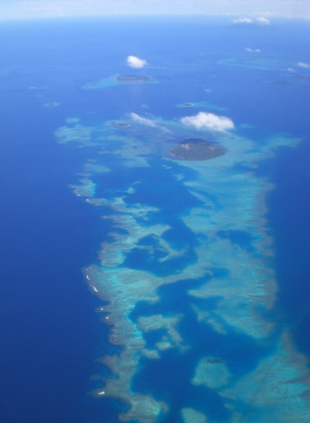

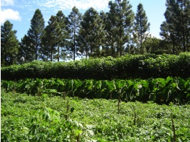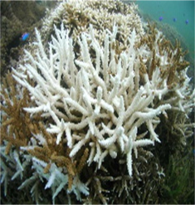Action Plan for Implementing the Convention on Biological Diversity’s

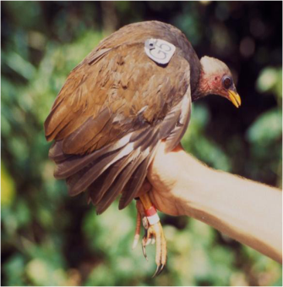Programme of Work on Protected Areas

Kingdom of Tonga

Submitted to the Secretariat of the Convention on Biological Diversity October 6, 2011

Protected area information:

PoWPA Focal Point:

Mr. Asipeli Palaki

Director

Ministry of Environment & Climate Change

P.O. Box 917

Nuku'alofa, Tonga

E-Mail: [apalaki@gmail.com](mailto:apalaki@gmail.com)

Lead implementing agency:

Ministry of Environment & Climate Change

Multi-stakeholder committee:

National Biodiversity Advisory Committee (NBAC) was active for the period June 2003 until December 2004. A National Environment Coordinating Committee (NECC) was established in 2005 to replace the NBAC and to oversee all environment projects of the Ministry of Environment & Climate Change.

The NECC comprises the following:

Minister for Environment & Climate Change (Chair)

Director for Environment & Climate Change (Secretariat)

Director for Agriculture and Food, Forestry and Fisheries

Director for Tourism

Director for Transport

Director for Meteorology

Director for Education, Culture and Women Affairs

Secretary for Lands, Survey & Natural Resources

Secretary for Foreign Affairs

Secretary for Labour, Commerce and Industries

President of Chamber of Commerce

Secretary for Finance & Planning

Director for Civil Society

A Technical Working Group was established for the implementation of the NBSAP and PoWPA which consists of the following organisations:

Ministry of Environment & Climate Change

Ministry of Agriculture and Food, Forestry & Fisheries

Ministry of Tourism

NGO - Tonga Trust

Description of protected area system

# National Targets and Vision for Protected Areas

Tonga’s vision for biological diversity and natural resources are to protect, conserve and enrich; and to be enjoyed by present and future generations. This can be achieved by fulfilling national targets for Target 11 in thematic areas of forest and marine ecosystems, species conservation, and agro-biodiversity, and strengthening local communities and civil society engagement, financial resources and mechanisms, economic valuation and building climate resilience through protected area integration and mainstreaming.

Coverage

According to World data base on Protected Areas, as of 2010, 14.5% of Tonga’s terrestrial surface and 2.5% territorial Waters are protected.

Based on ecological gap analysis and other assessments conducted the realistic national targets for terrestrial and marine areas for target 11 are 5% marine and 17% terrestrial by 2020. Figure 1 maps the marine managed areas in Tonga. A list of protected terrestrial areas can be found in Annex 3 of the NBSAP 2006.

Description and background

Biodiversity conservation is one of the most difficult environmental issues facing Tonga. Often it poses choices between environmental protection and economic development and conflict between landowner rights and the government’s growing role in its stewardship responsibilities. However, the Government of Tonga is committed to the implementation of the CBD, including PoWPA, and has statutory laws that have provisions for biodiversity conservation. The importance of biodiversity as a basis for sustainable human development becomes even clearer when a cultural value has been added. As stated by Thaman et al., 1996, if cultural survival and economic sustainability are important objectives, the focus of biodiversity conservation programmes should not over-emphasise only native and endemic terrestrial and marine species, or larger “charismatic megafauna”, such as the whales, sea turtles, giant clams, rare birds, endemic plants, etc., but must also include a wide range of endangered or ecologically and culturally important ubiquitous and exotic (non-indigenous), and wild and domesticated, species or varieties. In Tonga, the total known species of higher plants are 463, with 2 identified as threatened species. Tonga has 2 mammals, both of which are considered endangered. 16 birds (with 3 identified as threatened), 17 reptiles (2 endangered) and 106 fishes (one endangered) have been found in Tonga (MECC 2006). Tonga has established 13 marine managed areas (five (5) MPAs – government managed; one (1) Marine Reserve – government managed; six (6) SMAs – locally managed; one (1) multipurpose conservation area), and seven (7) terrestrial parks and reserves, and is currently finalising site specific management plans.

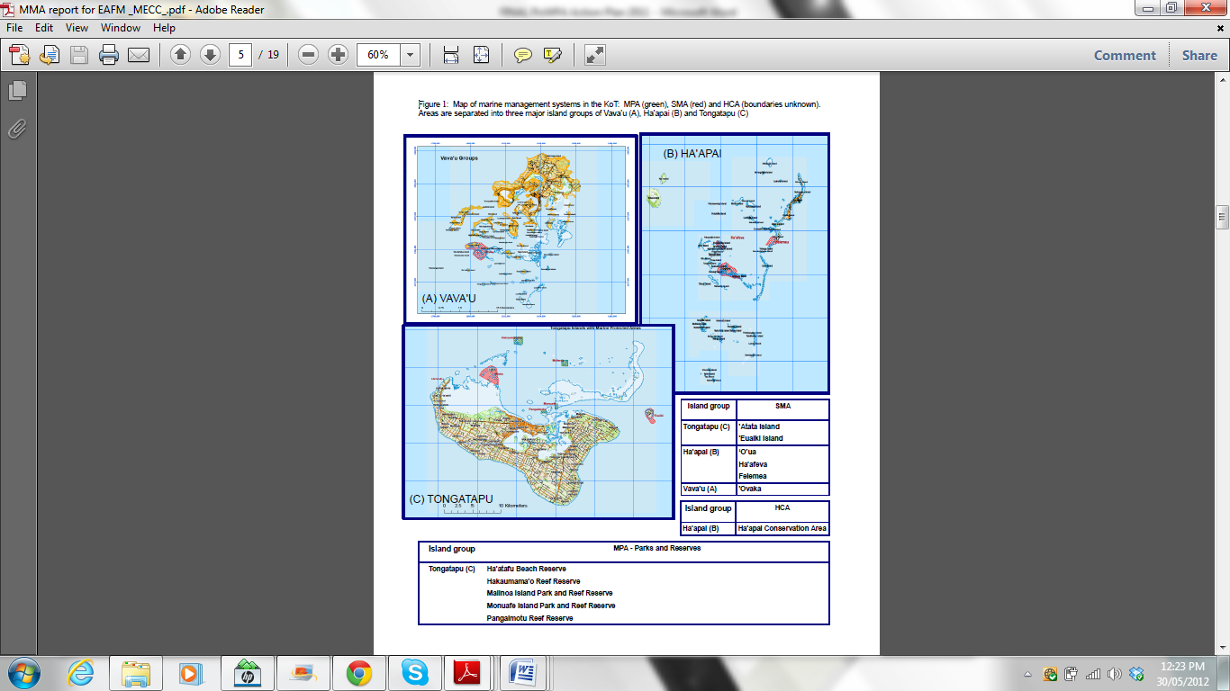

The primary objective for this request is to review the existing protected area network, make recommendations for its improvement and put in place the policy, legislation and institutional framework for strengthening the national protected area network. Like many developing countries, Tonga has faced many capacity and resourcing barriers in making this desire into a reality.

This project is the result of the PA ecological gap assessment, funded by UNOPs enabling activity, and promoting of Pas by legal, policy and community mechanisms, i.e. PoWPA Activity 1.1.5 and 2.1.2. This decision was based on the understanding that an enabling environment backed by a strengthened institutional framework is of foundational importance to go hand in hand with planning and establishing a new PA management system. It was acknowledged that institutional constraints were a major gap for effective implementation of existing PA management plans.

Governance types

The institutional setting for managing the PA system in Tonga is as follows:

| **Institution** | **Responsibilities for Protected Areas** |
| --- | --- |
| Ministry of Environment & Climate Change | The Ministry plays an advisory role to other Ministries who have the mandates for biodiversity conservation. The Ministry is responsible for drafting National Action Plans for Biodiversity and Climate Change in consultation with relevant stakeholders, as well as seeking financial assistance for implementation.  Surveys and Monitoring programmes have been established which are designed to assess and gather baseline information on important ecosystems and habitats, including Fanga’uta Lagoon, Marine Protected Areas, and coral reefs. Other related responsibilities include:   * Propose and recommend potential Marine Reserves sites for designation in accordance with the Parks & Reserves Act (1988) * Increase public/community awareness of environmental issues nationally like lagoon, coastal related issues, biodiversity) * Develop strategies for the conservation of biodiversity   The MECC also stands as the coordinating rtisanalon for the majority of international donor funded projects in the environmental sector. It also handles compliance with the international conventions such as the United Nations Framework Convention on Climate Change (UNFCC) and Convention on Biological Diversity (CDB). |
| Land Management, MLSNRE | The responsibility of MLSNR that addresses biodiversity conservation is the authority of the Minister to declare an area in the coastal environment or on land a Protected Area (PA/Marine Reserve) under the Parks and Reserves Act 1976 and Revised 1988. This Act is for the protection, preservation and control of any aquatic form of life and any other organic matter contained within this MPA boundary. |
| Department of Fisheries, MAFFF | The responsibility for the conservation, management and development of fisheries in Tonga.  The Fisheries Act, 1989 gives authority to the Minister and MoF to conserve endangered inshore marine resources by enforcing size limits on lobsters, giant clams, turtles, winged pearl oyster etc. This Act gives the MoF responsibility of enforcing the penalty if an offender is caught breaking the law. It also establishes Small Management Areas (SMAs) to be co-managed by a community and government. |
| Department of Forestry, MAFFF | The Forest Act CAP 126 provides the Minister of Forests with the Cabinets consent to make regulations in areas of concern to Tonga’s forests. The Forest Act also allows issuing of license in respect to forest produce. There are existing legislations with powers vested with the Minister of Forest, which includes ***Noxious Weeds Act (CAP 128),*** to proclaim noxious weeds under the authority to administer the ***Plant Quarantine Act (CAP 127).***  Tonga has a Forest Management policy 2009, which defines core functions which are as follows:   * Develop policies, legislations and regulations to enable sound management of the country’s forests resources * Promote forestry operations to contribute towards economic development * Ensure the natural forest reserves are protected, developed and monitored * Promote and undertake relevant scientific researches * Promote and encourage plantation forestry to improve local timber and wood production through; * Promote and encourage production of high valued tree species for export * Promote participatory agro – forestry development. * Promote production and protection forestry development activities on potential uninhibited islands. |
| Ministry of Tourism | The Tonga Visitors Bureau do not have any direct responsibilities with regards to Protected Areas which are mostly related with tourism for example whales and dolphins.  However they have a supportive and enforcement responsibility to other relevant authorities like Ministry of Fisheries where a co-junction between TVB and MoF to introduce guidelines and codes of practice for whale watching operators.  TVB also introduced code of practice for diving and snorkeling operators requiring them to comply with regulations and approved practices.  Increases awareness towards forests and tree planting and conservation. |
| Tonga Trust | Provide community-based research and extension support to current activities. |
| TANGO | Community awareness programmes |
| Civil Society | Provide community assistance in allocating financial assistance to national projects under the Small Grants Programme. |
| Tonga National Fisheries Association | Umbrella NGO for fisheries. Advocate and assist in the public awareness through all members (subsistence, rtisanal, and commercial fishermen). |

Overview of the PA system in Tonga:

|  |  |  |  |  |
| --- | --- | --- | --- | --- |
| **PA category/type** | **Quantity** | **Surface area, hectares** | **Corresponding IUCN category** | **Management authority** |
| Marine Protected Areas, protected seascape/ marine reserves | 5 | 3,330 | IV-VI | MLSNR/MAFFF/MECC |
| Managed resource terrestrial protected areas | 7 | 6,260 | II, V,VI | MAFFF/MLSNR/MECC |
| Multiple use | 1 | 990,600 | IA, II, V, VI | MECC/MLSNR/MAFFF |
| Managed resource protected areas/special management areas (SMA) – community based. | 6 | 9290 | VI | DoFish, MAFFF |
| Strict Nature Reserve (SMAs – community based) | 6 | 1,104.5 | IA | DoFish, MAFFF |

Note: Strict nature reserves (no take zones) are within SMAs.

Key threats

Threats to the protected areas

**Threat 1: Terrestrial protected areas**

Pressures and threats on protected areas are mainly related to population growth and the development of services required by the population and economic development such as agriculture. Several key conservation issues and problems become apparent in terms of ecosystem and biodiversity degradation such as:

* increased soil degradation, which is indicated by the increase in commercial agriculture and the increase in use of fertilizer and pesticide;
* increased pests, weeds and plant diseases;
* loss of native forest and general deforestation;
* loss of habitat, biodiversity and wildlife;
* problems of increasing waste quantities requiring management.

The state of protected areas, however, is difficult to determine due to lack of reliable information, adhoc research, lack of appropriate national indicators developed for conservation, inconsistent policies and data collection methods differs, which make it difficult to establish reliable biodiversity use trends.

**Threat 2: Marine & Coastal Protected Areas**

Pressures and threats on coastal and marine protected areas include natural phenomena and human activities.

Coastal area and wetlands reclamation have caused loss of mangrove areas and littoral forest, especially around Fanga’uta and Fangakakau Lagoon, on the main island of Tongatapu. A further allocation of coastal foreshore areas for residential and commercial purposes in the southern and eastern coast areas of Tongatapu has led to the destruction of the protective coastal tree belt and an increase in the damage caused by seawater spray.

Biodiversity and habitat loss in protected areas are caused by quarrying coral and removing sand from beaches for construction, and is increasing at an alarming rate. Environmental degradation with offshore dredging of sand is yet to be researched.

Coastal pollution from land-based activities and waste is becoming a major threat, for example, siltation from reclamation, solid waste dump sites, potential eutrophication and groundwater seepage into the lagoon or coastal waters.

Although marine reserves have been established as well as a major environmental management plan (Fanga’uta Lagoon Management Plan), there is a lack of commitment for implementation due to lack of resources, lack of skilled manpower and unclear institutional arrangement.

From the few studies that have been concentrated in Tongatapu, coastal fisheries habitats such as seawater quality, mangroves, and seagrass show signs of degradation as a result of development.

Barriers for effective implementation

(Description of key barrier s for effective implementation)

**Barrier 1: Legal and Policy framework**

Although legislation is the main instrument used in Tonga to protect the environment, some of the existing legislation is old and no longer applicable to the current physical and socio-economic environment of Tonga. Enforcement is also a major problem due to lack of staffing and finances for operations.

**Barrier 2: Lack of Community and NGOs Awareness and Participation**

There are only a few NGOs active in conservation programmes and two island groups each engaged in community-based marine management. A stock-taking exercise show that there are very few NGOs who consciously plan and implement conservation related programmes, such as Tonga Trust. Most related NGOs work programmes in the community are focusing on ‘keeping the village clean’, tree planting or determine by the objectives of the donor available. There is a need to ensure consultation and coordination among relevant government institutions and the general public, if not, participation in managing protected areas will continue to be sector-based, fragmented, and in many cases ineffective.

**Barrier 3: Mainstreaming**

For effective management of protected areas, there is a need to mainstream environmental issues that contribute to conservation and sustainable development into the national strategy development plans and each institutional stakeholders operational plans. For instance, it seems that the potential impact of climate change and sea level rise is not yet integrated into any national programme. Determining the state and trend of the coastal biodiversity resources is limited. Not only that, the lack of national indicators further constrained the effort to determine the state of marine/coastal biodiversity. The available data and information available only reflects the priorities of implementing agencies, what donor funded projects were running, and individual researchers’ interests.

**Barrier 4: Human capacity**

MECC is currently understaffed with only six staff members carrying out environmental management and research which involves planning and preparation of management plans that include MPA’s, solid waste and pollution. Two of these staff members are also involved in managing the Ministry. The number of staff in this Ministry is a limiting factor and support from staff of other government or non-government organisations are employed to carry out marine and terrestrial assessment studies. MECC has been trying to request additional staff to cope with the number of environmental issues arising.

**Barrier 5: Available funding**

Ministries that have responsibilities for biodiversity conservation or protected areas are responsible for requesting government funding through their budget proposals at every financial year. Further, these institutions also have responsibility for seeking donor financial support for their biodiversity conservation role through project developments. In the area of PA management, government funds mainly cover staff salaries only. Donor funding have been requested for relevant implementation, monitoring, training and awareness programme. However sustaining these activities after the donor funding ends is a major problem in Tonga.

# Status of key actions of the Programme of Work on Protected Areas

(Status, priority and timeline for key actions of the Programme of Work on Protected Areas)

|  |  |
| --- | --- |
| **Status of key actions of the Programme of Work on Protected Areas** | **Status** |
| * Has a **multistakeholder advisory committee** been formed? | 4 |
| * Progress on assessing **gaps in the protected area network** (1.1) | 3 |
| * Progress in assessing **protected area integration** (1.2) | 3 |
| * Progress in establishing **transboundary protected areas** and **regional networks** (1.3) | 1 |
| * Progress in developing **site-level management plans** (1.4) | 3 |
| * Progress in assessing **threats** and opportunities for **restoration** (1.5) | 3 |
| * Progress in assessing **equitable sharing** of benefits (2.1) * Progress in assessing protected area **governance** (2.1) | 3  3 |
| * Progress in assessing the **participation** of indigenous and local communities in key protected area decisions (2.2) | 3 |
| * Progress in assessing the **policy environment** for establishing and managing protected areas (3.1) * Progress in assessing the **values** of protected areas (3.1) | 3  2 |
| * Progress in assessing protected area **capacity** needs (3.2) | 3 |
| * Progress in assessing the **appropriate technology** needs (3.3) | 3 |
| * Progress in assessing protected area **sustainable finance** needs (3.4) | 1 |
| * Progress in conducting **public awareness** campaigns (3.5) | 3 |
| * Progress in developing **best practices and minimum standards** (4.1) | 3 |
| * Progress in assessing **management effectiveness** (4.2) | 2 |
| * Progress in establishing an **effective PA monitoring system** (4.3) | 3 |
| * Progress in developing a **research program** for protected areas (4.4) | 2 |
| * Progress in assessing opportunities for **marine** protection | 3 |
| * Progress in incorporating **climate change** aspects into protected areas | 3 |

Status: 0 = no work, 1 = just started, 2 = partially complete, 3 = nearly complete, 4 = complete

(Insert notes as appropriate)

# Priority actions for fully implementing the Programme of Work on Protected Areas:

(Insert priority actions)

Priority actions are as follows:

* Assessing gaps in the protected area network
* Establishing transboundary protected areas and regional networks
* Assessing the values of protected areas
* Sustainable financing and mechanism
* Assessing management effectiveness for both government and communities
* Establishing an effective PA monitoring system; and
* Developing a research programme for protected areas

# Timeline for completion of key actions

(Insert timeline)

|  |  |  |
| --- | --- | --- |
|  | **Key actions** | **Timeline** |
| 1 | Sustainable financing and mechanism | 2020 |
| 2 | Develop site-level management plans | 2013-2020 |
| 3 | Assessing gaps in the protected area network | 2015,2020 |
| 4 | Assessing the values of protected areas | 2016 |
| 5 | Assessing management effectiveness for both government and communities | 2015,2020 |
| 6 | Establishing an effective PA monitoring system; and | 2020 |
| 7 | Developing a research programme for protected areas | 2013-2020 |
| 8 | Establishing transboundary protected areas and regional networks | 2020 |

# Action Plans for completing priority actions of the Programme of Work on Protected Areas

(Insert detailed action plans)

Action 1: Sustainable financing

|  |  |  |  |
| --- | --- | --- | --- |
| **Key steps** | **Timeline** | **Responsible parties** | **Indicative budget** |
| Develop a policy or regulation under an existing Legislation to enable the establishment of an Environment Trust Fund. | 2017 | MECC/NECC | 10,000 |
| Develop an independent board to manage the trust fund (voluntary) | 2017 | MECC/MoFin | 5,000 |
| Develop guidelines for applications | 2014-15 | MECC/NECC/MoFin | 10,000 |
| Develop rules and criteria for approval processes of applications | 2014-15 | MECC/NECC/MoFin | 10,000 |
| Hold a Roundtable on Sustainable financing for Protected Areas | 2015/16 | MECC | 20,000 |
|  |  |  | **55,000** |

Action 2: Develop & implement site-level management plans

|  |  |  |  |
| --- | --- | --- | --- |
| **Key steps** | **Timeline** | **Responsible parties** | **Indicative budget** |
| Baseline study of the protected area | 2013-2018 | MECC/MAFFF | 300,000 |
| Identify specific realistic goals for management | 2014 | MECC/MAFFF | 200,000 |
| Develop targeted monitoring methodology | 2014-2015 | MECC/MAFFF |
| Develop management plans (with community and relevant stakeholder input) | 2014-2020 | MECC/MAFFF |
| Use monitoring results to update management plans | 2014-2020 | MECC/MAFFF | 100,000 |
| Implementation of management plan (at least one) | 2014-2020 | MECC/MAFFF | 100,000 |
|  |  |  | **700,000** |

Action 3: ***Assessing gaps in the protected area network***

|  |  |  |  |
| --- | --- | --- | --- |
| **Key steps** | **Timeline** | **Responsible parties** | **Indicative budget** |
| Analyses of existing data | 2014,2018 | MECC/MAFFF | 60,000 |
| Identify priorities | 2014, 2018 | MECC/NECC | 60,000 |
| Plot location of IUCN Red list species or nationally prioritized species | 2014, 2018 | MECC/MLSNR |
| Analysis of top priority sites (rare spp. Etc.) | 2014, 2018 | MECC/MAFFF |
| Report | 2016, 2020 | MECC | 20,000 |
|  |  |  | **140,000** |

Action 4: A***ssessing the values of protected areas***

|  |  |  |  |
| --- | --- | --- | --- |
| **Key steps** | **Timeline** | **Responsible parties** | **Indicative budget** |
| Identify ecosystem service to value | 2014-2015 | MECC/NECC | 10,000 |
| Valuation study of ecosystem service | 204-2015 | MECC/MAFFF | 50,000 |
| Communicate results to decision makers | 2015 | MECC/MAFFF/NECC | 40,000 |
|  |  |  | **100,000** |

Action 5: ***Assessing management effectiveness***

|  |  |  |  |
| --- | --- | --- | --- |
| **Key steps** | **Timeline** | **Responsible parties** | **Indicative budget** |
| Management goals clearly identified | 2015, 2020 | MECC/NECC | 10,000 |
| Monitoring measures to inform the goals | 2015, 2020 | MECC/NECC |
| Assess whether communities can independently implement adaptive management | 2015, 2020 | MECC/MAFFF | 50,000 |
| Comparison of PA and controlled sites | 2015,2020 | MECC/MAFFF | 40,000 |
|  |  |  | **100,000** |

Action 6: ***Establishing an effective PA monitoring system***

|  |  |  |  |
| --- | --- | --- | --- |
| **Key steps** | **Timeline** | **Responsible parties** | **Indicative budget** |
| Management goals and objectives clearly identified | 2015 | MECC/NECC | 10,000 |
| Monitoring indicators identified to meet goals for the different PA system | 2015, 2020 | MECC | 10,000 |
| Financial mechanism | 2018 | MECC/MoFin | 20,000 |
| Data management mechanism | 2018 | MECC/MAFFF | 20,000 |
| Reporting process | 2015 | MECC/MoFin/MAFFF | 10,000 |
|  |  |  | **70,000** |

Action 7: ***Developing a research programme for protected areas***

|  |  |  |  |
| --- | --- | --- | --- |
| **Key steps** | **Timeline** | **Responsible parties** | **Indicative budget** |
| Habitat modeling incorporating climate scenarios to evaluate different areas for habitat irreplaceability | 2013-2018 | MECC/MAFFF | 100,000 |
| Feasibility study on rehabilitating Fanga’uta and Fangakakau Lagoon Marine Reserve | 2013-2018 | MECC/NECC | 400,000 |
| Coral Reef Resilience | 2013-2018 | MECC/MAFFF | 400,000 |
|  |  |  | **900,000** |

Action 8: ***Establishing transboundary protected areas and regional networks***

|  |  |  |  |
| --- | --- | --- | --- |
| **Key steps** | **Timeline** | **Responsible parties** | **Indicative budget** |
| Agreements with regional partners/countries on ecological corridors for whales, turtles, etc. | 2013-2020 | Tonga/Fiji/NZ/CROP | 200,000 |
| Strengthen monitoring of compliance and enforcement for protected areas | 2013-2020 | Tonga and regional partners | 200,000 |
|  |  |  | **400,000** |