Action Plan for Implementing the Convention on Biological Diversity’s
Programme of Work on Protected Areas
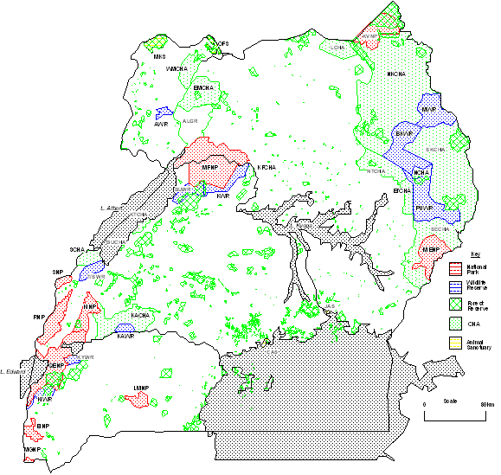
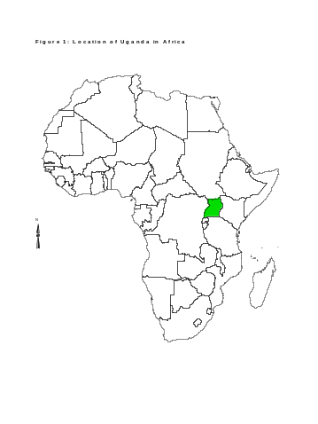

Uganda

Submitted to the Secretariat of the Convention on Biological Diversity
March 31, 2012
Protected area information:

PoWPA Focal Point: (Name, contact details)
Mr. Aggrey Rwetsiba
Senior Monitoring and Research Coordinator
Uganda Wildlife Authority,
P.O Box 3530
Kampala, Uganda
E-Mail: aggrey.rwetsiba@ ugandawildlife.or
aggreyrwetsiba@yahoo.com

Lead implementing agency:
National Environment Management
Multi-stakeholder committee: 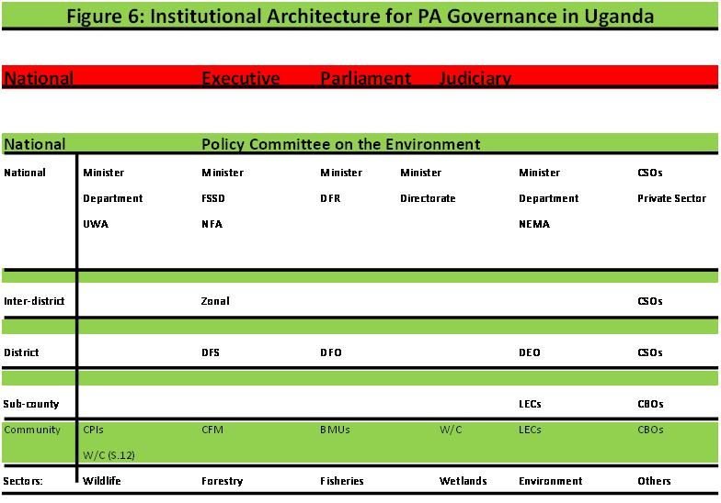

Description of protected area system

National Targets and Vision for Protected Areas
(Insert national targets for protected areas/Target 11 of the Aichi Targets. Include rationale from protected area gap assessment, if completed, along with any additional information about the vision for the protected area system, including statements about the value of the protected area system to the country)

Based on gap analysis and description of KBAs, IBAS, etc realistic national targets both quantitative and qualitative for target 11 for Uganda are :
Coverage
Uganda’s Protected Areas (PAs) are in form of Central Forest Reserves and Local Forest Reserves (24% of land surface) National Parks, Wildlife Reserves, Wildlife Sanctuaries and Community Wildlife Areas (14% of land surface). In total, the protected areas represent approximately 38% of Uganda land surface area (figure 1). However, these PAs are not representative of all the key ecosystems in Uganda. It would be worthwhile to establish a PA system that represents all key ecosystems including Aquatic resources, Wetlands and, Montane ecosystems.
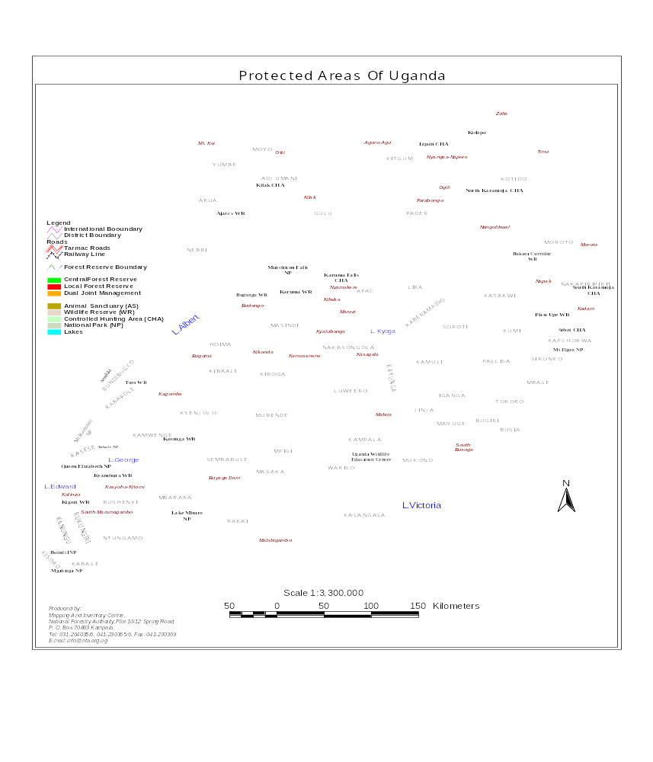
Figure 1: Protected Areas of Uganda
Description and background
Uganda is a landlocked country that lies astride the equator between 4oN and 1oS and stretches from 29.5 – 35oW. It is one of the smallest states in Eastern Africa covering an area of 236,000 km2 composed of 194,000 Km2 dry land, 33,926 Km2 open water and 7.674 km2 of permanent swamp (Langdale-Brown et al 1964, Langlands, 1973). Uganda has a marked diversity of habitats ranging from savannas and lowland forests to montane ecosystems which are punctuated with seasonal and permanent water bodies in the form of streams, rivers, lakes and wet season overflows in valley bottoms.
Natural diversity in ecosystems, habitats and species are managed for provision of essential economic benefits and services to human society—such as food, shelter, fuel and medicines—as well as ecological, recreational, cultural and aesthetic values, and thus plays an important role in sustainable development. Despite these values, natural resource management including protected areas and associated species have been faced with threats including extinction of some species overtime as a result of anthropological factors mainly fire, and the unsustainable use of flora and fauna resources alongside habitat degradation and climate
There are currently three major categories of protected areas in Uganda. These are National Parks, Wildlife Reserves, Wildlife Sanctuaries, Community Wildlife Areas and Forest Reserves. However, wetlands and the major rivers and lakes are also protected by law.
Uganda’s forest estate is currently estimated at 24% of the country’s total land area. The majority of this estate is comprised of woodland (81%), tropical high forest (19%) and forest plantation (less than 1%). Estimates by the Food and Agriculture Organization of the United Nations (FAO) suggest that Uganda’s forest estate has declined from 45% in 1890 to only 20% of Uganda’s total land area. Although there is insufficient data to determine precisely the rates of current deforestation trends, it is generally agreed that the major factors contributing to deforestation are: encroachment, land conversion for agriculture, unsustainable harvesting, urbanization, industrialization and institutional failures.
Central Forest Reserves (CFR) are managed by the National Forestry Authority (NFA) as a Permanent Forest Estate (PFE). These CFRs were established with two main objectives; to safeguard supplies of timber and other consumptive forest products and environmental services they provide as well as protect fragile catchment areas. Over the years these objectives have been expanded to include aspects such as nature conservation, amenity and recreation, research and education, and poverty eradication as reflected in the National Forest Policy. There are also Local Forest Reserves (LFR) which are managed by local governments. Local communities living adjacent to the forest and wildlife reserves often benefit from the resources through collaborative arrangements with the lead institutions.
The wildlife sub-sector covers the wildlife protected area estate in the country and the management of wildlife resources on private land. The protected wildlife estate is currently comprised of 10 national parks (11,180 sq. km), 10 wildlife reserves (8,764 sq. km), 7 wildlife sanctuaries (850 sq. km) and 13 community wildlife areas (27,604 sq. km) adding up to 14% of the total land cover of Uganda. These protected wildlife areas combine with a magnificent scenic beauty of extensive forests and woodlands, mountain peaks and other aesthetic resources to provide a back bone for the tourism industry.
Available statistics show evidence of trends of recovery in selected wildlife species. However, there is no data available to enable a complete analysis of beneficiaries in the sector whether by region, gender, age group or any other desegregation. Empirical research is still needed to determine whether poor people especially those living around protected areas are benefiting from the current levels of investment in the wildlife sub-sector.
Uganda Wildlife Authority (UWA) has responsibility for management of the wildlife protected area estate. UWA conservation approach mainly focuses on law enforcement, community conservation, research and monitoring and financial sustainability.
Extent of Uganda’s protected areas by category

Category | No. of reserves* | Area (km²) | %age of Uganda’s land area
Forest Reserves | 710 | 11,410** | 5.8
National Parks | 10 | 8,023** | 4.1
Forest Reserves/National Parks | - | 3,190 | 1.6
Wildlife Reserves | 12 | 9,024** | 4.6
Forest/Wildlife Reserves | - | 420 | 0.2
Total | 732 | 32,067 | 16.3

Note: * No. of reserves shown for each category includes those carrying dual status. ** Areas shown exclude reserves or parts of reserves carrying dual status. Land area of Uganda is 197,096 km² (Uganda Bureau of Statistics)
Extent of Protected Areas by IUCN Categories

Protected Area category | Area (x 1000 ha) | Updates
Nature Reserves, Wilderness Areas, and  National Parks (categories I and II) | 766
Natural Monuments, Species Management  Areas, and Protected Landscapes and  Seascapes (categories III, IV, and V) | 997
Areas Managed for Sustainable Use and  Unclassified Areas (category VI and "other") | 4,663
Total Area Protected (all categories) | 6,427
Marine and Littoral Protected Areas {a}
Protected Areas as a Percent of Total Land  Area, 2003 {b} | 26.40%
Number of Protected Areas, 2003 | 1,085
Number of Areas >100,000 ha, 2003 | 12
Number of Areas > 1 million ha, 2003 | 1
Wetlands of International Importance (Ramsar Sites), 2002: Number of Sites | 1
Total Area (000 ha) | 15
Biosphere Reserves, 2002
Number of Sites | 1
Total Area (000 ha) | 247
Information from various sources
Uganda is also well endowed with a complex system of wetlands and wetland resources. It is estimated that these ecosystems cover about 30,000 sq. km accounting for approximately 13% of Uganda’s total land area. Wetlands are a very rich source of biodiversity including endemic and migratory bird species. Wetland management and use are monitored by various institutions including the Ministry of Water and Environment (through the Wetlands Management Department) and NEMA.
Uganda is a landlocked country and therefore has no direct connection with the sea or ocean. The inland surface water resources cover about 16 percent of the country’s total area. Uganda’s major catchment basins are associated with River Nile and Lake Victoria as shown below.

The Major catchment basins in Uganda
Basin | Area
Victoria Nile (Lake & River) | 57,669
Kyoga Nile (Lake & River) | 26,796
Lakes Edward & George | 18,18,624
River Aswa | 26,868
Albert Nile at Panyango | 20,004

Management and use of the water resources are monitored by various institutions including the Ministry of Water and Environment, Fisheries Department, NEMA and others.

Governance types
Protected area matrix for PAs in Uganda based on governance type
IUCN Protected area categories | Uganda Protected Area categories | Governance types
IUCN Protected area categories | Uganda Protected Area categories | A. Governance by government | B. Shared governance | C. Private governance | D. Governance by local communities
Ia. PA managed mainly for science | National Parks | X | (X)
Ia. PA managed mainly for science | Biosphere Reserves | X
Ia. PA managed mainly for science | Nature Reserves | X
Ib. PA managed for wilderness protection | -
II. PA managed mainly for ecosystem protection and recreation | National Parks | X | (X)
 | Forest Reserves | X | (X)
 | Wildlife Reserves | X
 | Biosphere Reserves | X
 | Ramsar Sites | X
 | Community Wildlife Areas |  |  |  | X
III. PA managed mainly for conservation of natural features | -
IV. PA managed mainly for habitat and species conservation | Wildlife Reserves | X
IV. PA managed mainly for habitat and species conservation | Community Wildlife Areas |  |  |  | X
IV. PA managed mainly for habitat and species conservation | National Parks | X | (X)
IV. PA managed mainly for habitat and species conservation | Forest Reserves | X | (X)
IV. PA managed mainly for habitat and species conservation | Wildlife Sanctuaries | X
IV. PA managed mainly for habitat and species conservation | Private wildlife ranches |  |  | X
V. PA managed mainly for landscape conservation or recreation
VI. PA managed mainly for sustainable use of natural resources | Community Wildlife Areas |  |  |  | X
 | Ramsar Sites | X | (X)
 | Gazetted wetlands | X | (X)
 | National Parks | X | (X)
 | Central Forest Reserves | X | (X)
 | Wildlife Reserves | X

The Table above shows that, according to the IUCN classification system for protected areas, state governance is the predominant (Type A) type of governance for PAs in Uganda with authority and responsibility invested in central government through national agencies such as NFA, UWA and Department of Wetlands Management Department (DWMD). However, some PA categories do have shared responsibilities (approximating type B) especially National Parks, Central Forest Reserves, gazzeted wetlands and Ramsar sites where community participation in management of the PA is allowed. In the National Parks for example, The UWA policy on Collaborative Management of protected areas recognizes that UWA may not be able to manage all of the protected areas on its own. It also recognizes the need to maintain harmonious relationship with the local communities. UWA therefore shares management of the National Parks with local communities surrounding the Park. The communities then benefit through Collaborative Resource Agreements (which allow them access to the park resources) or through the revenue sharing programme under which 20% of the annual revenue from gate entry fees is given to the communities. In the Central Forest Reserves, a similar arrangement exists where Collaborative Forest Management (CFM) also addresses equity issues. However in both cases, the laws recognize rights to use of the PA resources only, but do not give the communities ownership rights to the PA section they have been allocated.
There are also a few private governance types with authority and responsibility by land owners who run them for profit (type C), as well as local community governance (Type D), with local communities having customary and/or legal rights to run the community conservation areas. An example of PA type C in Uganda is the Ziwa Rhino and Wildlife Ranch (which measures 35 sq. miles). Currently, there is wildlife in the ranch that include bushbucks, oribi, Uganda kob, sitatunga, vervet monkeys, bush pigs, a virety of birds including the rare Shoebill stork, snakes and crocodiles, among others. These, however, occur in small numbers and therefore cannot attract many tourists. There is need to increase the number and variety of wildlife in the ranch. The rhinos that had become extinct in Uganda in the 1980’s were re-introduced in Ziwa Rhino and Wildlife Ranch in 2002. The major purpose of establishing the Ziwa Rhino and Wildlife Ranch was to breed them so that they can be released into the areas where they originally occurred.
There are also a number of community wildlife areas which are mainly found on public land and land individually owned by members of the local communities. Because of lack of skills in wildlife management, such wildlife areas are usually run under collaborative management through a partnership agreement between District Local Government, UWA, District Wildlife Associations, the private sector and local communities. The partnership agreement serves to define roles and responsibilities of each party in the management of the PA. Usually the “supervisory partners” or District Local Government, UWA, District Wildlife Associations require the management partner or investor to manage the community wildlife area, on behalf of the other partners, in accordance with relevant laws. UWA would, among other responsibilities, conduct law enforcement services in collaboration with the other partners while Local Governments would enforce the existing laws, develop and pass by-laws pertaining to wildlife management and conservation. District Wildlife Associations are responsible for enforcing environmental conservation and wildlife by-laws within the community while the local communities participate fully in selling food and other raw materials to tourists, in the marketing of the area locally and regionally and in all activities of wildlife conservation and collaborative management.
Key threats
Encroachment on forest reserves
According to National Forest Authority (NFA 2011), encroachment into forested protected areas is cause by people who have come from other locations and have been “facilitated” by or are “protected” by local leaders or protected areas personnel. By 2008, there were over 300,000 illegal settlements in central forest reserves.
With regards to evictions of encroachers, efforts have been less effective, partly due to the protection given by authorities, political interests that compromise law enforcement, weak institutional performances when handling evictions.
Agricultural Expansion
The key agents of agricultural expansion into hitherto undisturbed landscapes and protected areas are small-scale farmers (88 % of the population of Uganda), immigrants and private large scale monoculture farming (Palm Oil and Sugar Canes).
Between 1990 and 2005, agricultural land area expanded by 2% (from 8,400,789ha to 8,847,591ha mostly in form of small-scale agriculture (NFA 2005). Subsistence agriculture expanded into wetlands, grasslands, and forests (Olson and Berry 2003). Agricultural expansion remains a major deforestation driver in Uganda (Knopfle 2008), especially in high population areas or areas with high influx of immigrants.
Large-scale agriculture is not so wide-spread, and has increased from 68,446 to 106,630 ha between 1990 and 2005 (NFA 2005), but it has also caused significant threat to forestry. Key examples include the signing over of 7,000 ha of forest on the islands (Bugala and Kalangala) by the Uganda Government to BIDCO for establishment of an oil palm plantation.
Climate change and variability
Uganda has had its share of effects of climate change characterized of severe droughts and evidence of change in glacial extent (area) on the Rwenzori Mountains (Mileham et al. in prep.). It is predicted that if current trends in global warming persist, ice cover remaining on three of the six main mountains of the Rwenzori (Mounts Baker, Speke and Stanley) will disappear altogether by 2023 (Mileham et al in prep.).
It is believed that change in micro and macro climate may result in change in habitat in terms of species composition and also the extent of the forest coverage. This needs further research to ascertain the extent of change expected and the possible implications on the conservation of wildlife and associated habitat.
Poaching
Poaching is a serious problem and has cost wildlife a lot of resources to fight it. Animals are hunted for bush-meat and trophies, non targeted species are sometimes injured or even killed by traps and snares targeting other animal species.
Wild animals are hunted for their products, such as hide, ivory, horn, teeth and bone, are sold to dealers who make clothes, jewelry and other materials from them. In others cases animals are poached for game meat, cultural and medicinal values.
Methods of poaching include; wire snaring, trap nets, spears and dogs, pitfalls, arrows and bows, guns and many kinds of traps.
In the past cultural beliefs in Uganda used to protect certain species from hunting for bush-meat but this state of affairs is not likely to stay for long considering immigration across the international borders where mixing of cultures is likely to occur over the long term. Mt. Gorillas and chimpanzees are sometimes hunted for body parts and infants captured for sale as pets. Vesperini (2002) gives the sale value of an infant gorilla as £86,000. It is believed however that international trade in live gorillas and chimpanzees including their parts, which used to be a threat, declined with the listing of the species on Appendix I of CITES. Uganda is a signatory to CITES and the requirements of this convention are partly being implemented. However, there are still some infrequent attempts to obtain baby gorillas and chimpanzees as shown by the recent poaching of two adult gorillas and a baby in 2002 (AWF, 2003) plus confiscation of 14 chimpanzees infants since 1998.
Human population increase
The primary cause of agricultural expansion is the demand for more land to meet the increasing demand for food for a growing population (UFRIC 2002; Nagujja 2001). In the eastern region, population density is highest in the highlands. For example, Bududa district has a population density of 952 persons/km2 compared to the national average of 124 people/km2.
Diseases in Wildlife
Disease spread and outbreak poses a great threat to wildlife health and production. According to the 1997 Population and Habitat Viability Analysis (PHVA) simulation modelling, diseases, together with war, are the primary agents of risk of significant population decline and eventual extinction of the Mt Gorillas and chimpanzees (Werikhe et al. 1997; Ecotourism and Education Working Group Report. 1997). Both Gorillas and Chimpanzees are closely related to humans, with similar anatomical and physiological features. This makes them vulnerable to a number of human related diseases. Because they have not developed the necessary immunity, exposure to these diseases may destroy the entire population.
Human-Wildlife Conflict
The majority wildlife protected areas occur areas with a high and increasing human population density with an ever-increasing demand for land and natural resources. This state of matters brings the needs of the people and those of wildlife in constant conflict. The conflict revolves mainly around destruction of crops / crop raiding, disease spread and transmission and in some case human injuries. This conflict affects all species, including those that occur outside protected areas. The fact that there are restrictions on the boundaries of protected areas as far as communities are concerned and yet the wildlife animals are not restricted in their use of community land has also brought some level of resentment.
Another concern is that while government derives tourism and sport hunting revenue from wildlife even when they are on community lands (and destroying personal property), there is no individual ‘compensation’ for this loss. This situation negatively affects the attitude of individual cost bearers to wildlife conservation and protected areas management.
Poverty
Like in some other countries, the human population around the protected areas in Uganda is very poor, being some of the poorest in Africa (Plumptre et al., 2004). The indicators of wealth status, (according to Kjersgard, 1997 and ITFC in prep, quoted in Plumptre, 2004) include land ownership, ability to hire labour, resources to ensure education, quality of housing, and income levels.
Because of the high levels of poverty, the people around the protected areas make constant demands for resources from within the protected areas. Resources demanded include fuel wood, timber, non-timber forest products, game meat and water. Because of poverty, there is limited capacity to develop alternatives to resources found within the wildlife protected areas. The community priority areas are focused on growing enough food to feed their families and possibly having a bit left for sell. Using their meagre resources to grow alternatives to resources which can easily be got from the wildlife protected areas is not a priority. Thus the demand for natural resources is not likely to diminish in the near future, but rather to increase.
Poverty is also related to inability to afford access to appropriate health care services. This leads to a community with a high prevalence of diseases that can easily be communicated to wildlife such as the Great Apes. In such instances, poverty is a secondary threat to the survival of the species.
Insecurity and conflicts
There insecurity in the region and this has had a profound effect on wildlife conservation. During the times of insecurity different species of animals have been indiscriminately for bush meat; trade in animal parts such as ivory. Wildlife habitats has been encroached and heavily degraded. Due to politics, there has been conflict in the Mt. Gorilla region since the early 1990s and this has had a negative effect on the gorilla habitat (resource utilization by the armed forces and displaced people and lost opportunity for the local community to use the resources within limited restrictions. This state of matters also increases disease risks due to shared habitats with militia / rebel groups who tend to favour the vegetation/forest cover.
Barriers for effective implementation
Barrier 1: National political and financial priority setting does not yet favor PAs
Although the protected areas are recognized as a key tool to counter the loss of the country’s biodiversity and contribute to sustainable development, most of the protected areas are under weak management, inadequate institutional collaboration as well as inadequate funding. This is so mainly because political will to support the protected areas system is needed. Protected areas do not receive enough priority compared to the country’s other social and economic sectors such health and education.. This is also due lack of appreciation by the population of the economic value and the contribution of environmental goods and services from PA resources, and the contribution to poverty alleviation. Generally there is also inadequate political will to deal with illegal activities which leads to biodiversity loss.
Barrier 2: Poor governance in the management of PAs
There are many factors contributing to poor governance. As mentioned above, collaboration between central Government institutions is weak. Similarly collaboration between these institutions and local government institutions are also weak. Sometimes this manifests itself in corruption practices that are not compatible with biodiversity conservation. Although management plans are increasing in a number of PA sites for the benefit of the local communities, many sites still need them. Uganda Wildlife Authority has instituted a system of revenue sharing mechanisms with local communities. However, these mechanisms do not benefit the local communities directly as the financial resources are channeled through local governments for community programmes. Conflicting messages from politicians, probably because of inadequate and information, also creates unnecessary conflicts between local communities and lead institutions in charge of PA management. For example,
Other barriers identified during the initial study also included inadequate financial resources for effective management of PAs, inadequate staff capacity in specialized areas and inadequate availability and access to relevant information, among others.

Status, priority and timeline for key actions of the Programme of Work on Protected Areas

Status of key actions of the Programme of Work on Protected Areas
Status of key actions of the Programme of Work on Protected Areas | Status
- Progress on assessing gaps in the protected area network (1.1) | 0
- Progress in assessing protected area integration (1.2) | 0
- Progress in establishing transboundary protected areas and regional networks (1.3) | 3
- Progress in developing site-level management plans (1.4) | 3
- Progress in assessing threats and opportunities for restoration (1.5) | 3
- Progress in assessing equitable sharing of benefits (2.1)  - Progress in assessing protected area governance (2.1) | 4
- Progress in assessing the participation of indigenous and local communities in key protected area decisions (2.2) | 4
- Progress in assessing the policy environment for establishing and managing protected areas (3.1)  - Progress in assessing the values of protected areas (3.1) | 4  4
- Progress in assessing protected area capacity needs (3.2) | 0
- Progress in assessing the appropriate technology needs (3.3) | 0
- Progress in assessing protected area sustainable finance needs (3.4) | 0
- Progress in conducting public awareness campaigns (3.5) | 0
- Progress in developing best practices and minimum standards (4.1) | 0
- Progress in assessing management effectiveness (4.2) | 0
- Progress in establishing an effective PA monitoring system (4.3) | Not yet established
- Progress in developing a research program for protected areas (4.4) | 2
- Progress in assessing opportunities for marine protection | N/A
- Progress in incorporating climate change aspects into protected areas | 1
Status: 0 = no work, 1 = just started, 2 = partially complete, 3 = nearly complete, 4 = complete
(Insert notes as appropriate)

Priority actions for fully implementing the Programme of Work on Protected Areas:

- Assessment of ecological gaps in the protected area network
- Assessment of management effectiveness
- Assessing protected area capacity needs and the appropriate technology needs

Timeline for completion of key actions
By 2015

Action Plans for completing priority actions of the Programme of Work on Protected Areas
(Insert detailed action plans)

Action 1: (Describe action)
Key steps | Timeline | Responsible parties | Indicative budget (US$)
Write a concept proposal (PPF) | June 2012 | UWA  NEMA  NFA  WETLAND Devision | 5,000
Prepare PPG | September 2012 – November 2012 | UWA  NEMA  NFA  WETLAND Devision | 20,000
Project Implementation | December 2012 – December 2013 | UWA, NEMA, NFA | 500,000

Action 2: (Describe action)
Key steps | Timeline | Responsible parties | Indicative budget
Write a concept proposal (PPF) | January 2013 | UWA  NEMA  NFA  WETLAND Devision | 5,000
Prepare PPG | April – June 2013 | UWA  NEMA  NFA  WETLAND Devision | 20,000
Project Implementation | September 2013- June 2014 | UWA, NEMA, NFA | 60,000

Action 3: (Describe action)
Key steps | Timeline | Responsible parties | Indicative budget
Write a concept proposal (PPF) | April 2013 | UWA  NEMA  NFA  WETLAND Devision | 5,000
Prepare PPG | July – September 2013 | UWA  NEMA  NFA  WETLAND Devision | 20,000
Project Implementation |  | UWA, NEMA, NFA | 30,000

(Insert more as needed)

Key assessment results
Ecological gap assessment (insert summary findings if available)

Management effectiveness assessment (Insert summary findings if available)

Sustainable finance assessment (Insert summary findings if available)

Capacity needs assessment (Insert summary findings if available)

Policy environment assessment (Insert summary findings if available)

Protected area integration and mainstreaming assessment (Insert summary findings if available)

Protected area valuation assessment (Insert summary findings if available)

Climate change resilience and adaptation assessment (Insert summary findings if available)

(Insert other assessment results if available)

Draft National Forest Plan, 2002.
Cited in 2000/2001 State of the Environment Report for Uganda, pg 31.
NEMA, 2001 pg 31.
See Uganda Wildlife Strategic Plan
Wetlands Sector Strategic Plan 2001-2011. January 2001.
Directorate of Water Development, Ministry of Water & Environment

