Action Plan for Implementing the Convention on Biological Diversity’s

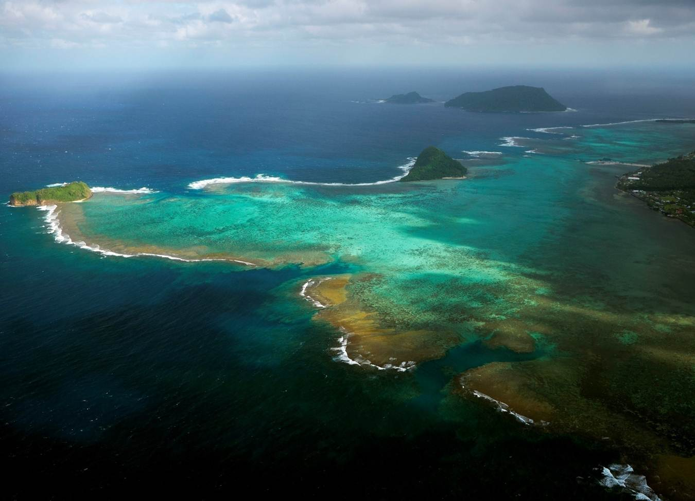
Programme of Work on Protected Areas

Samoa

Submitted to the Secretariat of the Convention on Biological Diversity October 6, 2011

Protected area information:

PoWPA Focal Point: Mr Faleafaga Toni Tipamaa
Assistant Chief Executive Officer
Division of Environment and Conservation
Ministry of Natural Resources and Enviornment
Apia, Samoa
Email: toni.tipamaa@mnre.gov.ws

Lead implementing agency: Ministry of Natural Resources and Environment (MNRE)

Multi-stakeholder committee: A stakeholder committee was formed at the offset of the PoWPA UNDP-GEF project in 2008 composed of members from different local organizations and government ministries. This includes representatives from international organizations, private sectors and local communities who have relevant tasks in helping the Executing Agency (MNRE) in the implementation of project activities.

Description of protected area system

National Targets and Vision for Protected Areas
According to the World data base on Protected Areas, as on 2010, as on 2010, while 1.34% of Samoa’s terrestrial surface is protected only 0.06% of its territorial waters are protected. Therefore, based on the ecological gap analysis and other assessments conducted under PoWPA, the realistic national targets for terrestrial and marine for target 11 are 18% terrestrial and 14% marine by 2020.
Coverage
There are now 13 declared protected areas (PAs) in Samoa, 3 of which are Marine Protected Areas (MPAs), covering 28,000 ha and 10,000 ha, respectively. Samoa aims to increase its protected areas coverage from 15% to 30% with the recent addition of 14,000 hectares of national parklands (NPs) on Savaii Island.
Map 1: Protected Areas and Key Biodiversity Areas of Samoa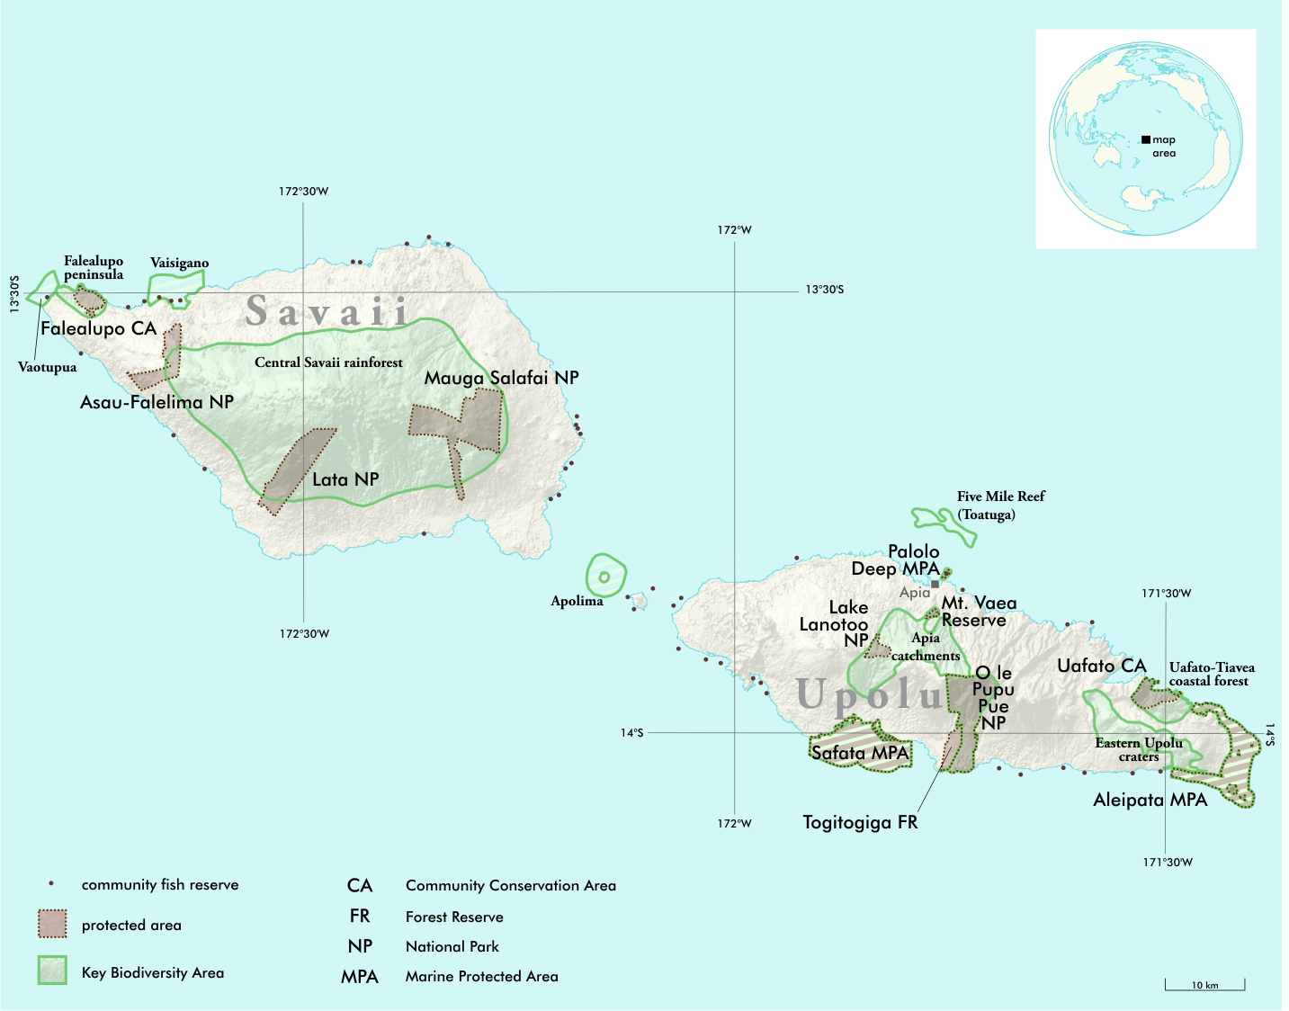
Map 2: Marine Key Biodiversity Areas and Marine Habitat
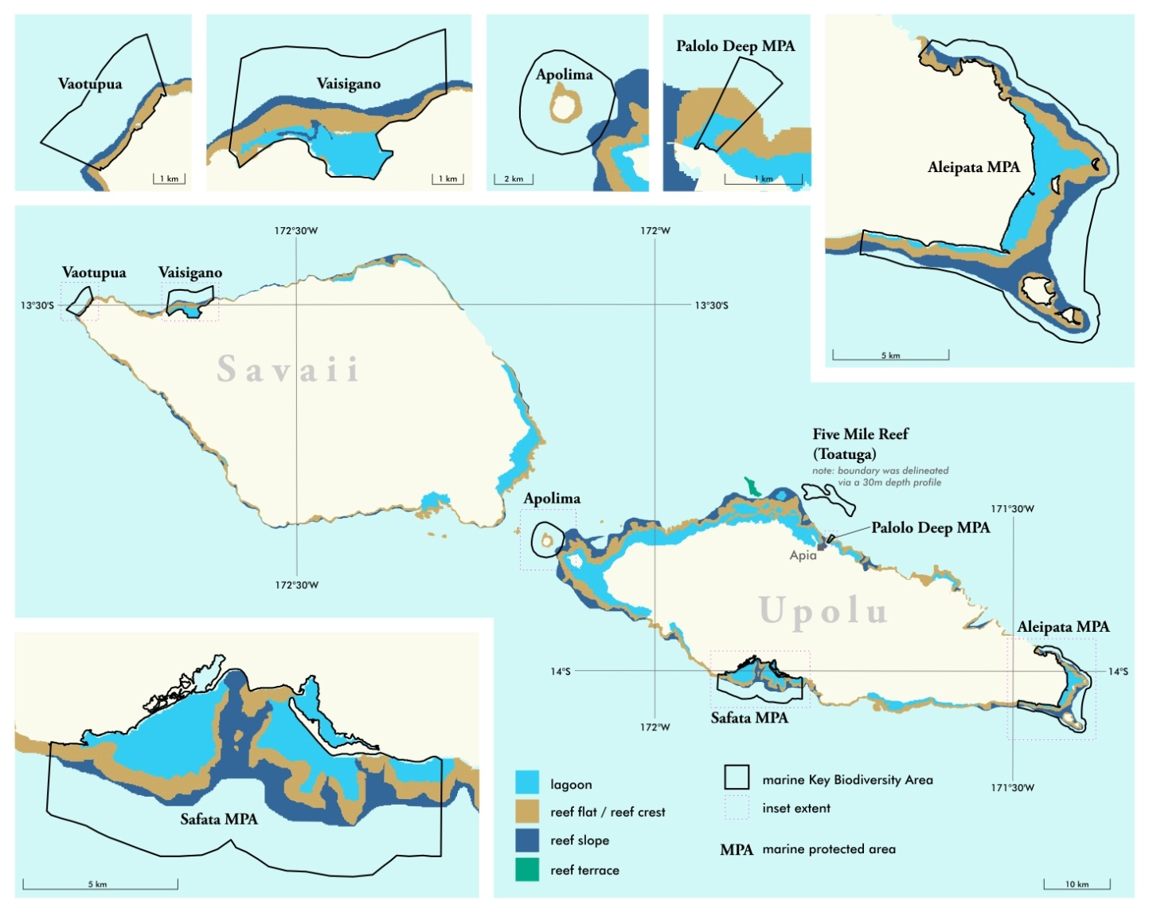

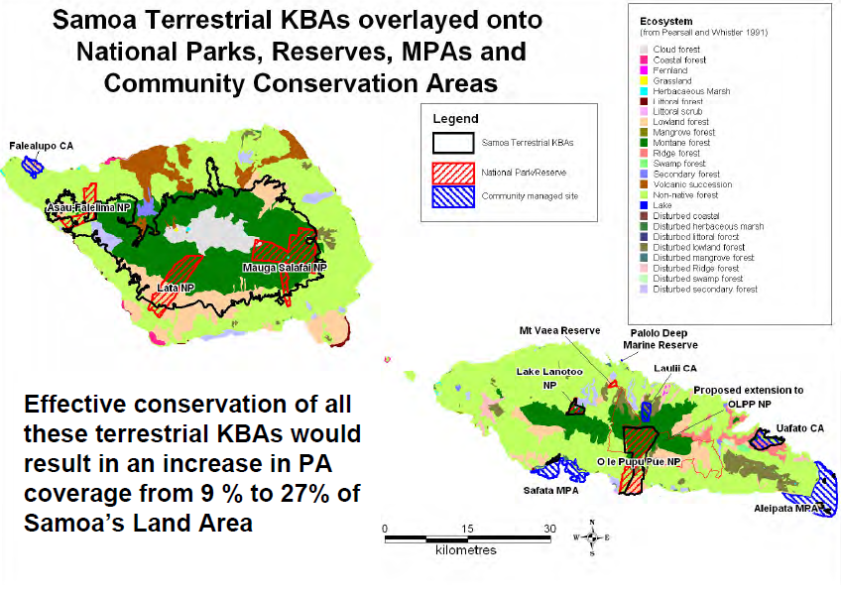

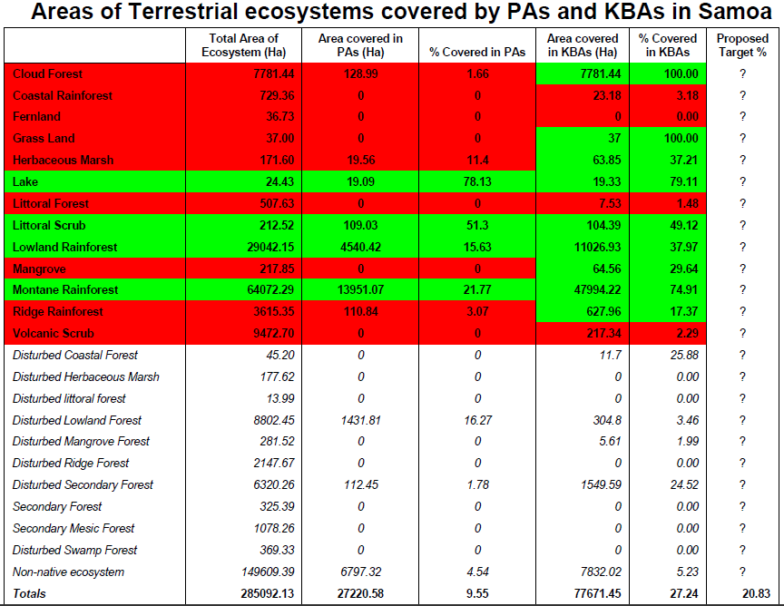

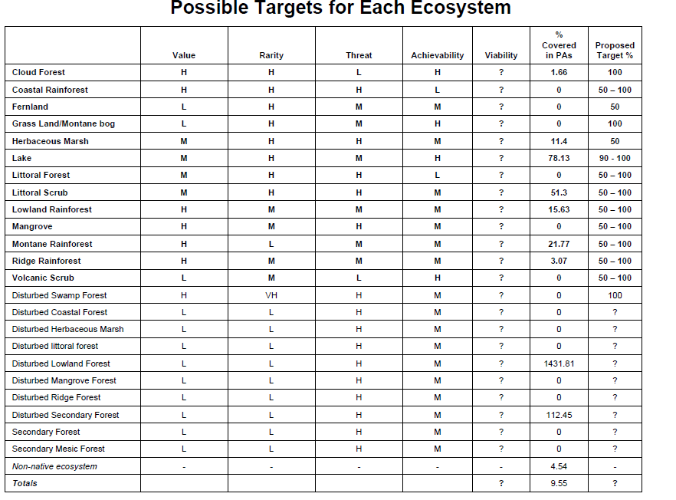
Description and background
Samoa is an independent small island developing state (SIDS) located in the South Pacific region. The country is geologically young and thus its biodiversity is not highly diverse. Nevertheless, isolation of the Samoan islands contributes to a very high species endemism of over 30%, with especially rare and endemic flora and fauna. The vegetation in Samoa is divided into five categories: littoral, wetland, rainforest, volcanic scrub and disturbed vegetation. Samoa is home to approximately 540 native flowering plant species and another 230 native fern and “fern ally” species. About one third of the native flowering plants are endemic to Samoa, i.e., they are found no where else on Earth. A further 500 or so species of plants have been introduced to the islands. There are 13 mammal species, 56 bird species, and 17 reptile species. No detailed studies of native freshwater fish have been conducted, but 991 marine fish species have been recorded. Little is known about terrestrial invertebrates, however, 21 species of butterflies, 20 species of land snails, and 59 species of ant have been found in Samoa. Threats to Samoa’s biodiversity include increasing forest clearance, agricultural expansion, bushfires, marine pollution, over-exploitation of marine resources, natural and manmade disasters, and negative impacts of global warming (see the Threats Section below for more information). Rural economic hardship is exacerbating conservation efforts: there is an urgent need to address this under-pinning economic issue and hence engaging organizations like the Development Bank of Samoa (DBS) and the South Pacific Business Development (SPBD) is essential.
Governance types
PA category/type | Quantity | Surface area, hectares | Corresponding IUCN category | Management authority
Mt Vaea Botanical Reserve and Palolo Deep Marine Reserve | 2 | 52 and 22 | IV | MNRE/DEC
National Parks (Lake Lanoto’o, O le Pupu Pue, Mauga Salafai, Lata and Falelima/Asau) | 5 | 201, 4,892, 5,974, 3,200, 2,100 | II | MNRE/DEC
Nature Reserves (Cape Puava, Tusitala Historic) | 2 | 404 | IV | MNRE/Community
Other areas (the World Database on Protected Areas says Samoa has 24 “other (fisheries) protected areas” : now increased to 40 http://www.unep-wcmc.org/wdpa/ | 60 | 400-500 | IV | MAF/Communities
Community Conservation Areas  e.g. Tafua Rainforest Preserve and Falealupo Rainforest Preserve | 2 | Approx 2500 | IV | Village Fono with assistance from NGOs
Marine Protected Areas (MPAs) | 2 | 11,361 | IV | MNRE/Communities
Recreational Reserves | 12 | 20 | III | MNRE/DEC

Key threats
There are numerous threats to protected areas in Samoa and these are described briefly below:
Threat 1. Invasive species, both plant and animals, introduced as well as native, are causing havoc in Samoa’s terrestrial and/or marine ecosystems. Further studies/activities need to be conducted to address this problem by identifying invasive species, assessing their impacts and implementing restorative measures. Funding for eradicating invasive avian species in Samoa has just been secured by MNRE from GOS. One cane toad has just been identified in Samoa last month by Quarantine Division. SPREP have a regional invasive species plan under formulation, but this needs urgent funding. Lists of Threatened Species in Samoa need to be compiled, especially in light of all the current impacts from invasive species.
Threat 2. Marine pollution and over-exploitation of marine resources have severely depleted marine biodiversity in Samoa. MNRE has applied for an International Waters Project partially to address surface run-off from urban areas into the nearby Vaiusu Mangrove Conservation Area. MAF have also targeted off-shore fisheries practices to help take pressure off the over-fished in-shore fisheries, damaged also by fish poisons, dynamiting, coral disturbances by local villagers, siltation and global warming (coral bleaching – past 10 years has seen the worst record of coral bleaching in the Pacific according to USP specialist, Dr. Leon Zann). Local NGOs are involved with coral gardening and inshore fisheries management practices. MNRE DEC and FD are actively involved in addressing such impacts on marine environments.
Threat 3. Natural disasters and global warming, including cyclones, are continuing to have serious negative impacts on both marine and terrestrial ecosystems. The Pacific is facing rising sea levels, warming of oceans, possible increased severity and frequency of cyclones/storms, tsunami, earthquakes, underwater landslides, volcanoes and bushfires, all impacting biodiversity adversely. MNRE has taken measures to apply for global climate change adaptation and mitigation projects with the main intent on protecting biodiversity (including human beings). In addition, related man-made disasters also need to be addressed including deforestation, upper atmospheric pollution with local precipitation, toxic chemicals in the food-chains, nuclear testing impacts, poor urban planning, etc. The MNRE has upgraded its Meteorological Division, its Planning and Urban Management Division, its Renewable Energy Division, etc. in response to such threats.
Threat 4. Non-sustainable forest clearance by customary landowners is continuing, and combined with storm damage and agriculture expansion into native forests by local farmers, is all severely depleting Samoa’s biodiversity. Samoa has had the highest annual deforestation rate amongst all PICTs at 3% pa, with less than 40% native forest cover remaining (with less than 0.5% original closed forest remaining). Whilst wholesale commercial logging has ceased, primarily foreign-owned, local commercial logging interests are continuing to take their toll. MNRE is designing new economic options to non-sustainable logging and combining this effort with a major national agro-forestry project with AusAID (2008-2013).
Threat 5. As Samoa’s closed forests are removed, and as the forest canopy is lost, drying of the understorey is inevitable, especially in low rainfall areas or during times of drought. Accidental bushfires have been devastating to local villagers in the past, and with global warming, the fire risks may increase. MNRE has taken a broad-brush holistic approach to managing biodiversity conservation in Samoa by concurrently addressing all the major threats mentioned above, including bushfires, and many of them closely linked with each other.
Barriers for effective implementation
Barrier 1. Biodiversity of Samoa remains least known; protected areas cannot be clearly established and managed without proper knowledge of the biological elements they are created for. Whilst some preliminary fauna and flora surveys have been completed, more in-depth surveys need to be completed, especially within the new PAS. Invasive species need to be identified and managed, threatened species need to be identified and addressed, and a programme of long-term monitoring of these parameters implemented. However, resources and capabilities are still limited.
Barrier 2. Unresolved conflict between customary land ownership, government land ownership and conservation goals is still a major barrier to biodiversity conservation. However, the management of National Parks by the GOS will set the example, help provide the resources to nearby customary landowners, and build capacity as environmental and economic trainings are completed. Less conflict can be expected as further economic development is assured.
Barrier 3. Capacity to do conservation research, conservation governance and conservation management is low to non-existent. Poor capacity of village councils to be engaged in protected area management is compounded by financial hardship and insufficient training. Insufficient management plans for PAS are in place.

Status, priority and timeline for key actions of the Programme of Work on Protected Areas

Status of key actions of the Programme of Work on Protected Areas
Status of key actions of the Programme of Work on Protected Areas | Status
- Progress on assessing gaps in the protected area network (1.1) | 2
- Progress in assessing protected area integration (1.2) | 2
- Progress in establishing transboundary protected areas and regional networks (1.3) | 0
- Progress in developing site-level management plans (1.4) | 3
- Progress in assessing threats and opportunities for restoration (1.5) | 1
- Progress in assessing equitable sharing of benefits (2.1)  - Progress in assessing protected area governance (2.1) | 1  2
- Progress in assessing the participation of indigenous and local communities in key protected area decisions (2.2) | 3
- Progress in assessing the policy environment for establishing and managing protected areas (3.1)  - Progress in assessing the values of protected areas (3.1) | 3  1
- Progress in assessing protected area capacity needs (3.2) | 2
- Progress in assessing the appropriate technology needs (3.3) | 1
- Progress in assessing protected area sustainable finance needs (3.4) | 0
- Progress in conducting public awareness campaigns (3.5) | 3
- Progress in developing best practices and minimum standards (4.1) | 1
- Progress in assessing management effectiveness (4.2) | 2
- Progress in establishing an effective PA monitoring system (4.3) | 0
- Progress in developing a research program for protected areas (4.4) | 0
- Progress in assessing opportunities for marine protection | 2
- Progress in incorporating climate change aspects into protected areas | 2
Status: 0 = no work, 1 = just started, 2 = partially complete, 3 = nearly complete, 4 = complete
(Insert notes as appropriate)

Priority actions for fully implementing the Programme of Work on Protected Areas:
- Effective implementation of the ecological gap analysis while incorporating input from local communities, government and other relevant stakeholders.
- Integration of protected areas into wider land and seascapes to showcase mainstreaming of biodiversity with other sectors and ecosystem based approaches to adaptation to climate change adaptation and leading to mitigation through carbon sequestration.
- Institutionalize management effectiveness assessment towards assessing 60% of the total areas and ensure that the results of the assessments are implemented.
- Diversification of governance types and recognition of ICCAs including through acknowledgement in national legislation or other effective means, formal inclusion in the national systems.
- Strengthened existing sustainable finance plans and development of new plans for protected area systems.
- Increase and introduce diverse management tool for protected areas including standardize monitoring methodology.
- Assessing the values and contribution of protected areas to the national and local economies and to achieving MDGs.

Timeline for completion of key actions
Key priority actions | Timeline
- Implementation of ecological gap analysis | 2019
- Strengthened and development of sustainable finance plans | 2018
- Integration of protected areas into wider land and seascapes | 2014
- Institutionalize management effectiveness assessment | 2015
- Diversification of governance types and recognition of ICCAs | 2015
- Protected areas management tools | 2014
- Values and contribution of protected areas | 2015

Action Plans for completing priority actions of the Programme of Work on Protected Areas
(Insert detailed action plans)
  - Action 1: Implementation of ecological gap analysis
Key steps | Timeline | Responsible parties | Indicative budget
Complete baseline information | 2013-2014 | MNRE | $500,000.00USD
Mobilize international and local experts | 2013 | SPREP, DOC, CI
Implementation of actions | 2014-2017 | MNRE, DOC, CI
Publication of results and awareness | 2018 | MNRE, SPREP
Monitoring programme | 2019 | MNRE

  - Action 2: Strengthened and development of sustainable finance plans
Key steps | Timeline | Responsible parties | Indicative budget
Review existing legislations for the formulation of subsistence financial mechanisms | 2014 | MNRE | $250,000.00
Mobilize international and local experts/consultants | 2014 | MNRE
Stakeholders consultations | 2015 | MNRE, MWCSD
Implementation of actions | 2015-2018 | MNRE, SPREP, CI
Review and monitoring | 2019-2020 | MNRE, SPREP, CI

  - Action 3: (Describe action)
Key steps | Timeline | Responsible parties | Indicative budget

(Insert more as needed)

Key assessment results
Ecological gap assessment (insert summary findings if available)
Samoa launched its Key Biodiversity Areas (KBA) report in 2010. The KBA was written for the general public to raise awareness about the key areas for conservation in Samoa and the species most threatened with extinction. The Government of Samoa in partnership with Secretariat of the Pacific Regional Environment Programme (SPREP) also has just completed a Biodiversity Rapid Assessment (BIORAP Project) carried out on one of Samoa’s upland forest of about 65,000 hectares. This forest area is considered as the largest and a very pristine remaining forest of Samoa and the whole of the Polynesia.

Management effectiveness assessment (Insert summary findings if available)
The government of Samoa has established the Ministry of Natural Resources and Environment (MNRE) focus solely on the sustainable development and effective management of Samoa’s natural resources and the environment. The government also highlighted in Samoa in its national plans (such as the Strategy for the Development of Samoa (SDS) the importance of the environment as a whole. NGO’s and private sectors also contribute with the good management of Samoa’s natural resources and the environment through its continuous partnership with the public sector in boosting awareness programmes in all levels.

Sustainable finance assessment (Insert summary findings if available)
Capacity needs assessment (Insert summary findings if available)
Policy environment assessment (Insert summary findings if available)
Several legislations and related plans are in place to mandate the sustainable use of the environment in Samoa. This includes;
- Environment Bill 2011
- Forestry Act 2011
- Water Resources Management Act 2008
- Lands Survey and Environment Act 1989
- Stevenson Memorial Reserve and Mt Vaea Scenic Reserve Ordinance 1958
- National Biodiversity of Samoa Action Plan (NBSAP) – under review
- State of the Environment (SOE) – under review
- National Environment Management Strategies (NEMS) 1993 – review completed
Protected area integration and mainstreaming assessment (Insert summary findings if available)

Protected area valuation assessment (Insert summary findings if available)

Climate change resilience and adaptation assessment (Insert summary findings if available)

(Insert other assessment results if available)

