## Republic of Yemen

## Ministry of Water and Environment

## Environment Protection Authority

Action Plan for Implementing the Programme of Work on Protected Areas of the Convention on Biological Diversity

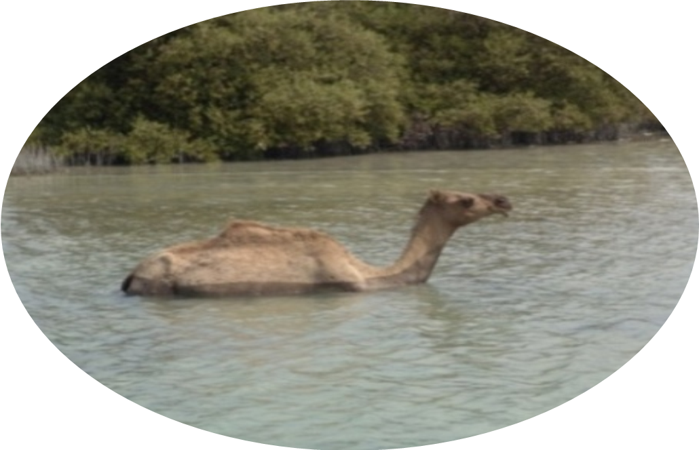

(

KAMARAN ISLAND PROTECTED AREA)

Submitted to the Secretariat of the Convention on Biological Diversity (08/05/2012)

Protected area information:

PoWPA Focal Point:

Mr. Mahmoud Shidiwah

Chairman of Environment Protection Authority

P.O Box 19719 Sana’a

Tel: +967 1

Fax: +967 1

Email : epa-yemen@yemen.net.ye

National Coordinator :

Mr. Abdul Hakim Aulaiah

Email:hak132001@gmail.com

Lead implementing agency:

Environment Protection Authority

Ministry of Water & Environment

Multi-stakeholder committee:

Relevant Agencies Ministry of Agriculture and irrigation, Ministry of Fisheries , Local Universities and relevant Environmental NGO’s .

Description of protected area system

Coverage

About 10% of Yemen total area covered with areas under sustainable management but not full protected only 6 protected Areas declared, total protected Areas less 5000 km2.

The total area of current protected sites are 4269.14 square km., as well as new Key Biodiversity Areas (KBAs) with total area of 25592.13 square km. are proposed to be included in the network which would encompass 6 % percent of the entire Yemen.

Description and background

According to the “Environment Protection Law” No. 26 for the year 1995, and article 11 of the bylaw No. 148 for the year 2000, “A protected Area may be established, in natural habitats, by a Prime Ministerial decree upon the recommendation of EPA or any specialized body”. The objectives for establishing protected areas are:

1- To ensure conservation of biological diversity and functioning of ecological processes incompliance with relevant international obligations, by preserving:

* selected examples of Yemen’s different biotic communities; and
* viable populations of rare, endemic and threatened species of wild plants and animals, and other species judged to be of special concern.

2- To protect and preserve selected sites or areas of senic beauty or of special interest.

3- To provide sustainable base for long term consumptive use of selected natural resources by local people.

4- To protect environments against erosion, flooding, watershed degradation, deforestation and desertification.

5- To provide a basis for conservation education and research, including maintaining undisturbed environments as a baseline for measuring environmental change.

6- To provide a sustainable base for developing and diversifying recreation and tourism.

7- To contribute to the economic and environmental well being of the country.

Most of selected areas sites of:

1. global significance for biodiversity conservation
2. matched the IUCN categories.
3. areas with exceptional concentrations of endemic species and undergoing exceptional loss of habitat
4. communities of species that form a bio-geographic unit such Soqotra and Camaran Islands
5. Areas of an important relict of a vegetation types such as J. Fartak (Al Mahara) , J. Eraf (Lahj) and J. Al Arays (Abyan)
6. most of the sites are matching in terms of species richness

How these sites should be managed.

Under the Yemeni society conditions selecting and effectively managed networks of protected areas are so difficult.

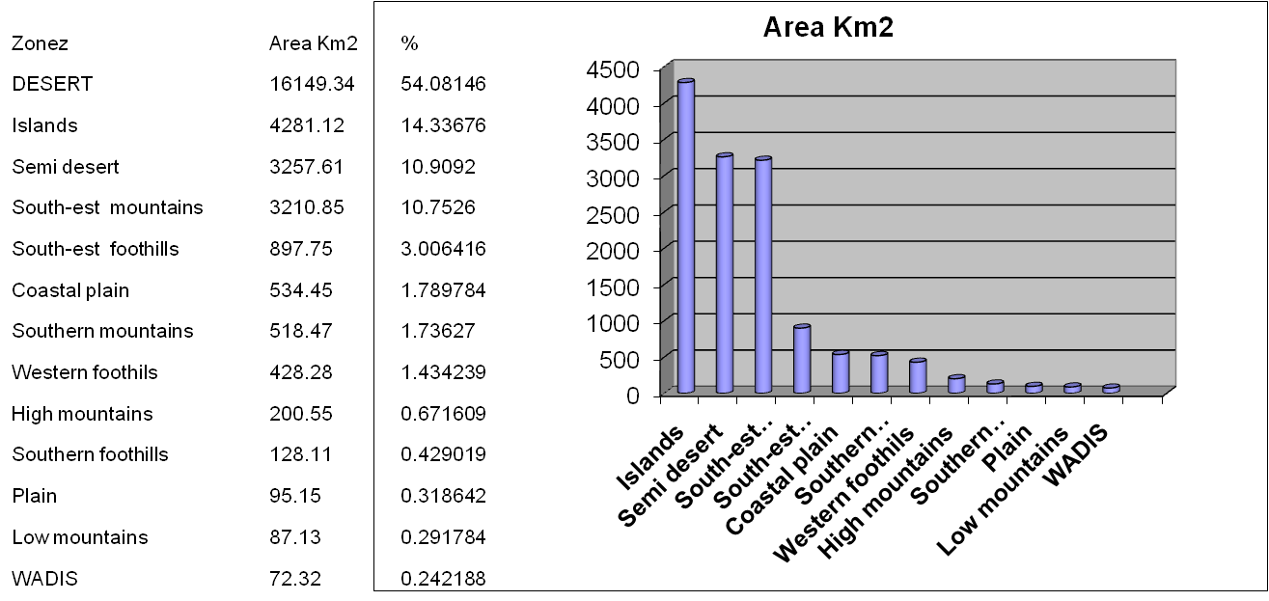

Table 2. shows Area in square meter and square kilometre of each KBA with their ecological site

Table 2. The Area in square meter and square kilometre of each KBA with their ecological site

|  |  |  |  |  |  |
| --- | --- | --- | --- | --- | --- |
| Id | NAMES | Ecosystem | Class | Governorate | km2 |
| 1 | HAT | DESERT | 2 | Al Maharah | 11184.4 |
| 2 | JARDAN SHABWAH | DESERT | 2 | Shabwah | 5103.5 |
| 3 | SOCOTRA | Islands | 1 | Hadramaut | 3704.1 |
| 4 | J. TOR SEEBSN | South-est mountains | 2 | Hadramaut | 3222.4 |
| 5 | ADH DHLIAAH SHABWAH | Semi desert | 2 | Hadramaut,Shabwah | 3113.5 |
| 6 | TARIM | Semi desert | 2 | Hadramaut | 1441.4 |
| 7 | HUF | South-est foothills | 1 | Al Maharah | 468.9 |
| 8 | RAS FARTAK | South-est foothills | 2 | Al Maharah | 436.5 |
| 9 | AL MA AFER | Southern mountains | 2 | Taiz | 397.6 |
| 10 | AL LUHEYAH AND MIDI | Coastal plain | 2 | Al Hudaydah, Hajjah | 178.6 |
| 11 | ABD AL KURI | Islands | 2 | Hadramaut | 133.5 |
| 12 | J. ALARAEES | Southern foothills | 2 | Abyan | 128.1 |
| 13 | ZOQAR | Islands | 2 | Al Hudaydah | 121.4 |
| 14 | J. ERAF | Southern mountains | 2 | Lahj | 120.9 |
| 15 | KAMARAN | Islands | 1 | Al Hudaydah | 106.7 |
| 16 | WUSAB AL ALI | High mountains | 2 | Dhamar, Ibb | 104.0 |
| 17 | QISHN | Coastal plain | 2 | Al Maharah | 97.0 |
| 18 | BIR ALI AND PELHAF | Coastal plain | 2 | Shabwah | 96.4 |
| 19 | ALHAWBAN | Plain | 2 | Taiz,Ibb | 95.1 |
| 20 | HONAISH ALKOBRA | Islands | 2 | Al Hudaydah | 71.4 |
| 21 | W. ANNAH | WADIS | 1 | Ibb | 67.3 |
| 22 | SHARMAH AND JATHMON | Coastal plain | 2 | Hadramaut | 62.2 |
| 23 | MAQBANAH | Low mountains | 2 | Taiz | 57.5 |
| 24 | Utomah | Western foothils | 1 | Dhamar | 448.5 |
| 25 | BURA | Western foothils | 1 | Al Hudaydah | 47.5 |
| 26 | JAZIRAT ANTUFASH | Islands | 2 | Al Hudaydah | 42.5 |
| 27 |  | Islands | 2 | Hadramaut | 42.2 |
| 28 | SUMARAH | High mountains | 2 | Ibb | 39.0 |
| 29 | ZAMHAR | Islands | 2 | Hajjah | 38.2 |
| 30 | ALMAFRAQ | Western foothils | 2 | Taiz | 35.1 |
| 31 | KHAWOR UMAYRAH | Coastal plain | 2 | Lahj | 34.3 |
| 32 | J. MILHAN | Western mountains | 2 | Al Mahwit | 29.6 |
| 33 | ALZBIR | Islands | 2 | Al Hudaydah | 23.0 |
| 34 | BIR ALI AND PELHAF | Coastal plain | 2 | Shabwah | 20.5 |
| 35 | BUQLAN | Islands | 2 | Hajjah | 12.7 |
| 36 | MAYYUN | Islands | 2 | Aden | 12.2 |
| 37 | AL BADI | Islands | 2 | Al Hudaydah | 11.0 |
| 38 | RAS AMRAN | Coastal plain | 2 | Aden | 10.5 |
| 39 | HONAISH ALSOURA | Islands | 2 | Al Hudaydah | 10.2 |
| 40 | AL URMAK | Islands | 2 | Al Hudaydah | 8.8 |
| 41 | BAB ALMANDABB | Coastal plain | 2 | Taiz | 8.5 |
| 42 | J. ALTIR | Islands | 2 | Al Hudaydah | 8.4 |
| 43 | QULENSYA | Islands | 2 | Hadramut | 8.2 |
| 44 | RAS AMRAN | Coastal plain | 2 | Aden | 6.4 |
| 45 | W.ALDABAB | WADIS | 2 | Taiz | 5.0 |
| 46 | ALARIRAH | Coastal plain | 2 | Taiz | 4.4 |
| 47 | J. AL LUAWZ | High mountains | 2 | Sana'a | 4.2 |
| 48 | J. ALTAKER | High mountains | 2 | Ibb | 3.7 |
| 49 |  | Islands | 2 | Hajjah | 2.7 |
| 50 |  | Islands | 2 | Shabwah | 1.0 |
| 51 |  | Islands | 2 | Aden | 0.7 |
| 52 | J. SABER | High mountains | 2 | Taiz | 0.4 |
| 53 | HESN HABB | high mountains | 2 | Ibb | 0.3 |
| 54 | Hadiya, Rayma | Western foothils | 2 | Raymah, | 345.6 |
| 55 | Al- Heswah | Coastal plain | 1 | Aden | 4.1 |
| 56 | Aden lake | Coastal plain | 1 | Aden | 0.9 |
| 57 | Aden lake | Coastal plain | 1 | Aden | 10.7 |
| 57 | Al-Memlah | Coastal plain | 1 | Aden | 10.7 |
| 58 | Al-Wadi Al-Kaber | Coastal plain | 1 | Aden | 1.3 |
| 59 | Khwor Ber Ahmed | Coastal plain | 1 | Aden | 13.1 |
| Key 1 = Class : Current protected area 2 = Proposed to be protected area | | | | | |

protected area distribution and status

The distribution, location and area of all protected areas:

**The following maps show the location of protected areas:**

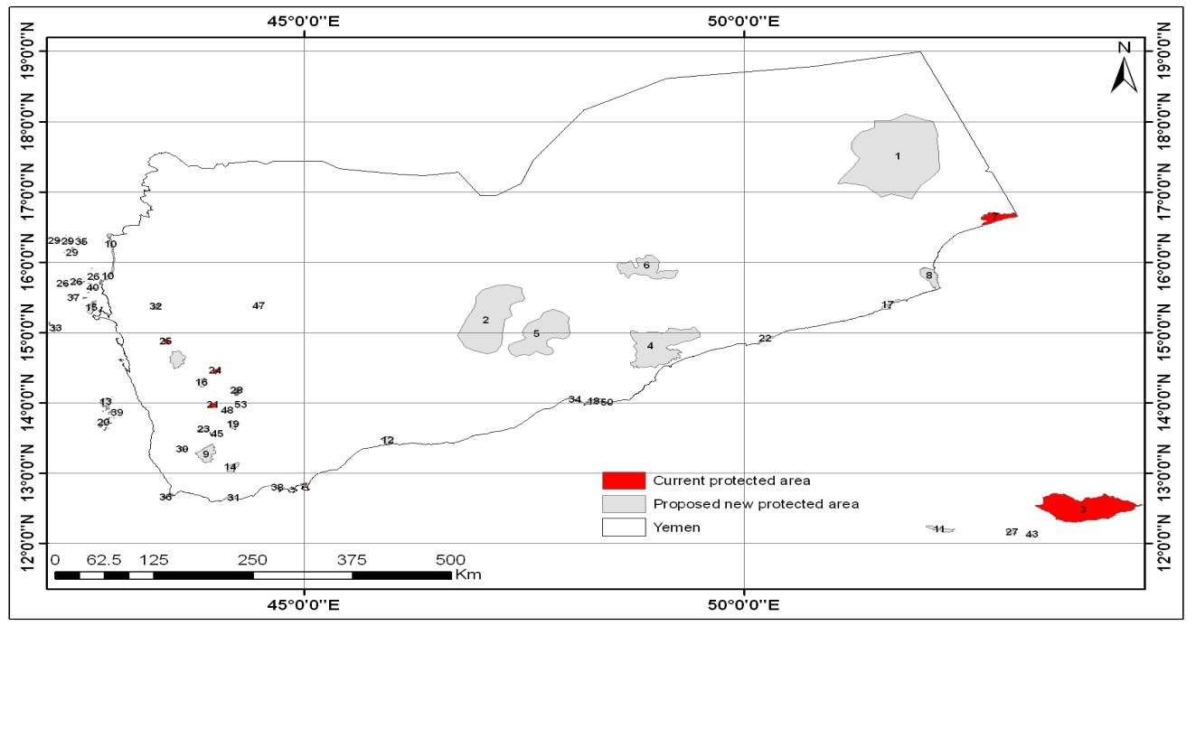

**Current and proposed protected areas**

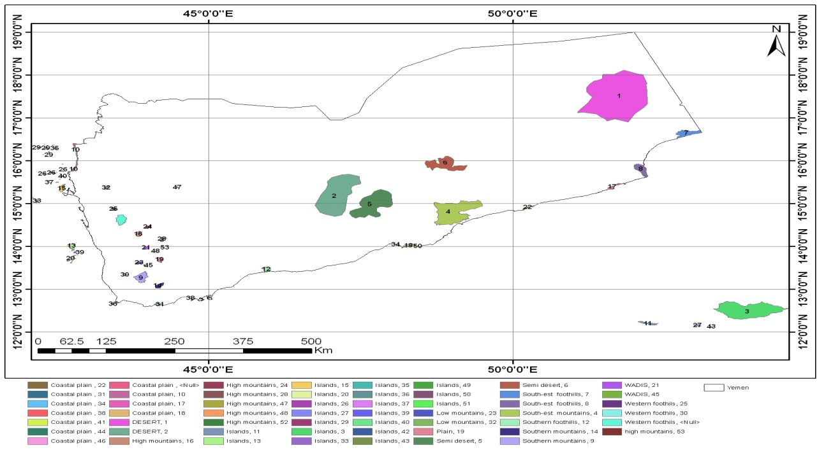

**Key Biodiversity Areas of Yemen**

**Current status of protected areas**

unfortunately, almost all current protected areas are without or poorly managed, or with management objectives that do not correspond with the needs of biodiversity.

Human activities have affected all kinds of habitats in one way or another. Some of these activities, and their effects are:

1. Arial photographs show that, during 1973 – 1988, up to 60% of Bura’a Forest has deteriorated. Over 53% of its woodland and 13% of the biodiversity, have disappeared.
2. Sharks are facing aggressive fishing for their flesh and fins, especially at the southern coasts.
3. Coral reefs are being destroyed in the expense of developing harbors. A good example is the damage caused to the coastal protected area at Balhaf, in Shabwa Governorate, where a harbour is being constructed for the export of liquefied natural gas.
4. Ibex hunting and leopard killing in Wadi Hadhramout and Wadea’a, respectively.
5. Overgrazing by sheep, goats, cattle and camels.
6. Wood harvesting for construction, firewood, manufacture of furniture and beehives.
7. Expansion of agriculture and/or urbanization on the expense of natural habitats
8. **Terrestrial ecosystem :** **Tropical forests ecosystem**

**Threatened :,** *terraces extension in forest area ,over grazing , hunting, conflagration, plant*

*cutting for multiuse ,traditional land use changes , invasive alien species* ***(Propospis julilfora,*  *Opuntia ficus-indica وOpuntia dille*)**

**Gaps :** *weeklies' Management ,no details studies in the fauna or the habitats.*

Gabal Bura’ protected area:

1. **Terrestrial ecosystem :Mountain**

**Threats : Threatened :,** *terraces erosions ,over grazing , hunting, conflagration, plant cutting for multiuse ,traditional land use changes ,* , less land management knowledge

**Gaps :** Information deficit **,**no management plan or details studies in the socio-economic orthe habitats.

1. **sup ecosystem forest or rangeland**

**Threatened :** over grazing **,** hunting, conflagration, traditional land use changes , less land management knowledge **.**

**Gaps :** Information deficit **,**no management plan implemented ,studies in habitats .

1. **Island ecosystem :** **Mountain ecosystem ,marine ecosystem , Freshwater and Caves ecosystem :**

**Threatened :** *over grazing, infrastructure, plant* *cutting for multiuse ,traditional land use changes , invasive alien species***, , Specimens collect , general tourism ,climate change .**

**Gaps :** *weeklies' Management ,no details studies in the fauna or the habitats, no* Management for all interesting plants and scientist areas **.**

**Table (4) Assessment of Minimum requirements for PA Management**

|  |  |  |  |  |  |  |
| --- | --- | --- | --- | --- | --- | --- |
| **Protect Area** | | | | | | **Minimum**  **Requirements** |
|  | | | | | |
| **Kamaran Island** | **Aden wetland** | **Bura'a** | **Hawf** | **Socotra** | **Autma** |
| **1) Legal designation** | | | | | | |
| 5 | 5 | 5 | 5 | 5 | 5 | - PA Law |
| 0 | 3 | 3 | 3 | 4 | 0 | - PA Regulation |
| 0 | 4 | 3 | 3 | 4 | 0 | **2) Agreement/ Delegation** |
| **3) Demarcation of PA** | | | | | | |
| 1 | 4 | 4 | 4 | 5 | 2 | - Coordination, Maps |
| 0 | 3 | 3 | 3 | 5 | 0 | -Zoning |
| 0 | 0 | 0 | 0 | 0 | 0 | -Physical Marking |
| 1 | 4 | 5 | 5 | 5 | 0 | **4) Clear Management Objectives** |
| 0 | 3 | 3 | 2 | 3 | 0 | **5) Operational Plan** |
| 0 | 2 | 2 | 0 | 3 | 2 | **6) Operational Budget** |
| 0 | 0 | 0 | 0 | 2 | 0 | **7) Monitoring Plan** |
| 0 | 3 | 3 | 2 | 3 | 1 | **8) Community Relation** |
| 0 | 0 | 0 | 0 | 1 | 0 | **9) Reducing Threat** |

According to RAPPAM[1] assessment 2 is the minimum required score for the these factors

Base line information on Yemen PAs

|  |  |  |  |  |  |  |  |
| --- | --- | --- | --- | --- | --- | --- | --- |
| **Implementation Status** | **Policies Situation** | **Legal Status** | **Date established** | **Type** | **Location** | **Protected area/site** | NO |
| No management setup in place  The NGOs active with some project funded by donors | - No Management plan | Cabinet declaration no.137 | June 05, 1999 | Terrestrial | Dhamar – Autma | Autma | 1 |
| Day to day Active management process for the PA with support of  International donors and the government. | Management plan been prepared according to site thorough studies | Presidential declaration no. 275 | Sep.27 2000 | Coastal/Marine and Terrestrial | Hadramout | Socotra | 2 |
| No management set up in place | Management plan been prepared according to site thorough studies | Cabinet declaration no. 260 | Augast.16 2005 | Terrestrial | Al-Mahara | Hawf Nature Reserve (HNR) | 3 |
| The management process initiated by 2007 with support of the SRNMP I and still ongoing | Management plan been prepared according to site thorough studies | Cabinet declaration no24. | January ,2006 | Terrestrial | Al-Hodidah | Jabal Bura'a National Park (JBNP)) | 4 |
| Management has delegated to NGOs. The management process initiated with support of SRNMP during its phase I life period. | Management plan been prepared according to site thorough studies | Cabinet declaration no304. | Augast,01 2006 | Wetland | Aden | Wetland Aden | 5 |
| No management activities in place. | No Management plan. | Cabinet declaration no 310. | Augast.16 2009 | Coastal/Marine | Al-Hodidah | Kamaran Island | 6 |
| No management activities in place | Management plan been prepared at result of site thorough studies | Under processing | Still on process | Coastal/Marine, Sea turtle nest | Hadramout | Sharmah-Jathmoun | 7 |
| No management activities in place | Management plan been prepared at result of site thorough studies | Under processing | Still on process | Coastal/Marine, Nursery area | Shabwah and Hadramout | Bir Ali-Burum | 8 |

Governance types

All Protected areas is Managed collaborating with the local communities and relevant s Stockholder’s .

Key threats

**Existing Threats for biodiversity**

It is clear that human activities are playing the main impact on biodiversity in Yemen through loss of species and ecosystems. As the human population passes the 30 million we will have degraded or destroyed most of the Yemen’s biodiversity

With appropriate and well managed system we could reserve the biodiversity in the protected areas and avoid the disappearing and destroying of the ecosystems.

The land ownership or the land tenure is the main difficulties and complexities to achieve our goal in selecting the protected areas and preserving the different ecosystems.

**The main pressure and threats are:**

•over Grazing

•Plant collection

•Hunting

•Infrastructure (roads, buildings etc..

•Land Use (agriculture and etc)

**The Coordinates of current and proposed protected areas of Yemen**

|  |  |  |  |
| --- | --- | --- | --- |
| NAMES | ID | X | Y |
| HAT | 1 | 16°53'41.80"N- 18° 5'51.91"N | 17° 8'15.66"N- 17°18'47.13"N |
| JARDAN SHABWAH | 2 | 47°30'8.82"E- 46°44'10.68"E | 14°41'25.29"N- 15°40'59.20"N |
| SOCOTRA | 3 | 53°18'24.57"E- 54°31'37.40"E | 12°17'39.70"N- 12°42'35.64"N |
| J. TOR SEEBSN | 4 | 49°29'51.58"E- 48°42'58.38"E | 14°29'43.27"N- 15° 3'38.49"N |
| ADH DHLIAAH SHABWAH | 5 | 47°18'53.25"E- 48° 1'24.00"E | 14°39'12.70"N- 15°19'51.81"N |
| TARIM | 6 | 49°14'53.35"E- 48°33'28.69"E | 15°46'19.99"N- 16° 6'14.19"N |
| HUF | 7 | 52°41'20.19"E- 53° 6'27.85"E | 16°31'24.18"N- 16°42'49.78"N |
| RAS FARTAK | 8 | 52° 0'5.92"E- 52°12'0.91"E | 15°36'25.15"N- 15°55'36.05"N |
| AL MA AFER | 9 | 43°45'46.21"E- 43°59'49.91"E | 13° 8'51.02"N- 13°24'58.51"N |
| AL LUHEYAH AND MIDI | 10 | 42°40'7.07"E- 42°49'46.15"E | 15°41'10.21"N- 16°24'12.14"N |
| ABD AL KURI | 11 | 52°58'53.47"E- 53° 5'28.12"E | 12° 7'41.38"N- 12°10'44.48"N |
| J. ALARAEES | 12 | 45°52'0.01"E- 46° 0'50.97"E | 13°24'34.20"N- 13°31'2.43"N |
| ZOQAR | 13 | 42°40'31.53"E- 42°49'24.16"E | 13°54'22.30"N- 42°49'21.68"E |
| J. ERAF | 14 | 44° 7'26.37"E- 44°15'26.00"E | 13° 1'0.26"N- 13° 9'5.51"N |
| KAMARAN | 15 | 42°31'49.57"E- 42°37'59.97"E | 15°15'52.99"N- 15°27'22.22"N |
| WUSAB AL ALI | 16 | 43°47'20.58"E- 43°53'31.87"E | 14°13'26.98"N- 14°21'4.12"N |
| QISHN | 17 | 51°33'49.19"E- 51°50'53.09"E | 15°19'40.68"N- 15°28'43.07"N |
| BIR ALI AND PELHAF | 18 | 48°11'58.53"E- 48°22'1.48"E | 13°58'38.15"N- 14° 2'19.49"N |
| ALHAWBAN | 19 | 44° 8'31.26"E- 44°14'19.15"E | 13°37'5.98"N- 13°44'34.33"N |
| HONAISH ALKOBRA | 20 | 42°40'13.23"E- 42°50'26.01"E | 13°36'18.89"N- 13°47'30.99"N |
| W. ANNAH | 21 | 43°55'46.54"E- 44° 0'49.83"E | 13°56'0.16"N-13°59'58.55"N |
| SHARMAH AND JATHMON | 22 | 50°21'26.12"E- 50° 9'35.59"E | 14°57'15.20"N- 14°50'26.22"N |
| MAQBANAH | 23 | 43°47'12.23"E- 43°54'43.36"E | 13°35'1.94"N- 13°38'34.74"N |
| UTMAH | 24 | 43°57'37.98"E- 44° 3'10.42"E | 14°24'22.39"N- 14°29'32.02"N |
| BURA | 25 | 43°23'17.09"E- 43°28'58.80"E | 14°50'6.41"N- 14°54'38.97"N |
| JAZIRAT ANTUFASH | 26 | 42°16'37.69"E- 42°37'36.12"E | 15°39'26.48"N- 15°55'36.76"N |
|  | 27 | 52°58'36.34"E- 53° 5'15.50"E | 12° 7'40.98"N- 12°10'25.68"N |
| SUMARAH | 28 | 44°12'21.37"E- 44°18'11.59"E | 14° 6'23.34"N- 14°12'46.10"N |
| ZAMHAR | 29 | 42°11'16.78"E- 42°25'11.88"E | 16° 5'12.71"N -16°23'17.93"N |
| ALMAFRAQ | 30 | 43°34'46.56"E- 43°39'45.63"E | 13°18'17.91"N- 13°22'12.82"N |
| KHAWOR UMAYRAH | 31 | 44° 5'32.30"E- 44°13'43.32"E | 12°36'54.63"N- 12°40'6.00"N |
| J. MILHAN | 32 | 43°16'44.40"E- 43°21'45.17"E | 15°19'37.07"N- 15°24'11.87"N |
| ALZBIR | 33 | 42° 1'9.69"E- 42°11'40.57"E | 15° 0'39.76"N- 15°12'48.69"N |
| BIR ALI AND PELHAF | 34 | 48°10'39.40"E- 47°58'15.55"E | 13°59'33.25"N- 14° 2'45.07"N |
| BUQLAN | 35 | 42°26'50.23"E- 42°30'13.03"E | 16°14'59.12"N- 16°21'55.40"N |
| MAYYUN | 36 | 43°23'17.10"E- 43°26'26.72"E | 12°37'56.25"N- 12°40'18.18"N |
| AL BADI | 37 | 42°21'27.94"E- 42°31'51.85"E | 15°28'9.96"N- 15°32'13.23"N |
| RAS AMRAN | 38 | 44°31'7.37"E- 44°44'19.30"E | 12°45'22.49"N- 12°49'10.55"N |
| HONAISH ALSOURA | 39 | 42°42'36.23"E- 42°49'20.79"E | 13°50'24.34"N- 13°53'57.80"N |
| AL URMAK | 40 | 42°31'58.18"E- 42°38'9.21"E | 15°33'42.70"N- 15°39'1.99"N |
| BAB ALMANDABB | 41 | 43°27'10.58"E- 43°30'6.32"E | 12°40'23.03"N- 12°42'22.49"N |
| J. ALTIR | 42 | 41°48'52.41"E- 41°51'10.06"E | 15°31'31.56"N- 15°33'43.94"N |
| QULENSYA | 43 | 53°14'51.44"E- 53°18'18.17"E | 12° 6'45.17"N- 12° 7'54.69"N |
| RAS AMRAN | 44 | 44°44'36.96"E- 44°46'42.81"E | 12°45'40.76"N- 12°47'27.94"N |
| W.ALDABAB | 45 | 43°55'36.08"E- 43°57'47.80"E | 13°31'13.24"N- 13°34'56.79"N |
| ALARIRAH | 46 | 43°28'6.93"E- 43°30'22.90"E | 12°42'22.49"N- 12°44'20.36"N |
| J. AL LUAWZ | 47 | 44°28'17.25"E- 44°29'49.77"E | 15°22'3.27"N- 15°23'22.79"N |
| J. ALTAKER | 48 | 44° 7'2.17"E- 44° 8'45.09"E | 13°52'38.09"N- 13°53'44.56"N |
|  | 49 | 41°57'45.57"E-41°58'34.29"E | 16°17'49.46"N- 16°19'15.76"N |
|  | 50 | 48°19'4.28"E- 48°23'42.37"E | 13°59'8.29"N- 14° 0'20.39"N |
|  | 51 | 44°42'6.76"E- 44°44'40.96"E | 12°43'50.32"N- 12°45'19.27"N |
| SABER | 52 | 44° 3'12.27"E- 44° 4'4.82"E | 13°33'40.64"N- 13°34'8.87"N |
| HESN HABB | 53 | 44°14'37.93"E- 44°15'17.28"E | 13°58'15.84"E- 13°58'39.24"N |
| HADIAH | 54 | 43°28'8.67"E- 43°39'1.02"E | 14°29'2.95"N- 14°44'11.27"N |

Barriers for effective implementation

**BIODIVERSITY PROBLEMS**

Under current accelerating growth of economy, environmental quality is fast deteriorating, as dramatized by the increased occurrence of environmental problems. Specifically, the gains of economic growth are being diminished and /or even negated by numerous problems including:

* Habitat destruction caused by activities associated with development.
* Degradation and conversion of natural habitat.
* Desertification, including wind erosion and sand dune encroachment
* Agricultural expansion and poor agricultural practices.
* Wood cutting for firewood, timber and charcoal production.
* Overgrazing of rangelands including loss of sustainable practices of sound rangeland

management by local people.

* Over-hunting and indiscriminate killing of wildlife species, especially ungulates and

carnivores.

* Overuse and depletion of limited fresh water.
* Degradation of wetland ecosystems.
* Contamination of ecosystems with sewage, industrial waste and other pollutants.
* Smuggling and uncontrolled exporting of indigenous livestock and native genetic species.
* Marine and coastal habitat degradation caused by unplanned coastal reclamation.
* Over-exploitation, pollution and mismanagement of fishing in the Red Sea, Arabian sea, Gulf of Aden and Yemeni Islands.
* Degradation of coastal and marine habitats caused by ship dumping, industrial, agricultural

and sewage waste.

* Sharp decline in important marine resources especially lobsters, cuttlefish, shrimps and

sharks caused by over-fishing, poaching of foreign vessels, uncontrolled gear and fishing

effort, and lack of quality controls.

* Destruction of coral reefs and underwater habitats caused by bottom trawling, ornamental

Fishing.

* Deterioration of native genetic resources as a result of introduction of alien species.
* Desertification, terraces and rangeland degradation associated with rapid urbanization.
* Increased water depletion for qat production and agriculture irrigation associated with lack

of water conservation systems.

* Declining agricultural production caused by drought and degradation of agro-systems.
* Over-cutting of trees and shrubs for fuel consumption and timber.
* Loss of natural habitats as a result of deforestation, desertification and land conversion.
* Destruction of sensitive natural habitats caused by unplanned land reclamation.
* Rapidly growing population with intensive use and pressure on natural resources

particularly in the densely populated centers of the country.

* Reduced economic values of marine and coastal biodiversity as a result of increasing

pollution and habitat destruction.

**Priority Problems**

The immediate and most critical problems contributing to the evolvement and continuation of this un favorable situations are water depletion and pollution, land degradation, habitat loss and waste disposal. The nature, extent and underlying cause of these problems are presented in the following parts of the report.

**Key Causes of Biodiversity Problems**

Several factors and root causes contribute to the existence of environmental problems and to the continuation of degradation and resource depletion. These are of Societal, managerial, institutional, financial, regulatory, cultural and technical nature and are presented in the following:

**Regulatory Policy and Legislative factors:**

To achieve sustainable and lasting improvement in natural resources management and environmental protection, there is a need for coherent policy and regulation frameworks and sector-specific actions to address the following policy and legislative constraints:

o Incomplete legal framework for protected areas, and flora and fauna.

o Lack of enforcement of wildlife protection measures;

o Absence of preventive and remediation measures;

o Lack of adequate legislative tools to control introductions of alien invasive species;

o Improper application and use of persistent pesticides and chemical fertilizers;

o Inappropriate agricultural practices.

o Abandonment of sustainable practices of sound rangeland management by local people;

o Inadequate legislative tools and conservation measures for the protection of indigenous

plant and animal species/varieties.

o Non- functional fishing law.

o Abandonment of productive traditional agricultural practices.

o Improper use of agro-chemicals (pesticides, fertilizers, fruit ripening agents, etc.);

o Weak implementation of EIA procedures for development projects.

o Lack of policy addressing air pollution, wastewater, and solid waste production from

industrial sources.

o Weak enforcement of standards regulating industrial activities;

o Lack of protection measures and legislations to regulate the use and release of living

modified organisms;

o Absence of policy addressing biotechnology and biosafety issues.

o Inadequate legislative framework and weak enforcement of eco-tourism legislation.

o Weak enforcement of solid waste management guidelines.

o Inappropriate practices/ lack of norms regarding waste management;

o Weak enforcement of existing standards for air-pollution control.

o Absence or inadequacy of existing legislation and standards regulating biodiversity use

and management, including agricultural practices.

o Inadequate law enforcement.

o Overlapping and unclear mandates of environmental agencies.

o Inexistence of establishment decrees for a number of agencies.

o Inexistence of a staff evaluation system within the public administration.

o Inadequate policies to comply with Yemen’s obligations committed under international

conventions.

o Antiquated environmental plans.

o Uncontrolled hunting of wildlife along with unregulated utilization of fuel wood,

rangelands and agricultural lands.

**Institutional, Managerial and monitoring issues**:

Achieving sustainable improvement in environmental management and monitoring depend in large part on the establishment of and Institutional and Management frameworks /and Monitoring systems: Specific focus should be given to resolve the following constraints:

1. Lack of effective administration and conservation management regimes for protected areas;
2. Lack of Institutional Capacities for protected area;
3. Inadequate systematic population monitoring of species, specially endangered ones;
4. Weak monitoring capabilities for endangered and rare species.;
5. Lack of institutional capacities in evaluating and preserving alien species;
6. Lack of monitoring system for alien invasive species;
7. Lack of institutional framework for the management and monitoring of biotechnology and

biosafety issues;

1. Inadequate systems for water management, inadequate restrictions on well drilling and

inefficient use of irrigation facilities.

1. Fragmented and non-participatory management and planning of watersheds.
2. Unclear mandates of agencies involved in watershed management;
3. Lack of national mitigation and adaptation plans for climate change.
4. Weak recognition of the climate change issue relative to other development priorities.
5. Absence of an institutional structure aimed at integrating climate change issues into

national plans.

1. Insufficient financial auditing system.
2. Unregulated inter-agencies coordination for biodiversity and protected areas.
3. Incomplete hierarchical structure of environmental agencies.
4. Lack of coordinated mechanism for monitoring biodiversity deterioration.
5. Lack of monitoring tools
6. Inadequate records on the state and extent of abandonment of traditional environmental

norms and practices.

1. Lack of land property registration.
2. Outdated land survey and registry records.
3. Outdated data on species and their habitat as a result of research and monitoring.
4. Absence of national indicators related to biodiversity.

**Societal:** Community participation, and Indigenous Knowledge and Traditions: To effective management and use of biological resources, involvement of all concerned parties, including local community, in the management and planning of natural resources should be facilitated by addressing the following most critical issue:

* Poor investment from the private sector in community-based biodiversity projects;
* Weak local communities and private sector participation in tourism management and

investment in this sector;

* Limited participation of local communities and NGOs in biodiversity related

initiatives;

* Lack of participation of local communities;
* Insufficient community role in planning, monitoring and managing natural

resources.

* Lack of allocation system to share, access and use rangelands and hunting grounds

equitably.

* Inadequate delegation of responsibilities from the center to the governorates district

level;

* Lack of allocation system for equitable sharing of fishery resources.
* Conflicts among fishery users over the control and use of marine resources.
* Retardation of environmentally friendly traditional and indigenous techniques,
* practices and management systems.

**Cultural:** Information, Research and Public Awareness: To facilitate effective resource management, sport should be targeted for expanding information and public awareness rising on environmental issues, focusing on the following areas of deficiency:

1. Lack of precise information on the number of fauna and flora species present in Yemen, or on rare, threatened endemic species and their habitats;
2. Criteria for defining critical habitats or biotypes are missing;
3. Lack of information on the status and habitat requirements of species at risk
4. Lack of adequate information of the type, numbers, status and structure of alien

species;

1. Low public awareness and appreciation for biodiversity conservation;
2. Insufficient and unreliable information and networking on agricultural biodiversity;
3. Limited capacity and funding for biodiversity and agricultural research;
4. Poor knowledge and understating of the nature and potential impacts of living

modified organisms (LMO) on biodiversity;

1. Lack of knowledge on eco-tourism attractions.
2. Poor environmental awareness and ecological education amongst populations;
3. Weak awareness and knowledge of solid waste impact;
4. Lack of information on the vulnerability of watersheds to climate change;
5. Limited public awareness on climate change and biodiversity issues;
6. Poor understanding of the science of climate change domestically;
7. Weak public awareness on biodiversity issues;
8. Lack of national policy on Environmental education (EE)
9. Biodiversity conservation and environmental protection themes are not integrated into

school and university curricula.

1. Notable absence of youth green clubs, green press, and eco-industry;
2. Low level of public awareness in traditional and indigenous natural resource management

systems, biodiversity conservation and sustainable development;

**Financial:** Tight Budget and limited financial resources are among the principle factors for the current deficiency in Infrastructure and facilities needed for addressing the following deficiencies:

* Lack of genetic resources centers that can collect genetic materials and conserve them to be

available for research and genetic improvement.

* Lack of botanical garden for collecting and preserving rare and endangered flora.
* Absence of a Natural History Museum for biological diversity in Yemen
* A generalized deficiency in eco-tourism facilities.
* Limited geographic coverage of Protected areas (PA) associated with lack of PA

management plans.

**Technological:**

Use of environmentally unfriendly technologies.

Weak of national capacity in the field of modern biotechnology specially in Biosafety.

**Development and access to alternative energy source:**

Capacity building: Reversing resources degradation require not only major investment in infrastructure, but the development of technical, financial, managerial and regulatory capacity to carry out effective environmental management and monitoring of available resources. Specific focus should be given to resolve the following capacity constraints:

1. Insufficient staff and resources
2. Insufficient level of professionalism and training in the tourism sector, including eco-

tourism;

1. Weak technical capacities in watershed management;
2. Lack of human resources to address climate change issues;
3. Notable shortage of trained manpower, specially of environmental educator and facilitators;
4. Lack of professional and systematic training in the field of biodiversity conservation.
5. Shortage of biodiversity specialists and general lack of adequately trained human resources

in research, planning, policy development, monitoring and documentation.

1. Poor training opportunities for local communities.
2. Lack of training and financial support for electronic networking and access and use of the

Interne;

1. Insufficient manpower of regional and local environmental bodies in planning and

monitoring managing natural resources.

# National Targets and Vision for Protected Areas

(Insert national targets for protected areas/Target 11 of the Aichi Targets. Include rationale from protected area gap assessment, if completed, along with any additional information about the vision for the protected area system, including statements about the value of the protected area system to the country)

Progress in and plans for achieving the goals of the Programme of Work on Protected Areas

**Progress**: 0 = no work, 1 = just started, 2 = partially complete, 3 = nearly complete, 4 = complete

|  |  |
| --- | --- |
| **Goals of the Programme of Work on Protected Areas** | **Progress 0-4** |
| * Progress in **establishing and strengthening national and regional systems** of protected areas (1.1) | 1 |
| * Progress in integrating protected areas into **broader land- and seascapes and sectors** so as to maintain ecological structure and function (1.2) | 1 |
| * Progress in establishing and strengthening **regional networks**, **transboundary protected areas** (TBPAs) and collaboration between neighbouring protected areas across **national boundaries** (1.3) | 0 |
| * Progress in substantially improving **site-based** protected area planning and management (1.4) | 1 |
| * Progress in preventing and mitigating the negative impacts of **key threats** to protected areas (1.5) | 1 |
| * Progress in promoting **equity and benefit-sharing** (2.1) * Progress in assessing and implementing diverse protected area **governance types** (2.1) | 0 |
| * Progress in enhancing and securing **involvement of indigenous and local communities and relevant stakeholders** (2.2) | 1 |
| * Progress in providing an **enabling policy, institutional and socio-economic** environment for protected areas (3.1) * Progress in assessing the **contribution of protected areas** to local and national economies (3.1) | 1 |
| * Progress in **building capacity** for the planning, establishment and management of protected areas (3.2) | 1 |
| * Progress in developing, applying and transferring appropriate **technologies** for protected areas (3.3) | 0 |
| * Progress in ensuring **financial sustainability** of protected areas and national and regional systems of protected areas (3.4) | 2 |
| * Progress in strengthening **communication, education and public awareness** (3.5) | 1 |
| * Progress in developing and adopting **minimum standards and best practices** for national and regional protected area systems (4.1) | 1 |
| * Progress in evaluating and improving the **effectiveness of protected areas management** (4.2) | 1 |
| * Progress in **assessing and monitoring** protected area status and trends (4.3) | 1 |
| * Progress in ensuring that **scientific knowledge** contributes to the establishment and effectiveness of protected areas and protected area systems (4.4) | 0 |
| * Progress in **marine protected areas** | 1 |
| * Progress in incorporating **climate change** aspects into protected areas | 0 |

**Provisional framework of goals, targets and indicators to assess progress**

|  |  |
| --- | --- |
| ***Goals and targets*** | ***Relevant indicators*** |
| **Protect the components of biodiversity** | |
| *Goal 1. Promote the conservation of the biological diversity of ecosystems, habitats and biomes* | |
| Target 1.1: At least 10% of each of the world’s ecological regions effectively conserved. | • Hardly reach the target  • 6 protected areas of them two marine areas and  9 ICZM at 9 coastal governorates.  • The total protected areas less 500 km2 out of  500,000 km2 |
| Target 1.2: Areas of particular importance to biodiversity protected | • Conservation of wild forests of endemic and medicine plants, supporting plenty of fauna, (insects, mammals, reptiles, baboons, birds….). the conservations also cover also wetlands ecosystem, mangroves and coral reef areas |
| *Goal 2. Promote the conservation of species diversity* | |
| Target 2.1: Restore, maintain, or reduce the decline of populations of species of selected taxonomic groups. | • Stabilize the saturations of the flora and fauna in the protected areas and restoring some species.  • No indictors for the wild species out of the protected areas except for some species like Arabian Leopard which restoring and increasing due ex situ conservations. |
| Target 2.2: Status of threatened species improved. | • There are improvement on the limited medicine plant species.  • Arabian Leopard breeding in Taiz zoo.  • About 10% of Yemen total area covered with areas under sustainable management but not full protected only 6 protected Areas declared, total protected Areas less  5000 km2. |

|  |  |
| --- | --- |
| ***Goals and targets*** | ***Relevant indicators*** |
| *Goal 3. Promote the conservation of genetic diversity* | |
| Target 3.1: Genetic diversity of crops, livestock, and of harvested species of trees, fish and wildlife and other valuable species conserved, and associated indigenous and local knowledge maintained. | • Research were carried out in classical plant breeding of field crops like wheat,  sorghum, maize millet, barely and pulses in limited areas (lentil).  • The vegetable breeding program of potato, tomato, and onion has many successes . The cash and oil crops like cotton, sesame, and peanut breeding programs started so early  • Research on shrimp and some commercial fish species aquaculture and reproduction to release to the sea.  • Gene banks established in AREA and University of Sana'a. Good collections of plants were preserved.  • National livestock research and reproduction center were established at Lahij governorate, it is collection covers the whole country lately reach Socotra Archipelago |
| **Promote sustainable use** | |
| *Goal 4. Promote sustainable use and consumption.* | |
| Target 4.1: Biodiversity-based products derived from sources that are sustainably managed, and production areas managed consistent with the conservation of biodiversity. | • Legislations and polices regulating the activities and practices related to the biodiversity in the field of agriculture*,* irrigations, marine fishing, wood cutting and land cultivation. These with propose of sustainable use and conservation of the biodiversity.  • Controlling the water pollution through entities responsible for water regulation establishment with clear mandates and supportive laws.  • Maintain good sea water quality, through surveillance and observation. By regular sampling and analyses  • Stock assessment for marine resources to determinate the allowed catch quantities regularly carried out, unfortunately not for all species. |

|  |  |
| --- | --- |
| ***Goals and targets*** | ***Relevant indicators*** |
| Target 4.2. Unsustainable consumption, of biological resources, or that impact upon biodiversity, reduced. | • Techniques to identify the Ecological footprint are still not available in Yemen. |
| Target 4.3: No species of wild flora or fauna endangered by international trade. | • Yemen is party of CITES, so CITES are well enforced in Yemen. Training for the customs, police and other related to trade handling and observation in Yemen working in the ports (Air, Sea and land at the boundaries). Therefore, there are no species endangered by international trade. |
| **Address threats to biodiversity** | |
| *Goal 5. Pressures from habitat loss, land use change and degradation, and unsustainable water use, reduced.* | |
| Target 5.1. Rate of loss and degradation of natural habitats decreased. | • Yemen territory is very wide, and needs more technical and financial resources to enable the government to undertake surveys and inventories for the whole area. However, Yemen implements many projects to prevent the loss of natural habitats.  • Formulate and implement group of policies in land and natural resources conservation.  • Yemen has enforced the Environment law, and enacted the EIAs mechanisms in agricultural infrastructure projects, Road construction and the development in the coastal areas |
| *Goal 6. Control threats from invasive alien species* | |
| Target 6.1. Pathways for major potential alien invasive species controlled. | • In spite of the effort addressed in invasive alien species, but there is no planned control for their distribution in Yemen |
| Target 6. 2. Management plans in place for major alien species that threaten ecosystems, habitats or species. | • Still there is no inventory identifying and documenting the alien species in Yemen, therefore also there is no management plans to control them. However, there are attempts to prepare management plan in the future. But before that there are needs to prepare list of the alien invasive species.  • There is no attempts to wards the marine alien species |

|  |  |
| --- | --- |
| ***Goals and targets*** | ***Relevant indicators*** |
| *Goal 7. Address challenges to biodiversity from climate change, and pollution* | |
| Target 7.1. Maintain and enhance resilience of the components of biodiversity to adapt to climate change. | • Studies and reports on water, agricultural and marine sectors and their adaptation to climate change impact been carried and formulated. Still there are undergoing works on climate change impact modeling on the water and agricultural sectors, for the next fifteen years in Yemen. |
| Target 7.2. Reduce pollution and its impacts on biodiversity. | • Because of the lack of industries in Yemen, there are no major pollution sources in country. It is likely that the oil pollution caused the oil tankers is the problem to marine biodiversity, however, there big efforts to prevent these pollution to occur and there are facilities to control it. It is important to mention that the oil spill events very rare and Yemen territorial sea water quality is very good. |
| ***Maintain goods and services from biodiversity to support human well- being*** | |
| *Goal 8. Maintain capacity of ecosystems to deliver goods and services and support livelihoods* | |
| Target 8.1. Capacity of ecosystems to deliver goods and services maintained. | • Big concern to maintain areas of ecosystems delivers good and services provided by the government and local communities, to sustainably use the resources for daily livelihood. |
| Target 8.2. Biological resources that support sustainable livelihoods, local food security and health care, especially of poor people maintained. | • Number of protected areas established in order to maintain the biodiversity and natural resources supportive to local food security and health care to the poor people.  • Group of policies and legislations were issues to conserve the biodiversity to enable them to continue providing goods to people  • These mentioned above effort still moderate and totally effective. |

|  |  |
| --- | --- |
| ***Goals and targets*** | ***Relevant indicators*** |
| **Protect traditional knowledge, innovations and practices** | |
| *Goal 9 Maintain socio-cultural diversity of indigenous and local communities* | |
| Target 9.1. Protect traditional knowledge, innovations and practices. | • In this regards Yemen still not documented the traditional knowledge used to been practiced in the natural resources conservation and sustainable use. However, it was hardly accompanied in the legal frame work of the established protected areas. |
| Target 9.2. Protect the rights of indigenous and local communities over their traditional knowledge,  innovations and practices, including their rights to benefit sharing. | • In spite their variety and the of their practices in the past, but still not documented yet. |
| **Ensure the fair and equitable sharing of benefits arising out of the use of genetic resources** | |
| *Goal 10. Ensure the fair and equitable sharing of benefits arising out of the use of genetic resources* | |
| Target 10.1. All access to genetic resources is in line with the Convention on Biological Diversity and its relevant provisions. | • Locally there are no roles against or not allowing the access to the genetic resources. However, Yemen is a party of the convention of biodiversity and committed to implement it, but according to manageterial process keeping the intellectual wrights for Yemen. |
| Target 10.2. Benefits arising from the commercial and other utilization of genetic resources shared in a fair and equitable way with the countries providing such resources in line with the Convention on Biological Diversity and its relevant provisions | *Indicator to be developed* |
| **Ensure provision of adequate resources** | |
| *Goal 11: Parties have improved financial, human, scientific, technical and technological capacity to implement the Convention* | |
| Target 11.1. New and additional financial resources are transferred to developing country Parties, to allow for the effective implementation of their commitments under the Convention, in accordance with Article 20. | • There a financial support provision, but still needs more to develop the country capacity to fully fulfill their commitment and obligation to implement the convention. |

|  |  |
| --- | --- |
| ***Goals and targets*** | ***Relevant indicators*** |
| Target 11.2. Technology is transferred to developing country Parties, to allow for the effective implementation of their commitments under the Convention, in accordance with its Article 20, paragraph 4. | *Indicator to be developed* |

# Priority activities for fully implementing the Programme of Work on Protected Areas:

|  |  |
| --- | --- |
| **Activities** | **Timeline** |
| * Progress in establishment and strengthen national and regional systems of protected areas integrated into a global network as a contribution to globally agreed goals. | 2015 |
| * Progress to establish and strengthen regional networks, transboundary protected areas (TBPAs) and collaboration between neighbouring protected areas across national boundaries. | 2017 |
| * Progress in preventing and mitigating the negative impacts of key threats to protected areas (1.5) | 2015 |
| * Progress in promoting equity and benefit-sharing (2.1) | 2019 |
| * Progress in assessing and implementing diverse protected area governance types (2.1) | 2016 |
| * Progress in enhancing and securing involvement of indigenous and local communities and relevant stakeholders (2.2) | 2017 |
| * Progress in providing an enabling policy, institutional and socio-economic environment for protected areas (3.1) * Progress in assessing the contribution of protected areas to local and national economies (3.1) | 2015  2016 |
| * Progress in building capacity for the planning, establishment and management of protected areas (3.2) | 2017 |
| * Progress in developing, applying and transferring appropriate technologies for protected areas (3.3) | 2018 |
| * Progress in ensuring financial sustainability of protected areas and national and regional systems of protected areas (3.4) | 2015 |
| * Progress in strengthening communication, education and public awareness (3.5) | 2013 |
| * Progress in developing and adopting minimum standards and best practices for national and regional protected area systems (4.1) | 2016 |
| * Progress in evaluating and improving the effectiveness of protected areas management (4.2) | 2015 |
| * Progress in assessing and monitoring protected area status and trends (4.3) | 2014 |
| * Progress in ensuring that scientific knowledge contributes to the establishment and effectiveness of protected areas and protected area systems (4.4) | 2015 |
| * Progress in marine protected areas | 2014 |
| * Progress in incorporating climate change aspects into protected areas | 2015 |

(Insert more as needed)

# Action Plans (detailed steps) for completing priority activities for fully implementing the Programme of Work on Protected Areas:

Activity 1:

|  |  |  |  |
| --- | --- | --- | --- |
| **Key steps** | **Timeline** | **Responsible agencies** | **Indicative budget** |
| * Develop and strengthen coordinating management mechanisms to improve integrated management of the protected areas system. | 2012-2016 | EPA, MWE | 20000 |
| * Maintain and develop an integrated and adequate network of protected areas, representing key eco-systems of Yemen. | 2013- 2016 | EPA, MWE | 50000 |
| * Prepare management plans for selected priority protected areas. | 2012- 2018 | EPA, MWE, NGOs | 3000000 |
| * . Expand the Protected area network to include Ramsar sites, World Heritage sites, and World Biosphere Reserves. | 2012 - 2018 | EPA, MWE | 50000 |
| * Expand management planning and implementation in selected protected areas. | 2012 - 2016 | EPA, MWE,NGOs | 2000000 |
| * Establish an integrated database for biodiversity resources and protected areas | 2012- 2014 | EPA, MWE | 30000 |
| * Promote research targeted on protected areas improved conservation management practices. | 2012 – 2016 | EPA, MWE,MAI | 100000 |
| * Provide equipment, transport, communications and other material to strengthen conservation of protected areas. | 2012 – 2015 | EPA, MWE | 2000000 |
| * complete protected area system gap analyses at national and regional levels based on the requirements for representative systems of protected areas that adequately conserve terrestrial, marine and inland and ecosystems | 2012 - 2014 | EPA, MWE | 100000 |
| * establish and begin to implement sustainable financing plans that support national systems of protected areas, including necessary regulatory, legislative, policy, institutional and other measures. | 2012 - 2015 | EPA, MWE,MF | 300000 |
| **TOTEL** |  |  |  |

Activity 2:

|  |  |  |  |
| --- | --- | --- | --- |
| **Key steps** | **Timeline** | **Responsible agencies** | **Indicative budget** |
| * Inventory existing information on endemic plant and animal species. | 2012- 2014 | EPA , NUs,MAE | 500000 |
| * Prepare and effect by-laws and regulations on protection of endangered and threatened wildlife species. | 2012- 2014 | EPA , ML | 10000 |
| * Prepare and establish an IUCN red list of rare and endangered species of Yemen. | 2012- 2013 | EPA , ML,MWE | 50000 |
| . |  |  |  |
| * Prepare and implement recovery and rehabilitation plan for threatened species. | 2012- 2016 | EPA , MAI,MWE | 1000000 |
| * Expand the establishment of botanical gardens, National Herbarium and Seed Banks to collect, house and preserve rare and endangered native taxonomic groups of plants species of Yemen. | 2012- 2016 | EPA , ML,MWE | 5000000 |
| * Identify and establish positive incentives that support the integrity and maintenance of protected areas and the involvement of local communities and stakeholders in conservation. | 2012- 2015 | EPA , ML,MWE | 300000 |

Activity 3:

|  |  |  |  |
| --- | --- | --- | --- |
| **Key steps** | **Timeline** | **Responsible agencies** | **Indicative budget** |
| * Develop and establish a basic reporting system for monitoring biodiversity deterioration. | 2012- 2013 | EPA , ML,MWE | 10000 |
| * Prepare and adopt a national policy on ex-situ conservation. | 2012- 2013 | EPA , ML,MWE | 8000 |
| * Stimulate ex situ conservation through the establishment of gene banks, seed banks, green belts and public gardens. |  | EPA , ML,MWE | 6000000 |
| * Develop guidelines for collection, maintenance and reintroduction of plants and animal species in ex-situ programmes | 2012- 2016 | EPA , ML,MWE | 20000 |
| * Establish and strengthen national policies to deal with access to genetic resources within protected areas and fair and equitable sharing of benefits arising from their utilization. | 2012- 2014 | EPA , ML,MWE, | 100000 |

Key assessment results

**Ecological gap assessment**

Management of protected areas has been mixed. Weak areas include ecological outputs, research and monitoring. There are a number of strengths, including design and layout of the protected area and legal security. Critical management issues surround zoning and boundary demarcation in protected areas, surrounding land use, critical site level law enforcement, infrastructure, staff numbers and employment conditions, community outreach, conflict resolution and communication. Furthermore, capacity building appears to be a relative weakness and is critical at mostly all the PAs. Likewise public education and awareness on the importance of protected areas in biodiversity conservation are very limited.

Though training has been given some focus in particular sites, there is still need for greater emphasis on capacity building. Likewise, greater efforts are needed to ensure that environmental protection goals are incorporated and embedded into all aspects of policy development. There is also need for improved levels of collaboration and cooperation amongst natural resource departments.

The general feeling is that the areas protected to maintain natural processes are quite inadequate. There are no periodic assessments to determine gaps and weaknesses to the system on an ongoing basis.

There are factors external to the system that directly affect management effectiveness and are an essential part of the management context to be considered in the evaluation. While there may be no direct control over these types of challenges or issues, they must at least be recognized. Climate change is a critical factor both currently and in the future. However, it was noted that climate change and natural disasters were beyond the control of protected area personnel but that at least they need to be acknowledged and respected. PAs provide the ecosystems and habitats in which important biodiversity reside and can be sheltered from the effects of climate change. Ensuring that PAs exist within a system can in some ways help to minimize or mitigate the effects of climate change on them.

Management effectiveness assessment (Insert summary findings if available)

**MANAGEMENT EFFECTIVENSS AT THE SITE LEVEL**

**Summary of Management Effectiveness**

Management of protected areas has been mixed. Weak areas include ecological outputs, research and monitoring. There are a number of strengths, including design and layout of the protected area and legal security. Critical management issues surround zoning and boundary demarcation in protected areas, surrounding land use, critical site level law enforcement, infrastructure, staff numbers and employment conditions, community outreach, conflict resolution and communication. Furthermore, capacity building appears to be a relative weakness and is critical at mostly all the PAs. Likewise public education and awareness on the importance of protected areas in biodiversity conservation are very limited.

Though training has been given some focus in particular sites, there is still need for greater emphasis on capacity building. Likewise, greater efforts are needed to ensure that environmental protection goals are incorporated and embedded into all aspects of policy development. There is also need for improved levels of collaboration and cooperation amongst natural resource departments.

The general feeling is that the areas protected to maintain natural processes are quite inadequate. There are no periodic assessments to determine gaps and weaknesses to the system on an ongoing basis.

There are factors external to the system that directly affect management effectiveness and are an essential part of the management context to be considered in the evaluation. While there may be no direct control over these types of challenges or issues, they must at least be recognized. Climate change is a critical factor both currently and in the future. However, it was noted that climate change and natural disasters were beyond the control of protected area personnel but that at least they need to be acknowledged and respected. PAs provide the ecosystems and habitats in which important biodiversity reside and can be sheltered from the effects of climate change. Ensuring that PAs exist within a system can in some ways help to minimize or mitigate the effects of climate change on them.

**LIST OF IDENTIFIED PAS MANAGEMENT GAPS**

**Planning**

* Inadequate protection objectives
* Lack of consistent policies
* Shortage knowledge of PAs staff
* Limited community support
* Lack of PAs boundary demarcation
* Weak law enforcement
* Inappropriate surrounding land use

**Input**

* Shortage of PAs staffing and inadequate PAs staff skills
* Inadequate training programme
* Insufficient employment conditions
* Inadequate communication with adjacent land users
* Lack of communication with local communities
* Lack of proper inventories
* Insufficient field equipment
* Limited staff facilities
* Shortage of visitor facilities
* Limited PAs management Budget
* Insufficient PAs financial management
* Inadequate resource allocation for PAs implementation

**Process**

* Lack of PAs Institutional Capacities
* Lack of inventories
* Lack of threats analysis and recording
* Lack of day to day work plan
* Limited community participation in PAs management
* Poor record of impact to PAs
* Lack of ecological and social research
* Lack of monitoring and evaluation.

Sustainable finance assessment (Insert summary findings if available)

**Problems facing protected area financing**

Protected areas are confronted by a set of inter-connected barriers to achieving financial viability. The common denominator is over-dependence on government and donor’s projects subventions that are below estimated financial needs.

The major barriers were identified in Yemen as follows:

* Government budget allocations that are below estimates of need.
* Legislative, political, or institutional constraints to innovation and cost-effective operations. Protected areas are poorly integrated into national development policies, and are prevented or discouraged from generating or retaining revenues from alternative sources.
* In most cases, protected areas have not developed strategic financial plans and even management plans are often not in place.
* Limited technical knowledge on screening, assessment, formulation and implementation of new mechanisms to improve protected area financing.

Three PA established entrance fees and limited handcrafts and PA productions.

Capacity needs assessment (Insert summary findings if available)

The limited knowledge, the lack of effective system for sharing of biodiversity information databases, the retardation of indigenous knowledge and skills, lack of facilities, inadequate expertise in species identification, and poor means of monitoring trends in biodiversity resources are the major constraints affecting biodiversity conservation of Yemen.

Effective management of natural habitats is hampered by; ineffective regulatory and economic Policies; limited information base; limited public awareness on biological resources at the individual, communal, and national levels. Ineffective management related to the conservation of biodiversity in Yemen is attributed to:

lack of adequate legislation to protect flora and fauna. The effective management, monitoring and evaluation of the Yemen’s biological resources is further constrained by inadequate political will to streamline public support and community participation in biodiversity conservation. In addition, existing institutional setup is not appropriate in mobilizing adequate resources for biodiversity conservation. Shortcoming in this area is attributed to limited personnel in conservation issues, lack of coordination between ministries, and lack of enforcement capacity.

Another issue is related to low level of public awareness of environmental regarding the protection of biodiversity. The lack of regulating policies and the low level of public awareness of environmental problems are increasing the rate of deterioration of natural resources and agriculture biodiversity of the country. These include: apply traditional agriculture knowledge in the management and use of natural resources, preservation of plant genetic resources by establishing genetic banks and botanical gardens, adopt integrated pest management, raising public awareness on implication of the natural resources degradation, national environmental policies/strategies, and law enforcement.

Develop and implement national, regional and local training plans addressing relevant biodiversity issues.

Strengthen the capacities of relevant institutions, including NGOs and local communities in the

implementation and management of biodiversity and protected areas projects.

Provide training for various stakeholders on coordinated policy planning, project development, implementation, and monitoring of environmental resources. The urgent need are :

Review and assess training plans and amend appropriately.

Establish regularly information system on biodiversity.

Build national staff capacity in preparing and enforcing EIA regulations for development projects.

Develop and strengthen national capacity in monitoring biological resources utilization

Develop the capacity in combating oil pollution. Continue capacity building of various stakeholders, including local communities, fishery management, coastal and marine protection.

Develop staff capacities in preparing, reviewing and updating action plans.

Strengthen biodiversity management capabilities line environmental agencies.

Policy environment assessment (Insert summary findings if available)

***Environmental Policy and Strategy :***

The government has recognized the importance of integrating environmental issues in the developmental plans. In the recent years significant steps have taken place to enable a more systematic consideration of environmental issues. Provisions have been made in the Environment Protection Law to enable incorporation of environmental aspects and concerns at all stages of the developmental plans. The NEAP acknowledges the inter-relationship of socio-economic developments and sound environmental developments. This NEAP formed the basis for the

environmental chapters in the Five Year Development Plan for the period 1996-2000 and for the

National Population Strategy and Action Plan for the same period. These plans recognized this approach. These provisions and documents form the basis to integrate environmental concerns in development policies and plans and reflect the commitments and efforts of the country in integration of environmental concerns into developmental plans as being a major item in the country’s development agenda. Furthermore this commitment is evident in the government initiative for the development of the Socotra Island with strong commitment for environmental protection and biodiversity conservation of the island. Several environmental policies and strategies was established as follows :

National Environmental Action plan.

The Second and the third Five-Year Developmental Plan 2010

The Poverty Reduction Strategy Paper 2003 – 2005

Vision 2025

Environment and Sustainable Development Investment Programme 2003 – 2008

The National Strategy for Environmental Sustainability 2006

Environmental and Sustainable Development Investment Program 2003–2008

Millennium Development Goals

National Capacity Self Assessment

National Adaptation Programme of Action

National Agricultural & Natural Resources Management Policies (PRSP) Agricultural policies :

Forestry and Anti-Desertification Policies

Agriculture Research Policies

Livestock Policies

Fisheries Strategy

Education and Public Awareness strategy

Genetic Resources in Yemen

Biosafety framework

Protected area integration and mainstreaming assessment (Insert summary findings if available)

Protected area valuation assessment (Insert summary findings if available)

Climate change resilience and adaptation assessment (Insert summary findings if available)

(Insert other assessment results if available)

1.